Ecosystem Description

Aniko B. Toth

## Ecosystem Env1_sdm2, Dry coastal lichen fields

Env1_sdm2, Dry coastal lichen fields. Primarily occurs on flat, rocky terrain or low outcrops on cold, dry and windy coastlines, commonly (but not exclusively) adjacent to ice shelves. Characteristic biota includes several tardigrade, rotifer and arthopods taxa recorded primarily from this unit. Nutrient fluxes potentially influenced by Emperor penguin colonies on adjacent ice sheets.

### Photos (if available)

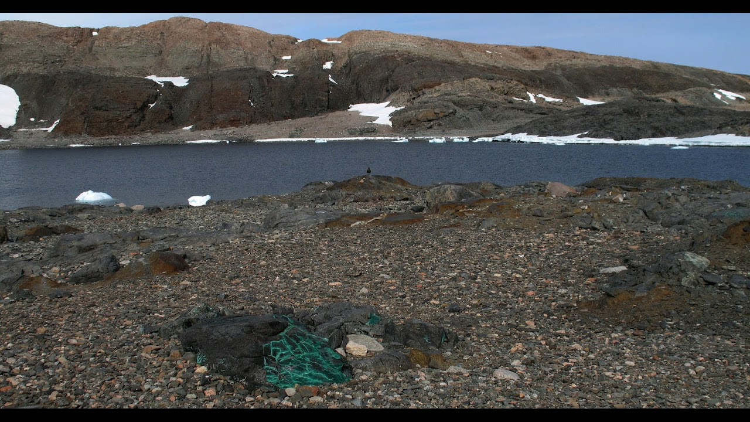

Ecosystem photo

### Distribution

Maps - Full map

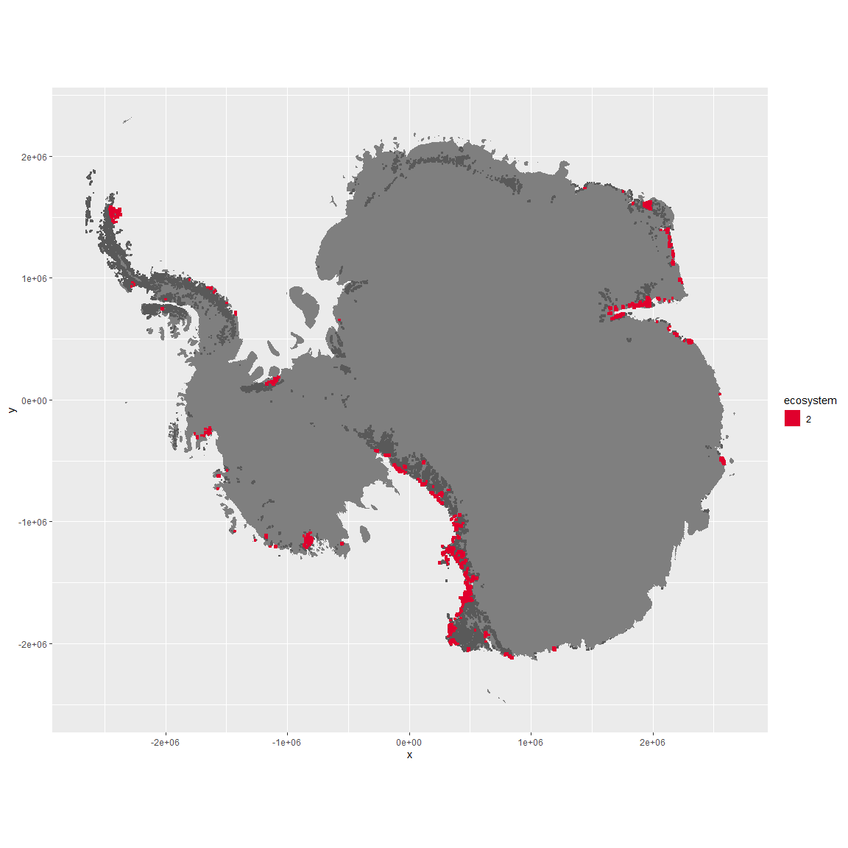

Regional maps

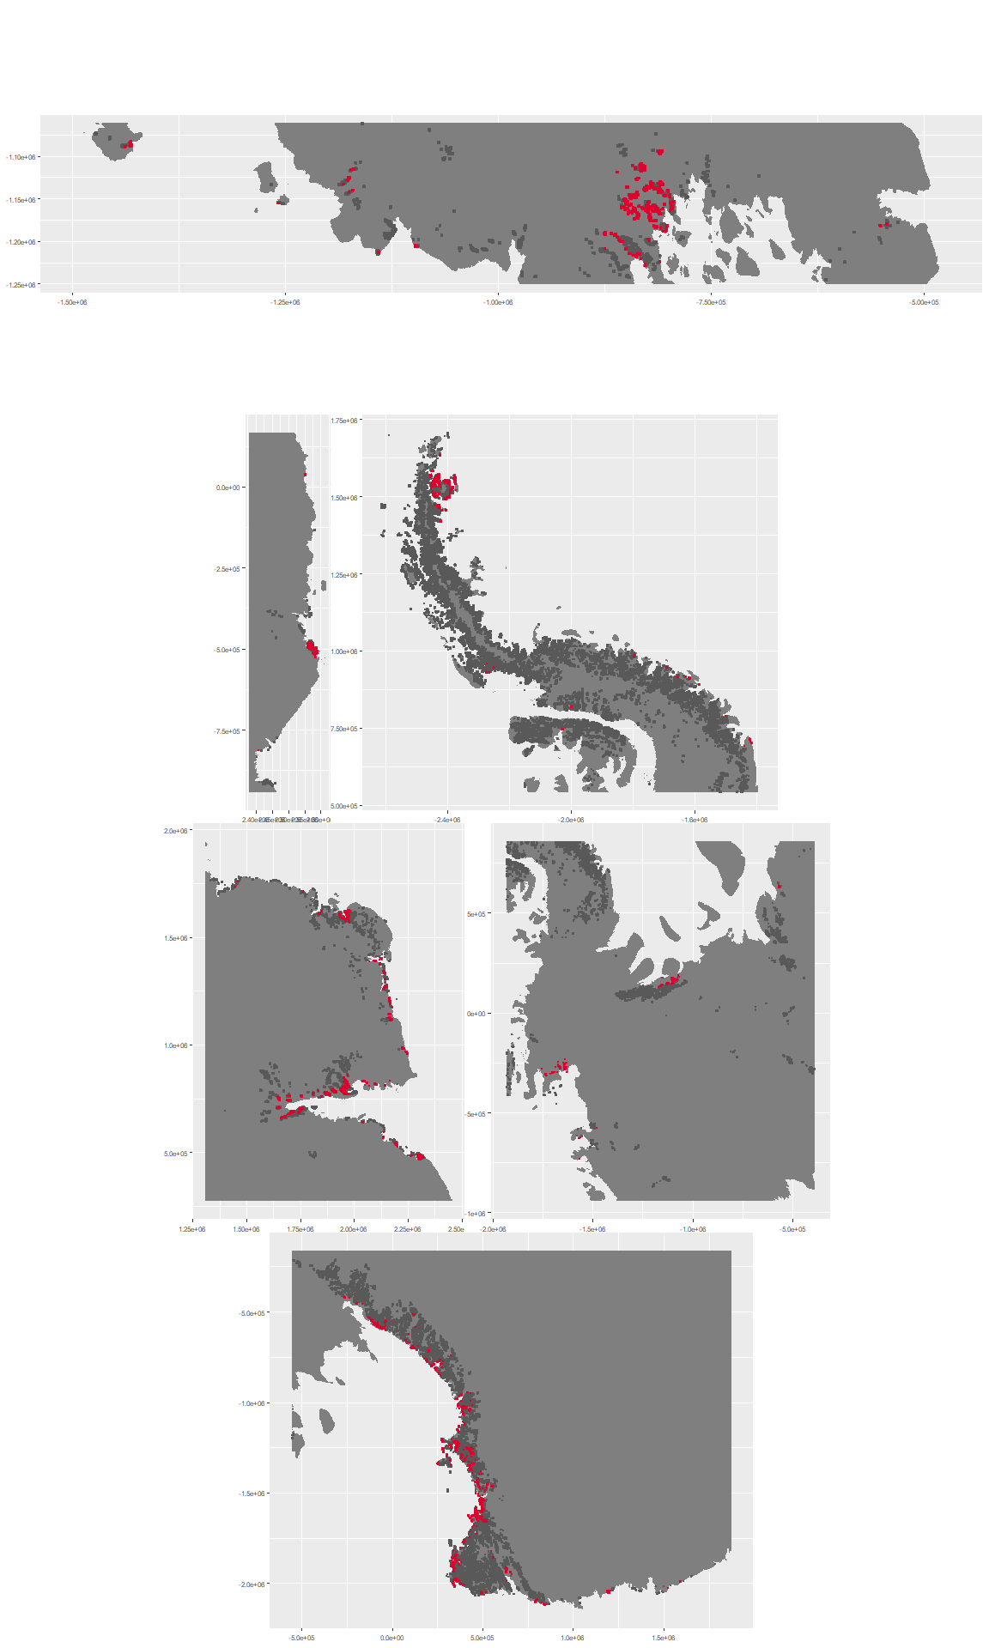

### Environment

The unit env1_sdm2 is part of the environmental supergroup env1.

This supergroup is, on average, substantially higher in sumtemp, temp, modT_0315 and melt than continental antarctica. It is substantially lower in slope, rugos and elev than the rest of the continent.

The elevation of unit env1_sdm2 ranges from 0 to 1939 metres above sea level, but 90% of its pixels fall above 4 and below 949 metres. Its average elevation is 361 metres.

The unit is higher in wind and lower in temp, cloud and melt than the rest of its environmental supergroup.

#### Distinctiveness of the unit from its group and the rest of Antarctica

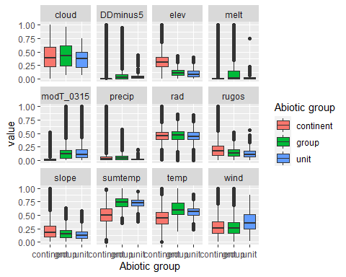

### Biota

Most widespread species in the unit (found in most pixels)

The top most widespread species in ecosystem env1_sdm2

| scientific | Functional_group | phylum | restricted | count | relative_pct |
| --- | --- | --- | --- | --- | --- |
| Bryum pseudotriquetrum | Bryophyta_Bryopsida_Bryales___ | Bryophyta | FALSE | 78 | 2.7445 |
| Buellia frigida | Ascomycota_Lecanoromycetes_Teloschistales_Physciaceae__ | Ascomycota | TRUE | 72 | 2.5334 |
| Xanthoria elegans | Ascomycota_Lecanoromycetes_Teloschistales_Teloschistaceae__ | Ascomycota | FALSE | 61 | 2.1464 |
| Lecanora expectans | Ascomycota_Lecanoromycetes_Lecanorales_Lecanoraceae__ | Ascomycota | TRUE | 52 | 1.8297 |
| Umbilicaria aprina | Ascomycota_Lecanoromycetes_Umbilicariales_Umbilicariaceae__ | Ascomycota | FALSE | 52 | 1.8297 |
| Umbilicaria decussata | Ascomycota_Lecanoromycetes_Umbilicariales_Umbilicariaceae__ | Ascomycota | FALSE | 52 | 1.8297 |
| Acarospora gwynnii | Ascomycota_Lecanoromycetes_Acarosporales_Acarosporaceae__ | Ascomycota | TRUE | 50 | 1.7593 |
| Rhizoplaca melanophthalma | Ascomycota_Lecanoromycetes_Lecanorales_Lecanoraceae__ | Ascomycota | FALSE | 50 | 1.7593 |
| Candelariella flava | Ascomycota_Lecanoromycetes_Candelariales_Candelariaceae__ | Ascomycota | TRUE | 49 | 1.7241 |
| Caloplaca citrina | Ascomycota_Lecanoromycetes_Teloschistales_Teloschistaceae__ | Ascomycota | TRUE | 46 | 1.6186 |

This supergroup is, on average, substantially higher in suitability for Rotifers, Springtails_slim, Nematodes, mosses_Pottiales, mites_Trombidiformes, lichens_Physcid_(shadow), lichens_Teloschistid, lichens_Candelarid, mites_Sarcoptiformes, algae_Green, mosses_Dicranales, lichens_Lecanorid, lichens_Parmelid, lichens_Rhizocarpid, mites_Mesostigmata, lichens_Acarosporacid, lichens_Stereocaulid, Algae, mosses_Bryales, penguins_Gentoo, mosses_Hypnales_(feather), penguins_Chinstrap, mosses_Polytrichales, lichens_Cladonid and lichens,_Bacidiacid functional groups than continental Antarctica. It is substantially lower in suitability for no variables than the rest of the continent.

Unit env1_sdm2 is higher in suitability for lichens_Acarosporacid, Algae, Rotifers, lichens_Physcid_(shadow), lichens_Lecanorid, lichens_Candelarid and lichens_Teloschistid and lower in suitability for no variables than the rest of its environmental supergroup.

Distinctiveness of the unit from the environmental group and the rest of Antarctica

