Ecosystem Description

Aniko B. Toth

## Ecosystem Env2_sdm1 Meltwater-fed low coastal mountains

Env2_sdm1 Meltwater-fed low coastal mountains. Occurs mainly in the rugged areas of Alexander and Adelaide Islands and on the coastal peninsula with some outliers elsewhere. Maritime influence makes these systems warmer and wetter than others within the Env2 group, and they also have greater relief and higher exposure to meltwater at lower elevations. Sampled biota includes mainly common lichen and moss species, but this system also has unusually high suitability for mosses of Hypnales and Polytrichales, lichens of Bacidiaceae and Cladoniaceae, and adjacent to the coast, penguins.

### Photos (if available)

### Distribution

Maps - Full map

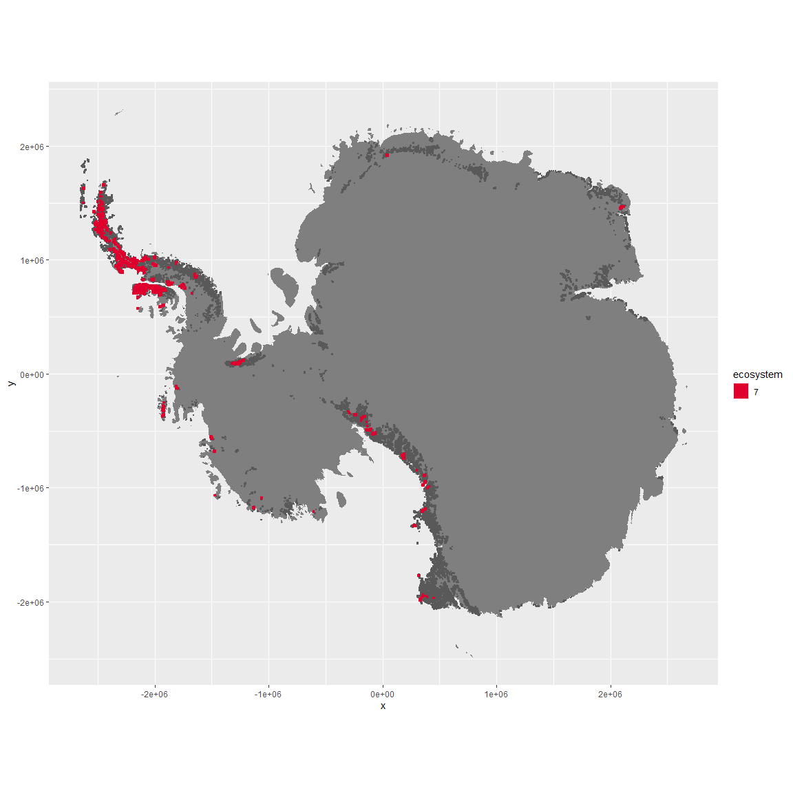

Regional maps

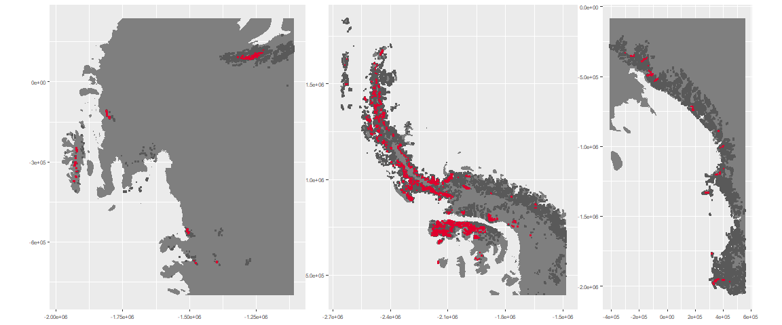

### Environment

The unit env2_sdm1 is part of the environmental supergroup env2.

This supergroup is, on average, substantially higher in cloud, precip, temp and sumtemp than continental antarctica. It is substantially lower in no variables than the rest of the continent.

The elevation of unit env2_sdm1 ranges from 0 to 4955 metres above sea level, but 90% of its pixels fall above 391 and below 2726 metres. Its average elevation is 1164 metres.

The unit is higher in melt, temp, sumtemp, cloud, precip, slope, rugos and modT_0315 and lower in elev and wind than the rest of its environmental supergroup.

#### Distinctiveness of the unit from its group and the rest of Antarctica

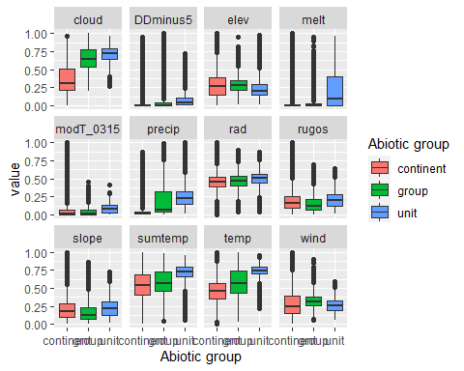

### Biota

Most widespread species in the unit (found in most pixels)

The top most widespread species in ecosystem env2_sdm1

| scientific | Functional_group | phylum | restricted | count | relative_pct |
| --- | --- | --- | --- | --- | --- |
| Usnea sphacelata | Ascomycota_Lecanoromycetes_Lecanorales_Parmeliaceae__ | Ascomycota | TRUE | 19 | 2.9688 |
| Umbilicaria decussata | Ascomycota_Lecanoromycetes_Umbilicariales_Umbilicariaceae__ | Ascomycota | FALSE | 12 | 1.8750 |
| Pseudephebe minuscula | Ascomycota_Lecanoromycetes_Lecanorales_Parmeliaceae__ | Ascomycota | FALSE | 11 | 1.7188 |
| Pohlia cruda | Bryophyta_Bryopsida_Bryales___ | Bryophyta | FALSE | 10 | 1.5625 |
| Schistidium antarctici | Bryophyta_Bryopsida_Grimmiales___ | Bryophyta | TRUE | 9 | 1.4062 |
| Umbilicaria antarctica | Ascomycota_Lecanoromycetes_Umbilicariales_Umbilicariaceae__ | Ascomycota | TRUE | 9 | 1.4062 |
| Bryum pseudotriquetrum | Bryophyta_Bryopsida_Bryales___ | Bryophyta | FALSE | 8 | 1.2500 |
| Syntrichia princeps | Bryophyta_Bryopsida_Pottiales___ | Bryophyta | FALSE | 8 | 1.2500 |
| Usnea antarctica | Ascomycota_Lecanoromycetes_Lecanorales_Parmeliaceae__ | Ascomycota | FALSE | 8 | 1.2500 |
| Bartramia patens | Bryophyta_Bryopsida_Bryales___ | Bryophyta | FALSE | 7 | 1.0938 |
| Cephaloziella varians | Marchantiophyta_____ | Marchantiophyta | FALSE | 7 | 1.0938 |
| Ceratodon purpureus | Bryophyta_Bryopsida_Dicranales___ | Bryophyta | FALSE | 7 | 1.0938 |
| Grimmia reflexidens | Bryophyta_Bryopsida_Grimmiales___ | Bryophyta | FALSE | 7 | 1.0938 |
| Pleopsidium chlorophanum | Ascomycota_Lecanoromycetes_Acarosporales_Acarosporaceae__ | Ascomycota | FALSE | 7 | 1.0938 |
| Pohlia nutans | Bryophyta_Bryopsida_Bryales___ | Bryophyta | FALSE | 7 | 1.0938 |
| Sanionia uncinata | Bryophyta_Bryopsida_Hypnales___ | Bryophyta | FALSE | 7 | 1.0938 |
| Usnea aurantiaco-atra | Ascomycota_Lecanoromycetes_Lecanorales_Parmeliaceae__ | Ascomycota | FALSE | 7 | 1.0938 |
| Xanthoria elegans | Ascomycota_Lecanoromycetes_Teloschistales_Teloschistaceae__ | Ascomycota | FALSE | 7 | 1.0938 |

This supergroup is, on average, substantially higher in suitability for no variables functional groups than continental Antarctica. It is substantially lower in suitability for mites_Trombidiformes, Nematodes, lichens_Acarosporacid, lichens_Teloschistid, lichens_Candelarid, lichens_Lecanorid, lichens_Physcid_(shadow), algae_Green, Rotifers and Algae than the rest of the continent.

Unit env2_sdm1 is higher in suitability for penguins_Chinstrap, lichens_Cladonid, penguins_Gentoo, mosses_Hypnales_(feather), lichens,_Bacidiacid, mosses_Polytrichales, mosses_Bryales, mosses_Dicranales and mosses_Pottiales and lower in suitability for lichens_Lecanorid, lichens_Acarosporacid, lichens_Candelarid and Algae than the rest of its environmental supergroup.

Distinctiveness of the unit from the environmental group and the rest of Antarctica

