Ecosystem Description

Aniko B. Toth

## Ecosystem Env2_sdm4

Env2_sdm4. Occurs mainly along the highest peaks set back from the coast on the peninsula. Similar to 2.2 but receive a lot more snowfall, and consequently avalanches may be more frequent. Cladonid and Bacidiacid lichens are present but conditions are largely unsuitable for most other groups.

### Photos (if available)

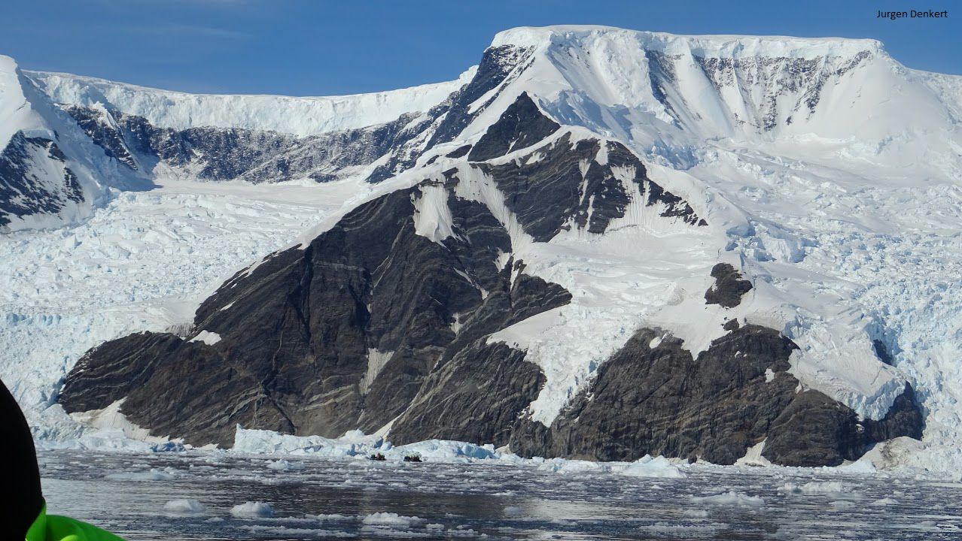

Ecosystem photo

### Distribution

Maps - Full map

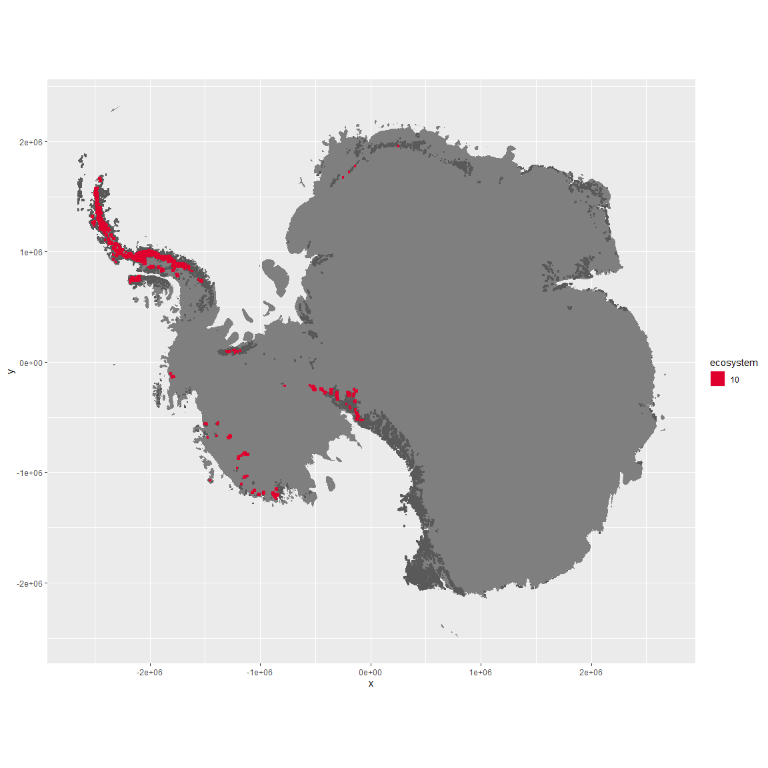

Regional maps

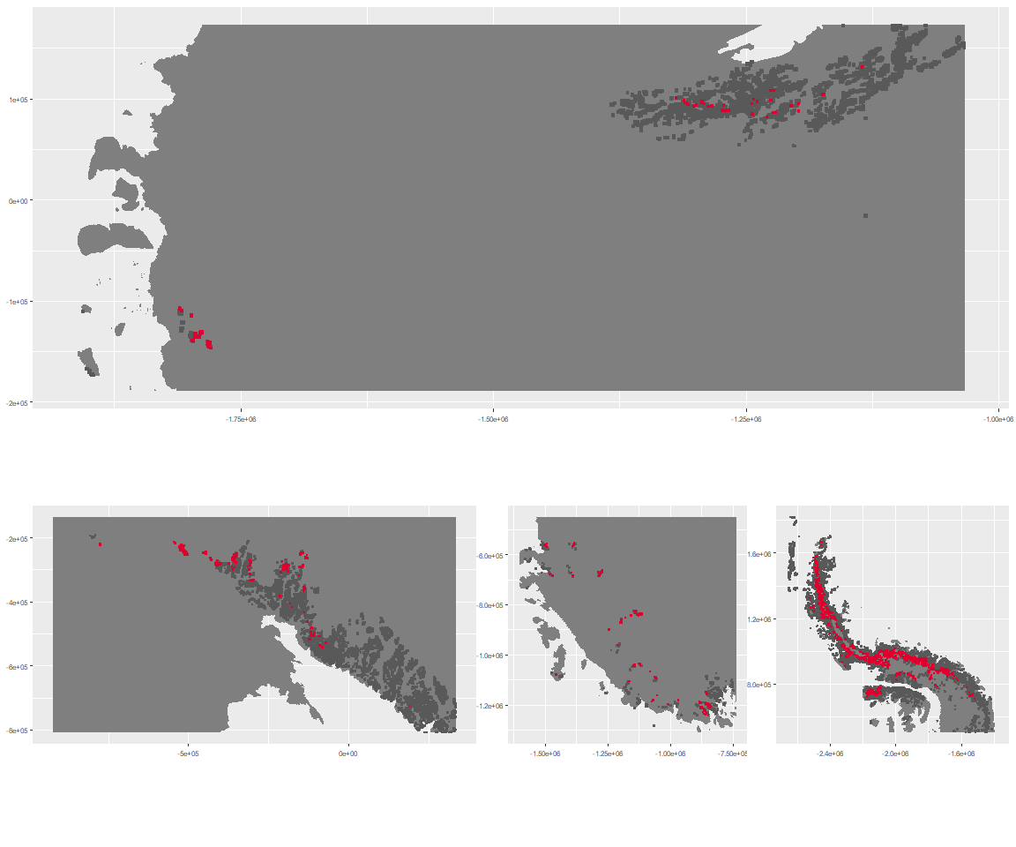

### Environment

The unit env2_sdm4 is part of the environmental supergroup env2.

This supergroup is, on average, substantially higher in cloud, precip, temp and sumtemp than continental antarctica. It is substantially lower in no variables than the rest of the continent.

The elevation of unit env2_sdm4 ranges from 0 to 4511 metres above sea level, but 90% of its pixels fall above 699 and below 2661 metres. Its average elevation is 1516 metres.

The unit is higher in elev and cloud and lower in melt than the rest of its environmental supergroup.

#### Distinctiveness of the unit from its group and the rest of Antarctica

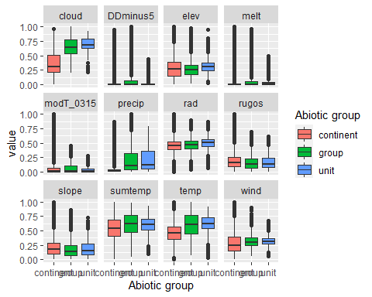

### Biota

Most widespread species in the unit (found in most pixels)

The top most widespread species in ecosystem env2_sdm4

| scientific | Functional_group | phylum | restricted | count | relative_pct |
| --- | --- | --- | --- | --- | --- |
| Pseudephebe minuscula | Ascomycota_Lecanoromycetes_Lecanorales_Parmeliaceae__ | Ascomycota | FALSE | 18 | 15.3846 |
| Usnea sphacelata | Ascomycota_Lecanoromycetes_Lecanorales_Parmeliaceae__ | Ascomycota | TRUE | 12 | 10.2564 |
| Lecidea cf. cancriformis | Ascomycota_Lecanoromycetes_Lecanorales_Lecideaceae__ | Ascomycota | TRUE | 11 | 9.4017 |
| Pleopsidium chlorophanum | Ascomycota_Lecanoromycetes_Acarosporales_Acarosporaceae__ | Ascomycota | FALSE | 6 | 5.1282 |
| Carbonea vorticosa | Ascomycota_Lecanoromycetes_Lecanorales_Lecanoraceae__ | Ascomycota | FALSE | 5 | 4.2735 |
| Umbilicaria decussata | Ascomycota_Lecanoromycetes_Umbilicariales_Umbilicariaceae__ | Ascomycota | FALSE | 5 | 4.2735 |
| Ceratodon purpureus | Bryophyta_Bryopsida_Dicranales___ | Bryophyta | FALSE | 4 | 3.4188 |
| Lecidea cancriformis | Ascomycota_Lecanoromycetes_Lecanorales_Lecideaceae__ | Ascomycota | TRUE | 4 | 3.4188 |
| Acarospora gwynnii | Ascomycota_Lecanoromycetes_Acarosporales_Acarosporaceae__ | Ascomycota | TRUE | 3 | 2.5641 |
| Rhizoplaca melanophthalma | Ascomycota_Lecanoromycetes_Lecanorales_Lecanoraceae__ | Ascomycota | FALSE | 3 | 2.5641 |

This supergroup is, on average, substantially higher in suitability for no variables functional groups than continental Antarctica. It is substantially lower in suitability for mites_Trombidiformes, Nematodes, lichens_Acarosporacid, lichens_Teloschistid, lichens_Candelarid, lichens_Lecanorid, lichens_Physcid_(shadow), algae_Green, Rotifers and Algae than the rest of the continent.

Unit env2_sdm4 is higher in suitability for no variables and lower in suitability for mites_Mesostigmata, mosses_Polytrichales, mosses_Hypnales_(feather), Algae, mosses_Bryales, mosses_Dicranales, lichens_Acarosporacid, Springtails_slim, mites_Sarcoptiformes, lichens_Lecanorid, lichens_Candelarid, lichens_Parmelid, lichens_Rhizocarpid, lichens_Stereocaulid, lichens_Physcid_(shadow), mosses_Pottiales, lichens_Teloschistid, Nematodes, mites_Trombidiformes and algae_Green than the rest of its environmental supergroup.

Distinctiveness of the unit from the environmental group and the rest of Antarctica

