Ecosystem Description

Aniko B. Toth

## Ecosystem Env3_sdm1

Env3_sdm1. Occurs mainly in the Transantarctic mountains, Victoria Land and Dronning Maud land. Unit has especially low cloud and highest wind in the group. Main sampled biota appears to be arthopods (springtails and mites) but Chlorophyta, Nematodes, and lichens are also represented. Suitability appears especially low for many mosses, penguins, and some lichens (Cladoniaceae and Bacidiaceae).

### Photos (if available)

### Distribution

Maps - Full map

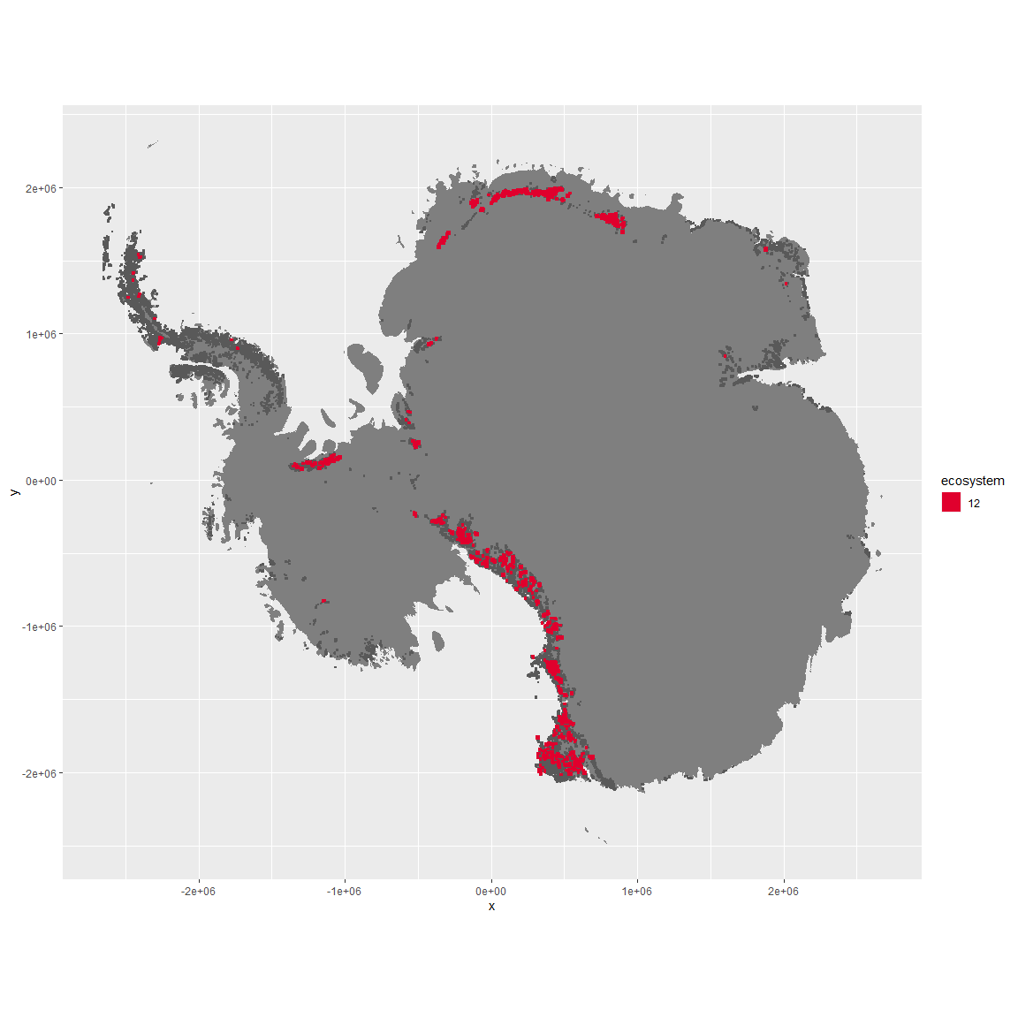

Regional maps

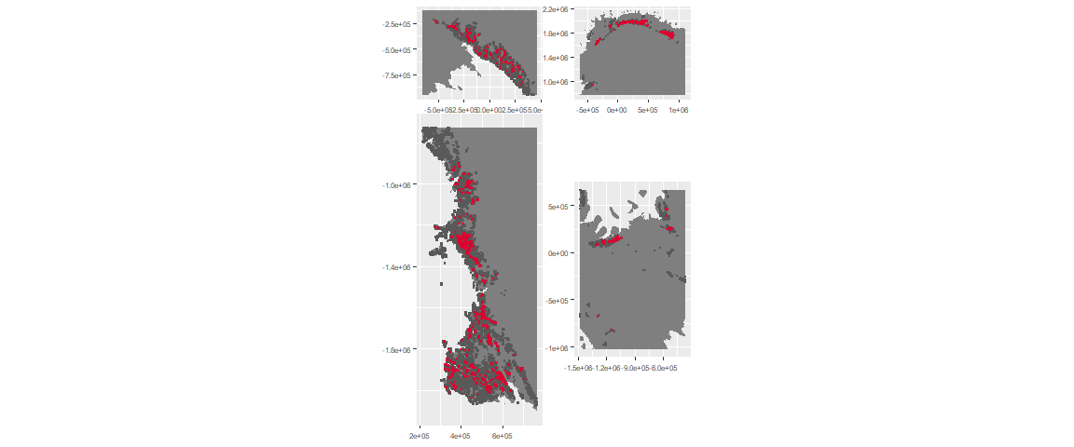

### Environment

The unit env3_sdm1 is part of the environmental supergroup env3.

This supergroup is, on average, substantially higher in slope, rugos and elev than continental antarctica. It is substantially lower in cloud, sumtemp and temp than the rest of the continent.

The elevation of unit env3_sdm1 ranges from 0 to 3679 metres above sea level, but 90% of its pixels fall above 775 and below 2536 metres. Its average elevation is 1696 metres.

The unit is higher in wind and lower in cloud than the rest of its environmental supergroup.

#### Distinctiveness of the unit from its group and the rest of Antarctica

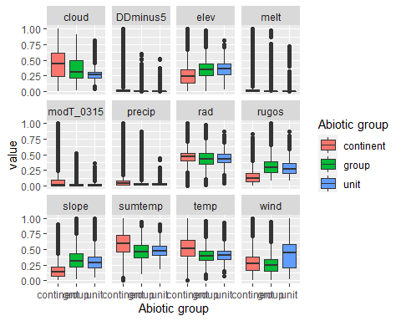

### Biota

Most widespread species in the unit (found in most pixels)

The top most widespread species in ecosystem env3_sdm1

| scientific | Functional_group | phylum | restricted | count | relative_pct |
| --- | --- | --- | --- | --- | --- |
| Gomphiocephalus hodgsoni | Arthropoda_Entognatha_Poduromorpha___ | Arthropoda | TRUE | 6 | 5.3097 |
| Stereotydeus mollis | Arthropoda_Arachnida_Trombidiformes___ | Arthropoda | TRUE | 5 | 4.4248 |
| Xanthoria elegans | Ascomycota_Lecanoromycetes_Teloschistales_Teloschistaceae__ | Ascomycota | FALSE | 4 | 3.5398 |
| Lecidea cancriformis | Ascomycota_Lecanoromycetes_Lecanorales_Lecideaceae__ | Ascomycota | TRUE | 3 | 2.6549 |
| Plectus frigophilus | Nematoda_____ | Nematoda | TRUE | 3 | 2.6549 |
| Prasiola crispa | Chlorophyta_____ | Chlorophyta | FALSE | 3 | 2.6549 |
| Candelariella hallettensis | Ascomycota_Lecanoromycetes_Candelariales_Candelariaceae__ | Ascomycota | TRUE | 2 | 1.7699 |
| Carbonea vorticosa | Ascomycota_Lecanoromycetes_Lecanorales_Lecanoraceae__ | Ascomycota | FALSE | 2 | 1.7699 |
| Cryptopygus sverdrupi | Arthropoda_Entognatha_Entomobryomorpha___ | Arthropoda | TRUE | 2 | 1.7699 |
| Eudorylaimus antarcticus | Nematoda_____ | Nematoda | TRUE | 2 | 1.7699 |
| Eupodes angardi | Arthropoda_Arachnida_Trombidiformes___ | Arthropoda | TRUE | 2 | 1.7699 |
| Lecanora fuscobrunnea | Ascomycota_Lecanoromycetes_Lecanorales_Lecanoraceae__ | Ascomycota | TRUE | 2 | 1.7699 |
| Pseudephebe minuscula | Ascomycota_Lecanoromycetes_Lecanorales_Parmeliaceae__ | Ascomycota | FALSE | 2 | 1.7699 |
| Pygoscelis adeliae | Chordata_Aves_Sphenisciformes_Spheniscidae_Pygoscelis_adeliae | Chordata | FALSE | 2 | 1.7699 |
| Tydeus erebus | Arthropoda_Arachnida_Trombidiformes___ | Arthropoda | TRUE | 2 | 1.7699 |
| Umbilicaria aprina | Ascomycota_Lecanoromycetes_Umbilicariales_Umbilicariaceae__ | Ascomycota | FALSE | 2 | 1.7699 |
| Umbilicaria decussata | Ascomycota_Lecanoromycetes_Umbilicariales_Umbilicariaceae__ | Ascomycota | FALSE | 2 | 1.7699 |
| Xanthoria sp. | Ascomycota_Lecanoromycetes_Teloschistales_Teloschistaceae__ | Ascomycota | TRUE | 2 | 1.7699 |

This supergroup is, on average, substantially higher in suitability for no variables functional groups than continental Antarctica. It is substantially lower in suitability for Springtails_slim, lichens_Cladonid, mosses_Hypnales_(feather), penguins_Chinstrap, mosses_Polytrichales, mites_Sarcoptiformes, mites_Mesostigmata and penguins_Gentoo than the rest of the continent.

Unit env3_sdm1 is higher in suitability for lichens_Acarosporacid, lichens_Parmelid, lichens_Candelarid, algae_Green, lichens_Rhizocarpid, lichens_Teloschistid, lichens_Lecanorid, lichens_Physcid_(shadow), mites_Sarcoptiformes, Algae, mites_Trombidiformes, mosses_Pottiales and lichens_Stereocaulid and lower in suitability for mosses_Polytrichales, mosses_Bryales, penguins_Gentoo, penguins_Chinstrap, lichens,_Bacidiacid and lichens_Cladonid than the rest of its environmental supergroup.

Distinctiveness of the unit from the environmental group and the rest of Antarctica

