Ecosystem Description

Aniko B. Toth

## Ecosystem Env4_sdm2, Sheltered upper slopes and inclined plateaus

Env4_sdm2, Sheltered upper slopes and inclined plateaus. Occurs mainly on the eastern coast of the northern peninsula and in Victoria Land. This unit is on the milder end of the group, with more ruggedness and cloud and less wind/higher temp than the group average, though still high radiation. Most sampled faunas are Rotifers, though singletons of various other groups have been detected. Suitability appears to be especially low for many lichen functional groups (but high for Cladoniaceae and Bacidiaceae) and Trombidiformes (Arachnids) and high for chinstrap penguins and several moss groups.

### Photos (if available)

### Distribution

Maps - Full map

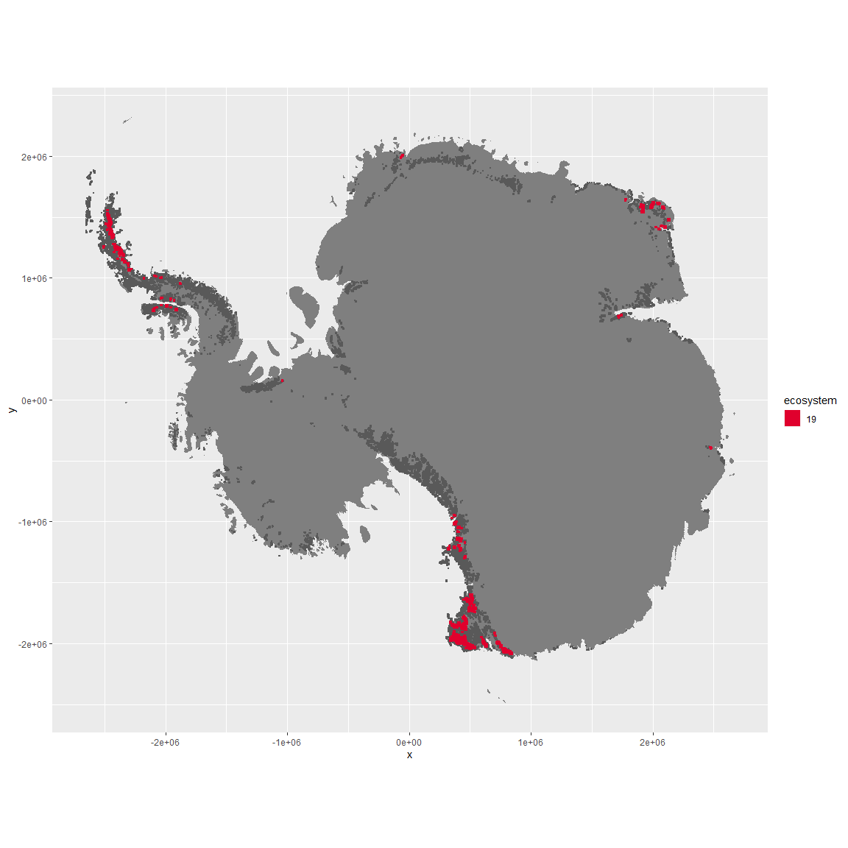

Regional maps

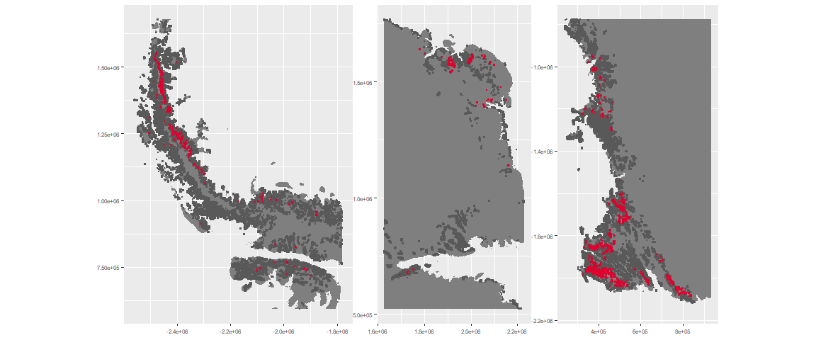

### Environment

The unit env4_sdm2 is part of the environmental supergroup env4.

This supergroup is, on average, substantially higher in wind, elev and rad than continental antarctica. It is substantially lower in rugos, sumtemp, slope, temp and cloud than the rest of the continent.

The elevation of unit env4_sdm2 ranges from 230 to 3472 metres above sea level, but 90% of its pixels fall above 678 and below 2777 metres. Its average elevation is 1669 metres.

The unit is higher in cloud, temp, slope, sumtemp, rugos, rad and precip and lower in wind than the rest of its environmental supergroup.

#### Distinctiveness of the unit from its group and the rest of Antarctica

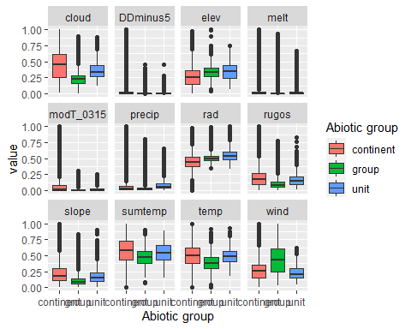

### Biota

Most widespread species in the unit (found in most pixels)

The top most widespread species in ecosystem env4_sdm2

| scientific | Functional_group | phylum | restricted | count | relative_pct |
| --- | --- | --- | --- | --- | --- |
| Adineta gracilis | Rotifera_____ | Rotifera | FALSE | 1 | 2.6316 |
| Adineta steineri | Rotifera_____ | Rotifera | TRUE | 1 | 2.6316 |
| Adineta vaga | Rotifera_____ | Rotifera | FALSE | 1 | 2.6316 |
| Andreaea depressinervis | Bryophyta_Andreaeopsida_Andreaeales___ | Bryophyta | TRUE | 1 | 2.6316 |
| Aphanocapsa elachista | Cyanophycota_____ | Cyanophycota | FALSE | 1 | 2.6316 |
| Bacidia harrissoni | Ascomycota_Lecanoromycetes_Lecanorales_Ramalinaceae__ | Ascomycota | TRUE | 1 | 2.6316 |
| Campylopus pyriformis | Bryophyta_Bryopsida_Dicranales___ | Bryophyta | FALSE | 1 | 2.6316 |
| Catillaria inconspicua | Ascomycota_Lecanoromycetes_Lecanorales_Catillariaceae__ | Ascomycota | TRUE | 1 | 2.6316 |
| Cephaloziella exiliflora | Marchantiophyta_____ | Marchantiophyta | FALSE | 1 | 2.6316 |
| Ceratodon purpureus | Bryophyta_Bryopsida_Dicranales___ | Bryophyta | FALSE | 1 | 2.6316 |
| Chlorella sp. | Chlorophyta_____ | Chlorophyta | TRUE | 1 | 2.6316 |
| Coenochloris oleifera | Chlorophyta_____ | Chlorophyta | TRUE | 1 | 2.6316 |
| Corythion dubium | Cercozoa_____ | Cercozoa | TRUE | 1 | 2.6316 |
| Drepanocladus uncinatus | Bryophyta_Bryopsida_Hypnales___ | Bryophyta | TRUE | 1 | 2.6316 |
| Gloeocapsa magma | Cyanobacteria_____ | Cyanobacteria | FALSE | 1 | 2.6316 |
| Graesiella emersonii | Chlorophyta_____ | Chlorophyta | FALSE | 1 | 2.6316 |
| Habrotrocha elusa | Rotifera_____ | Rotifera | TRUE | 1 | 2.6316 |
| Hassallia bouteillei | Cyanobacteria_____ | Cyanobacteria | TRUE | 1 | 2.6316 |
| Huea smaragdula | Ascomycota_Lecanoromycetes_Teloschistales_Teloschistaceae__ | Ascomycota | TRUE | 1 | 2.6316 |
| Hygroamblystegium filum | Bryophyta_Bryopsida_Hypnales___ | Bryophyta | FALSE | 1 | 2.6316 |
| Macrobiotus ?fuciger | Tardigrada_____ | Tardigrada | TRUE | 1 | 2.6316 |
| Macrobiotus sp. | Tardigrada_____ | Tardigrada | TRUE | 1 | 2.6316 |
| Macrotrachela ambigua | Rotifera_____ | Rotifera | TRUE | 1 | 2.6316 |
| Macrotrachela cf. ligulata | Rotifera_____ | Rotifera | TRUE | 1 | 2.6316 |
| Mastigocladus laminosus | Cyanobacteria_____ | Cyanobacteria | FALSE | 1 | 2.6316 |
| Mniobia sp. | Rotifera_____ | Rotifera | TRUE | 1 | 2.6316 |
| Phormidium fragile | Cyanobacteria_____ | Cyanobacteria | FALSE | 1 | 2.6316 |
| Pleopsidium chlorophanum | Ascomycota_Lecanoromycetes_Acarosporales_Acarosporaceae__ | Ascomycota | FALSE | 1 | 2.6316 |
| Pohlia nutans | Bryophyta_Bryopsida_Bryales___ | Bryophyta | FALSE | 1 | 2.6316 |
| Pseudococcomyxa simplex | Chlorophyta_____ | Chlorophyta | TRUE | 1 | 2.6316 |
| Rhizocarpon adarense | Ascomycota_Lecanoromycetes_Not assigned_Rhizocarpaceae__ | Ascomycota | TRUE | 1 | 2.6316 |
| Rhizocarpon copelandii | Ascomycota_Lecanoromycetes_Not assigned_Rhizocarpaceae__ | Ascomycota | FALSE | 1 | 2.6316 |
| Rhizocarpon sp. | Ascomycota_Lecanoromycetes_Not assigned_Rhizocarpaceae__ | Ascomycota | TRUE | 1 | 2.6316 |
| Stereocaulon vesuvianum | Ascomycota_Lecanoromycetes_Lecanorales_Stereocaulaceae__ | Ascomycota | FALSE | 1 | 2.6316 |
| Stigonema ocellatum | Cyanobacteria_____ | Cyanobacteria | FALSE | 1 | 2.6316 |
| Toninia johnstonii | Ascomycota_Lecanoromycetes_Rhizocarpales_Catillariaceae__ | Ascomycota | TRUE | 1 | 2.6316 |
| Usnea sphacelata | Ascomycota_Lecanoromycetes_Lecanorales_Parmeliaceae__ | Ascomycota | TRUE | 1 | 2.6316 |
| Xanthoria elegans | Ascomycota_Lecanoromycetes_Teloschistales_Teloschistaceae__ | Ascomycota | FALSE | 1 | 2.6316 |

This supergroup is, on average, substantially higher in suitability for no variables functional groups than continental Antarctica. It is substantially lower in suitability for lichens_Lecanorid, Nematodes, lichens_Parmelid, mosses_Dicranales, mites_Sarcoptiformes, mosses_Pottiales, Springtails_slim, mosses_Bryales, mites_Trombidiformes, mosses_Hypnales_(feather), lichens,_Bacidiacid, mosses_Polytrichales, penguins_Chinstrap, lichens_Cladonid, mites_Mesostigmata, penguins_Gentoo and lichens_Stereocaulid than the rest of the continent.

Unit env4_sdm2 is higher in suitability for lichens,*Bacidiacid, lichens_Cladonid, penguins_Chinstrap, mosses_Bryales, penguins_Gentoo, mosses_Hypnales*(feather), mosses_Polytrichales and mosses_Dicranales and lower in suitability for lichens_Physcid_(shadow), lichens_Teloschistid, lichens_Lecanorid, lichens_Acarosporacid, lichens_Rhizocarpid, Algae and lichens_Candelarid than the rest of its environmental supergroup.

Distinctiveness of the unit from the environmental group and the rest of Antarctica

