Ecosystem Description

Aniko B. Toth

## Ecosystem Env4_sdm3, Clear windy plateaus

Env4_sdm3, Clear windy plateaus. Occurs mainly in Victoria land, Enderby Land and in the Prince Charles mountains. Its elevation is lower than the rest of the group, but it is especially windy and low in cloud cover (radians are not especially high for the group, possibly due to aspect? East, west, and south-facing slopes?). Sampled biota are exclusively lichens. Though the group has lower suitability than the continental average for all functional groups, this unit nonetheless has higher-than-average suitability for Ochrophytes, Rotifers, and Acarosporaceae lichens.

### Photos (if available)

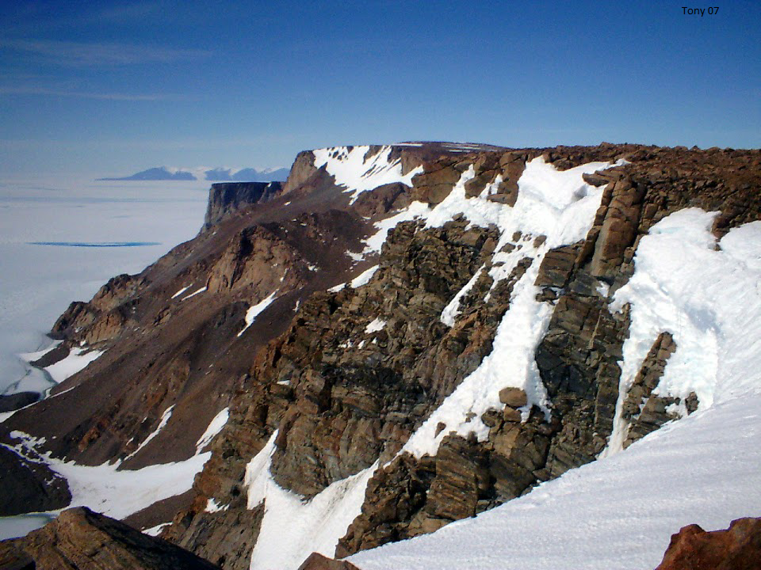

Ecosystem photo

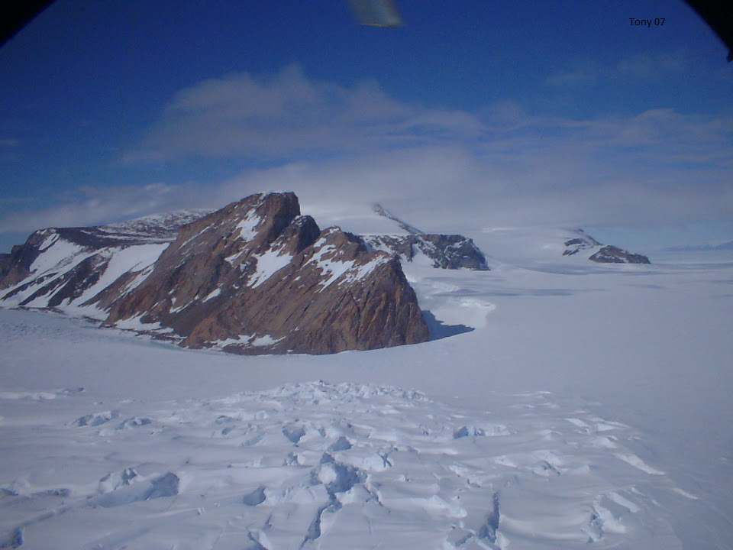

Ecosystem photo

### Distribution

Maps - Full map

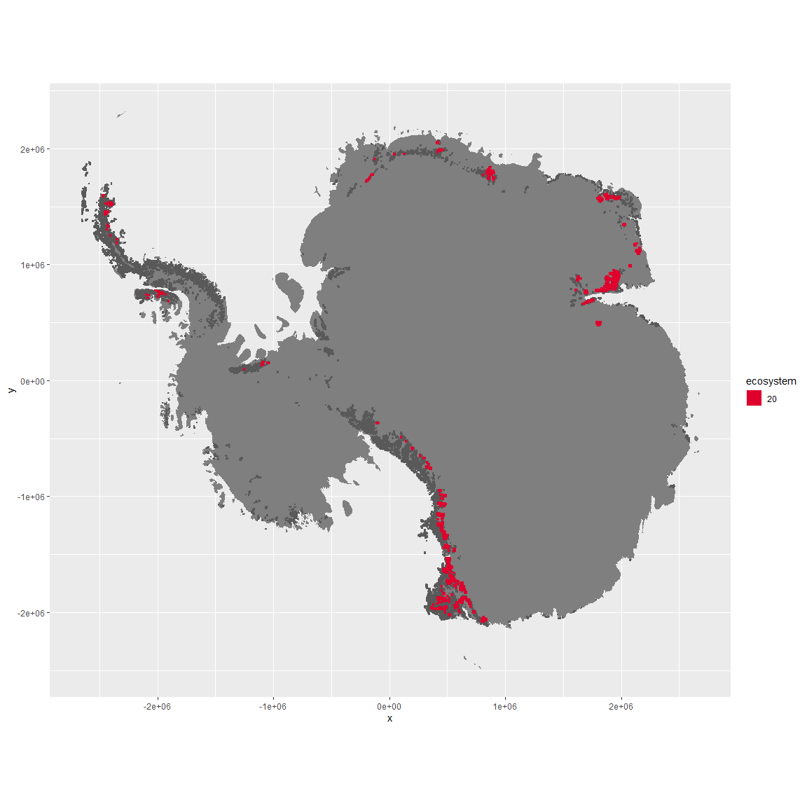

Regional maps

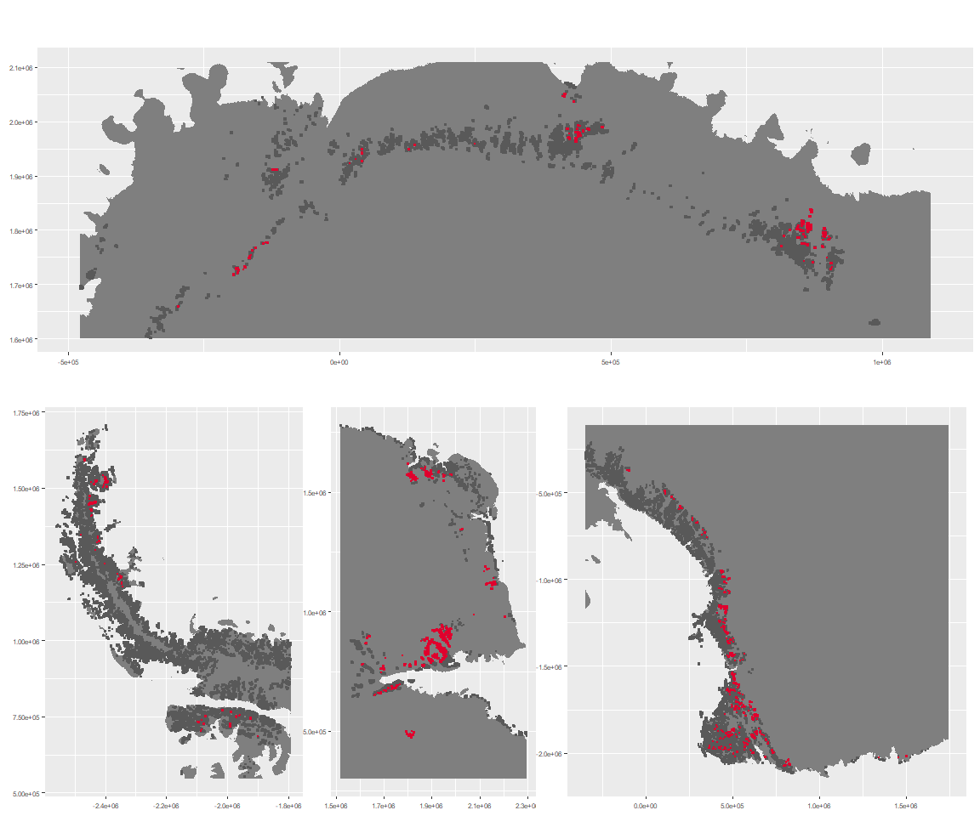

### Environment

The unit env4_sdm3 is part of the environmental supergroup env4.

This supergroup is, on average, substantially higher in wind, elev and rad than continental antarctica. It is substantially lower in rugos, sumtemp, slope, temp and cloud than the rest of the continent.

The elevation of unit env4_sdm3 ranges from 0 to 4700 metres above sea level, but 90% of its pixels fall above 676 and below 2357 metres. Its average elevation is 1405 metres.

The unit is higher in wind and lower in elev and cloud than the rest of its environmental supergroup.

#### Distinctiveness of the unit from its group and the rest of Antarctica

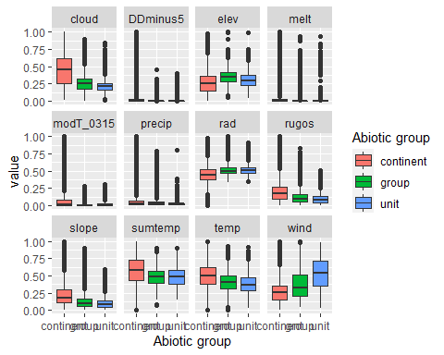

### Biota

Most widespread species in the unit (found in most pixels)

The top most widespread species in ecosystem env4_sdm3

| scientific | Functional_group | phylum | restricted | count | relative_pct |
| --- | --- | --- | --- | --- | --- |
| Pleopsidium chlorophanum | Ascomycota_Lecanoromycetes_Acarosporales_Acarosporaceae__ | Ascomycota | FALSE | 5 | 9.2593 |
| Xanthoria elegans | Ascomycota_Lecanoromycetes_Teloschistales_Teloschistaceae__ | Ascomycota | FALSE | 5 | 9.2593 |
| Acarospora gwynnii | Ascomycota_Lecanoromycetes_Acarosporales_Acarosporaceae__ | Ascomycota | TRUE | 3 | 5.5556 |
| Buellia frigida | Ascomycota_Lecanoromycetes_Teloschistales_Physciaceae__ | Ascomycota | TRUE | 3 | 5.5556 |
| Pseudephebe minuscula | Ascomycota_Lecanoromycetes_Lecanorales_Parmeliaceae__ | Ascomycota | FALSE | 3 | 5.5556 |
| Lepraria cacuminum | Ascomycota_Lecanoromycetes_Lecanorales_Stereocaulaceae__ | Ascomycota | FALSE | 2 | 3.7037 |
| Rhizocarpon sp. | Ascomycota_Lecanoromycetes_Not assigned_Rhizocarpaceae__ | Ascomycota | TRUE | 2 | 3.7037 |
| Rhizocarpon superficiale | Ascomycota_Lecanoromycetes_Not assigned_Rhizocarpaceae__ | Ascomycota | FALSE | 2 | 3.7037 |
| Rhizoplaca melanophthalma | Ascomycota_Lecanoromycetes_Lecanorales_Lecanoraceae__ | Ascomycota | FALSE | 2 | 3.7037 |
| Umbilicaria decussata | Ascomycota_Lecanoromycetes_Umbilicariales_Umbilicariaceae__ | Ascomycota | FALSE | 2 | 3.7037 |
| Usnea sphacelata | Ascomycota_Lecanoromycetes_Lecanorales_Parmeliaceae__ | Ascomycota | TRUE | 2 | 3.7037 |

This supergroup is, on average, substantially higher in suitability for no variables functional groups than continental Antarctica. It is substantially lower in suitability for lichens_Lecanorid, Nematodes, lichens_Parmelid, mosses_Dicranales, mites_Sarcoptiformes, mosses_Pottiales, Springtails_slim, mosses_Bryales, mites_Trombidiformes, mosses_Hypnales_(feather), lichens,_Bacidiacid, mosses_Polytrichales, penguins_Chinstrap, lichens_Cladonid, mites_Mesostigmata, penguins_Gentoo and lichens_Stereocaulid than the rest of the continent.

Unit env4_sdm3 is higher in suitability for lichens_Acarosporacid, Rotifers, Algae, lichens_Teloschistid, lichens_Physcid_(shadow), mosses_Bryales, lichens_Lecanorid, mosses_Polytrichales and lichens_Cladonid and lower in suitability for no variables than the rest of its environmental supergroup.

Distinctiveness of the unit from the environmental group and the rest of Antarctica

