Ecosystem Description

Aniko B. Toth

## Ecosystem Env4_sdm4, Clear sheltered plateaus

Env4_sdm4, Clear sheltered plateaus. Mainly occurs in Victoria land with some representation on the eastern coast of the northern peninsula. Unit is lower in cloud and wind than the rest of its group (likely also south-facing?), so a milder version. Sampled biota is scarce and consists mainly of singletons. Most are lichens and cyanobacteria, along with some Ochrophyta and mosses. Suitability above group average but still below continental average for Ochrophyta, Rotifera, Nematoda, and Trombidiformes.

### Photos (if available)

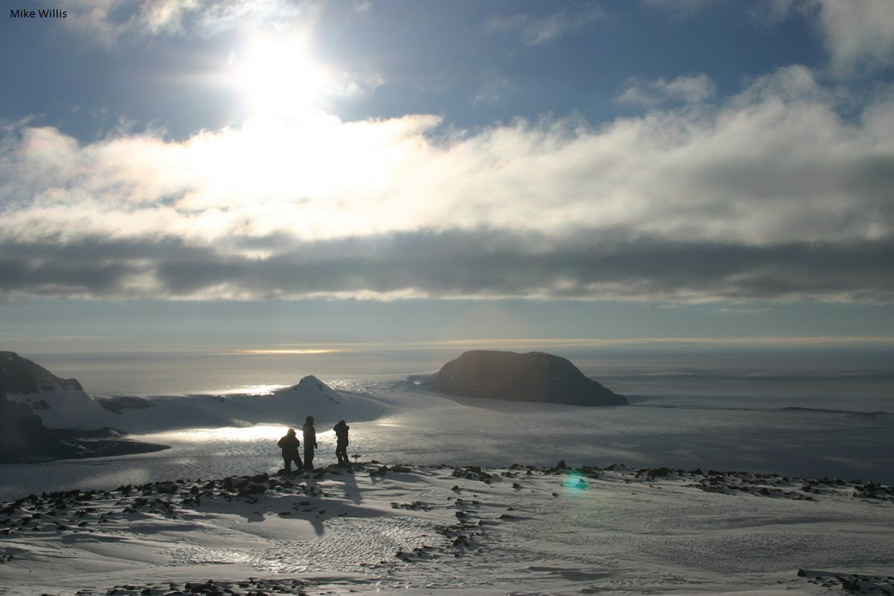

Ecosystem photo

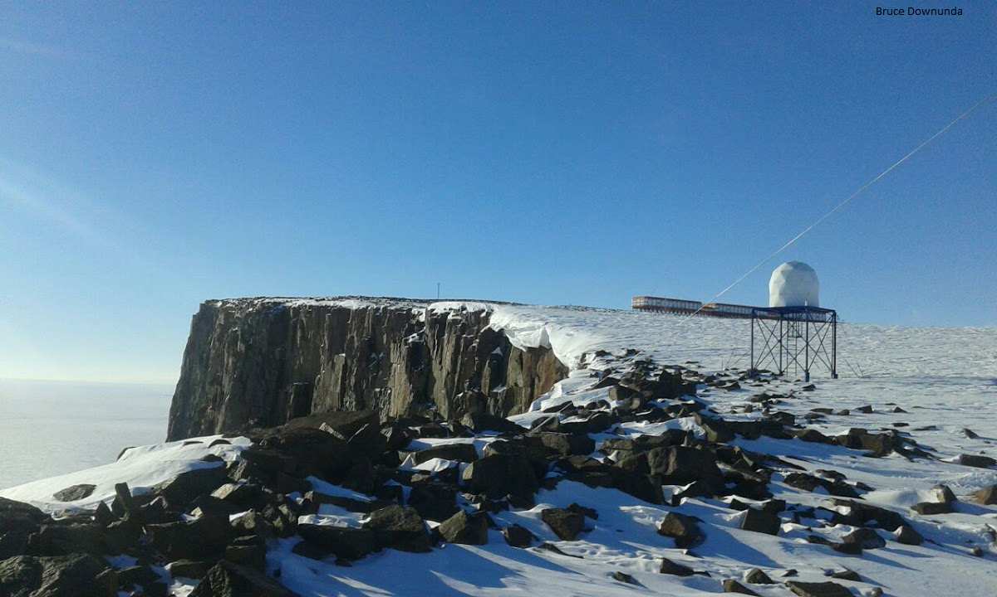

Ecosystem photo

### Distribution

Maps - Full map

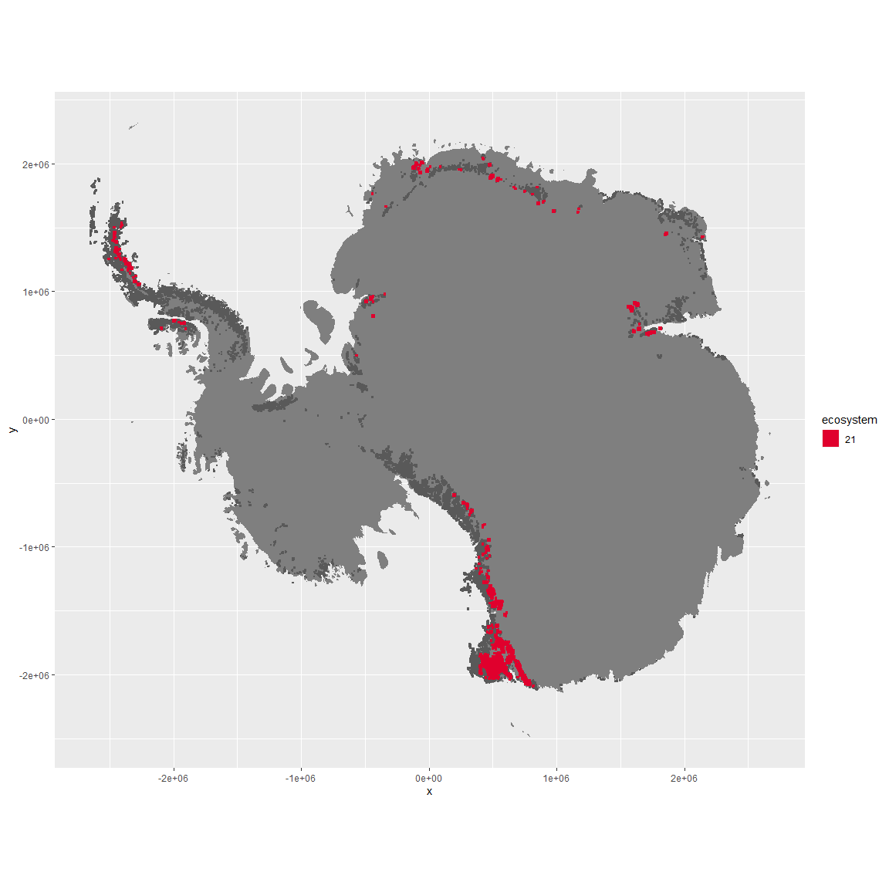

Regional maps

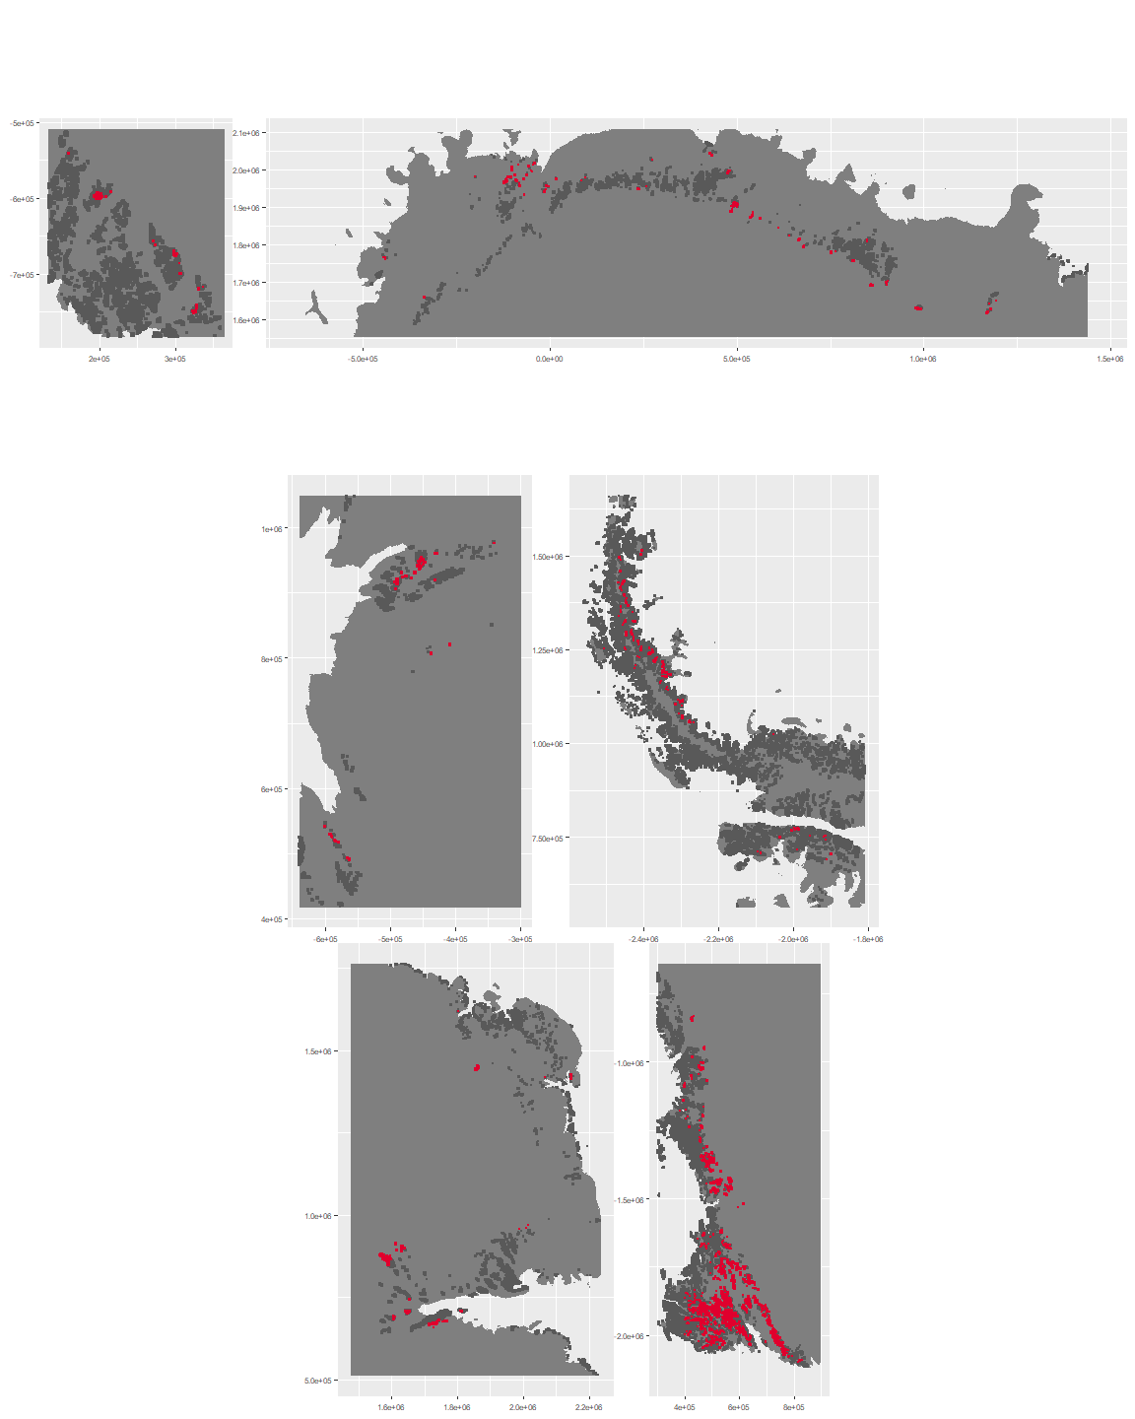

### Environment

The unit env4_sdm4 is part of the environmental supergroup env4.

This supergroup is, on average, substantially higher in wind, elev and rad than continental antarctica. It is substantially lower in rugos, sumtemp, slope, temp and cloud than the rest of the continent.

The elevation of unit env4_sdm4 ranges from 32 to 2707 metres above sea level, but 90% of its pixels fall above 754 and below 2262 metres. Its average elevation is 1657 metres.

The unit is higher in no variables and lower in cloud and wind than the rest of its environmental supergroup.

#### Distinctiveness of the unit from its group and the rest of Antarctica

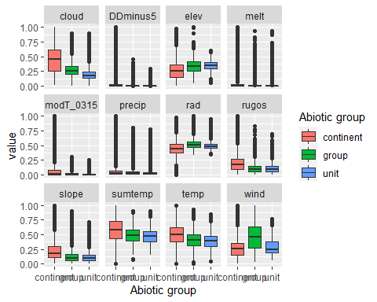

### Biota

Most widespread species in the unit (found in most pixels)

The top most widespread species in ecosystem env4_sdm4

| scientific | Functional_group | phylum | restricted | count | relative_pct |
| --- | --- | --- | --- | --- | --- |
| Lepraria cacuminum | Ascomycota_Lecanoromycetes_Lecanorales_Stereocaulaceae__ | Ascomycota | FALSE | 2 | 2.8986 |
| Schizothrix antarctica | Cyanobacteria_____ | Cyanobacteria | TRUE | 2 | 2.8986 |
| Arthrorhaphis citrinella | Ascomycota_Lecanoromycetes_Not assigned_Arthrorhaphidaceae__ | Ascomycota | FALSE | 1 | 1.4493 |
| Binuclearia tectorum | Chlorophyta_____ | Chlorophyta | FALSE | 1 | 1.4493 |
| Brachythecium austroglareosum | Bryophyta_Bryopsida_Hypnales___ | Bryophyta | FALSE | 1 | 1.4493 |
| Bryum subrotundifolium | Bryophyta_Bryopsida_Bryales___ | Bryophyta | TRUE | 1 | 1.4493 |
| Buellia pallida | Ascomycota_Lecanoromycetes_Teloschistales_Physciaceae__ | Ascomycota | TRUE | 1 | 1.4493 |
| Buellia subfrigida | Ascomycota_Lecanoromycetes_Teloschistales_Physciaceae__ | Ascomycota | TRUE | 1 | 1.4493 |
| Calothrix braunii | Cyanobacteria_____ | Cyanobacteria | FALSE | 1 | 1.4493 |
| Calothrix parietina | Cyanobacteria_____ | Cyanobacteria | FALSE | 1 | 1.4493 |
| Carbonea capsulata | Ascomycota_Lecanoromycetes_Lecanorales_Lecanoraceae__ | Ascomycota | TRUE | 1 | 1.4493 |
| Chlorella minutissima | Chlorophyta_____ | Chlorophyta | TRUE | 1 | 1.4493 |
| Chlorosarcinopsis sp. | Chlorophyta_____ | Chlorophyta | TRUE | 1 | 1.4493 |
| Chlorosphaera kerguelensis | Chlorophyta_____ | Chlorophyta | TRUE | 1 | 1.4493 |
| Choricystis chodatii | Chlorophyta_____ | Chlorophyta | TRUE | 1 | 1.4493 |
| Chroococcus montanus | Cyanobacteria_____ | Cyanobacteria | TRUE | 1 | 1.4493 |
| Chroococcus westii | Cyanobacteria_____ | Cyanobacteria | FALSE | 1 | 1.4493 |
| Cladonia cf. pocillum | Ascomycota_Lecanoromycetes_Lecanorales_Cladoniaceae__ | Ascomycota | TRUE | 1 | 1.4493 |
| Cryptomonas sp. | Cryptophyta_____ | Cryptophyta | TRUE | 1 | 1.4493 |
| Desmococcus olivaceus | Chlorophyta_____ | Chlorophyta | FALSE | 1 | 1.4493 |
| Diphascon sanae | Tardigrada_____ | Tardigrada | TRUE | 1 | 1.4493 |
| Gloeocapsa kuetzingiana | Cyanobacteria_____ | Cyanobacteria | TRUE | 1 | 1.4493 |
| Gloeocapsa magma | Cyanobacteria_____ | Cyanobacteria | FALSE | 1 | 1.4493 |
| Gloeocapsa ralfsiana | Cyanobacteria_____ | Cyanobacteria | TRUE | 1 | 1.4493 |
| Heterotrichella gracilis | Ochrophyta_____ | Ochrophyta | TRUE | 1 | 1.4493 |
| Hypnum revolutum | Bryophyta_Bryopsida_Hypnales___ | Bryophyta | FALSE | 1 | 1.4493 |
| Lecanora fuscobrunnea | Ascomycota_Lecanoromycetes_Lecanorales_Lecanoraceae__ | Ascomycota | TRUE | 1 | 1.4493 |
| Minibiotus stuckenbergi | Tardigrada_____ | Tardigrada | TRUE | 1 | 1.4493 |
| Monodus chodatii | Ochrophyta_____ | Ochrophyta | TRUE | 1 | 1.4493 |
| Nephrodiella semilunaris | Ochrophyta_____ | Ochrophyta | FALSE | 1 | 1.4493 |
| Nodularia harveyana | Cyanobacteria_____ | Cyanobacteria | FALSE | 1 | 1.4493 |
| Nostoc commune | Cyanobacteria_____ | Cyanobacteria | TRUE | 1 | 1.4493 |
| Nostoc longstaffii | Cyanobacteria_____ | Cyanobacteria | TRUE | 1 | 1.4493 |
| Nostoc pruniforme | Cyanobacteria_____ | Cyanobacteria | FALSE | 1 | 1.4493 |
| Oscillatoria curviceps | Cyanobacteria_____ | Cyanobacteria | FALSE | 1 | 1.4493 |
| Oscillatoria tenuis | Cyanobacteria_____ | Cyanobacteria | FALSE | 1 | 1.4493 |
| Pannaria hookeri | Ascomycota_Lecanoromycetes_Peltigerales_Pannariaceae__ | Ascomycota | FALSE | 1 | 1.4493 |
| Parmelia saxatilis | Ascomycota_Lecanoromycetes_Lecanorales_Parmeliaceae__ | Ascomycota | FALSE | 1 | 1.4493 |
| Phormidium priestleyi | Cyanobacteria_____ | Cyanobacteria | TRUE | 1 | 1.4493 |
| Placopsis contortuplicata | Ascomycota_Lecanoromycetes_Baeomycetales_Trapeliaceae__ | Ascomycota | TRUE | 1 | 1.4493 |
| Pohlia nutans | Bryophyta_Bryopsida_Bryales___ | Bryophyta | FALSE | 1 | 1.4493 |
| Polytrichum piliferum | Bryophyta_Bryopsida_Polytrichales___ | Bryophyta | FALSE | 1 | 1.4493 |
| Prasiococcus calcarius | Chlorophyta_____ | Chlorophyta | TRUE | 1 | 1.4493 |
| Prasiola crispa | Chlorophyta_____ | Chlorophyta | FALSE | 1 | 1.4493 |
| Pseudephebe pubescens | Ascomycota_Lecanoromycetes_Lecanorales_Parmeliaceae__ | Ascomycota | FALSE | 1 | 1.4493 |
| Pseudotetraspora gainii | Chlorophyta_____ | Chlorophyta | TRUE | 1 | 1.4493 |
| Rhizocarpon distinctum | Ascomycota_Lecanoromycetes_Not assigned_Rhizocarpaceae__ | Ascomycota | FALSE | 1 | 1.4493 |
| Rhizoplaca melanophthalma | Ascomycota_Lecanoromycetes_Lecanorales_Lecanoraceae__ | Ascomycota | FALSE | 1 | 1.4493 |
| Rhodomonas sp. | Cryptophyta_____ | Cryptophyta | TRUE | 1 | 1.4493 |
| Sarconeurum glaciale | Bryophyta_Bryopsida_Pottiales___ | Bryophyta | TRUE | 1 | 1.4493 |
| Scotinosphaera paradoxa | Chlorophyta_____ | Chlorophyta | TRUE | 1 | 1.4493 |
| Stauroneis agrestis | Ochrophyta_____ | Ochrophyta | FALSE | 1 | 1.4493 |
| Stereocaulon glabrum | Ascomycota_Lecanoromycetes_Lecanorales_Stereocaulaceae__ | Ascomycota | FALSE | 1 | 1.4493 |
| Stereocaulon vesuvianum | Ascomycota_Lecanoromycetes_Lecanorales_Stereocaulaceae__ | Ascomycota | FALSE | 1 | 1.4493 |
| Stereotydeus mollis | Arthropoda_Arachnida_Trombidiformes___ | Arthropoda | TRUE | 1 | 1.4493 |
| Stichococcus bacillaris | Chlorophyta_____ | Chlorophyta | FALSE | 1 | 1.4493 |
| Synechocystis aquatilis | Cyanobacteria_____ | Cyanobacteria | FALSE | 1 | 1.4493 |
| Synechocystis crassa | Cyanobacteria_____ | Cyanobacteria | TRUE | 1 | 1.4493 |
| Synechocystis pevalekii | Cyanobacteria_____ | Cyanobacteria | FALSE | 1 | 1.4493 |
| Synechocystis sallensis | Cyanobacteria_____ | Cyanobacteria | TRUE | 1 | 1.4493 |
| Tetracystis sp. | Chlorophyta_____ | Chlorophyta | TRUE | 1 | 1.4493 |
| Tropidoneis laevissima | Ochrophyta_____ | Ochrophyta | TRUE | 1 | 1.4493 |
| Umbilicaria decussata | Ascomycota_Lecanoromycetes_Umbilicariales_Umbilicariaceae__ | Ascomycota | FALSE | 1 | 1.4493 |
| Umbilicaria umbilicarioides | Ascomycota_Lecanoromycetes_Umbilicariales_Umbilicariaceae__ | Ascomycota | FALSE | 1 | 1.4493 |
| Vitreochlamys sp. | Chlorophyta_____ | Chlorophyta | TRUE | 1 | 1.4493 |
| Xanthonema antarcticum | Ochrophyta_____ | Ochrophyta | TRUE | 1 | 1.4493 |
| Xanthoria elegans | Ascomycota_Lecanoromycetes_Teloschistales_Teloschistaceae__ | Ascomycota | FALSE | 1 | 1.4493 |

This supergroup is, on average, substantially higher in suitability for no variables functional groups than continental Antarctica. It is substantially lower in suitability for lichens_Lecanorid, Nematodes, lichens_Parmelid, mosses_Dicranales, mites_Sarcoptiformes, mosses_Pottiales, Springtails_slim, mosses_Bryales, mites_Trombidiformes, mosses_Hypnales_(feather), lichens,_Bacidiacid, mosses_Polytrichales, penguins_Chinstrap, lichens_Cladonid, mites_Mesostigmata, penguins_Gentoo and lichens_Stereocaulid than the rest of the continent.

Unit env4_sdm4 is higher in suitability for Nematodes and lower in suitability for mosses_Polytrichales, mosses_Hypnales_(feather), mosses_Dicranales and lichens_Parmelid than the rest of its environmental supergroup.

Distinctiveness of the unit from the environmental group and the rest of Antarctica

