Ecosystem Description

Aniko B. Toth

## Ecosystem Env5_sdm2, Mild mesic coastal nunataks

Env5_sdm2, Mild mesic coastal nunataks. Occurs mainly along the east coast of the southern peninsula, throughout the Transantarctic mountains, and in North Victoria Land. Very similar to previous unit environmentally but has higher moisture availability (cloud, melt, precip) and insolation. Main sampled biota consists of lichens and mosses. Suitability again separates this unit from its group and the previous unit; it has highest suitability for penguins, Cladoniaceae and Bacidaceae lichens, and several functional groups of mosses.

### Photos (if available)

### Distribution

Maps - Full map

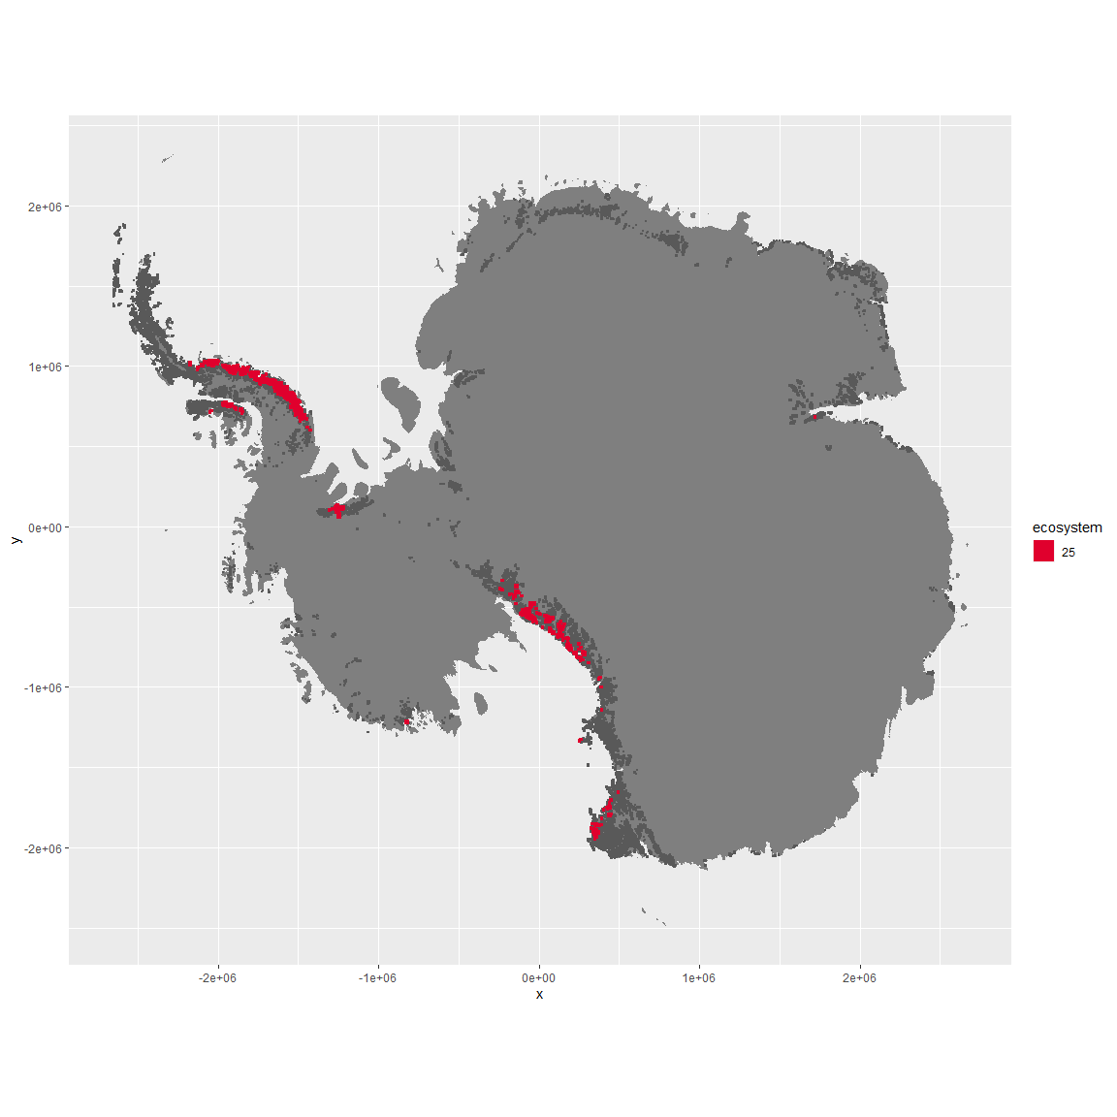

Regional maps

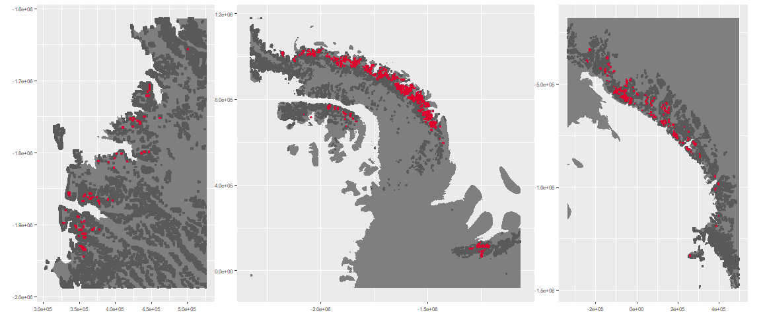

### Environment

The unit env5_sdm2 is part of the environmental supergroup env5.

This supergroup is, on average, substantially higher in elev than continental antarctica. It is substantially lower in modT_0315, rad, precip, temp, sumtemp and wind than the rest of the continent.

The elevation of unit env5_sdm2 ranges from 135 to 4231 metres above sea level, but 90% of its pixels fall above 651 and below 2735 metres. Its average elevation is 1310 metres.

The unit is higher in cloud, temp, sumtemp, rad and melt and lower in elev than the rest of its environmental supergroup.

#### Distinctiveness of the unit from its group and the rest of Antarctica

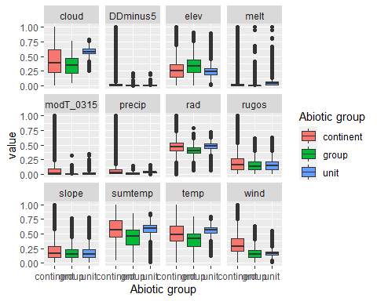

### Biota

Most widespread species in the unit (found in most pixels)

The top most widespread species in ecosystem env5_sdm2

| scientific | Functional_group | phylum | restricted | count | relative_pct |
| --- | --- | --- | --- | --- | --- |
| Usnea sphacelata | Ascomycota_Lecanoromycetes_Lecanorales_Parmeliaceae__ | Ascomycota | TRUE | 14 | 10.0719 |
| Pseudephebe minuscula | Ascomycota_Lecanoromycetes_Lecanorales_Parmeliaceae__ | Ascomycota | FALSE | 8 | 5.7554 |
| Umbilicaria decussata | Ascomycota_Lecanoromycetes_Umbilicariales_Umbilicariaceae__ | Ascomycota | FALSE | 6 | 4.3165 |
| Acarospora gwynnii | Ascomycota_Lecanoromycetes_Acarosporales_Acarosporaceae__ | Ascomycota | TRUE | 4 | 2.8777 |
| Xanthoria elegans | Ascomycota_Lecanoromycetes_Teloschistales_Teloschistaceae__ | Ascomycota | FALSE | 4 | 2.8777 |
| Bryum pseudotriquetrum | Bryophyta_Bryopsida_Bryales___ | Bryophyta | FALSE | 3 | 2.1583 |
| Physcia caesia | Ascomycota_Lecanoromycetes_Teloschistales_Physciaceae__ | Ascomycota | FALSE | 3 | 2.1583 |
| Candelariella vitellina | Ascomycota_Lecanoromycetes_Candelariales_Candelariaceae__ | Ascomycota | FALSE | 2 | 1.4388 |
| Lecanora cf. orosthea | Ascomycota_Lecanoromycetes_Lecanorales_Lecanoraceae__ | Ascomycota | TRUE | 2 | 1.4388 |
| Lecanora cf. physciella | Ascomycota_Lecanoromycetes_Lecanorales_Lecanoraceae__ | Ascomycota | TRUE | 2 | 1.4388 |
| Lecidea cancriformis | Ascomycota_Lecanoromycetes_Lecanorales_Lecideaceae__ | Ascomycota | TRUE | 2 | 1.4388 |
| Lecidea cf. cancriformis | Ascomycota_Lecanoromycetes_Lecanorales_Lecideaceae__ | Ascomycota | TRUE | 2 | 1.4388 |
| Lepraria cacuminum | Ascomycota_Lecanoromycetes_Lecanorales_Stereocaulaceae__ | Ascomycota | FALSE | 2 | 1.4388 |
| Pannaria hookeri | Ascomycota_Lecanoromycetes_Peltigerales_Pannariaceae__ | Ascomycota | FALSE | 2 | 1.4388 |
| Pleopsidium chlorophanum | Ascomycota_Lecanoromycetes_Acarosporales_Acarosporaceae__ | Ascomycota | FALSE | 2 | 1.4388 |
| Pohlia cruda | Bryophyta_Bryopsida_Bryales___ | Bryophyta | FALSE | 2 | 1.4388 |
| Rhizoplaca melanophthalma | Ascomycota_Lecanoromycetes_Lecanorales_Lecanoraceae__ | Ascomycota | FALSE | 2 | 1.4388 |
| Syntrichia princeps | Bryophyta_Bryopsida_Pottiales___ | Bryophyta | FALSE | 2 | 1.4388 |
| Tortella alpicola | Bryophyta_Bryopsida_Pottiales___ | Bryophyta | FALSE | 2 | 1.4388 |

This supergroup is, on average, substantially higher in suitability for no variables functional groups than continental Antarctica. It is substantially lower in suitability for lichens_Acarosporacid, lichens_Parmelid, mites_Mesostigmata and lichens_Rhizocarpid than the rest of the continent.

Unit env5_sdm2 is higher in suitability for mosses_Hypnales_(feather), penguins_Gentoo, mosses_Polytrichales, mosses_Dicranales, lichens_Cladonid, lichens,*Bacidiacid, lichens_Parmelid, mosses_Bryales, mites_Mesostigmata, penguins_Chinstrap, mosses_Pottiales, lichens_Stereocaulid, mites_Sarcoptiformes, Springtails_slim, lichens_Teloschistid and lichens_Physcid*(shadow) and lower in suitability for no variables than the rest of its environmental supergroup.

Distinctiveness of the unit from the environmental group and the rest of Antarctica

