Ecosystem Description

Aniko B. Toth

## Ecosystem Env5_sdm3, High sheltered mountain slopes

Env5_sdm3, High sheltered mountain slopes. Occurs mainly throughout the Transantarctic mountains and in North Victoria Land. This unit has higher elev/ruggedness and colder temps than the rest of its group, constituting a more extreme example of the group. Sampled fauna mostly Cyanobacteria and Chlorophyta. Suitability is bad for everything, but slightly less bad for Cladoniaceae and Bacidiaceaelichens.

### Photos (if available)

### Distribution

Maps - Full map

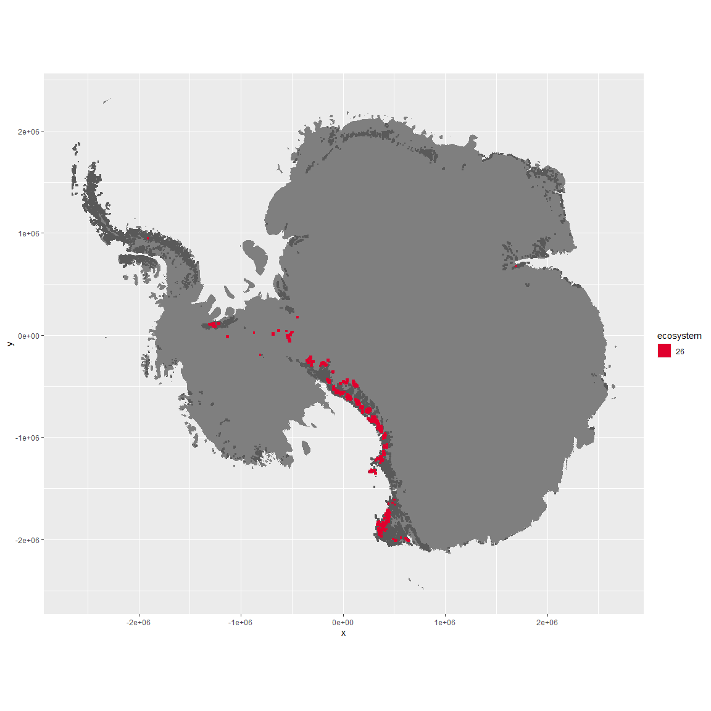

Regional maps

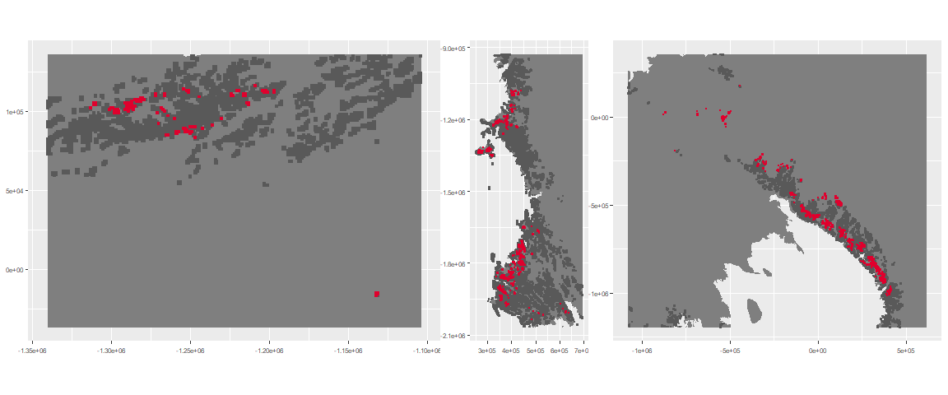

### Environment

The unit env5_sdm3 is part of the environmental supergroup env5.

This supergroup is, on average, substantially higher in elev than continental antarctica. It is substantially lower in modT_0315, rad, precip, temp, sumtemp and wind than the rest of the continent.

The elevation of unit env5_sdm3 ranges from 55 to 4338 metres above sea level, but 90% of its pixels fall above 1253 and below 3090 metres. Its average elevation is 2124 metres.

The unit is higher in elev, slope and rugos and lower in temp and sumtemp than the rest of its environmental supergroup.

#### Distinctiveness of the unit from its group and the rest of Antarctica

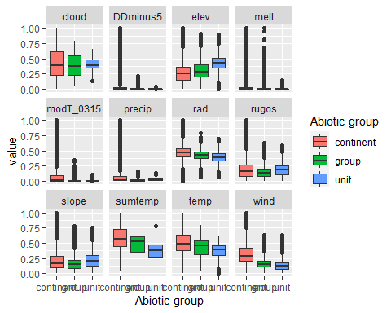

### Biota

Most widespread species in the unit (found in most pixels)

The top most widespread species in ecosystem env5_sdm3

| scientific | Functional_group | phylum | restricted | count | relative_pct |
| --- | --- | --- | --- | --- | --- |
| Auxenochlorella┬á protothecoides | Chlorophyta_____ | Chlorophyta | TRUE | 2 | 3.3333 |
| Chloroidium saccharophilum | Chlorophyta_____ | Chlorophyta | FALSE | 2 | 3.3333 |
| Coccomyxa curvata | Chlorophyta_____ | Chlorophyta | TRUE | 2 | 3.3333 |
| Coccomyxa gloeobotrydiformis | Chlorophyta_____ | Chlorophyta | TRUE | 2 | 3.3333 |
| Coelastrella terrestris | Chlorophyta_____ | Chlorophyta | TRUE | 2 | 3.3333 |
| Elliptochloris subsphaerica┬á | Chlorophyta_____ | Chlorophyta | TRUE | 2 | 3.3333 |
| Graesiella emersonii | Chlorophyta_____ | Chlorophyta | FALSE | 2 | 3.3333 |
| Mastigocladus laminosus | Cyanobacteria_____ | Cyanobacteria | FALSE | 2 | 3.3333 |
| Pseudococcomyxa simplex | Chlorophyta_____ | Chlorophyta | TRUE | 2 | 3.3333 |
| Rhizocarpon geographicum | Ascomycota_Lecanoromycetes_Not assigned_Rhizocarpaceae__ | Ascomycota | FALSE | 2 | 3.3333 |
| Sarconeurum glaciale | Bryophyta_Bryopsida_Pottiales___ | Bryophyta | TRUE | 2 | 3.3333 |

This supergroup is, on average, substantially higher in suitability for no variables functional groups than continental Antarctica. It is substantially lower in suitability for lichens_Acarosporacid, lichens_Parmelid, mites_Mesostigmata and lichens_Rhizocarpid than the rest of the continent.

Unit env5_sdm3 is higher in suitability for no variables and lower in suitability for lichens_Cladonid, lichens,*Bacidiacid, mosses_Polytrichales, mosses_Hypnales*(feather), Algae, mosses_Bryales, lichens_Stereocaulid, mites_Mesostigmata, lichens_Lecanorid, Rotifers, lichens_Rhizocarpid, lichens_Acarosporacid, lichens_Teloschistid, mosses_Pottiales, mosses_Dicranales, mites_Sarcoptiformes, Springtails_slim, lichens_Parmelid, Nematodes, mites_Trombidiformes, lichens_Physcid_(shadow), lichens_Candelarid and algae_Green than the rest of its environmental supergroup.

Distinctiveness of the unit from the environmental group and the rest of Antarctica

