Ecosystem Description

Aniko B. Toth

## Ecosystem Env6_sdm2 Coastal/Island tundra

Env6_sdm2 Coastal/Island tundra. This unit occurs exclusively on the outer tip of the Antarctic peninsula and surrounding islands. It is teeming with penguins, features antarctic hair grass, two moss species, followed by a variety of lichens and arthropods. Snowy Sheathbill is found primarily in this unit, as are gentoo penguins, both vascular plants, and several moss and lichen species. Suitability is high for pretty much everything except Rotifers, but especially high for Parmeliaceae, Cladoniaceae, and Bacidiaceae lichens as well as Mesostigmatid mites, chinstrap penguins, and Hypnales/Polytrichiales mosses. This is probably the most habitable unit on the continent.

### Photos (if available)

### Distribution

Maps - Full map

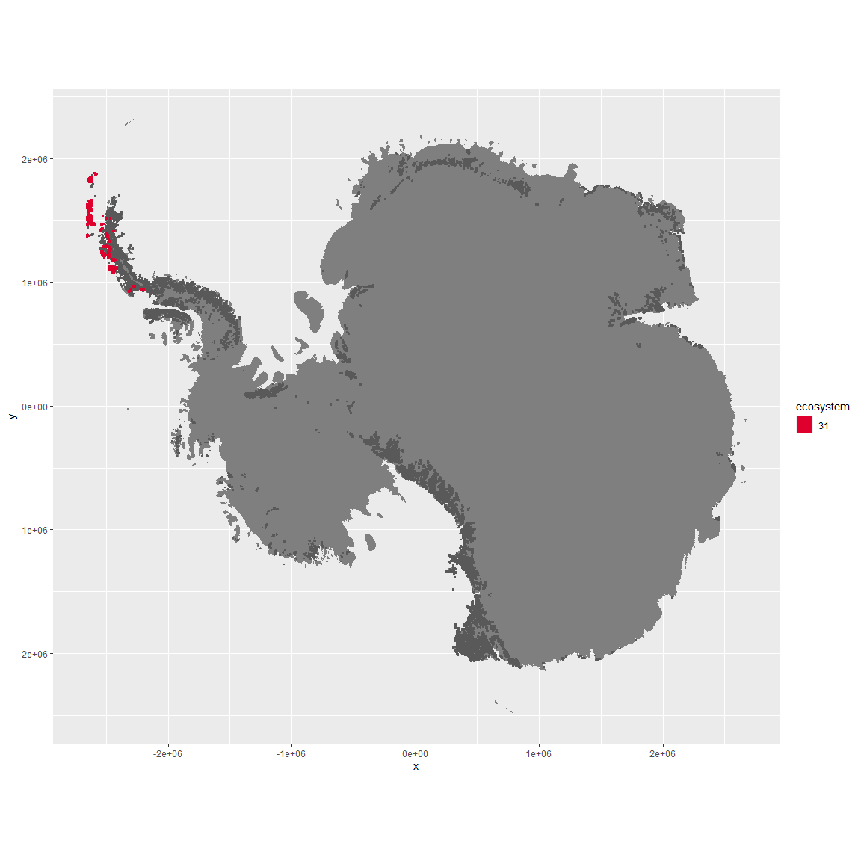

Regional maps

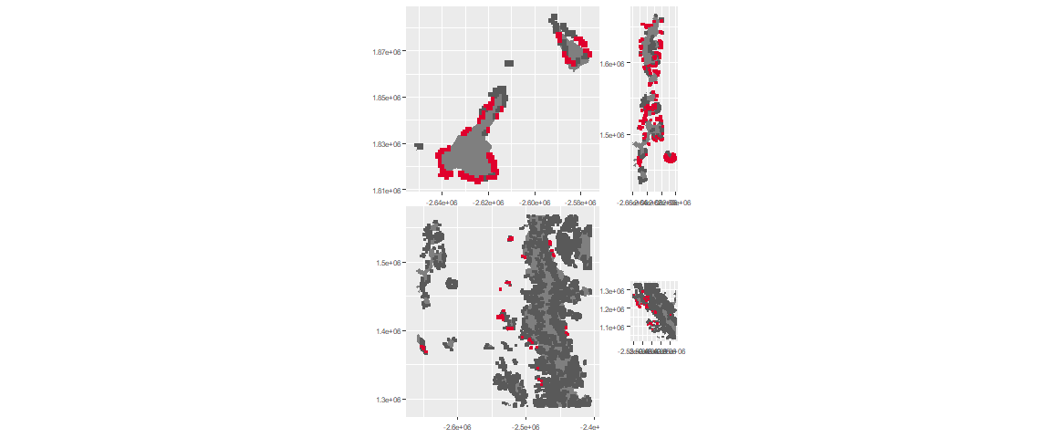

### Environment

The unit env6_sdm2 is part of the environmental supergroup env6.

This supergroup is, on average, substantially higher in NA, NA, NA, NA, NA, NA, NA, NA, NA, NA, NA and NA than continental antarctica. It is substantially lower in NA, NA, NA, NA, NA, NA, NA, NA, NA, NA, NA and NA than the rest of the continent.

The elevation of unit env6_sdm2 ranges from 0 to 1778 metres above sea level, but 90% of its pixels fall above 0 and below 407 metres. Its average elevation is 72 metres.

The unit is higher in NA, NA, NA, NA, NA, NA, NA, NA, NA, NA, NA and NA and lower in NA, NA, NA, NA, NA, NA, NA, NA, NA, NA, NA and NA than the rest of its environmental supergroup.

#### Distinctiveness of the unit from its group and the rest of Antarctica

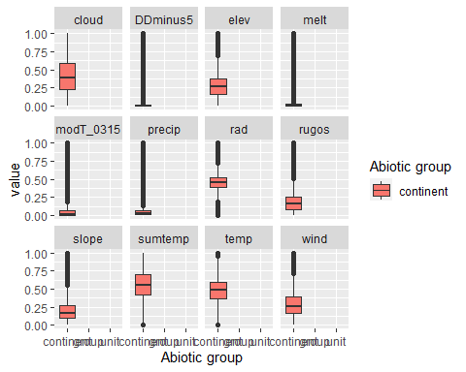

### Biota

Most widespread species in the unit (found in most pixels)

The top most widespread species in ecosystem env6_sdm2

| scientific | Functional_group | phylum | restricted | count | relative_pct |
| --- | --- | --- | --- | --- | --- |
| Pygoscelis antarctica | Chordata_Aves_Sphenisciformes_Spheniscidae_Pygoscelis_antarctica | Chordata | TRUE | 90 | 4.2135 |
| Polytrichastrum alpinum | Bryophyta_Bryopsida_Polytrichales___ | Bryophyta | FALSE | 42 | 1.9663 |
| Syntrichia princeps | Bryophyta_Bryopsida_Pottiales___ | Bryophyta | FALSE | 32 | 1.4981 |
| Usnea antarctica | Ascomycota_Lecanoromycetes_Lecanorales_Parmeliaceae__ | Ascomycota | FALSE | 32 | 1.4981 |
| Pygoscelis papua | Chordata_Aves_Sphenisciformes_Spheniscidae_Pygoscelis_papua | Chordata | FALSE | 30 | 1.4045 |
| Sanionia uncinata | Bryophyta_Bryopsida_Hypnales___ | Bryophyta | FALSE | 30 | 1.4045 |
| Bryum pseudotriquetrum | Bryophyta_Bryopsida_Bryales___ | Bryophyta | FALSE | 29 | 1.3577 |
| Ceratodon purpureus | Bryophyta_Bryopsida_Dicranales___ | Bryophyta | FALSE | 29 | 1.3577 |
| Bartramia patens | Bryophyta_Bryopsida_Bryales___ | Bryophyta | FALSE | 25 | 1.1704 |
| Brachythecium austro-salebrosum | Bryophyta_Bryopsida_Hypnales___ | Bryophyta | TRUE | 25 | 1.1704 |
| Cryptopygus antarcticus | Arthropoda_Entognatha_Entomobryomorpha___ | Arthropoda | TRUE | 25 | 1.1704 |
| Syntrichia filaris | Bryophyta_Bryopsida_Pottiales___ | Bryophyta | TRUE | 25 | 1.1704 |

This supergroup is, on average, substantially higher in suitability for mites_Mesostigmata, lichens_Rhizocarpid, penguins_Gentoo, lichens_Parmelid, mites_Sarcoptiformes, penguins_Chinstrap, Springtails_slim, mosses_Pottiales, mosses_Polytrichales, mosses_Dicranales, mites_Trombidiformes, mosses_Hypnales_(feather), algae_Green, Nematodes, lichens_Physcid_(shadow), lichens_Acarosporacid, lichens_Teloschistid, lichens_Stereocaulid, lichens_Candelarid, lichens_Lecanorid, lichens_Cladonid, mosses_Bryales, lichens,_Bacidiacid, Algae and Rotifers functional groups than continental Antarctica. It is substantially lower in suitability for no variables than the rest of the continent.

Unit env6_sdm2 is higher in suitability for mosses_Polytrichales, lichens_Parmelid, lichens_Stereocaulid and mosses_Hypnales_(feather) and lower in suitability for Rotifers than the rest of its environmental supergroup.

Distinctiveness of the unit from the environmental group and the rest of Antarctica

