Ecosystem Description

Aniko B. Toth

## Ecosystem Env6_sdm3 Islands3

Env6_sdm3 Islands3. Occurs mainly on the northernmost parts of the peninsula and on the coast of Victoria land. Most common biota is Adelie penguins, but also Emperor penguins and south polar skua. Several Arthropod, moss, and lichen species are also present in numbers. It is the most popular ecosystem for several Rotifer species, two Arthropods, and the skua. Suitability is high for everything, especially Arthropod functional groups (Trombidiformes and Springtails) and Nematodes.

### Photos (if available)

### Distribution

Maps - Full map

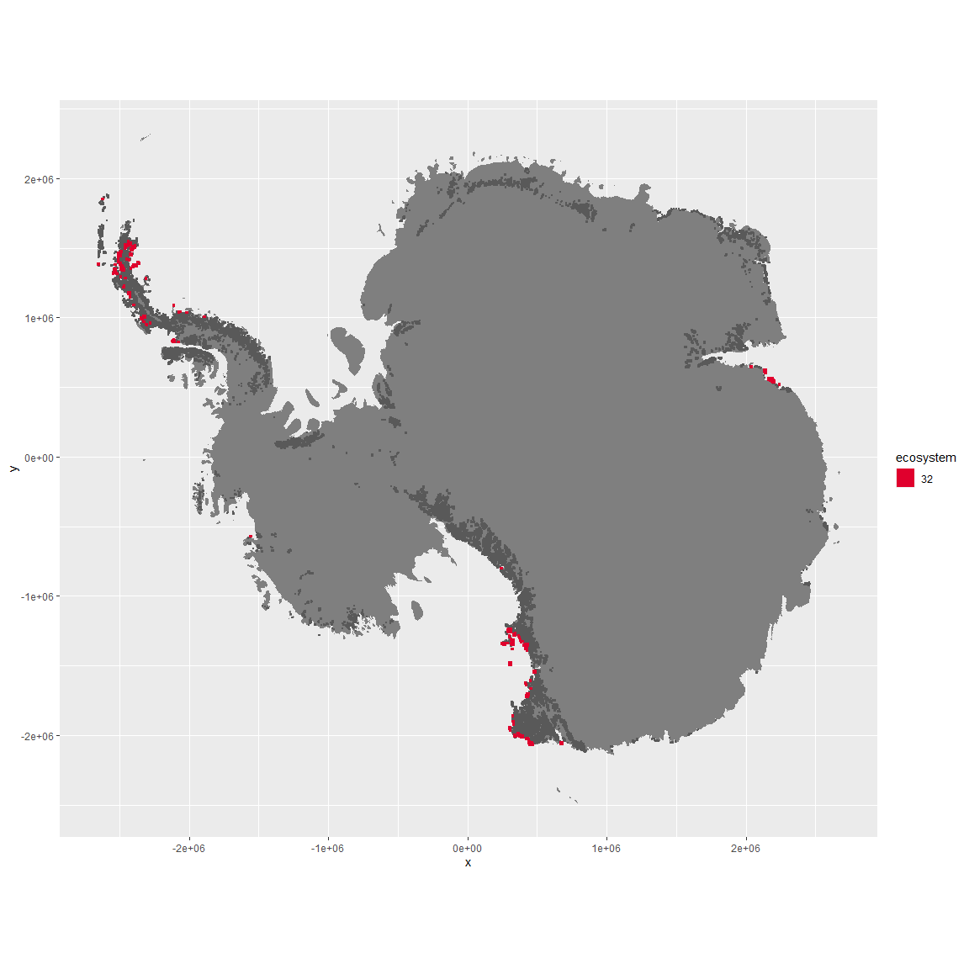

Regional maps

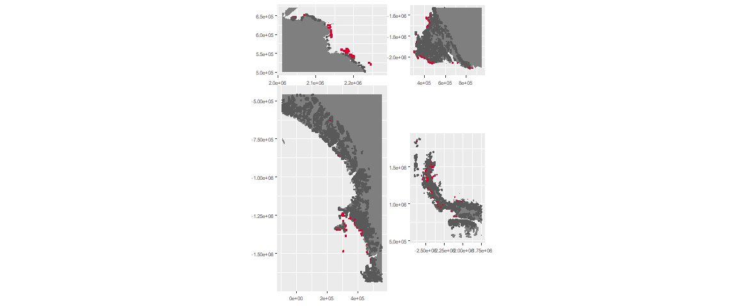

### Environment

The unit env6_sdm3 is part of the environmental supergroup env6.

This supergroup is, on average, substantially higher in NA, NA, NA, NA, NA, NA, NA, NA, NA, NA, NA and NA than continental antarctica. It is substantially lower in NA, NA, NA, NA, NA, NA, NA, NA, NA, NA, NA and NA than the rest of the continent.

The elevation of unit env6_sdm3 ranges from 0 to 2374 metres above sea level, but 90% of its pixels fall above 0 and below 314 metres. Its average elevation is 63 metres.

The unit is higher in NA, NA, NA, NA, NA, NA, NA, NA, NA, NA, NA and NA and lower in NA, NA, NA, NA, NA, NA, NA, NA, NA, NA, NA and NA than the rest of its environmental supergroup.

#### Distinctiveness of the unit from its group and the rest of Antarctica

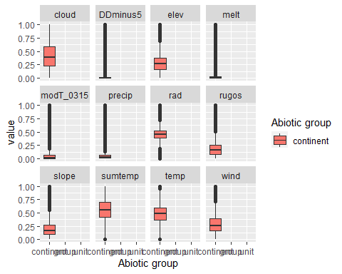

### Biota

Most widespread species in the unit (found in most pixels)

The top most widespread species in ecosystem env6_sdm3

| scientific | Functional_group | phylum | restricted | count | relative_pct |
| --- | --- | --- | --- | --- | --- |
| Pygoscelis adeliae | Chordata_Aves_Sphenisciformes_Spheniscidae_Pygoscelis_adeliae | Chordata | FALSE | 23 | 1.9409 |
| Gomphiocephalus hodgsoni | Arthropoda_Entognatha_Poduromorpha___ | Arthropoda | TRUE | 19 | 1.6034 |
| Bryum pseudotriquetrum | Bryophyta_Bryopsida_Bryales___ | Bryophyta | FALSE | 17 | 1.4346 |
| Stereotydeus mollis | Arthropoda_Arachnida_Trombidiformes___ | Arthropoda | TRUE | 16 | 1.3502 |
| Buellia frigida | Ascomycota_Lecanoromycetes_Teloschistales_Physciaceae__ | Ascomycota | TRUE | 15 | 1.2658 |
| Bryum argenteum | Bryophyta_Bryopsida_Bryales___ | Bryophyta | FALSE | 13 | 1.0970 |
| Xanthoria elegans | Ascomycota_Lecanoromycetes_Teloschistales_Teloschistaceae__ | Ascomycota | FALSE | 13 | 1.0970 |
| Lecanora expectans | Ascomycota_Lecanoromycetes_Lecanorales_Lecanoraceae__ | Ascomycota | TRUE | 12 | 1.0127 |
| Stercorarius maccormicki | Chordata_Aves_Charadriiformes___ | Chordata | FALSE | 11 | 0.9283 |
| Caloplaca citrina | Ascomycota_Lecanoromycetes_Teloschistales_Teloschistaceae__ | Ascomycota | TRUE | 10 | 0.8439 |
| Candelariella flava | Ascomycota_Lecanoromycetes_Candelariales_Candelariaceae__ | Ascomycota | TRUE | 10 | 0.8439 |
| Nanorchestes antarcticus | Arthropoda_Arachnida_Sarcoptiformes___ | Arthropoda | TRUE | 10 | 0.8439 |
| Sarconeurum glaciale | Bryophyta_Bryopsida_Pottiales___ | Bryophyta | TRUE | 10 | 0.8439 |
| Xanthoria mawsonii | Ascomycota_Lecanoromycetes_Teloschistales_Teloschistaceae__ | Ascomycota | TRUE | 10 | 0.8439 |

This supergroup is, on average, substantially higher in suitability for mites_Mesostigmata, lichens_Rhizocarpid, penguins_Gentoo, lichens_Parmelid, mites_Sarcoptiformes, penguins_Chinstrap, Springtails_slim, mosses_Pottiales, mosses_Polytrichales, mosses_Dicranales, mites_Trombidiformes, mosses_Hypnales_(feather), algae_Green, Nematodes, lichens_Physcid_(shadow), lichens_Acarosporacid, lichens_Teloschistid, lichens_Stereocaulid, lichens_Candelarid, lichens_Lecanorid, lichens_Cladonid, mosses_Bryales, lichens,_Bacidiacid, Algae and Rotifers functional groups than continental Antarctica. It is substantially lower in suitability for no variables than the rest of the continent.

Unit env6_sdm3 is higher in suitability for Rotifers, Nematodes, mites_Trombidiformes, Algae, lichens_Lecanorid, Springtails_slim, lichens_Physcid_(shadow) and lichens_Stereocaulid and lower in suitability for no variables than the rest of its environmental supergroup.

Distinctiveness of the unit from the environmental group and the rest of Antarctica

