Ecosystem Description

Aniko B. Toth

## Ecosystem Env1_sdm1, Mesic warm coastal lichenfields

Env1_sdm1, Mesic warm coastal lichenfields. Primarily occurs on flat, rocky coastlines or low outcrops, which have frequent cloud cover and may receive thick seasonal snow cover. Exposure to meltwaters is higher than other ecosystem types in the group. The dominant biota include several lichen species. Includes areas suitable for penguin colonies (Gentoo, Chinstrap), except where adjacent to ice shelves.

### Photos (if available)

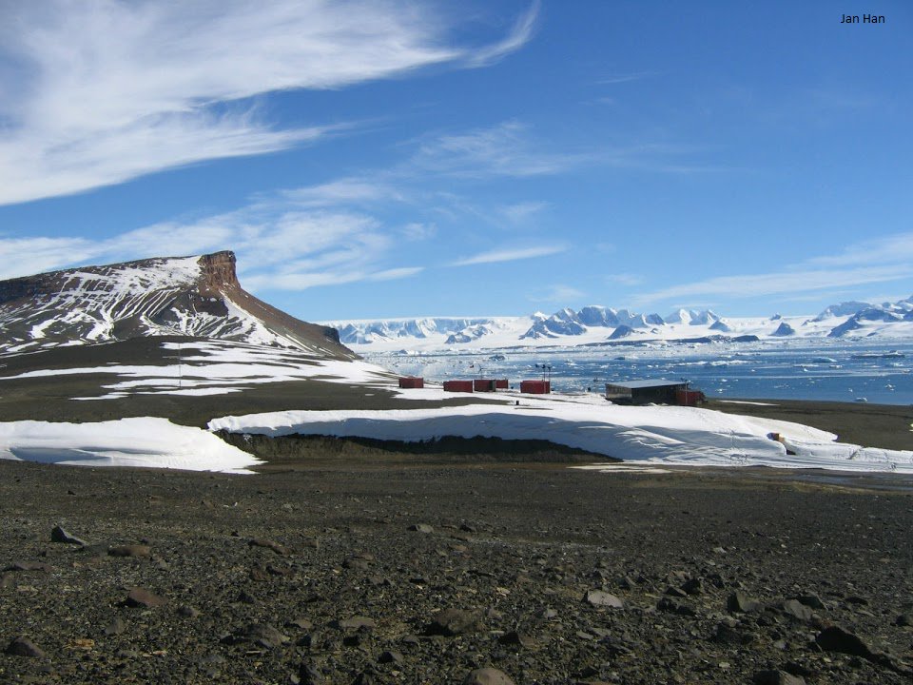 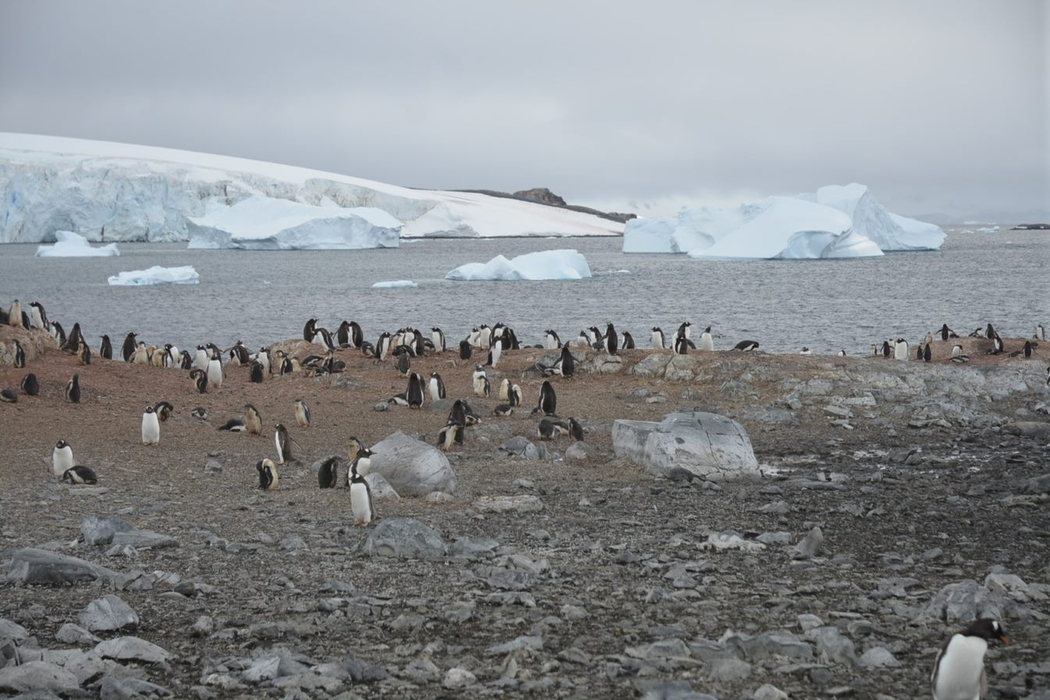

### Distribution

Maps - Full map

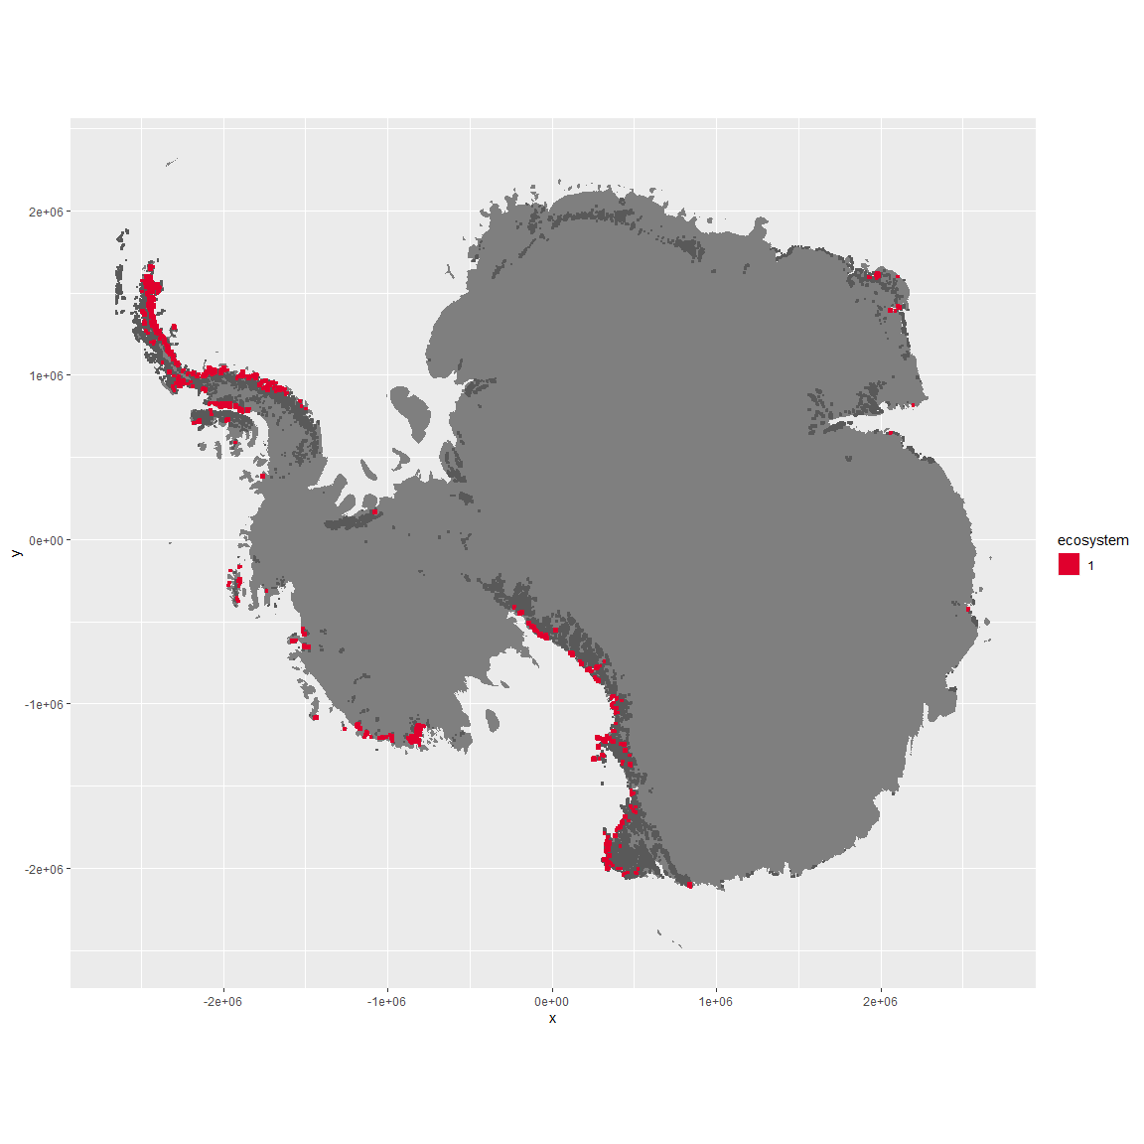

Smaller maps

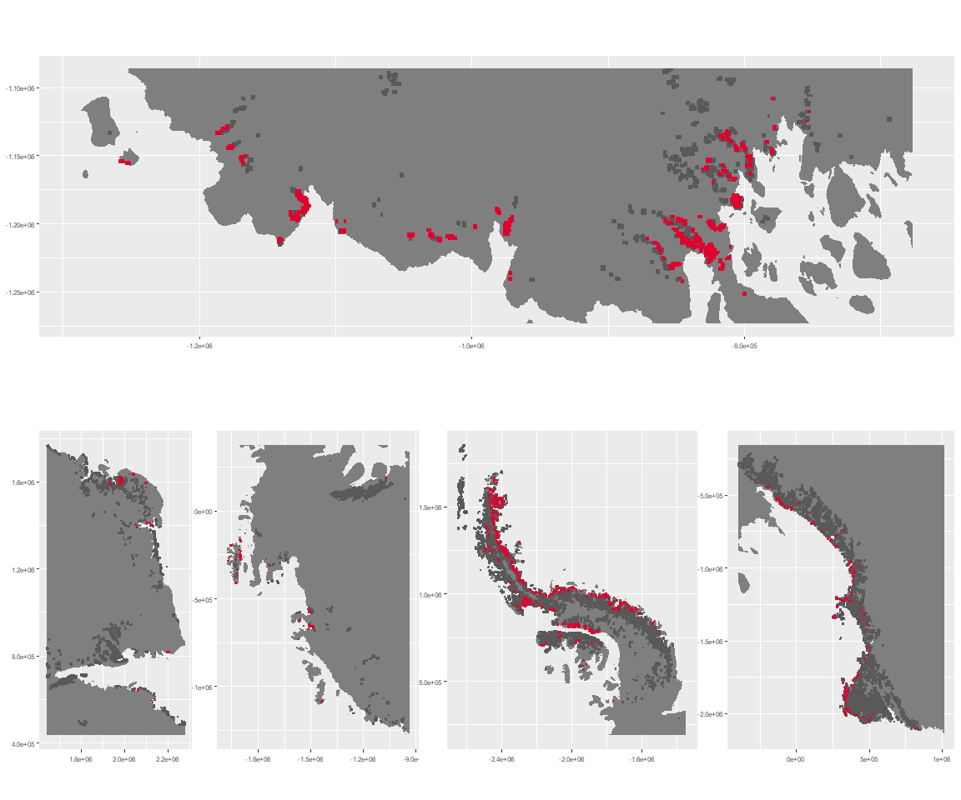

### Environment

The unit env1_sdm1 is part of the environmental supergroup env1.

This supergroup is, on average, substantially higher in sumtemp, temp, modT_0315 and melt than continental antarctica. It is substantially lower in slope, rugos and elev than the rest of the continent.

The elevation of unit env1_sdm1 ranges from 0 to 1793 metres above sea level, but 90% of its pixels fall above 51 and below 900 metres. Its average elevation is 437 metres.

The unit is higher in cloud, temp, sumtemp, DDminus5 and precip and lower in no variables than the rest of its environmental supergroup.

The table below shows the difference in the mean values of all environmental variables in the environmental group compared to the continent, the unit compared to the environmental group, and finally the unit compared to the rest of the continent.

–>

#### Distinctiveness of the unit from its group and the rest of Antarctica

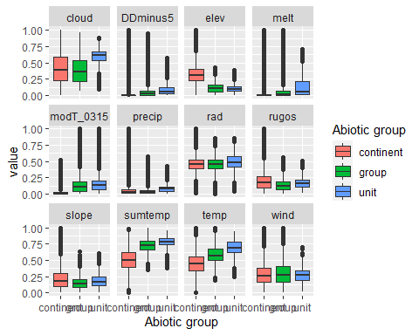

Distinctiveness of unit env1_sdm1 from rest of environmental group

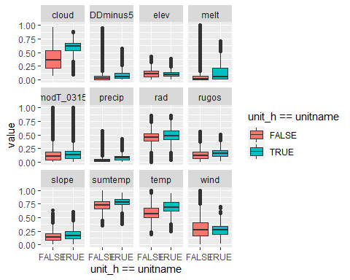

Distinctiveness of unit env1_sdm1 from rest of antarctica. 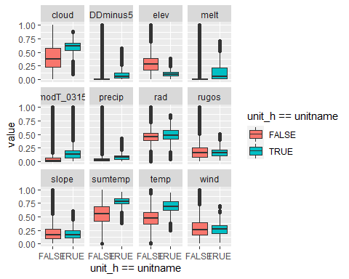

–>

### Biota

–>

Most widespread species in the unit (found in most pixels)

The top most widespread species in ecosystem env1_sdm1

| scientific | Functional_group | phylum | restricted | count | relative_pct |
| --- | --- | --- | --- | --- | --- |
| Usnea sphacelata | Ascomycota_Lecanoromycetes_Lecanorales_Parmeliaceae__ | Ascomycota | TRUE | 25 | 4.5372 |
| Umbilicaria decussata | Ascomycota_Lecanoromycetes_Umbilicariales_Umbilicariaceae__ | Ascomycota | FALSE | 20 | 3.6298 |
| Pseudephebe minuscula | Ascomycota_Lecanoromycetes_Lecanorales_Parmeliaceae__ | Ascomycota | FALSE | 19 | 3.4483 |
| Pleopsidium chlorophanum | Ascomycota_Lecanoromycetes_Acarosporales_Acarosporaceae__ | Ascomycota | FALSE | 13 | 2.3593 |
| Physcia caesia | Ascomycota_Lecanoromycetes_Teloschistales_Physciaceae__ | Ascomycota | FALSE | 12 | 2.1779 |
| Xanthoria elegans | Ascomycota_Lecanoromycetes_Teloschistales_Teloschistaceae__ | Ascomycota | FALSE | 12 | 2.1779 |
| Buellia frigida | Ascomycota_Lecanoromycetes_Teloschistales_Physciaceae__ | Ascomycota | TRUE | 10 | 1.8149 |
| Rhizoplaca melanophthalma | Ascomycota_Lecanoromycetes_Lecanorales_Lecanoraceae__ | Ascomycota | FALSE | 10 | 1.8149 |
| Schistidium antarctici | Bryophyta_Bryopsida_Grimmiales___ | Bryophyta | TRUE | 10 | 1.8149 |
| Bryum pseudotriquetrum | Bryophyta_Bryopsida_Bryales___ | Bryophyta | FALSE | 8 | 1.4519 |
| Pygoscelis adeliae | Chordata_Aves_Sphenisciformes_Spheniscidae_Pygoscelis_adeliae | Chordata | FALSE | 8 | 1.4519 |
| Usnea antarctica | Ascomycota_Lecanoromycetes_Lecanorales_Parmeliaceae__ | Ascomycota | FALSE | 8 | 1.4519 |

Any well-sampled species that occur MOST commonly in the unit (these may have potential use as diagnostic species).

## NULL

Sampling locations of the species with the highest relative percent of occurrences found in this unit.

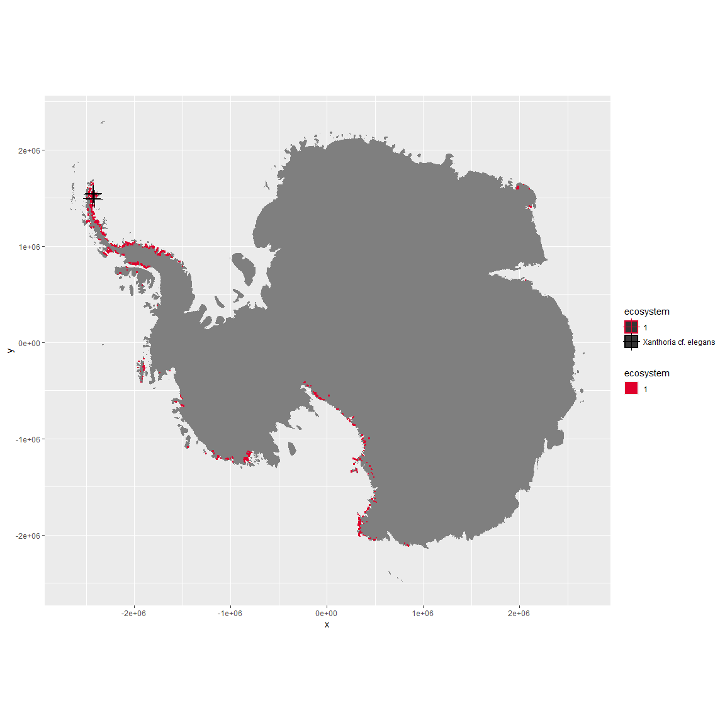

## NULL

A list of doubletons (two sampled individuals) found in the unit

## NULL

–>

This supergroup is, on average, substantially higher in suitability for Rotifers, Springtails_slim, Nematodes, mosses_Pottiales, mites_Trombidiformes, lichens_Physcid_(shadow), lichens_Teloschistid, lichens_Candelarid, mites_Sarcoptiformes, algae_Green, mosses_Dicranales, lichens_Lecanorid, lichens_Parmelid, lichens_Rhizocarpid, mites_Mesostigmata, lichens_Acarosporacid, lichens_Stereocaulid, Algae, mosses_Bryales, penguins_Gentoo, mosses_Hypnales_(feather), penguins_Chinstrap, mosses_Polytrichales, lichens_Cladonid and lichens,_Bacidiacid functional groups than continental antarctica. It is substantially lower in suitability for no variables than the rest of the continent.

Unit env1_sdm1 is higher in suitability for penguins_Gentoo, penguins_Chinstrap, mosses_Polytrichales, lichens_Cladonid and lichens,*Bacidiacid and lower in suitability for lichens_Teloschistid, Nematodes, lichens_Physcid*(shadow), lichens_Candelarid, lichens_Acarosporacid, mites_Trombidiformes, Algae and algae_Green than the rest of its environmental supergroup.

The table below shows the difference in the mean values of all suitability variables in the environmental group compared to the continent, the unit compared to the environmental group, and finally the unit compared to the rest of the continent.

–>

Distinctiveness of the unit from the environmental group and the rest of Antarctica

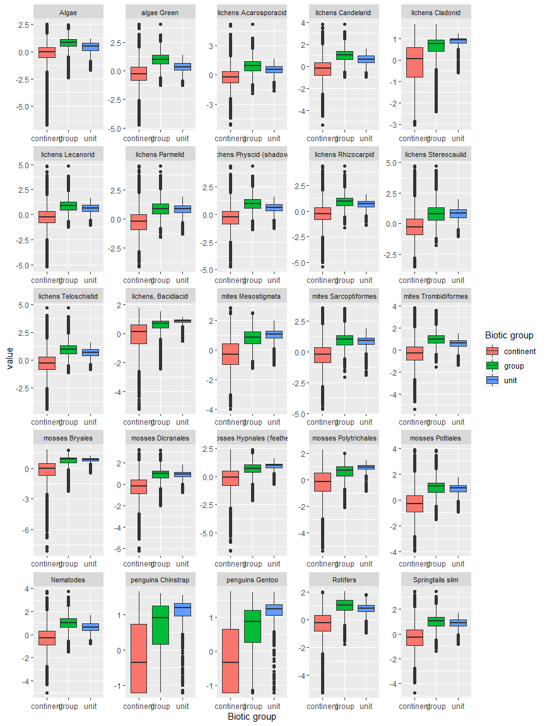

Distinctiveness of unit env1_sdm1 from rest of environmental group

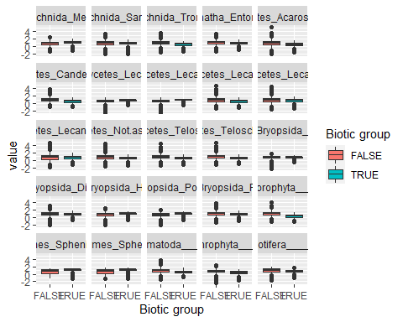

Distinctiveness from rest of antarctica.



