Ecosystem Description

Aniko B. Toth

## Ecosystem Env1_sdm4 Xeric valley floors

Env1_sdm4 Xeric valley floors. Flat or rolling valley bottoms typically carved by antecedent glaciers and surrounded by valley sides and high peaks. The valleys may extend many kilometres inland and are relatively sheltered from the wind and extremely dry, but often contains lakes maintained by meltwater streams. Some incidence of this unit also seen between the edge of existing glaciers and steep mountain slopes. These systems are colder than the rest of the lowlands, but still warmer than the continental average. The vegetation is sparse due to extremely dry conditions, which are largely unsuitable for mosses, and instead characterised by algae, Stereocaulid lichens with nematodes and trombidiformid mites, rotifers and springtails.

### Photos (if available)

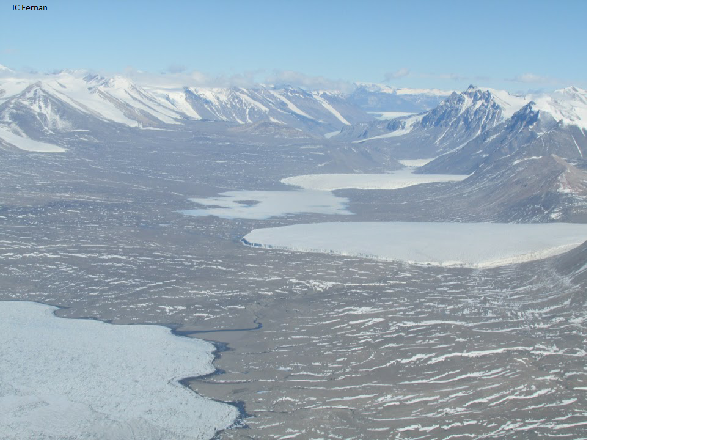

Ecosystem photo

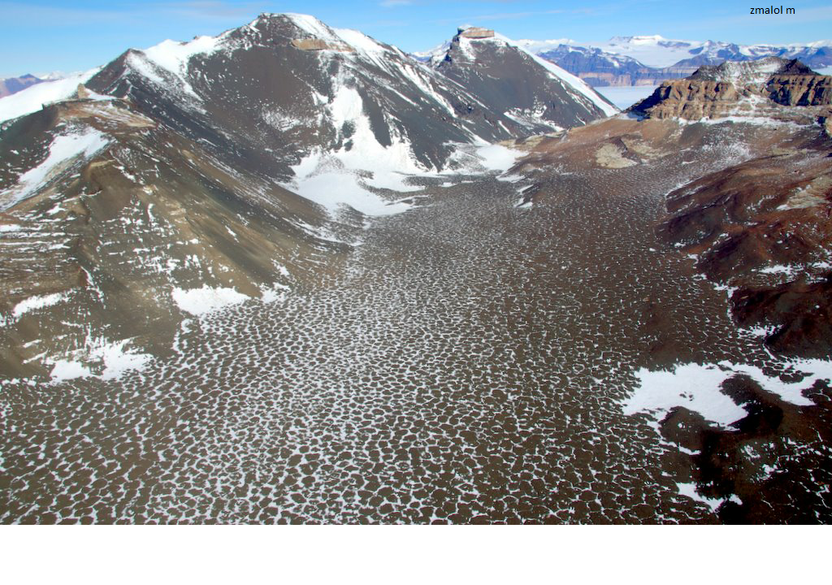

Ecosystem photo

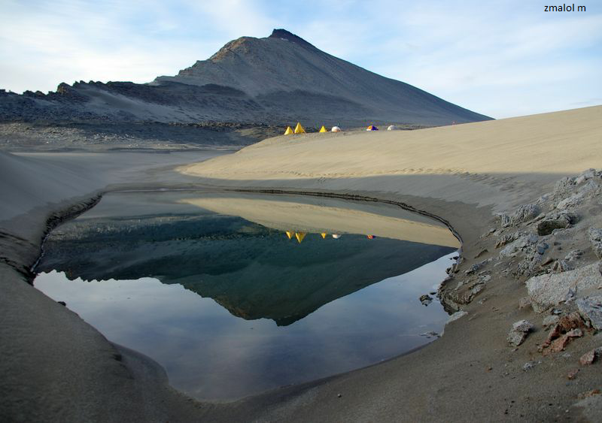

Ecosystem photo

### Distribution

Maps - Full map

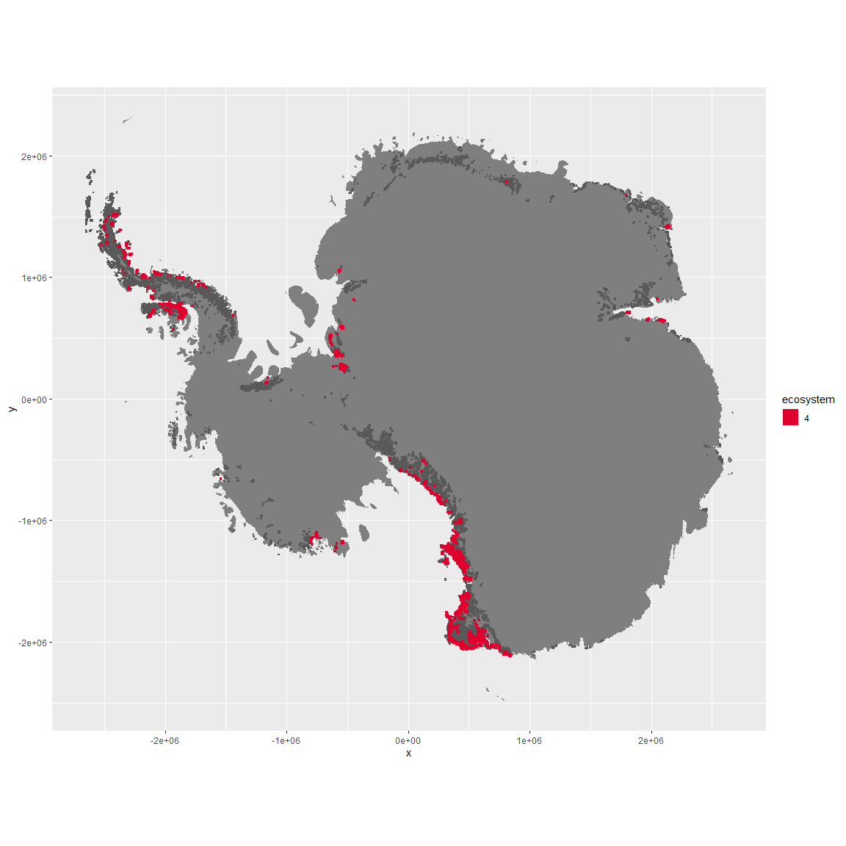

Regional maps

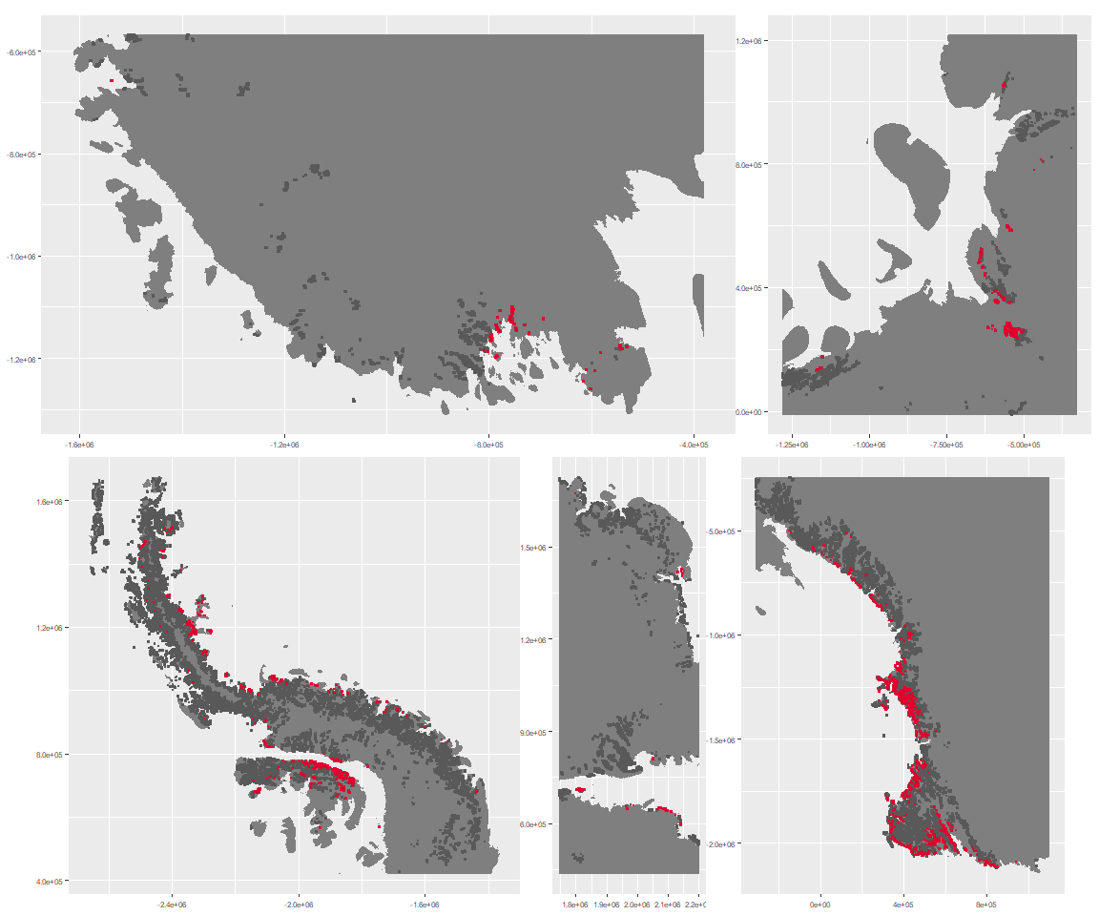

### Environment

The unit env1_sdm4 is part of the environmental supergroup env1.

This supergroup is, on average, substantially higher in sumtemp, temp, modT_0315 and melt than continental antarctica. It is substantially lower in slope, rugos and elev than the rest of the continent.

The elevation of unit env1_sdm4 ranges from 0 to 1903 metres above sea level, but 90% of its pixels fall above 53 and below 1016 metres. Its average elevation is 496 metres.

The unit is higher in no variables and lower in DDminus5, temp, cloud and wind than the rest of its environmental supergroup.

#### Distinctiveness of the unit from its group and the rest of Antarctica

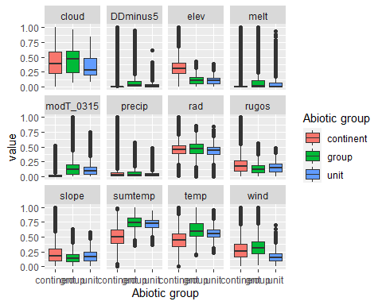

### Biota

Most widespread species in the unit (found in most pixels)

The top most widespread species in ecosystem env1_sdm4

| scientific | Functional_group | phylum | restricted | count | relative_pct |
| --- | --- | --- | --- | --- | --- |
| Gomphiocephalus hodgsoni | Arthropoda_Entognatha_Poduromorpha___ | Arthropoda | TRUE | 50 | 3.2362 |
| Usnea sphacelata | Ascomycota_Lecanoromycetes_Lecanorales_Parmeliaceae__ | Ascomycota | TRUE | 38 | 2.4595 |
| Scottnema lindsayae | Nematoda_____ | Nematoda | TRUE | 37 | 2.3948 |
| Stereotydeus mollis | Arthropoda_Arachnida_Trombidiformes___ | Arthropoda | TRUE | 33 | 2.1359 |
| Eudorylaimus antarcticus | Nematoda_____ | Nematoda | TRUE | 27 | 1.7476 |
| Buellia frigida | Ascomycota_Lecanoromycetes_Teloschistales_Physciaceae__ | Ascomycota | TRUE | 26 | 1.6828 |
| Xanthoria elegans | Ascomycota_Lecanoromycetes_Teloschistales_Teloschistaceae__ | Ascomycota | FALSE | 24 | 1.5534 |
| Pseudephebe minuscula | Ascomycota_Lecanoromycetes_Lecanorales_Parmeliaceae__ | Ascomycota | FALSE | 23 | 1.4887 |
| Umbilicaria decussata | Ascomycota_Lecanoromycetes_Umbilicariales_Umbilicariaceae__ | Ascomycota | FALSE | 23 | 1.4887 |
| Bryum pseudotriquetrum | Bryophyta_Bryopsida_Bryales___ | Bryophyta | FALSE | 21 | 1.3592 |

This supergroup is, on average, substantially higher in suitability for Rotifers, Springtails_slim, Nematodes, mosses_Pottiales, mites_Trombidiformes, lichens_Physcid_(shadow), lichens_Teloschistid, lichens_Candelarid, mites_Sarcoptiformes, algae_Green, mosses_Dicranales, lichens_Lecanorid, lichens_Parmelid, lichens_Rhizocarpid, mites_Mesostigmata, lichens_Acarosporacid, lichens_Stereocaulid, Algae, mosses_Bryales, penguins_Gentoo, mosses_Hypnales_(feather), penguins_Chinstrap, mosses_Polytrichales, lichens_Cladonid and lichens,_Bacidiacid functional groups than continental Antarctica. It is substantially lower in suitability for no variables than the rest of the continent.

Unit env1_sdm4 is higher in suitability for Nematodes and mites_Trombidiformes and lower in suitability for mosses_Polytrichales than the rest of its environmental supergroup.

Distinctiveness of the unit from the environmental group and the rest of Antarctica

