Ecosystem Description

Aniko B. Toth

## Ecosystem Env1_sdm5 Subcoastal mossy rises [cf

Env1_sdm5 Subcoastal mossy rises [cf. terraces/ridges]. These moss-dominated ecosystems occupy low-relief rocky outcrops, usually in the subcoastal hinterlands, extending to higher elevations than other coastal ice-free terrestrial ecosystems, although some are quite close to the coastline. Conditions are sufficiently warm and sunny to promote moss growth, but somewhat cooler and windier than other coastal systems in Group 1. Several processes are likely to enhance habitat suitability for mosses by promoting nutrient enrichment. Many occurrences co-incide with abandoned penguin colonies that were active earlier in the Holocene when sea levels were higher than at present. Toxic nitrogen levels associated with active colonies have since been leached, while residual levels of N and other nutrients promote moss growth. Alternatively, more elevated sites receive nutirent influxes from nesting seabirds or aerosol inputs via updrafts from extant penguin colonies below. While mosses are conspicuous features of these systems, lichens and some nematodes are also widespread, and several cyanobacteria species are characteristic of occurrences in different regions of the continent.

### Photos (if available)

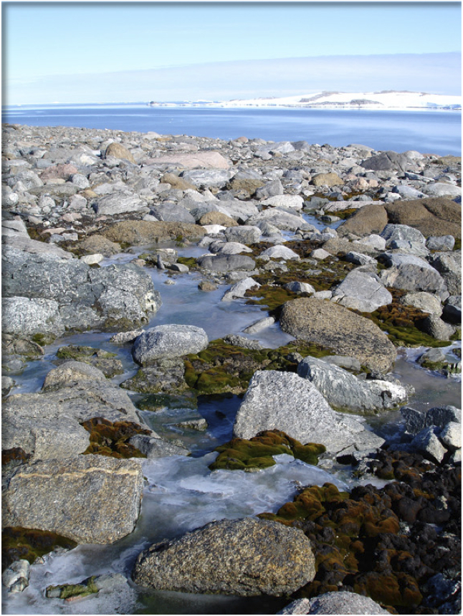

Ecosystem photo

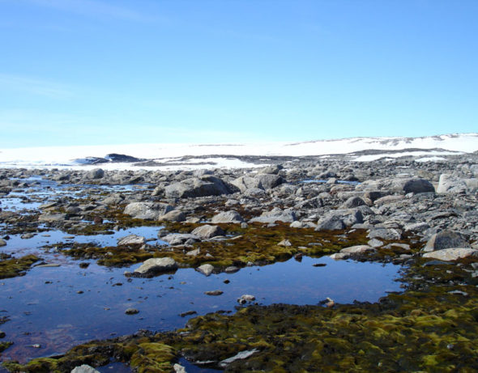

Ecosystem photo

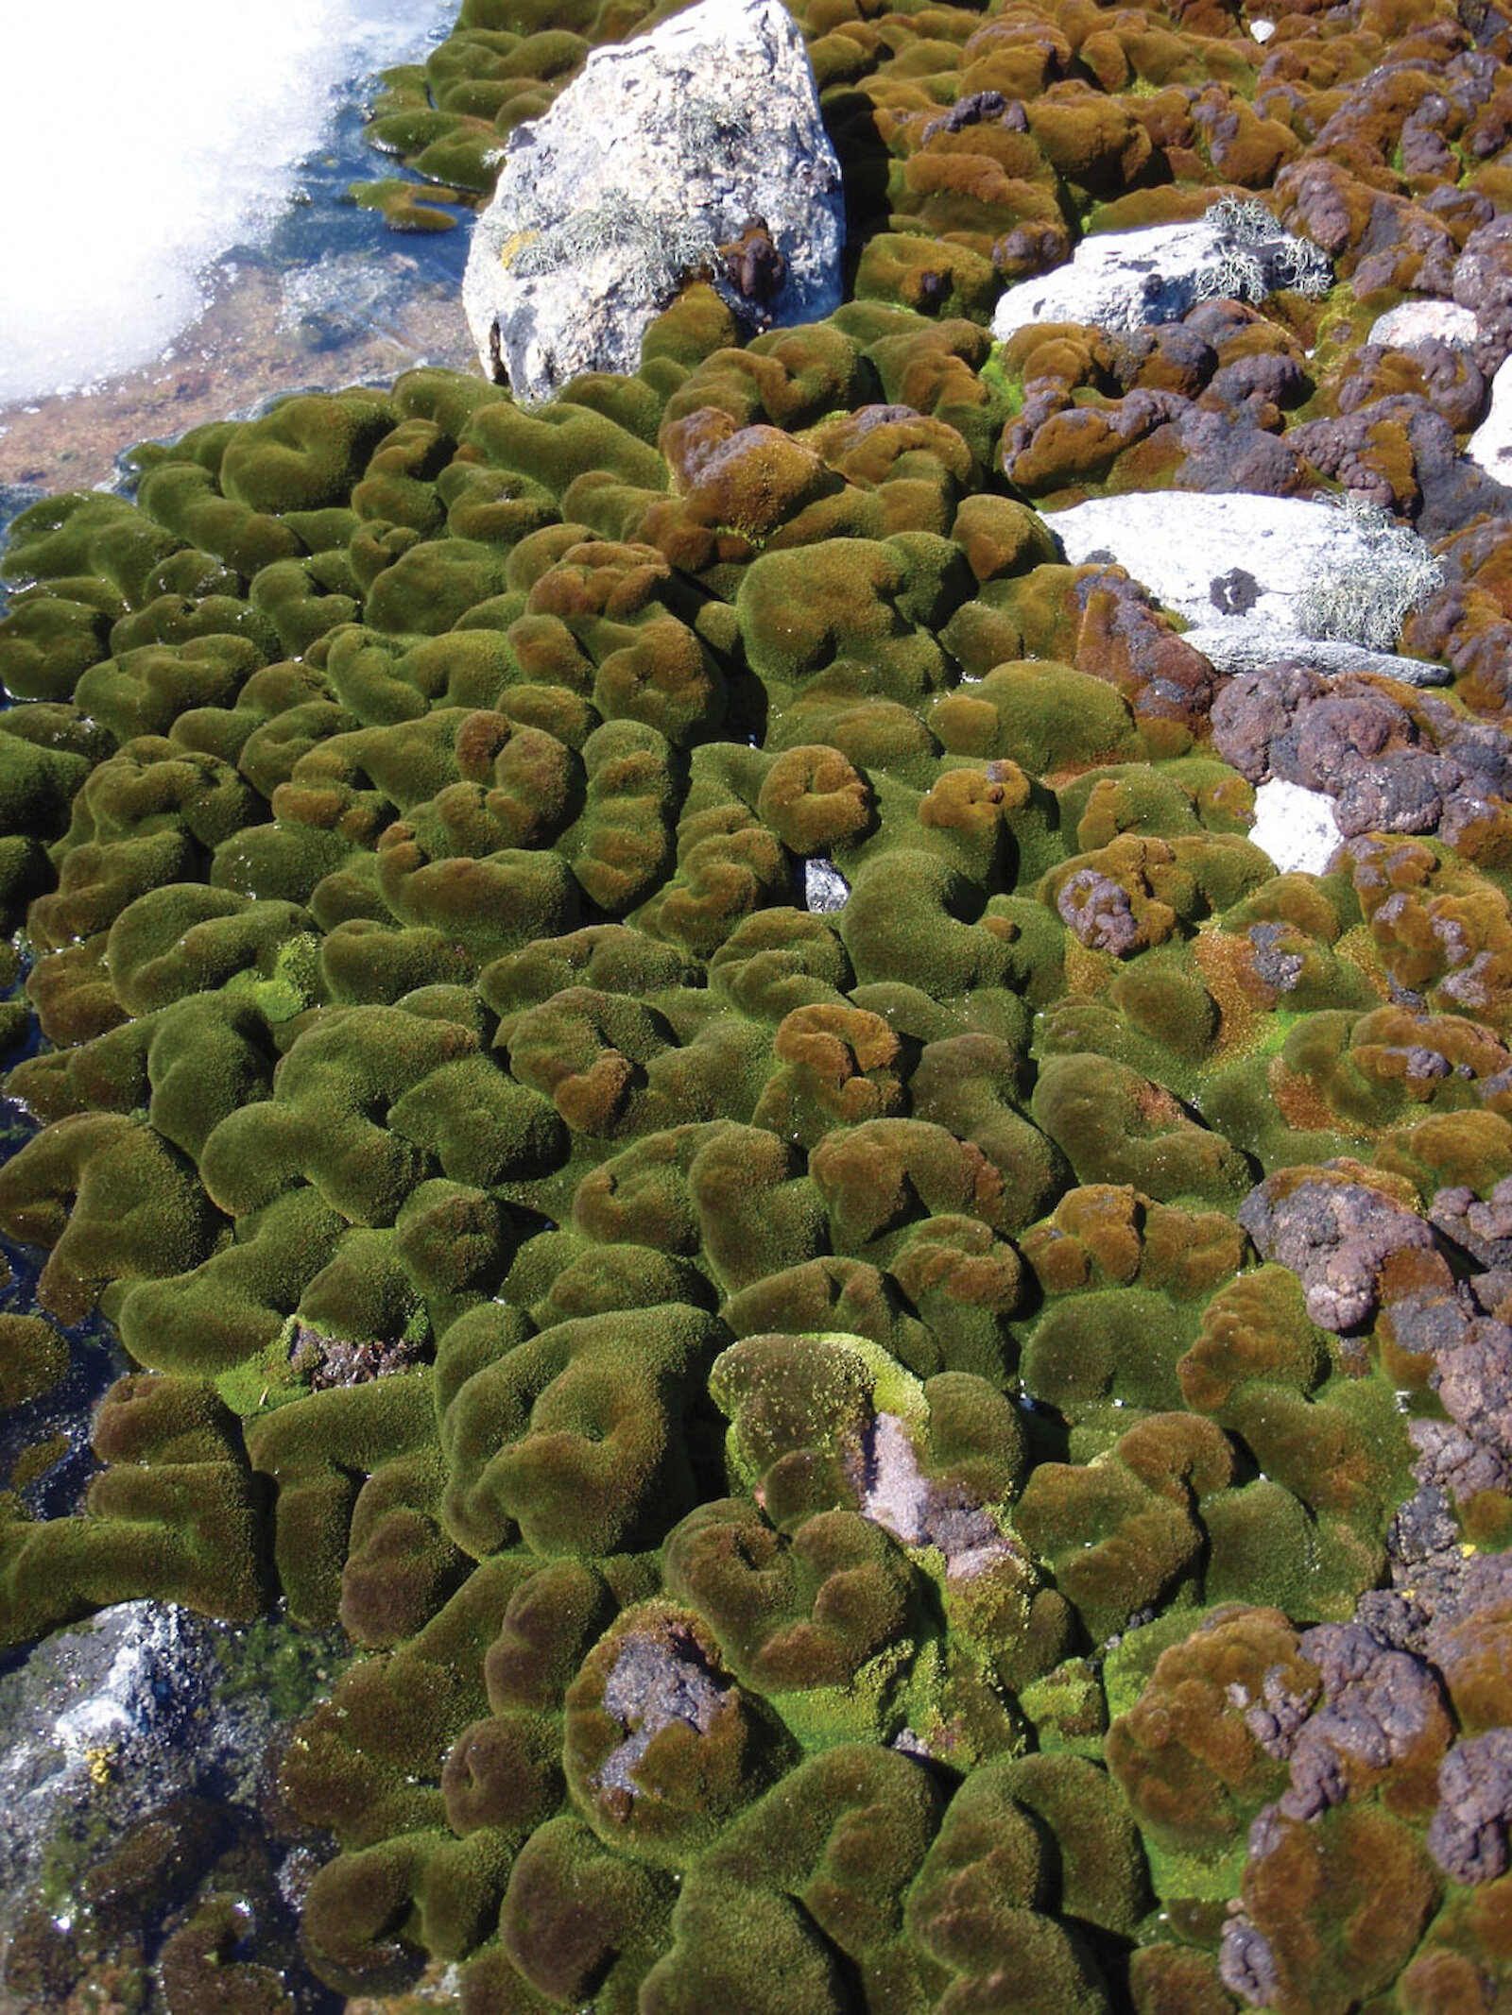

Ecosystem photo

### Distribution

Maps - Full map

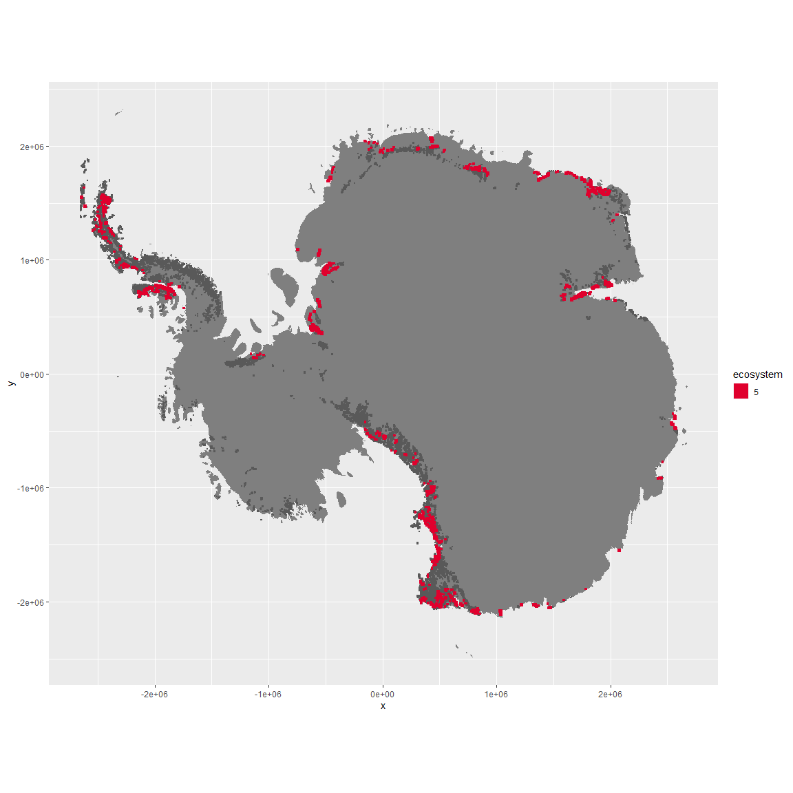

Regional maps

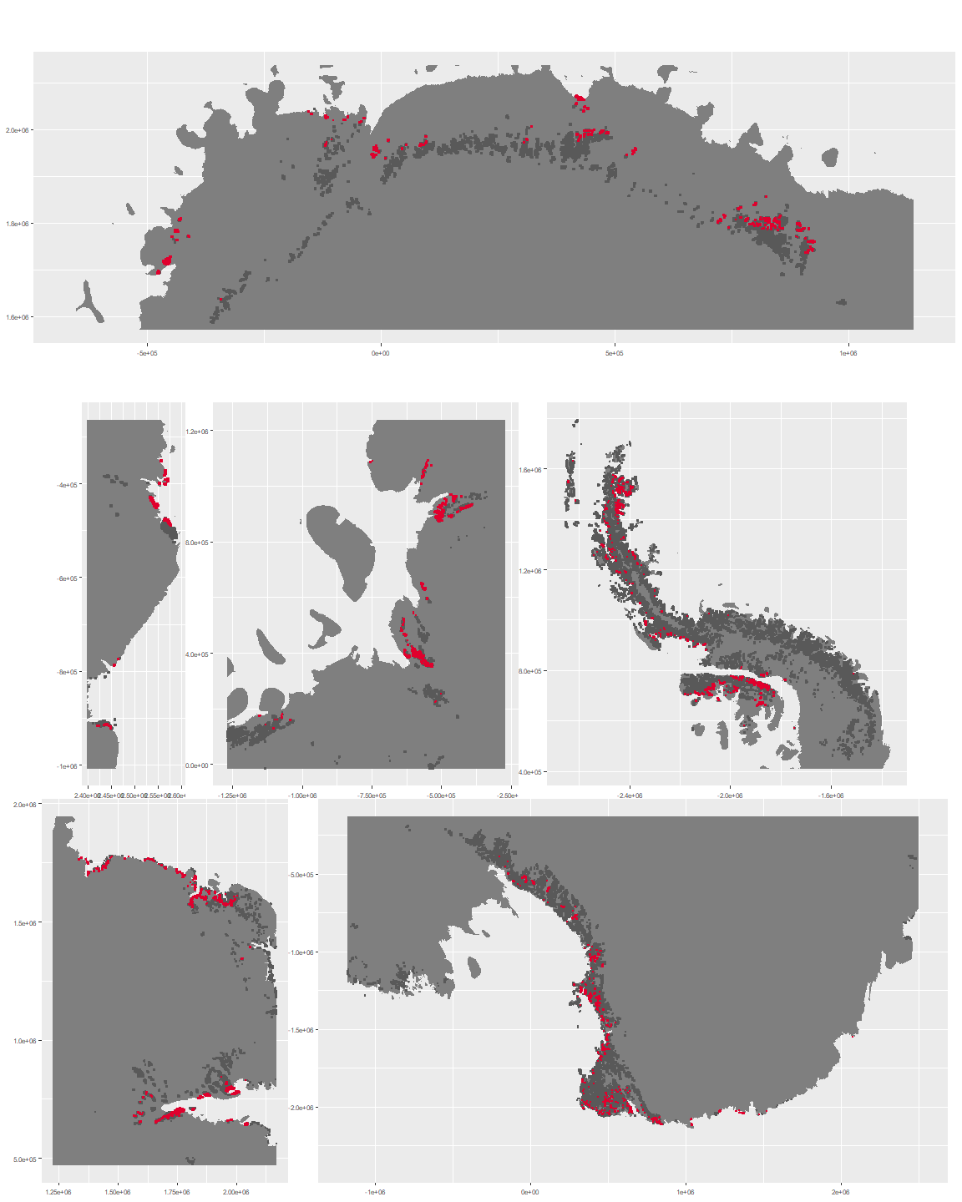

### Environment

The unit env1_sdm5 is part of the environmental supergroup env1.

This supergroup is, on average, substantially higher in sumtemp, temp, modT_0315 and melt than continental antarctica. It is substantially lower in slope, rugos and elev than the rest of the continent.

The elevation of unit env1_sdm5 ranges from 0 to 1836 metres above sea level, but 90% of its pixels fall above 20 and below 1364 metres. Its average elevation is 616 metres.

The unit is higher in wind and lower in sumtemp and cloud than the rest of its environmental supergroup.

#### Distinctiveness of the unit from its group and the rest of Antarctica

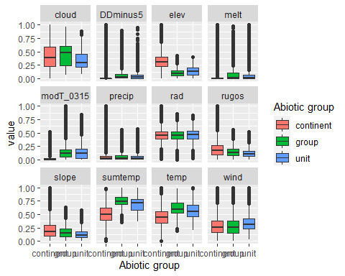

### Biota

Most widespread species in the unit (found in most pixels)

The top most widespread species in ecosystem env1_sdm5

| scientific | Functional_group | phylum | restricted | count | relative_pct |
| --- | --- | --- | --- | --- | --- |
| Ceratodon purpureus | Bryophyta_Bryopsida_Dicranales___ | Bryophyta | FALSE | 55 | 2.5253 |
| Bryum pseudotriquetrum | Bryophyta_Bryopsida_Bryales___ | Bryophyta | FALSE | 47 | 2.1579 |
| Usnea sphacelata | Ascomycota_Lecanoromycetes_Lecanorales_Parmeliaceae__ | Ascomycota | TRUE | 39 | 1.7906 |
| Umbilicaria decussata | Ascomycota_Lecanoromycetes_Umbilicariales_Umbilicariaceae__ | Ascomycota | FALSE | 36 | 1.6529 |
| Pseudephebe minuscula | Ascomycota_Lecanoromycetes_Lecanorales_Parmeliaceae__ | Ascomycota | FALSE | 32 | 1.4692 |
| Xanthoria elegans | Ascomycota_Lecanoromycetes_Teloschistales_Teloschistaceae__ | Ascomycota | FALSE | 31 | 1.4233 |
| Buellia frigida | Ascomycota_Lecanoromycetes_Teloschistales_Physciaceae__ | Ascomycota | TRUE | 27 | 1.2397 |
| Usnea antarctica | Ascomycota_Lecanoromycetes_Lecanorales_Parmeliaceae__ | Ascomycota | FALSE | 24 | 1.1019 |
| Bryum argenteum | Bryophyta_Bryopsida_Bryales___ | Bryophyta | FALSE | 23 | 1.0560 |
| Pottia heimii | Bryophyta_Bryopsida_Pottiales___ | Bryophyta | FALSE | 23 | 1.0560 |

This supergroup is, on average, substantially higher in suitability for Rotifers, Springtails_slim, Nematodes, mosses_Pottiales, mites_Trombidiformes, lichens_Physcid_(shadow), lichens_Teloschistid, lichens_Candelarid, mites_Sarcoptiformes, algae_Green, mosses_Dicranales, lichens_Lecanorid, lichens_Parmelid, lichens_Rhizocarpid, mites_Mesostigmata, lichens_Acarosporacid, lichens_Stereocaulid, Algae, mosses_Bryales, penguins_Gentoo, mosses_Hypnales_(feather), penguins_Chinstrap, mosses_Polytrichales, lichens_Cladonid and lichens,_Bacidiacid functional groups than continental Antarctica. It is substantially lower in suitability for no variables than the rest of the continent.

Unit env1_sdm5 is higher in suitability for no variables and lower in suitability for penguins_Gentoo, penguins_Chinstrap, Springtails_slim, mites_Sarcoptiformes, lichens_Lecanorid, mites_Mesostigmata and lichens_Stereocaulid than the rest of its environmental supergroup.

Distinctiveness of the unit from the environmental group and the rest of Antarctica

