Ecosystem Description

Aniko B. Toth

## Ecosystem Env2_sdm2 Cool dry hill slopes

Env2_sdm2 Cool dry hill slopes. Occurs mainly in the south Antarctic peninsula, Ellsworth mountains, and western end of the Transantarctic mountains. On the south peninsula, it occurs in association with Env5 (may be quite similar to some Env5 units). Most arid and cold unit in Env2, receiving relatively low snowfall. Unit is higher elevation than its group but not rugged, colder and drier than rest of the subgroup (melt, precip, and temp variables low). In some cases, temp and moisture variables drop below continental average. Sampled biota appear to be mainly mosses, but suitability is lower than continental average for most functional groups, particularly Ochrophytes, Nematodes, and penguins.

### Photos (if available)

### Distribution

Maps - Full map

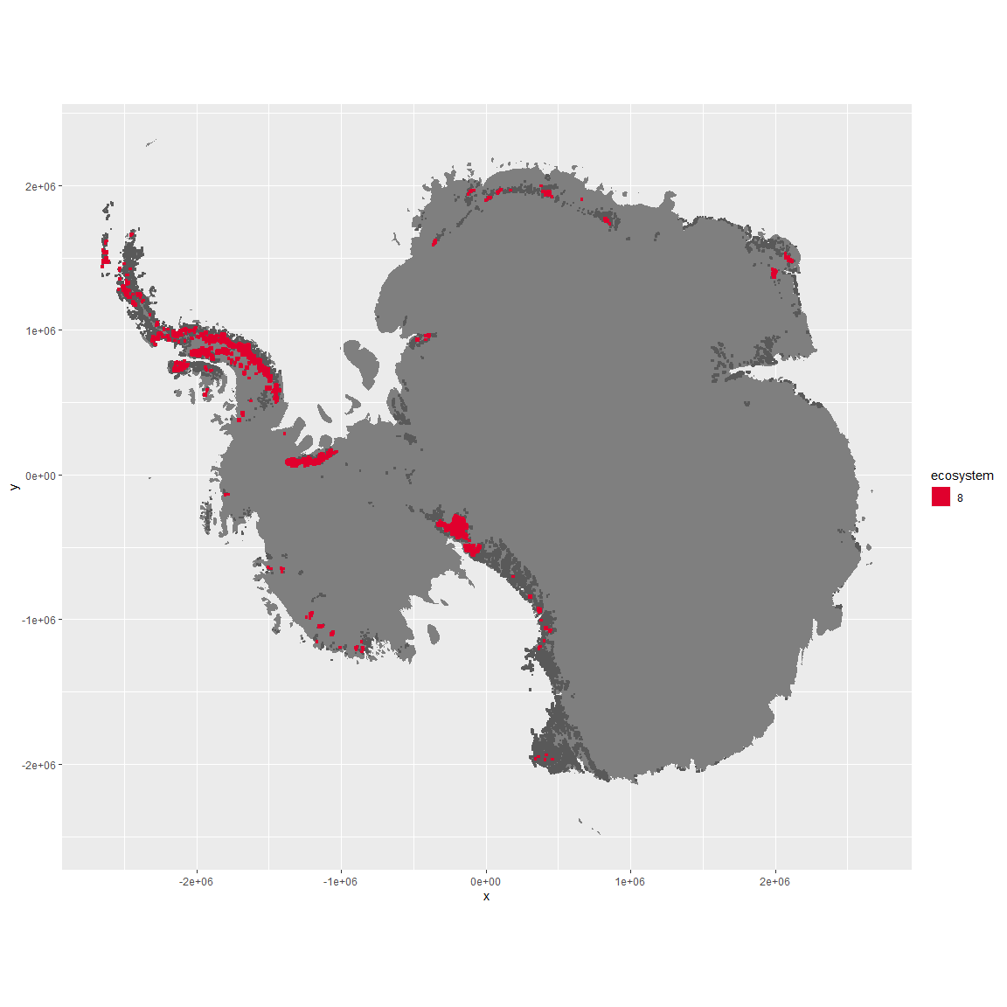

Regional maps

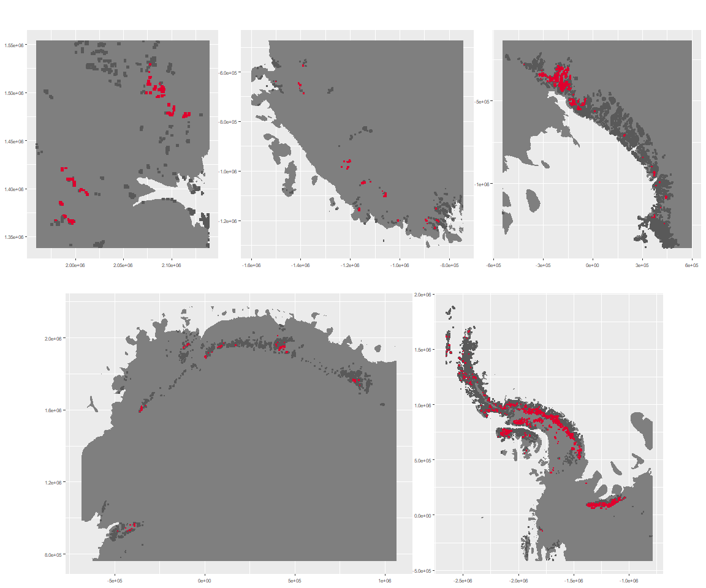

### Environment

The unit env2_sdm2 is part of the environmental supergroup env2.

This supergroup is, on average, substantially higher in cloud, precip, temp and sumtemp than continental antarctica. It is substantially lower in no variables than the rest of the continent.

The elevation of unit env2_sdm2 ranges from 0 to 3974 metres above sea level, but 90% of its pixels fall above 623 and below 2321 metres. Its average elevation is 1468 metres.

The unit is higher in elev and lower in modT_0315, DDminus5, rad, melt, rugos, slope, cloud, sumtemp, temp and precip than the rest of its environmental supergroup.

#### Distinctiveness of the unit from its group and the rest of Antarctica

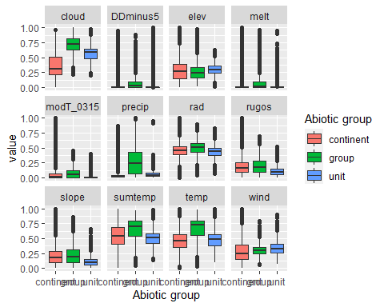

### Biota

Most widespread species in the unit (found in most pixels)

The top most widespread species in ecosystem env2_sdm2

| scientific | Functional_group | phylum | restricted | count | relative_pct |
| --- | --- | --- | --- | --- | --- |
| Syntrichia princeps | Bryophyta_Bryopsida_Pottiales___ | Bryophyta | FALSE | 10 | 1.9342 |
| Bryum pseudotriquetrum | Bryophyta_Bryopsida_Bryales___ | Bryophyta | FALSE | 9 | 1.7408 |
| Ceratodon purpureus | Bryophyta_Bryopsida_Dicranales___ | Bryophyta | FALSE | 8 | 1.5474 |
| Polytrichastrum alpinum | Bryophyta_Bryopsida_Polytrichales___ | Bryophyta | FALSE | 8 | 1.5474 |
| Schistidium antarctici | Bryophyta_Bryopsida_Grimmiales___ | Bryophyta | TRUE | 8 | 1.5474 |
| Usnea sphacelata | Ascomycota_Lecanoromycetes_Lecanorales_Parmeliaceae__ | Ascomycota | TRUE | 8 | 1.5474 |
| Andreaea gainii | Bryophyta_Andreaeopsida_Andreaeales___ | Bryophyta | TRUE | 7 | 1.3540 |
| Lecidea cf. cancriformis | Ascomycota_Lecanoromycetes_Lecanorales_Lecideaceae__ | Ascomycota | TRUE | 7 | 1.3540 |
| Pohlia nutans | Bryophyta_Bryopsida_Bryales___ | Bryophyta | FALSE | 7 | 1.3540 |
| Sanionia uncinata | Bryophyta_Bryopsida_Hypnales___ | Bryophyta | FALSE | 7 | 1.3540 |

This supergroup is, on average, substantially higher in suitability for no variables functional groups than continental Antarctica. It is substantially lower in suitability for mites_Trombidiformes, Nematodes, lichens_Acarosporacid, lichens_Teloschistid, lichens_Candelarid, lichens_Lecanorid, lichens_Physcid_(shadow), algae_Green, Rotifers and Algae than the rest of the continent.

Unit env2_sdm2 is higher in suitability for Algae, Rotifers, lichens_Lecanorid, lichens_Physcid_(shadow), lichens_Acarosporacid, lichens_Candelarid and lichens_Teloschistid and lower in suitability for mites_Mesostigmata, lichens_Cladonid, mosses_Hypnales_(feather), mosses_Polytrichales, penguins_Gentoo and penguins_Chinstrap than the rest of its environmental supergroup.

Distinctiveness of the unit from the environmental group and the rest of Antarctica

