Ecosystem Description

Aniko B. Toth

## Ecosystem Env2_sdm3 Rugged sparsely vegetated slopes

Env2_sdm3 Rugged sparsely vegetated slopes. These systems occur mainly on the west side of the northern Antarctic peninsula with outliers in Marie Byrd land and the Transanarctic Mountains. Maritime influence makes conditions warm with high precipitation like unit 2.1, but they are in windier locations, span a greater climatic range, have a longer growing season (degree-days above -5°C) and there is much less meltwater. The biota is characterised by lichens, mosses and mites, but these systems appear to be unsuitable for rotifers and ochrophytes.

### Photos (if available)

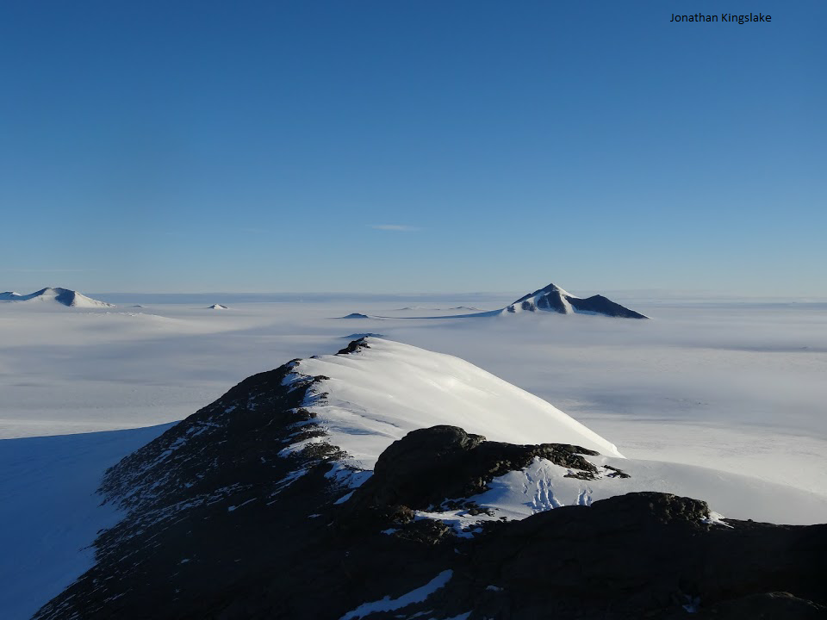

Ecosystem photo

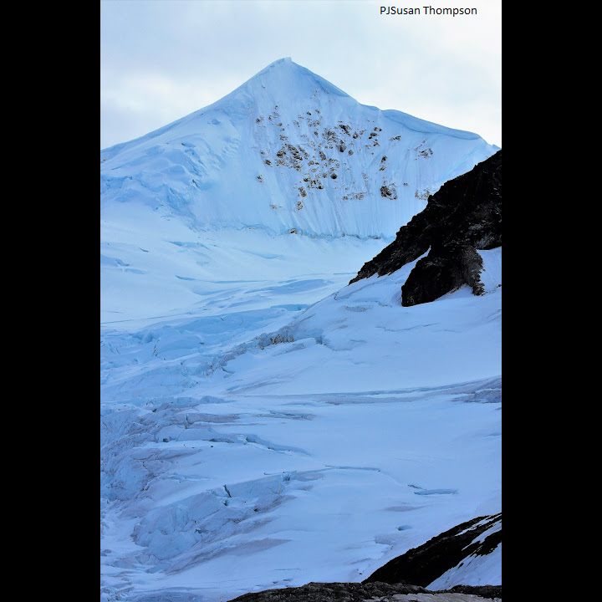

Ecosystem photo

### Distribution

Maps - Full map

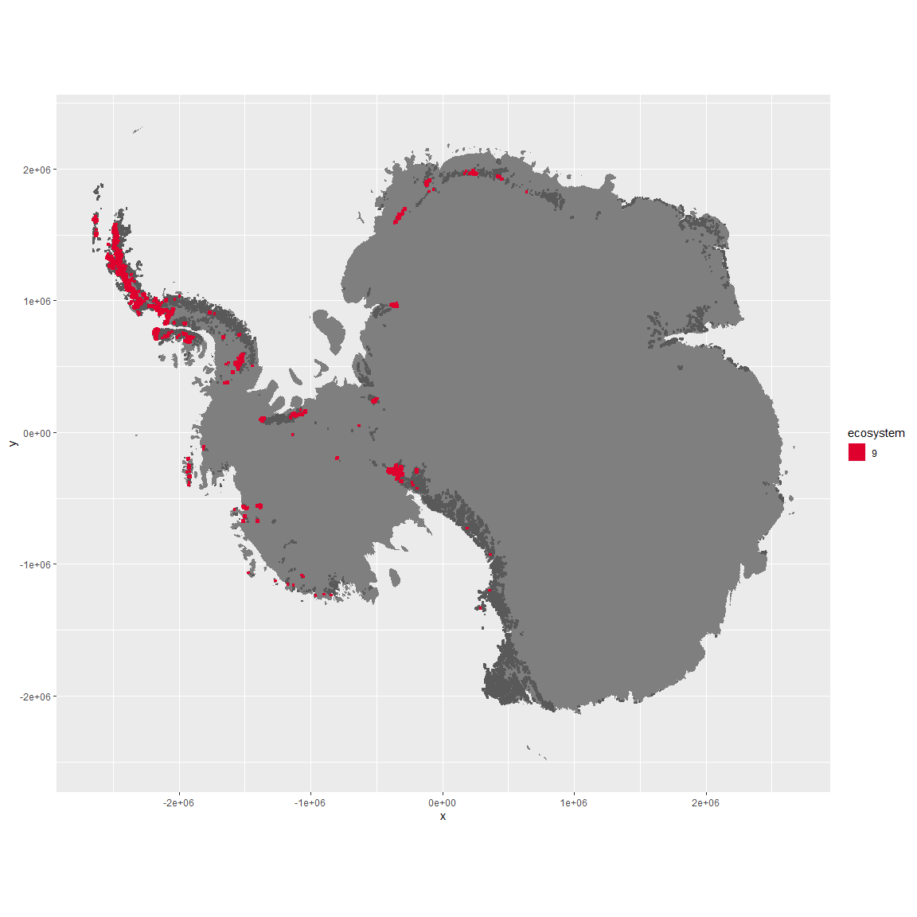

Regional maps

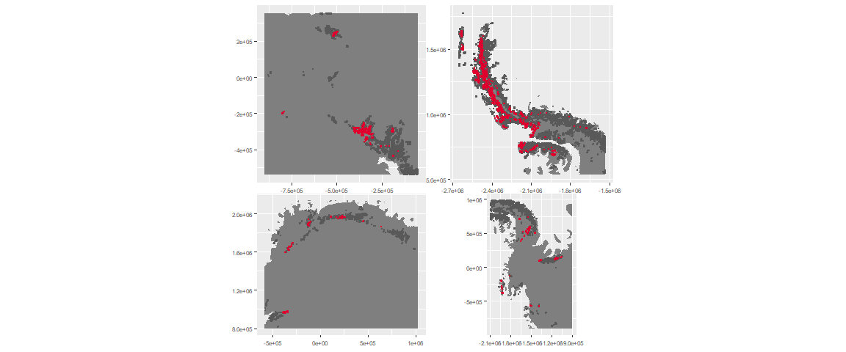

### Environment

The unit env2_sdm3 is part of the environmental supergroup env2.

This supergroup is, on average, substantially higher in cloud, precip, temp and sumtemp than continental antarctica. It is substantially lower in no variables than the rest of the continent.

The elevation of unit env2_sdm3 ranges from 0 to 3302 metres above sea level, but 90% of its pixels fall above 223 and below 1858 metres. Its average elevation is 964 metres.

The unit is higher in precip, sumtemp, temp, DDminus5, slope, cloud, rugos and modT_0315 and lower in elev than the rest of its environmental supergroup.

#### Distinctiveness of the unit from its group and the rest of Antarctica

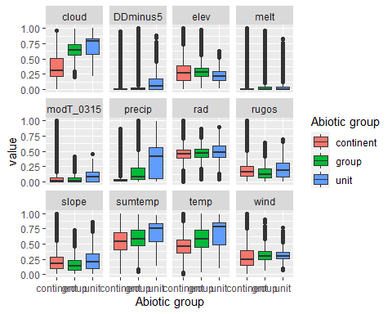

### Biota

Most widespread species in the unit (found in most pixels)

The top most widespread species in ecosystem env2_sdm3

| scientific | Functional_group | phylum | restricted | count | relative_pct |
| --- | --- | --- | --- | --- | --- |
| Andreaea regularis | Bryophyta_Andreaeopsida_Andreaeales___ | Bryophyta | TRUE | 18 | 2.5140 |
| Polytrichastrum alpinum | Bryophyta_Bryopsida_Polytrichales___ | Bryophyta | FALSE | 16 | 2.2346 |
| Sanionia uncinata | Bryophyta_Bryopsida_Hypnales___ | Bryophyta | FALSE | 15 | 2.0950 |
| Syntrichia princeps | Bryophyta_Bryopsida_Pottiales___ | Bryophyta | FALSE | 14 | 1.9553 |
| Pseudephebe minuscula | Ascomycota_Lecanoromycetes_Lecanorales_Parmeliaceae__ | Ascomycota | FALSE | 13 | 1.8156 |
| Deschampsia antarctica | Tracheophyta_____ | Tracheophyta | FALSE | 12 | 1.6760 |
| Bryum pseudotriquetrum | Bryophyta_Bryopsida_Bryales___ | Bryophyta | FALSE | 11 | 1.5363 |
| Pohlia cruda | Bryophyta_Bryopsida_Bryales___ | Bryophyta | FALSE | 11 | 1.5363 |
| Bartramia patens | Bryophyta_Bryopsida_Bryales___ | Bryophyta | FALSE | 10 | 1.3966 |
| Colobanthus quitensis | Tracheophyta_____ | Tracheophyta | FALSE | 10 | 1.3966 |
| Distichium capillaceum | Bryophyta_Bryopsida_Dicranales___ | Bryophyta | FALSE | 10 | 1.3966 |
| Schistidium antarctici | Bryophyta_Bryopsida_Grimmiales___ | Bryophyta | TRUE | 10 | 1.3966 |
| Usnea antarctica | Ascomycota_Lecanoromycetes_Lecanorales_Parmeliaceae__ | Ascomycota | FALSE | 10 | 1.3966 |
| Usnea aurantiaco-atra | Ascomycota_Lecanoromycetes_Lecanorales_Parmeliaceae__ | Ascomycota | FALSE | 10 | 1.3966 |
| Usnea sphacelata | Ascomycota_Lecanoromycetes_Lecanorales_Parmeliaceae__ | Ascomycota | TRUE | 10 | 1.3966 |

This supergroup is, on average, substantially higher in suitability for no variables functional groups than continental Antarctica. It is substantially lower in suitability for mites_Trombidiformes, Nematodes, lichens_Acarosporacid, lichens_Teloschistid, lichens_Candelarid, lichens_Lecanorid, lichens_Physcid_(shadow), algae_Green, Rotifers and Algae than the rest of the continent.

Unit env2_sdm3 is higher in suitability for lichens_Rhizocarpid, mites_Trombidiformes, Nematodes, penguins_Chinstrap, mites_Mesostigmata, algae_Green, Springtails_slim, penguins_Gentoo and mites_Sarcoptiformes and lower in suitability for Rotifers and Algae than the rest of its environmental supergroup.

Distinctiveness of the unit from the environmental group and the rest of Antarctica

