Ecosystem Description

Aniko B. Toth

## Ecosystem Env3_sdm2 Steep coastal wind-shaded cliffs and mountainsides

Env3_sdm2 Steep coastal wind-shaded cliffs and mountainsides. Occurs mainly along the Eastern coast of the peninsula and throughout the Transantarctic mountains and Victoria Land. Lowest wind and warmest temps in the group, relatively moist (cloud and precip). Unit is lower than group average but still above continental average in elevation, but higher than both in rugosity and slope. Biota are mainly lichens with some nematodes sampled.

### Photos (if available)

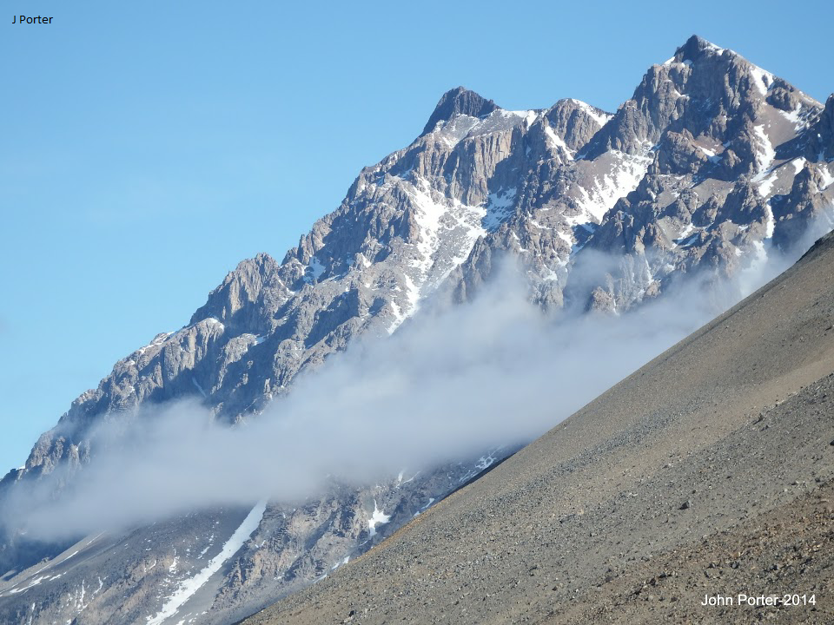

Ecosystem photo

### Distribution

Maps - Full map

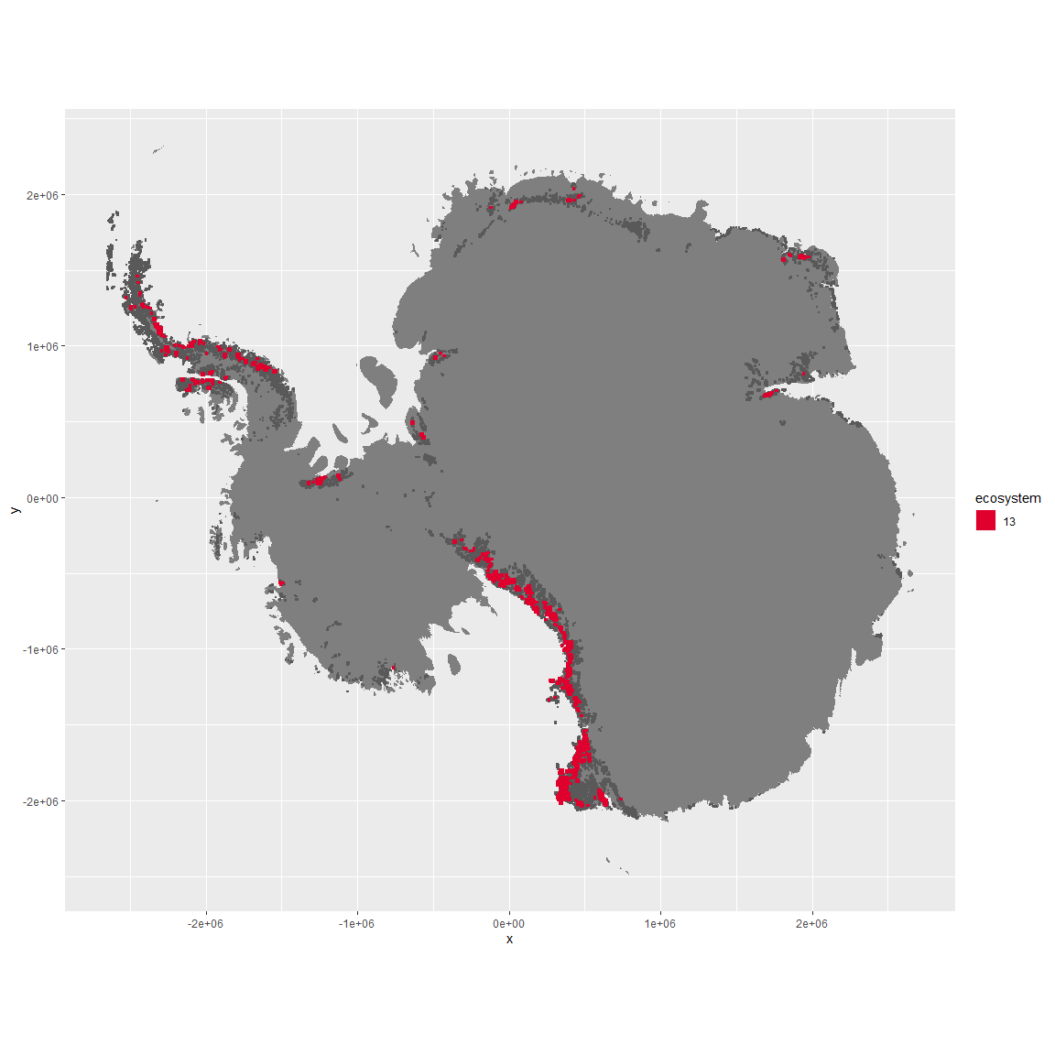

Regional maps

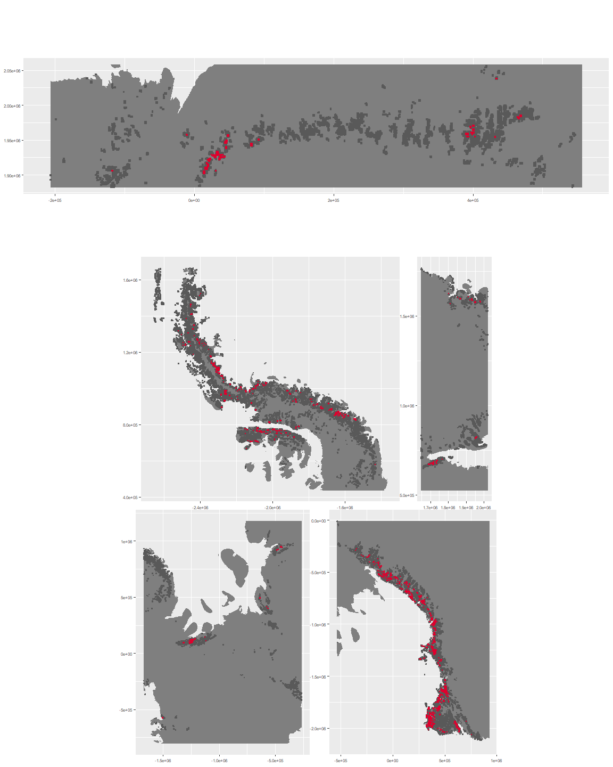

### Environment

The unit env3_sdm2 is part of the environmental supergroup env3.

This supergroup is, on average, substantially higher in slope, rugos and elev than continental antarctica. It is substantially lower in cloud, sumtemp and temp than the rest of the continent.

The elevation of unit env3_sdm2 ranges from 0 to 4815 metres above sea level, but 90% of its pixels fall above 567 and below 2908 metres. Its average elevation is 1582 metres.

The unit is higher in temp, slope, cloud, rugos, sumtemp, rad and melt and lower in wind than the rest of its environmental supergroup.

#### Distinctiveness of the unit from its group and the rest of Antarctica

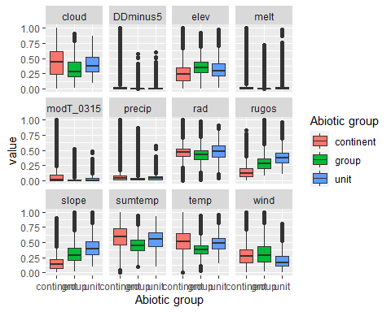

### Biota

Most widespread species in the unit (found in most pixels)

The top most widespread species in ecosystem env3_sdm2

| scientific | Functional_group | phylum | restricted | count | relative_pct |
| --- | --- | --- | --- | --- | --- |
| Pleopsidium chlorophanum | Ascomycota_Lecanoromycetes_Acarosporales_Acarosporaceae__ | Ascomycota | FALSE | 7 | 4.2683 |
| Umbilicaria decussata | Ascomycota_Lecanoromycetes_Umbilicariales_Umbilicariaceae__ | Ascomycota | FALSE | 5 | 3.0488 |
| Usnea sphacelata | Ascomycota_Lecanoromycetes_Lecanorales_Parmeliaceae__ | Ascomycota | TRUE | 5 | 3.0488 |
| Acarospora gwynnii | Ascomycota_Lecanoromycetes_Acarosporales_Acarosporaceae__ | Ascomycota | TRUE | 4 | 2.4390 |
| Buellia frigida | Ascomycota_Lecanoromycetes_Teloschistales_Physciaceae__ | Ascomycota | TRUE | 4 | 2.4390 |
| Lecanora physciella | Ascomycota_Lecanoromycetes_Lecanorales_Lecanoraceae__ | Ascomycota | FALSE | 3 | 1.8293 |
| Pohlia nutans | Bryophyta_Bryopsida_Bryales___ | Bryophyta | FALSE | 3 | 1.8293 |
| Pseudephebe minuscula | Ascomycota_Lecanoromycetes_Lecanorales_Parmeliaceae__ | Ascomycota | FALSE | 3 | 1.8293 |
| Rhizoplaca melanophthalma | Ascomycota_Lecanoromycetes_Lecanorales_Lecanoraceae__ | Ascomycota | FALSE | 3 | 1.8293 |
| Xanthoria elegans | Ascomycota_Lecanoromycetes_Teloschistales_Teloschistaceae__ | Ascomycota | FALSE | 3 | 1.8293 |

This supergroup is, on average, substantially higher in suitability for no variables functional groups than continental Antarctica. It is substantially lower in suitability for Springtails_slim, lichens_Cladonid, mosses_Hypnales_(feather), penguins_Chinstrap, mosses_Polytrichales, mites_Sarcoptiformes, mites_Mesostigmata and penguins_Gentoo than the rest of the continent.

Unit env3_sdm2 is higher in suitability for penguins_Chinstrap, lichens,*Bacidiacid, lichens_Cladonid, penguins_Gentoo, mosses_Bryales, mosses_Hypnales*(feather), mosses_Polytrichales and mosses_Dicranales and lower in suitability for lichens_Rhizocarpid and lichens_Candelarid than the rest of its environmental supergroup.

Distinctiveness of the unit from the environmental group and the rest of Antarctica

