Ecosystem Description

Aniko B. Toth

## Ecosystem Env3_sdm3

Env3_sdm3. Occurs mainly in the Transantarctic mountains, Victoria land, and the Prince Charles mountains. May be both coastal and inland. Does not deviate much from group averages except that it’s less cloudy, maybe a tad less rugged than the group average. Most sampled biota are nematodes, but lichens and Entognatha (Arthropods) are also represented. Suitability is low for most functional groups, but Suitability for Ochrophyta and Rotifera is above the continental average, and suitability for Chlorophyta and Nematoda are above the group average. Unit is particularly unsuitable for penguins.

### Photos (if available)

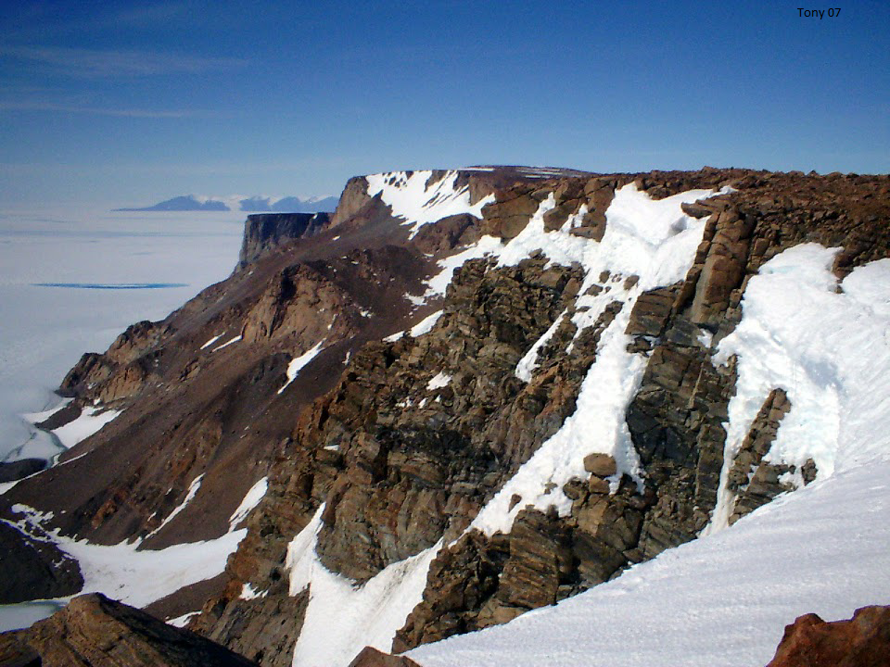

Ecosystem photo

### Distribution

Maps - Full map

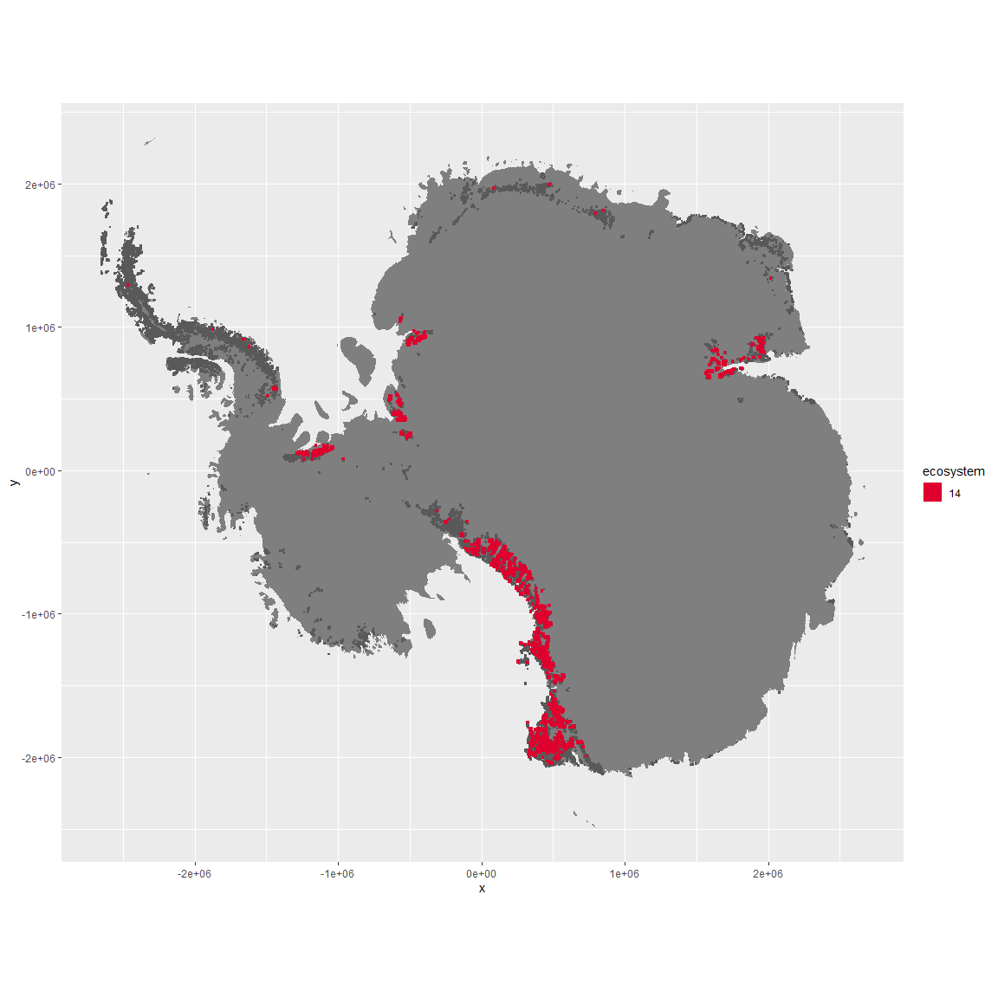

Regional maps

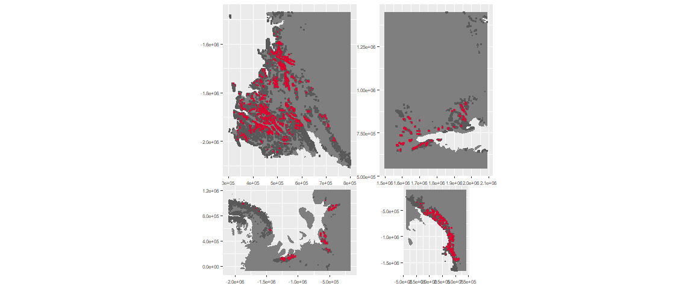

### Environment

The unit env3_sdm3 is part of the environmental supergroup env3.

This supergroup is, on average, substantially higher in slope, rugos and elev than continental antarctica. It is substantially lower in cloud, sumtemp and temp than the rest of the continent.

The elevation of unit env3_sdm3 ranges from 0 to 4143 metres above sea level, but 90% of its pixels fall above 579 and below 2554 metres. Its average elevation is 1532 metres.

The unit is higher in no variables and lower in wind, elev, temp, rugos, slope and cloud than the rest of its environmental supergroup.

#### Distinctiveness of the unit from its group and the rest of Antarctica

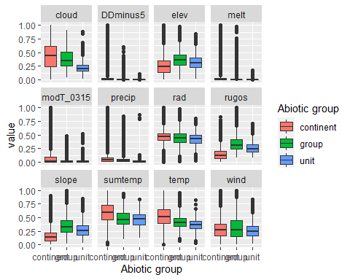

### Biota

Most widespread species in the unit (found in most pixels)

The top most widespread species in ecosystem env3_sdm3

| scientific | Functional_group | phylum | restricted | count | relative_pct |
| --- | --- | --- | --- | --- | --- |
| Scottnema lindsayae | Nematoda_____ | Nematoda | TRUE | 10 | 9.6154 |
| Eudorylaimus antarcticus | Nematoda_____ | Nematoda | TRUE | 6 | 5.7692 |
| Acarospora gwynnii | Ascomycota_Lecanoromycetes_Acarosporales_Acarosporaceae__ | Ascomycota | TRUE | 4 | 3.8462 |
| Buellia pallida | Ascomycota_Lecanoromycetes_Teloschistales_Physciaceae__ | Ascomycota | TRUE | 3 | 2.8846 |
| Gomphiocephalus hodgsoni | Arthropoda_Entognatha_Poduromorpha___ | Arthropoda | TRUE | 3 | 2.8846 |
| Biscoia sudpolaris | Arthropoda_Entognatha_Poduromorpha___ | Arthropoda | TRUE | 2 | 1.9231 |
| Carbonea capsulata | Ascomycota_Lecanoromycetes_Lecanorales_Lecanoraceae__ | Ascomycota | TRUE | 2 | 1.9231 |
| Geomonhystera antarcticola | Nematoda_____ | Nematoda | TRUE | 2 | 1.9231 |
| Lecanora expectans | Ascomycota_Lecanoromycetes_Lecanorales_Lecanoraceae__ | Ascomycota | TRUE | 2 | 1.9231 |
| Lecanora fuscobrunnea | Ascomycota_Lecanoromycetes_Lecanorales_Lecanoraceae__ | Ascomycota | TRUE | 2 | 1.9231 |
| Lecidea cancriformis | Ascomycota_Lecanoromycetes_Lecanorales_Lecideaceae__ | Ascomycota | TRUE | 2 | 1.9231 |
| Nanorchestes antarcticus | Arthropoda_Arachnida_Sarcoptiformes___ | Arthropoda | TRUE | 2 | 1.9231 |
| Plectus murrayi | Nematoda_____ | Nematoda | TRUE | 2 | 1.9231 |
| Pleopsidium chlorophanum | Ascomycota_Lecanoromycetes_Acarosporales_Acarosporaceae__ | Ascomycota | FALSE | 2 | 1.9231 |
| Rhizoplaca melanophthalma | Ascomycota_Lecanoromycetes_Lecanorales_Lecanoraceae__ | Ascomycota | FALSE | 2 | 1.9231 |
| Xanthoria elegans | Ascomycota_Lecanoromycetes_Teloschistales_Teloschistaceae__ | Ascomycota | FALSE | 2 | 1.9231 |

This supergroup is, on average, substantially higher in suitability for no variables functional groups than continental Antarctica. It is substantially lower in suitability for Springtails_slim, lichens_Cladonid, mosses_Hypnales_(feather), penguins_Chinstrap, mosses_Polytrichales, mites_Sarcoptiformes, mites_Mesostigmata and penguins_Gentoo than the rest of the continent.

Unit env3_sdm3 is higher in suitability for Rotifers and Nematodes and lower in suitability for lichens_Parmelid than the rest of its environmental supergroup.

Distinctiveness of the unit from the environmental group and the rest of Antarctica

