Ecosystem Description

Aniko B. Toth

## Ecosystem Env3_sdm4 Steep coastal wind-exposed cliffs and mountainsides

Env3_sdm4 Steep coastal wind-exposed cliffs and mountainsides. Occurs mainly in the North peninsula and western Transantarctic mountains. Cloudier and a bit more rugged than rest of unit and than the continental average. Sampled biota is a mix of nematodes, lichens, mosses, and Arthropods. Suitability is lower than the continental average for all functional groups, but is apparently highest for Ochrophytes and perhaps some lichen groups.

### Photos (if available)

### Distribution

Maps - Full map

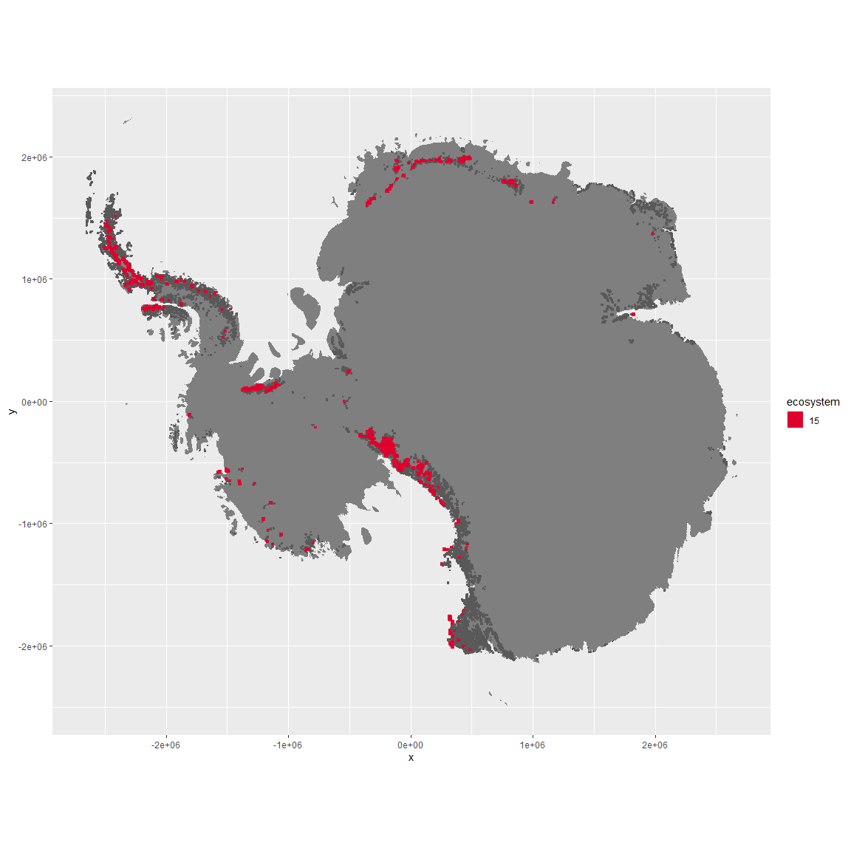

Regional maps

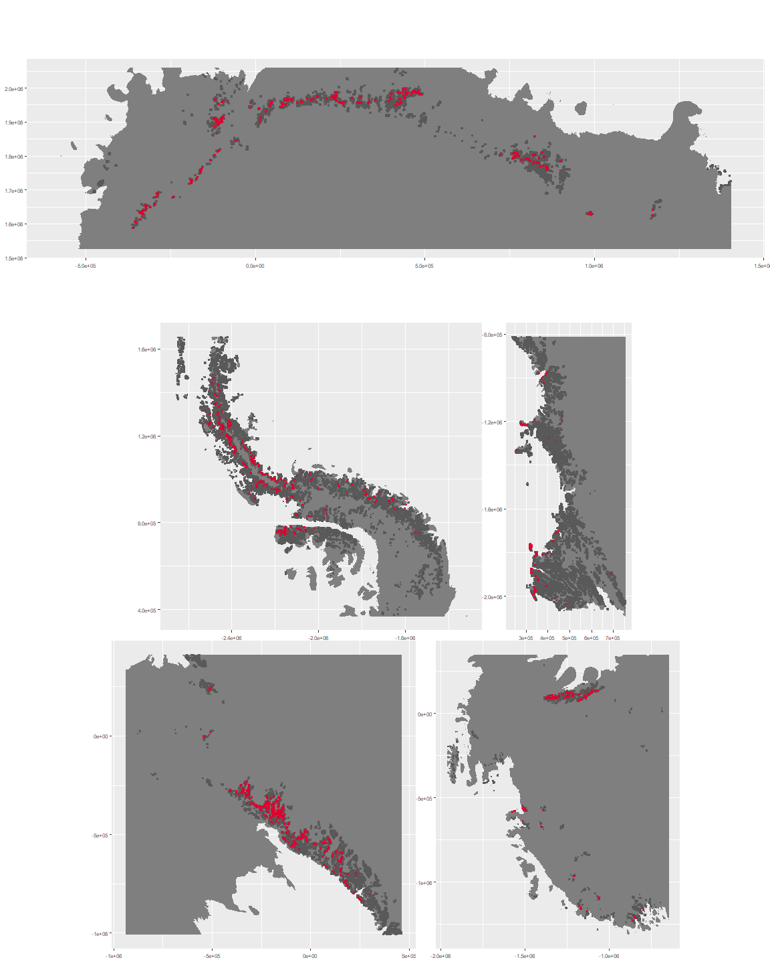

### Environment

The unit env3_sdm4 is part of the environmental supergroup env3.

This supergroup is, on average, substantially higher in slope, rugos and elev than continental antarctica. It is substantially lower in cloud, sumtemp and temp than the rest of the continent.

The elevation of unit env3_sdm4 ranges from 0 to 4966 metres above sea level, but 90% of its pixels fall above 227 and below 2923 metres. Its average elevation is 1613 metres.

The unit is higher in cloud, precip, slope, rugos, temp and wind and lower in no variables than the rest of its environmental supergroup.

#### Distinctiveness of the unit from its group and the rest of Antarctica

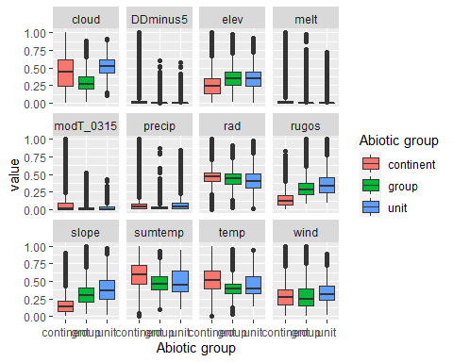

### Biota

Most widespread species in the unit (found in most pixels)

The top most widespread species in ecosystem env3_sdm4

| scientific | Functional_group | phylum | restricted | count | relative_pct |
| --- | --- | --- | --- | --- | --- |
| Pohlia cruda | Bryophyta_Bryopsida_Bryales___ | Bryophyta | FALSE | 3 | 4.8387 |
| Pseudephebe minuscula | Ascomycota_Lecanoromycetes_Lecanorales_Parmeliaceae__ | Ascomycota | FALSE | 3 | 4.8387 |
| Pygoscelis adeliae | Chordata_Aves_Sphenisciformes_Spheniscidae_Pygoscelis_adeliae | Chordata | FALSE | 3 | 4.8387 |
| Acarospora gwynnii | Ascomycota_Lecanoromycetes_Acarosporales_Acarosporaceae__ | Ascomycota | TRUE | 2 | 3.2258 |
| Lecidea cancriformis | Ascomycota_Lecanoromycetes_Lecanorales_Lecideaceae__ | Ascomycota | TRUE | 2 | 3.2258 |
| Lecidea cf. cancriformis | Ascomycota_Lecanoromycetes_Lecanorales_Lecideaceae__ | Ascomycota | TRUE | 2 | 3.2258 |
| Nanorchestes antarcticus | Arthropoda_Arachnida_Sarcoptiformes___ | Arthropoda | TRUE | 2 | 3.2258 |
| Plectus murrayi | Nematoda_____ | Nematoda | TRUE | 2 | 3.2258 |
| Usnea sphacelata | Ascomycota_Lecanoromycetes_Lecanorales_Parmeliaceae__ | Ascomycota | TRUE | 2 | 3.2258 |
| Arthrorhaphis citrinella | Ascomycota_Lecanoromycetes_Not assigned_Arthrorhaphidaceae__ | Ascomycota | FALSE | 1 | 1.6129 |
| Brachythecium austro-salebrosum | Bryophyta_Bryopsida_Hypnales___ | Bryophyta | TRUE | 1 | 1.6129 |
| Brachythecium subpilosum | Bryophyta_Bryopsida_Hypnales___ | Bryophyta | FALSE | 1 | 1.6129 |
| Buellia darbishirei | Ascomycota_Lecanoromycetes_Teloschistales_Physciaceae__ | Ascomycota | TRUE | 1 | 1.6129 |
| Buellia frigida | Ascomycota_Lecanoromycetes_Teloschistales_Physciaceae__ | Ascomycota | TRUE | 1 | 1.6129 |
| Caloplaca isidioclada | Ascomycota_Lecanoromycetes_Teloschistales_Teloschistaceae__ | Ascomycota | FALSE | 1 | 1.6129 |
| Candelaria murrayi | Ascomycota_Lecanoromycetes_Candelariales_Candelariaceae__ | Ascomycota | TRUE | 1 | 1.6129 |
| Candelariella flava | Ascomycota_Lecanoromycetes_Candelariales_Candelariaceae__ | Ascomycota | TRUE | 1 | 1.6129 |
| Ceratodon purpureus | Bryophyta_Bryopsida_Dicranales___ | Bryophyta | FALSE | 1 | 1.6129 |
| Cladonia galindezii | Ascomycota_Lecanoromycetes_Lecanorales_Cladoniaceae__ | Ascomycota | TRUE | 1 | 1.6129 |
| Coccorhagidia gressitti | Arthropoda_Arachnida_Trombidiformes___ | Arthropoda | TRUE | 1 | 1.6129 |
| Colobanthus quitensis | Tracheophyta_____ | Tracheophyta | FALSE | 1 | 1.6129 |
| Deschampsia antarctica | Tracheophyta_____ | Tracheophyta | FALSE | 1 | 1.6129 |
| Desmococcus sp. | Chlorophyta_____ | Chlorophyta | TRUE | 1 | 1.6129 |
| Eudorylaimus antarcticus | Nematoda_____ | Nematoda | TRUE | 1 | 1.6129 |
| Gloeocapsa sp. | Cyanobacteria_____ | Cyanobacteria | TRUE | 1 | 1.6129 |
| Gomphiocephalus hodgsoni | Arthropoda_Entognatha_Poduromorpha___ | Arthropoda | TRUE | 1 | 1.6129 |
| Grimmia lawiana | Bryophyta_Bryopsida_Grimmiales___ | Bryophyta | TRUE | 1 | 1.6129 |
| Grimmia reflexidens | Bryophyta_Bryopsida_Grimmiales___ | Bryophyta | FALSE | 1 | 1.6129 |
| Isotoma klovstadi | Arthropoda_Entognatha_Entomobryomorpha___ | Arthropoda | TRUE | 1 | 1.6129 |
| Lecanora cf. orosthea | Ascomycota_Lecanoromycetes_Lecanorales_Lecanoraceae__ | Ascomycota | TRUE | 1 | 1.6129 |
| Lecanora expectans | Ascomycota_Lecanoromycetes_Lecanorales_Lecanoraceae__ | Ascomycota | TRUE | 1 | 1.6129 |
| Lecanora fuscobrunnea | Ascomycota_Lecanoromycetes_Lecanorales_Lecanoraceae__ | Ascomycota | TRUE | 1 | 1.6129 |
| Luticola sp. | Ochrophyta_____ | Ochrophyta | TRUE | 1 | 1.6129 |
| Pannaria hookeri | Ascomycota_Lecanoromycetes_Peltigerales_Pannariaceae__ | Ascomycota | FALSE | 1 | 1.6129 |
| Placopsis contortuplicata | Ascomycota_Lecanoromycetes_Baeomycetales_Trapeliaceae__ | Ascomycota | TRUE | 1 | 1.6129 |
| Pleopsidium chlorophanum | Ascomycota_Lecanoromycetes_Acarosporales_Acarosporaceae__ | Ascomycota | FALSE | 1 | 1.6129 |
| Polytrichastrum alpinum | Bryophyta_Bryopsida_Polytrichales___ | Bryophyta | FALSE | 1 | 1.6129 |
| Polytrichum juniperinum | Bryophyta_Bryopsida_Polytrichales___ | Bryophyta | FALSE | 1 | 1.6129 |
| Polytrichum piliferum | Bryophyta_Bryopsida_Polytrichales___ | Bryophyta | FALSE | 1 | 1.6129 |
| Rhizocarpon adarense | Ascomycota_Lecanoromycetes_Not assigned_Rhizocarpaceae__ | Ascomycota | TRUE | 1 | 1.6129 |
| Rhizocarpon sp. | Ascomycota_Lecanoromycetes_Not assigned_Rhizocarpaceae__ | Ascomycota | TRUE | 1 | 1.6129 |
| Sanionia uncinata | Bryophyta_Bryopsida_Hypnales___ | Bryophyta | FALSE | 1 | 1.6129 |
| Stereocaulon antarcticum | Ascomycota_Lecanoromycetes_Lecanorales_Stereocaulaceae__ | Ascomycota | TRUE | 1 | 1.6129 |
| Stereotydeus mollis | Arthropoda_Arachnida_Trombidiformes___ | Arthropoda | TRUE | 1 | 1.6129 |
| Stichococcus bacillaris | Chlorophyta_____ | Chlorophyta | FALSE | 1 | 1.6129 |
| Syntrichia princeps | Bryophyta_Bryopsida_Pottiales___ | Bryophyta | FALSE | 1 | 1.6129 |
| Tephromela atra | Ascomycota_Lecanoromycetes_Lecanorales_Mycoblastaceae__ | Ascomycota | FALSE | 1 | 1.6129 |
| Umbilicaria aprina | Ascomycota_Lecanoromycetes_Umbilicariales_Umbilicariaceae__ | Ascomycota | FALSE | 1 | 1.6129 |
| Warnstorfia sarmentosa | Bryophyta_Bryopsida_Hypnales___ | Bryophyta | FALSE | 1 | 1.6129 |
| Xanthoria elegans | Ascomycota_Lecanoromycetes_Teloschistales_Teloschistaceae__ | Ascomycota | FALSE | 1 | 1.6129 |

This supergroup is, on average, substantially higher in suitability for no variables functional groups than continental Antarctica. It is substantially lower in suitability for Springtails_slim, lichens_Cladonid, mosses_Hypnales_(feather), penguins_Chinstrap, mosses_Polytrichales, mites_Sarcoptiformes, mites_Mesostigmata and penguins_Gentoo than the rest of the continent.

Unit env3_sdm4 is higher in suitability for mites_Mesostigmata and lower in suitability for Rotifers, lichens_Physcid_(shadow), Nematodes, lichens_Acarosporacid, Algae and algae_Green than the rest of its environmental supergroup.

Distinctiveness of the unit from the environmental group and the rest of Antarctica

