Ecosystem Description

Aniko B. Toth

## Ecosystem Env3_sdm5 Inland high mountains

Env3_sdm5 Inland high mountains. Occurs mainly in the Transantarctic mountains and Victoria land. This unit is an extreme example, higher and colder than the unit average. Unit does not occur near the coast. Biota is sparse but consists mainly of lichens, but suitability is below the continental average for all functional groups. The highest suitability is apparently for Ochrophyta.

### Photos (if available)

### Distribution

Maps - Full map

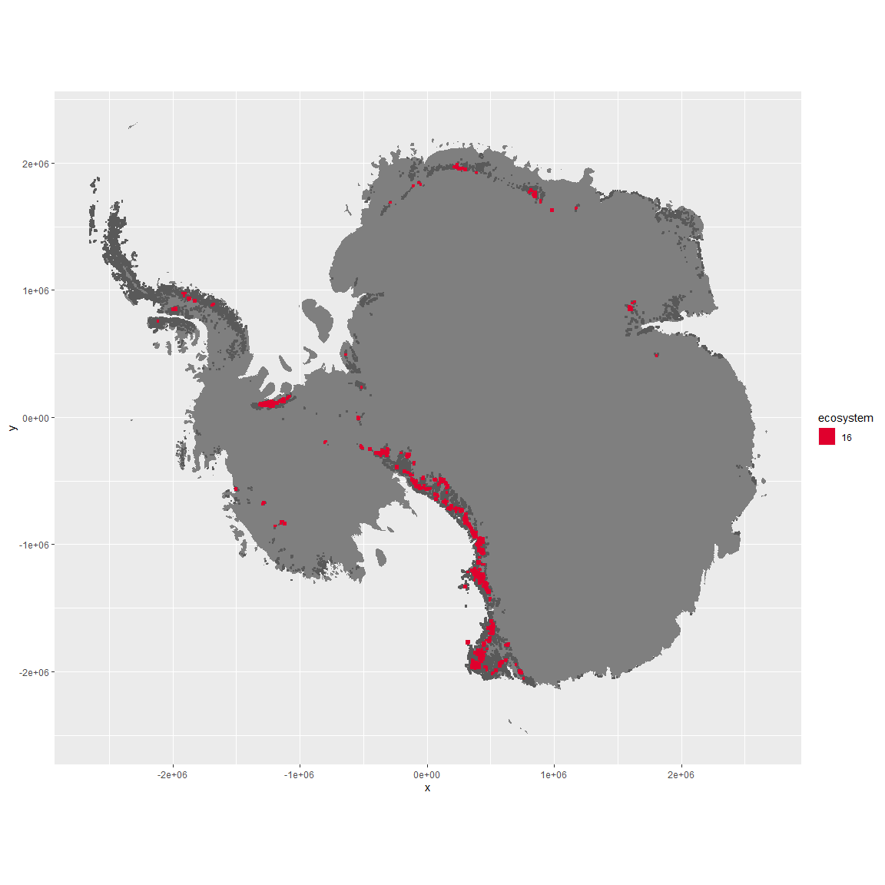

Regional maps

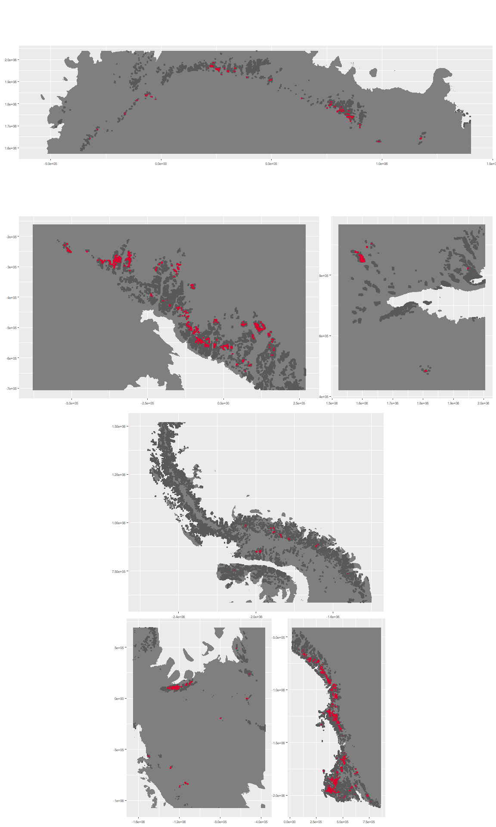

### Environment

The unit env3_sdm5 is part of the environmental supergroup env3.

This supergroup is, on average, substantially higher in slope, rugos and elev than continental antarctica. It is substantially lower in cloud, sumtemp and temp than the rest of the continent.

The elevation of unit env3_sdm5 ranges from 93 to 4365 metres above sea level, but 90% of its pixels fall above 1324 and below 2943 metres. Its average elevation is 2064 metres.

The unit is higher in elev and lower in wind, temp and sumtemp than the rest of its environmental supergroup.

#### Distinctiveness of the unit from its group and the rest of Antarctica

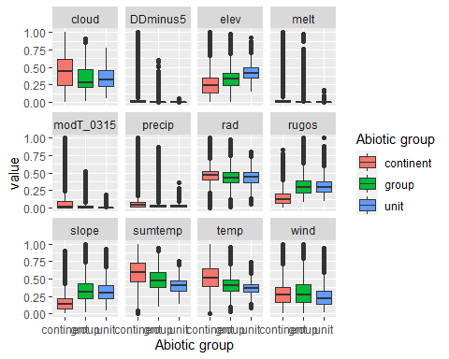

### Biota

Most widespread species in the unit (found in most pixels)

The top most widespread species in ecosystem env3_sdm5

| scientific | Functional_group | phylum | restricted | count | relative_pct |
| --- | --- | --- | --- | --- | --- |
| Carbonea capsulata | Ascomycota_Lecanoromycetes_Lecanorales_Lecanoraceae__ | Ascomycota | TRUE | 3 | 5.2632 |
| Candelariella flava | Ascomycota_Lecanoromycetes_Candelariales_Candelariaceae__ | Ascomycota | TRUE | 2 | 3.5088 |
| Carbonea vorticosa | Ascomycota_Lecanoromycetes_Lecanorales_Lecanoraceae__ | Ascomycota | FALSE | 2 | 3.5088 |
| Hemichloris antarctica | Chlorophyta_____ | Chlorophyta | FALSE | 2 | 3.5088 |
| Heterococcus endolithicus | Ochrophyta_____ | Ochrophyta | TRUE | 2 | 3.5088 |
| Lecanora fuscobrunnea | Ascomycota_Lecanoromycetes_Lecanorales_Lecanoraceae__ | Ascomycota | TRUE | 2 | 3.5088 |
| Neocryptopygus nivicolus | Arthropoda_Entognatha_Entomobryomorpha___ | Arthropoda | TRUE | 2 | 3.5088 |
| Scottnema lindsayae | Nematoda_____ | Nematoda | TRUE | 2 | 3.5088 |
| Xanthoria elegans | Ascomycota_Lecanoromycetes_Teloschistales_Teloschistaceae__ | Ascomycota | FALSE | 2 | 3.5088 |
| Acarospora gwynnii | Ascomycota_Lecanoromycetes_Acarosporales_Acarosporaceae__ | Ascomycota | TRUE | 1 | 1.7544 |
| Achnanthes sp. | Ochrophyta_____ | Ochrophyta | TRUE | 1 | 1.7544 |
| Antarcticinella monoculata | Arthropoda_Entognatha_Entomobryomorpha___ | Arthropoda | TRUE | 1 | 1.7544 |
| Aulacoseira sp. | Ochrophyta_____ | Ochrophyta | TRUE | 1 | 1.7544 |
| Blastenia cf. bastini | Ascomycota_Lecanoromycetes_Teloschistales_Teloschistaceae__ | Ascomycota | TRUE | 1 | 1.7544 |
| Buellia bastinii | Ascomycota_Lecanoromycetes_Teloschistales_Physciaceae__ | Ascomycota | TRUE | 1 | 1.7544 |
| Buellia evanescens | Ascomycota_Lecanoromycetes_Teloschistales_Physciaceae__ | Ascomycota | TRUE | 1 | 1.7544 |
| Buellia grisea | Ascomycota_Lecanoromycetes_Teloschistales_Physciaceae__ | Ascomycota | FALSE | 1 | 1.7544 |
| Buellia pallida | Ascomycota_Lecanoromycetes_Teloschistales_Physciaceae__ | Ascomycota | TRUE | 1 | 1.7544 |
| Caloneis tenuis | Ochrophyta_____ | Ochrophyta | FALSE | 1 | 1.7544 |
| Campylopus pyriformis | Bryophyta_Bryopsida_Dicranales___ | Bryophyta | FALSE | 1 | 1.7544 |
| Coccomyxa gloeobotrydiformis | Chlorophyta_____ | Chlorophyta | TRUE | 1 | 1.7544 |
| Cyclotella ocellata | Ochrophyta_____ | Ochrophyta | FALSE | 1 | 1.7544 |
| Elliptochloris reniformis | Chlorophyta_____ | Chlorophyta | TRUE | 1 | 1.7544 |
| Eudorylaimus antarcticus | Nematoda_____ | Nematoda | TRUE | 1 | 1.7544 |
| Fragilaria berolinensis | Ochrophyta_____ | Ochrophyta | TRUE | 1 | 1.7544 |
| Fragilaria sp. | Ochrophyta_____ | Ochrophyta | TRUE | 1 | 1.7544 |
| Gloeocapsa magma | Cyanobacteria_____ | Cyanobacteria | FALSE | 1 | 1.7544 |
| Gomphiocephalus hodgsoni | Arthropoda_Entognatha_Poduromorpha___ | Arthropoda | TRUE | 1 | 1.7544 |
| Graesiella emersonii | Chlorophyta_____ | Chlorophyta | FALSE | 1 | 1.7544 |
| Hassallia bouteillei | Cyanobacteria_____ | Cyanobacteria | TRUE | 1 | 1.7544 |
| Lecidea cancriformis | Ascomycota_Lecanoromycetes_Lecanorales_Lecideaceae__ | Ascomycota | TRUE | 1 | 1.7544 |
| Lecidea cf. cancriformis | Ascomycota_Lecanoromycetes_Lecanorales_Lecideaceae__ | Ascomycota | TRUE | 1 | 1.7544 |
| Lecidea coreyi | Ascomycota_Lecanoromycetes_Lecanorales_Lecideaceae__ | Ascomycota | TRUE | 1 | 1.7544 |
| Mastigocladus laminosus | Cyanobacteria_____ | Cyanobacteria | FALSE | 1 | 1.7544 |
| Parmelia griseola | Ascomycota_Lecanoromycetes_Lecanorales_Parmeliaceae__ | Ascomycota | TRUE | 1 | 1.7544 |
| Pinnularia maior | Ochrophyta_____ | Ochrophyta | FALSE | 1 | 1.7544 |
| Pseudephebe minuscula | Ascomycota_Lecanoromycetes_Lecanorales_Parmeliaceae__ | Ascomycota | FALSE | 1 | 1.7544 |
| Pseudococcomyxa simplex | Chlorophyta_____ | Chlorophyta | TRUE | 1 | 1.7544 |
| Rhizocarpon geographicum | Ascomycota_Lecanoromycetes_Not assigned_Rhizocarpaceae__ | Ascomycota | FALSE | 1 | 1.7544 |
| Rhizoplaca melanophthalma | Ascomycota_Lecanoromycetes_Lecanorales_Lecanoraceae__ | Ascomycota | FALSE | 1 | 1.7544 |
| Stereotydeus mollis | Arthropoda_Arachnida_Trombidiformes___ | Arthropoda | TRUE | 1 | 1.7544 |
| Stigonema ocellatum | Cyanobacteria_____ | Cyanobacteria | FALSE | 1 | 1.7544 |
| Trebouxia sp. | Chlorophyta_____ | Chlorophyta | TRUE | 1 | 1.7544 |
| Umbilicaria aprina | Ascomycota_Lecanoromycetes_Umbilicariales_Umbilicariaceae__ | Ascomycota | FALSE | 1 | 1.7544 |
| Umbilicaria cf. krascheninnikovii | Ascomycota_Lecanoromycetes_Umbilicariales_Umbilicariaceae__ | Ascomycota | TRUE | 1 | 1.7544 |
| Umbilicaria decussata | Ascomycota_Lecanoromycetes_Umbilicariales_Umbilicariaceae__ | Ascomycota | FALSE | 1 | 1.7544 |
| Usnea sphacelata | Ascomycota_Lecanoromycetes_Lecanorales_Parmeliaceae__ | Ascomycota | TRUE | 1 | 1.7544 |

This supergroup is, on average, substantially higher in suitability for no variables functional groups than continental Antarctica. It is substantially lower in suitability for Springtails_slim, lichens_Cladonid, mosses_Hypnales_(feather), penguins_Chinstrap, mosses_Polytrichales, mites_Sarcoptiformes, mites_Mesostigmata and penguins_Gentoo than the rest of the continent.

Unit env3_sdm5 is higher in suitability for no variables and lower in suitability for mosses_Polytrichales, mites_Sarcoptiformes, lichens_Physcid_(shadow), mosses_Bryales, mosses_Hypnales_(feather), lichens_Teloschistid, Rotifers, Nematodes, lichens_Rhizocarpid, mites_Trombidiformes, Springtails_slim, lichens_Parmelid, lichens_Candelarid, algae_Green, mites_Mesostigmata, mosses_Pottiales and mosses_Dicranales than the rest of its environmental supergroup.

Distinctiveness of the unit from the environmental group and the rest of Antarctica

