Ecosystem Description

Aniko B. Toth

## Ecosystem Env4_sdm1, Windy overcast plateaus

Env4_sdm1, Windy overcast plateaus. Occurs mainly on the eastern coast of the northern peninsula, Dronning Maud land, Enderby land, and in the Prince Charles mountains. This unit is especially windy and high in radiation (North-facing slopes?). Sampled fauna is scarce but consists of lichens, a few mosses and the occasional tardigrade. Suitability is below continental average for all functional groups in Env 4 but this unit nonetheless has higher than continental average suitability for Candelariaceae, Rhizocarpaceae, Acarosporaceae and to a lesser extent Permeliaceae lichens.

### Photos (if available)

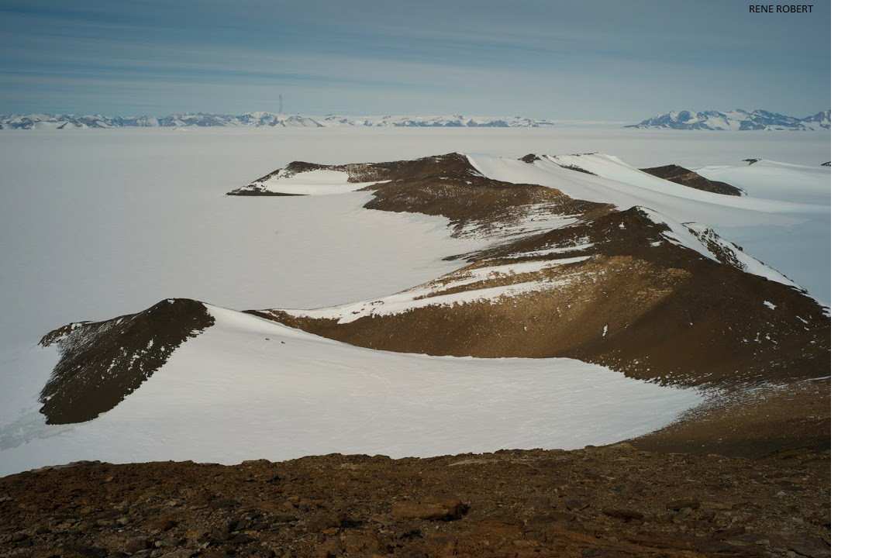

Ecosystem photo

### Distribution

Maps - Full map

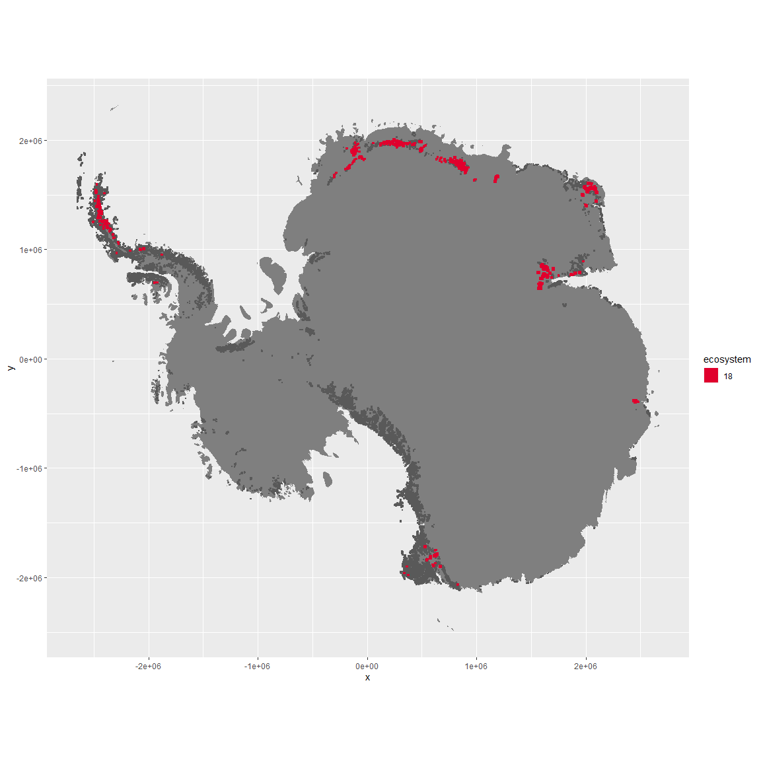

Regional maps

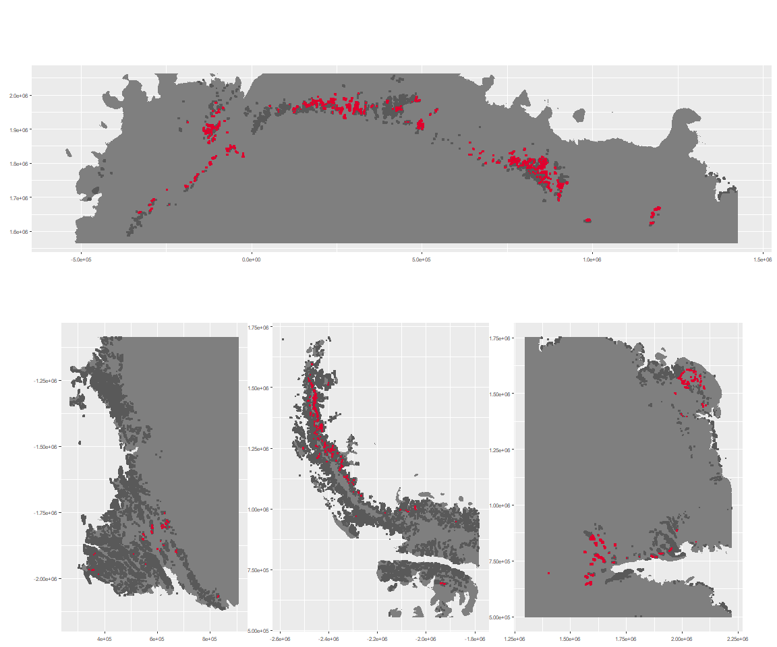

### Environment

The unit env4_sdm1 is part of the environmental supergroup env4.

This supergroup is, on average, substantially higher in wind, elev and rad than continental antarctica. It is substantially lower in rugos, sumtemp, slope, temp and cloud than the rest of the continent.

The elevation of unit env4_sdm1 ranges from 21 to 2952 metres above sea level, but 90% of its pixels fall above 662 and below 2110 metres. Its average elevation is 1399 metres.

The unit is higher in wind and cloud and lower in no variables than the rest of its environmental supergroup.

#### Distinctiveness of the unit from its group and the rest of Antarctica

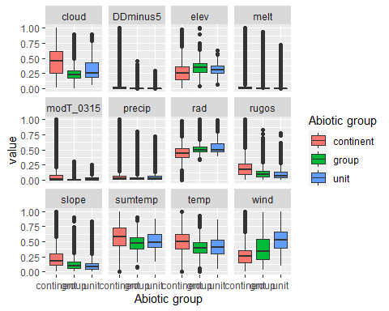

### Biota

Most widespread species in the unit (found in most pixels)

The top most widespread species in ecosystem env4_sdm1

| scientific | Functional_group | phylum | restricted | count | relative_pct |
| --- | --- | --- | --- | --- | --- |
| Candelariella flava | Ascomycota_Lecanoromycetes_Candelariales_Candelariaceae__ | Ascomycota | TRUE | 2 | 6.6667 |
| Coscinodon lawianus | Bryophyta_Bryopsida_Grimmiales___ | Bryophyta | TRUE | 2 | 6.6667 |
| Macrobiotus blocki | Tardigrada_____ | Tardigrada | TRUE | 2 | 6.6667 |
| Pleopsidium chlorophanum | Ascomycota_Lecanoromycetes_Acarosporales_Acarosporaceae__ | Ascomycota | FALSE | 2 | 6.6667 |
| Pseudephebe minuscula | Ascomycota_Lecanoromycetes_Lecanorales_Parmeliaceae__ | Ascomycota | FALSE | 2 | 6.6667 |
| Acarospora gwynnii | Ascomycota_Lecanoromycetes_Acarosporales_Acarosporaceae__ | Ascomycota | TRUE | 1 | 3.3333 |
| Andreaea depressinervis | Bryophyta_Andreaeopsida_Andreaeales___ | Bryophyta | TRUE | 1 | 3.3333 |
| Buellia grisea | Ascomycota_Lecanoromycetes_Teloschistales_Physciaceae__ | Ascomycota | FALSE | 1 | 3.3333 |
| Buellia pallida | Ascomycota_Lecanoromycetes_Teloschistales_Physciaceae__ | Ascomycota | TRUE | 1 | 3.3333 |
| Carbonea cf. vorticosa | Ascomycota_Lecanoromycetes_Lecanorales_Lecanoraceae__ | Ascomycota | TRUE | 1 | 3.3333 |
| Chlorosphaera sp. | Chlorophyta_____ | Chlorophyta | TRUE | 1 | 3.3333 |
| Diphascon sanae | Tardigrada_____ | Tardigrada | TRUE | 1 | 3.3333 |
| Echiniscus jenningsi | Tardigrada_____ | Tardigrada | TRUE | 1 | 3.3333 |
| Grimmia lawiana | Bryophyta_Bryopsida_Grimmiales___ | Bryophyta | TRUE | 1 | 3.3333 |
| Grimmia reflexidens | Bryophyta_Bryopsida_Grimmiales___ | Bryophyta | FALSE | 1 | 3.3333 |
| Hypsibius antarcticus | Tardigrada_____ | Tardigrada | TRUE | 1 | 3.3333 |
| Lecidea andersonii | Ascomycota_Lecanoromycetes_Lecanorales_Lecideaceae__ | Ascomycota | TRUE | 1 | 3.3333 |
| Lecidea sp. | Ascomycota_Lecanoromycetes_Lecanorales_Lecideaceae__ | Ascomycota | TRUE | 1 | 3.3333 |
| Minibiotus stuckenbergi | Tardigrada_____ | Tardigrada | TRUE | 1 | 3.3333 |
| Parmelia griseola | Ascomycota_Lecanoromycetes_Lecanorales_Parmeliaceae__ | Ascomycota | TRUE | 1 | 3.3333 |
| Physcia llanoi | Ascomycota_Lecanoromycetes_Teloschistales_Physciaceae__ | Ascomycota | TRUE | 1 | 3.3333 |
| Rhizocarpon adarense | Ascomycota_Lecanoromycetes_Not assigned_Rhizocarpaceae__ | Ascomycota | TRUE | 1 | 3.3333 |
| Sarconeurum glaciale | Bryophyta_Bryopsida_Pottiales___ | Bryophyta | TRUE | 1 | 3.3333 |
| Umbilicaria aprina | Ascomycota_Lecanoromycetes_Umbilicariales_Umbilicariaceae__ | Ascomycota | FALSE | 1 | 3.3333 |
| Xanthoria elegans | Ascomycota_Lecanoromycetes_Teloschistales_Teloschistaceae__ | Ascomycota | FALSE | 1 | 3.3333 |

This supergroup is, on average, substantially higher in suitability for no variables functional groups than continental Antarctica. It is substantially lower in suitability for lichens_Lecanorid, Nematodes, lichens_Parmelid, mosses_Dicranales, mites_Sarcoptiformes, mosses_Pottiales, Springtails_slim, mosses_Bryales, mites_Trombidiformes, mosses_Hypnales_(feather), lichens,_Bacidiacid, mosses_Polytrichales, penguins_Chinstrap, lichens_Cladonid, mites_Mesostigmata, penguins_Gentoo and lichens_Stereocaulid than the rest of the continent.

Unit env4_sdm1 is higher in suitability for lichens_Parmelid, lichens_Rhizocarpid, lichens_Candelarid, mites_Mesostigmata, mites_Sarcoptiformes, lichens_Teloschistid and lichens_Lecanorid and lower in suitability for mosses_Bryales, lichens_Cladonid and lichens,_Bacidiacid than the rest of its environmental supergroup.

Distinctiveness of the unit from the environmental group and the rest of Antarctica

