Ecosystem Description

Aniko B. Toth

## Ecosystem Env4_sdm5, High windy plateaus

Env4_sdm5, High windy plateaus. Mainly occurs in Victoria land and Dronning Maud land. Unit is higher elevation, wind, and radiation than the rest of the group, plus lower temp and lower ruggedness. Extremely low sampling but most are Athropods. Suitability is lower than group average for all functional groups except Parmeliaceae lichens, and especially bad for penguins.

### Photos (if available)

### Distribution

Maps - Full map

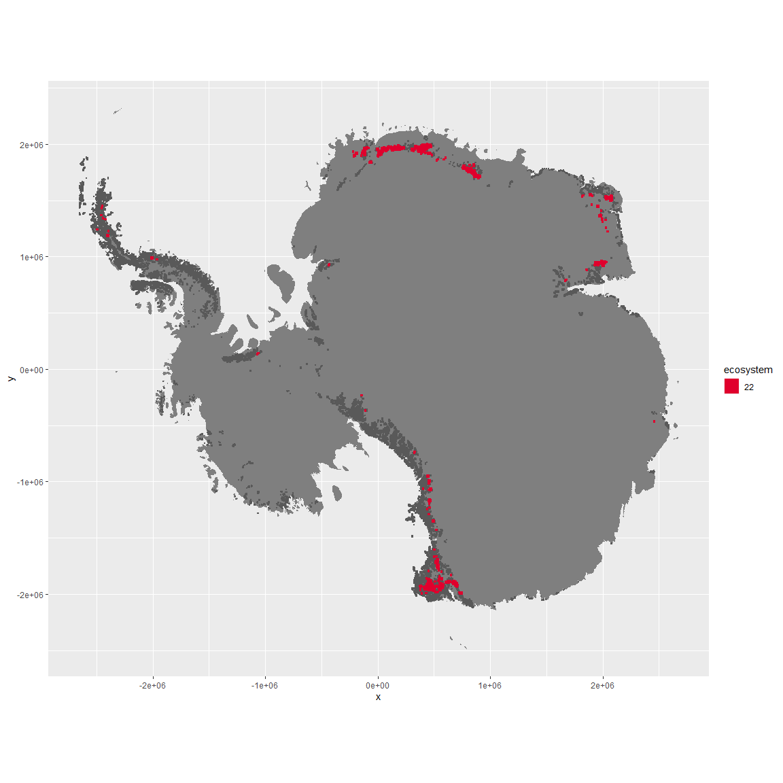

Regional maps

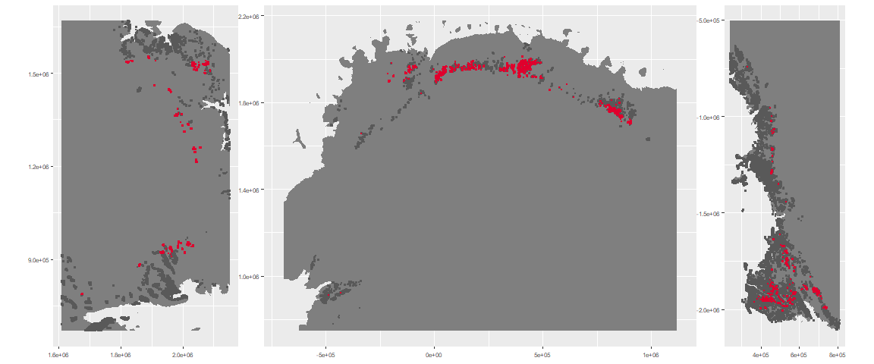

### Environment

The unit env4_sdm5 is part of the environmental supergroup env4.

This supergroup is, on average, substantially higher in wind, elev and rad than continental antarctica. It is substantially lower in rugos, sumtemp, slope, temp and cloud than the rest of the continent.

The elevation of unit env4_sdm5 ranges from 498 to 4645 metres above sea level, but 90% of its pixels fall above 1261 and below 2600 metres. Its average elevation is 1914 metres.

The unit is higher in wind and elev and lower in sumtemp than the rest of its environmental supergroup.

#### Distinctiveness of the unit from its group and the rest of Antarctica

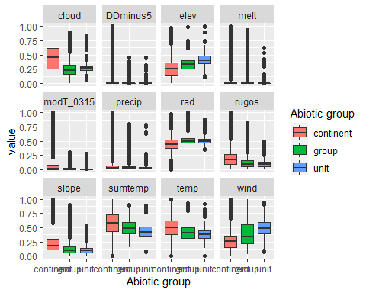

### Biota

Most widespread species in the unit (found in most pixels)

The top most widespread species in ecosystem env4_sdm5

| scientific | Functional_group | phylum | restricted | count | relative_pct |
| --- | --- | --- | --- | --- | --- |
| Cryptopygus sverdrupi | Arthropoda_Entognatha_Entomobryomorpha___ | Arthropoda | TRUE | 1 | 25 |
| Maudheimia wilsoni | Arthropoda_Arachnida_Sarcoptiformes___ | Arthropoda | TRUE | 1 | 25 |
| Nanorchestes antarcticus | Arthropoda_Arachnida_Sarcoptiformes___ | Arthropoda | TRUE | 1 | 25 |
| Umbilicaria decussata | Ascomycota_Lecanoromycetes_Umbilicariales_Umbilicariaceae__ | Ascomycota | FALSE | 1 | 25 |

This supergroup is, on average, substantially higher in suitability for no variables functional groups than continental Antarctica. It is substantially lower in suitability for lichens_Lecanorid, Nematodes, lichens_Parmelid, mosses_Dicranales, mites_Sarcoptiformes, mosses_Pottiales, Springtails_slim, mosses_Bryales, mites_Trombidiformes, mosses_Hypnales_(feather), lichens,_Bacidiacid, mosses_Polytrichales, penguins_Chinstrap, lichens_Cladonid, mites_Mesostigmata, penguins_Gentoo and lichens_Stereocaulid than the rest of the continent.

Unit env4_sdm5 is higher in suitability for no variables and lower in suitability for lichens_Rhizocarpid, mosses_Pottiales, lichens_Physcid_(shadow), lichens_Lecanorid, lichens_Acarosporacid, mites_Sarcoptiformes, mites_Trombidiformes, lichens_Stereocaulid, mites_Mesostigmata, mosses_Hypnales_(feather), mosses_Bryales, mosses_Polytrichales, Springtails_slim, penguins_Gentoo, lichens,_Bacidiacid, Rotifers, penguins_Chinstrap, Nematodes and lichens_Cladonid than the rest of its environmental supergroup.

Distinctiveness of the unit from the environmental group and the rest of Antarctica

