Ecosystem Description

Aniko B. Toth

## Ecosystem Env5_sdm1, Mild-climate arid nunataks

Env5_sdm1, Mild-climate arid nunataks. Occurs mainly along the east coast of the southern peninsula, in the Ellsworth mountains, throughout the Transantarctic mountains, and in North Victoria Land. This unit is a mild version of its group, with lower elev and higher temps than the rest of the group. Sampled fauna consists exclusively of lichens. Unit is separated from its group more by suitability; group has low suitability for all functional groups except Ochrophytes, but the unit has exceptionally high suitability for all lichens except Cladoniaceae and Bacidiaceae (for these latter two conditions are only slightly better than usual); all Arthropoda functional groups, and Pottiales mosses.

### Photos (if available)

### Distribution

Maps - Full map

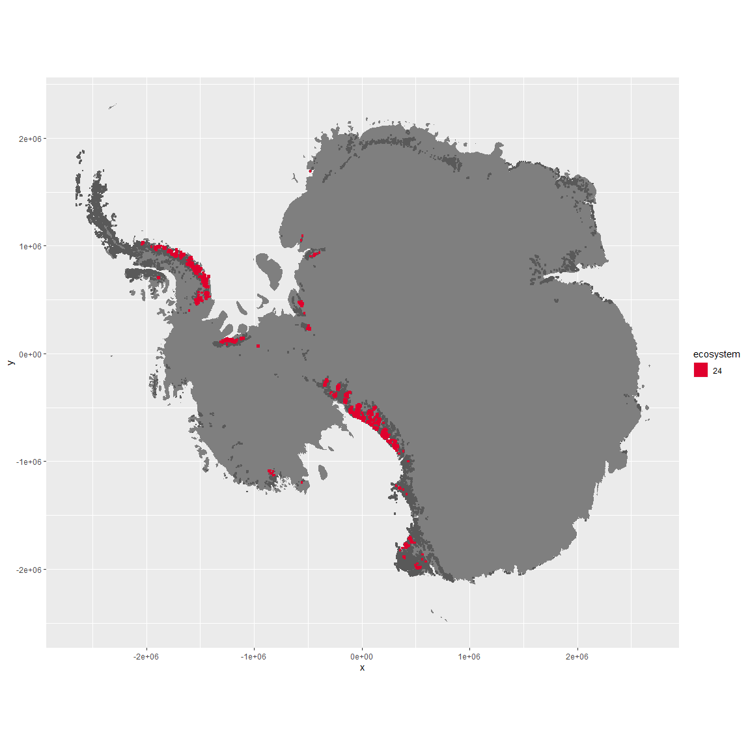

Regional maps



### Environment

The unit env5_sdm1 is part of the environmental supergroup env5.

This supergroup is, on average, substantially higher in elev than continental antarctica. It is substantially lower in modT_0315, rad, precip, temp, sumtemp and wind than the rest of the continent.

The elevation of unit env5_sdm1 ranges from 26 to 3032 metres above sea level, but 90% of its pixels fall above 364 and below 2042 metres. Its average elevation is 1062 metres.

The unit is higher in sumtemp, cloud and temp and lower in elev than the rest of its environmental supergroup.

#### Distinctiveness of the unit from its group and the rest of Antarctica

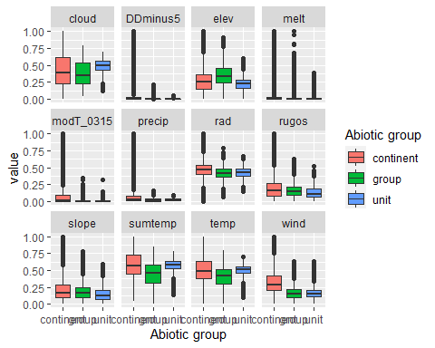

### Biota

Most widespread species in the unit (found in most pixels)

The top most widespread species in ecosystem env5_sdm1

| scientific | Functional_group | phylum | restricted | count | relative_pct |
| --- | --- | --- | --- | --- | --- |
| Lecidea cancriformis | Ascomycota_Lecanoromycetes_Lecanorales_Lecideaceae__ | Ascomycota | TRUE | 11 | 12.7907 |
| Lecidea cf. cancriformis | Ascomycota_Lecanoromycetes_Lecanorales_Lecideaceae__ | Ascomycota | TRUE | 8 | 9.3023 |
| Pseudephebe minuscula | Ascomycota_Lecanoromycetes_Lecanorales_Parmeliaceae__ | Ascomycota | FALSE | 8 | 9.3023 |
| Acarospora gwynnii | Ascomycota_Lecanoromycetes_Acarosporales_Acarosporaceae__ | Ascomycota | TRUE | 6 | 6.9767 |
| Usnea sphacelata | Ascomycota_Lecanoromycetes_Lecanorales_Parmeliaceae__ | Ascomycota | TRUE | 6 | 6.9767 |
| Buellia cf. frigida | Ascomycota_Lecanoromycetes_Teloschistales_Physciaceae__ | Ascomycota | TRUE | 4 | 4.6512 |
| Buellia frigida | Ascomycota_Lecanoromycetes_Teloschistales_Physciaceae__ | Ascomycota | TRUE | 3 | 3.4884 |
| Buellia pallida | Ascomycota_Lecanoromycetes_Teloschistales_Physciaceae__ | Ascomycota | TRUE | 3 | 3.4884 |
| Carbonea vorticosa | Ascomycota_Lecanoromycetes_Lecanorales_Lecanoraceae__ | Ascomycota | FALSE | 3 | 3.4884 |
| Buellia grisea | Ascomycota_Lecanoromycetes_Teloschistales_Physciaceae__ | Ascomycota | FALSE | 2 | 2.3256 |
| Candelariella flava | Ascomycota_Lecanoromycetes_Candelariales_Candelariaceae__ | Ascomycota | TRUE | 2 | 2.3256 |
| Lepraria sp. | Ascomycota_Lecanoromycetes_Lecanorales_Stereocaulaceae__ | Ascomycota | TRUE | 2 | 2.3256 |
| Rhizocarpon sp. | Ascomycota_Lecanoromycetes_Not assigned_Rhizocarpaceae__ | Ascomycota | TRUE | 2 | 2.3256 |
| Rhizoplaca melanophthalma | Ascomycota_Lecanoromycetes_Lecanorales_Lecanoraceae__ | Ascomycota | FALSE | 2 | 2.3256 |
| Umbilicaria decussata | Ascomycota_Lecanoromycetes_Umbilicariales_Umbilicariaceae__ | Ascomycota | FALSE | 2 | 2.3256 |
| Xanthoria cf. mawsonii | Ascomycota_Lecanoromycetes_Teloschistales_Teloschistaceae__ | Ascomycota | TRUE | 2 | 2.3256 |

This supergroup is, on average, substantially higher in suitability for no variables functional groups than continental Antarctica. It is substantially lower in suitability for lichens_Acarosporacid, lichens_Parmelid, mites_Mesostigmata and lichens_Rhizocarpid than the rest of the continent.

Unit env5_sdm1 is higher in suitability for lichens_Candelarid, lichens_Parmelid, mites_Sarcoptiformes, lichens_Rhizocarpid, lichens_Lecanorid, mites_Mesostigmata, lichens_Physcid_(shadow), lichens_Teloschistid, Springtails_slim, lichens_Stereocaulid, mites_Trombidiformes, lichens_Acarosporacid, mosses_Pottiales, Nematodes, Rotifers, mosses_Dicranales, Algae, algae_Green, mosses_Polytrichales, mosses_Hypnales_(feather) and mosses_Bryales and lower in suitability for no variables than the rest of its environmental supergroup.

Distinctiveness of the unit from the environmental group and the rest of Antarctica

