Ecosystem Description

Aniko B. Toth

## Ecosystem Env5_sdm4, Arid highland nunataks

Env5_sdm4, Arid highland nunataks. Occurs throughout the Transantarctic mountains and Victoria land. The main environmental group in the lower outcrops separating the dry valleys near McMurdo, this unit is higher in elev and lower in temp than the rest of its group (though not as high as previous unit). It has especially low cloud cover. Main sampled fauna are Athropods, Nematodes, and Chlorophytes. Suitability terrible for most functional groups except Chlorophyta and Ochrophyta.

### Photos (if available)

### Distribution

Maps - Full map

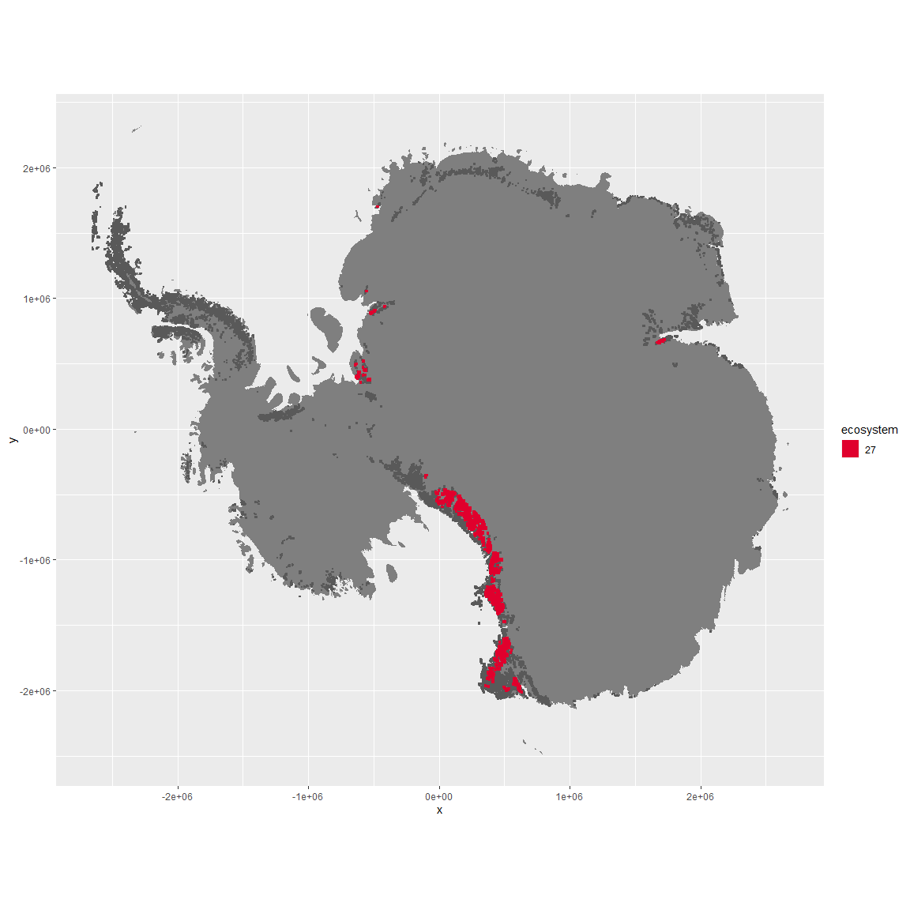

Regional maps

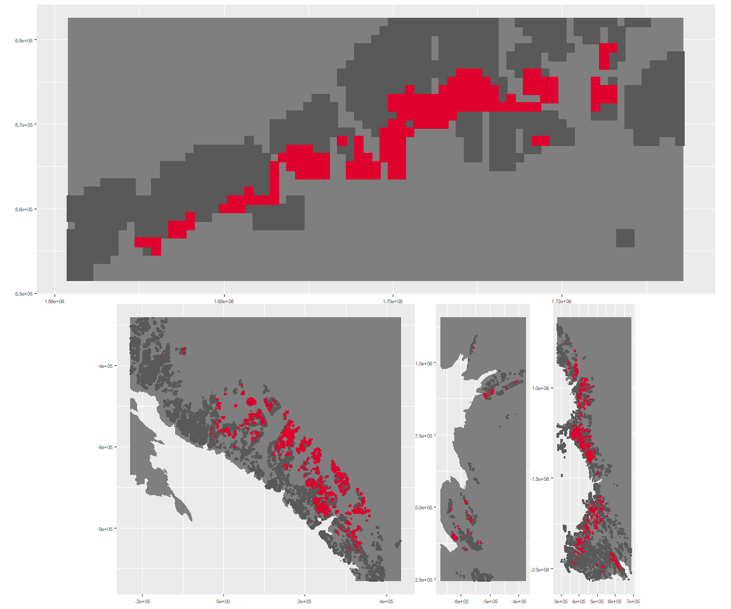

### Environment

The unit env5_sdm4 is part of the environmental supergroup env5.

This supergroup is, on average, substantially higher in elev than continental antarctica. It is substantially lower in modT_0315, rad, precip, temp, sumtemp and wind than the rest of the continent.

The elevation of unit env5_sdm4 ranges from 64 to 4329 metres above sea level, but 90% of its pixels fall above 819 and below 2943 metres. Its average elevation is 1809 metres.

The unit is higher in elev and lower in sumtemp, temp and cloud than the rest of its environmental supergroup.

#### Distinctiveness of the unit from its group and the rest of Antarctica

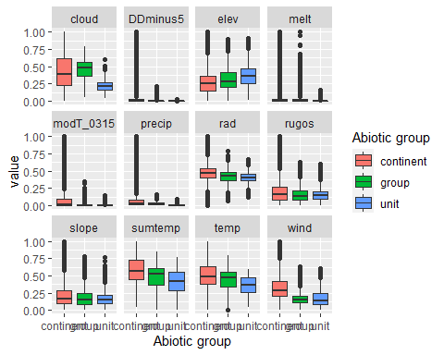

### Biota

Most widespread species in the unit (found in most pixels)

The top most widespread species in ecosystem env5_sdm4

| scientific | Functional_group | phylum | restricted | count | relative_pct |
| --- | --- | --- | --- | --- | --- |
| Gomphiocephalus hodgsoni | Arthropoda_Entognatha_Poduromorpha___ | Arthropoda | TRUE | 5 | 12.1951 |
| Eudorylaimus antarcticus | Nematoda_____ | Nematoda | TRUE | 3 | 7.3171 |
| Prasiola calophylla | Chlorophyta_____ | Chlorophyta | FALSE | 3 | 7.3171 |
| Stereotydeus mollis | Arthropoda_Arachnida_Trombidiformes___ | Arthropoda | TRUE | 3 | 7.3171 |
| Lecidea cancriformis | Ascomycota_Lecanoromycetes_Lecanorales_Lecideaceae__ | Ascomycota | TRUE | 2 | 4.8780 |
| Scottnema lindsayae | Nematoda_____ | Nematoda | TRUE | 2 | 4.8780 |
| Acarospora gwynnii | Ascomycota_Lecanoromycetes_Acarosporales_Acarosporaceae__ | Ascomycota | TRUE | 1 | 2.4390 |
| Adineta grandis | Rotifera_____ | Rotifera | TRUE | 1 | 2.4390 |
| Buellia frigida | Ascomycota_Lecanoromycetes_Teloschistales_Physciaceae__ | Ascomycota | TRUE | 1 | 2.4390 |
| Buellia olivaceobrunnea | Ascomycota_Lecanoromycetes_Teloschistales_Physciaceae__ | Ascomycota | TRUE | 1 | 2.4390 |
| Calothrix braunii | Cyanobacteria_____ | Cyanobacteria | FALSE | 1 | 2.4390 |
| Collotheca ornata | Rotifera_____ | Rotifera | FALSE | 1 | 2.4390 |
| Cylindrocystis brebissonii | Charophyta_____ | Charophyta | FALSE | 1 | 2.4390 |
| Gloeocapsa kuetzingiana | Cyanobacteria_____ | Cyanobacteria | TRUE | 1 | 2.4390 |
| Habrotrocha constricta | Rotifera_____ | Rotifera | TRUE | 1 | 2.4390 |
| Hymenelia glacialis | Ascomycota_Lecanoromycetes_Lecanorales_Hymeneliaceae__ | Ascomycota | TRUE | 1 | 2.4390 |
| Hypsibius arcticus | Tardigrada_____ | Tardigrada | TRUE | 1 | 2.4390 |
| Lecanora fuscobrunnea | Ascomycota_Lecanoromycetes_Lecanorales_Lecanoraceae__ | Ascomycota | TRUE | 1 | 2.4390 |
| Macrotrachela habita | Rotifera_____ | Rotifera | FALSE | 1 | 2.4390 |
| Microcoleus paludosus | Cyanobacteria_____ | Cyanobacteria | FALSE | 1 | 2.4390 |
| Nanorchestes antarcticus | Arthropoda_Arachnida_Sarcoptiformes___ | Arthropoda | TRUE | 1 | 2.4390 |
| Philodina antarctica | Rotifera_____ | Rotifera | TRUE | 1 | 2.4390 |
| Philodina gregaria | Rotifera_____ | Rotifera | TRUE | 1 | 2.4390 |
| Phormidium corium | Cyanobacteria_____ | Cyanobacteria | FALSE | 1 | 2.4390 |
| Phormidium uncinatum | Cyanobacteria_____ | Cyanobacteria | FALSE | 1 | 2.4390 |
| Plectus murrayi | Nematoda_____ | Nematoda | TRUE | 1 | 2.4390 |
| Rinodina sordida | Ascomycota_Lecanoromycetes_Teloschistales_Physciaceae__ | Ascomycota | TRUE | 1 | 2.4390 |
| Sarconeurum glaciale | Bryophyta_Bryopsida_Pottiales___ | Bryophyta | TRUE | 1 | 2.4390 |
| Tetracystis sp. | Chlorophyta_____ | Chlorophyta | TRUE | 1 | 2.4390 |

This supergroup is, on average, substantially higher in suitability for no variables functional groups than continental Antarctica. It is substantially lower in suitability for lichens_Acarosporacid, lichens_Parmelid, mites_Mesostigmata and lichens_Rhizocarpid than the rest of the continent.

Unit env5_sdm4 is higher in suitability for algae_Green and lower in suitability for lichens_Stereocaulid, mosses_Hypnales_(feather), mites_Sarcoptiformes, mosses_Polytrichales, penguins_Gentoo, lichens_Parmelid and mites_Mesostigmata than the rest of its environmental supergroup.

Distinctiveness of the unit from the environmental group and the rest of Antarctica

