Ecosystem Description

Aniko B. Toth

## Ecosystem Env5_sdm5, High snowy mountain slopes

Env5_sdm5, High snowy mountain slopes. Occurs mainly along the east coast of the southern peninsula, in the Ellsworth mountains, throughout the Transantarctic mountains, and throughout Victoria Land. This unit is clearer and colder than the rest of its group, but very similar to 5.3, difference is mainly higher cloud cover on average. Sampled biota mainly Chlorophytes, Cyanobacteria, and lichens. Suitability is low for every group and especially some lichen groups.

### Photos (if available)

### Distribution

Maps - Full map

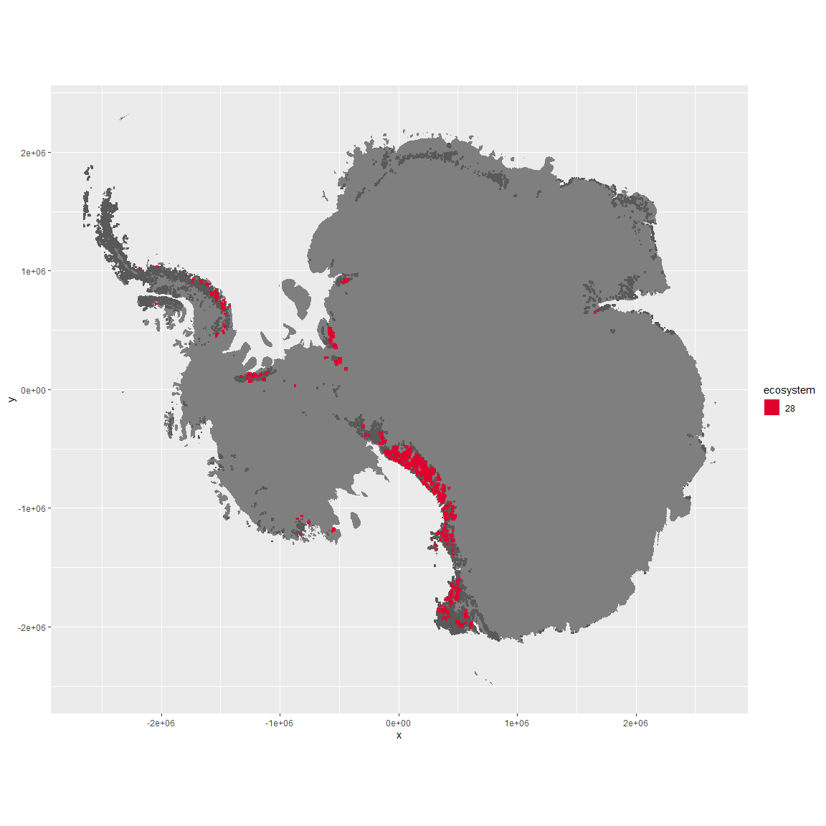

Regional maps

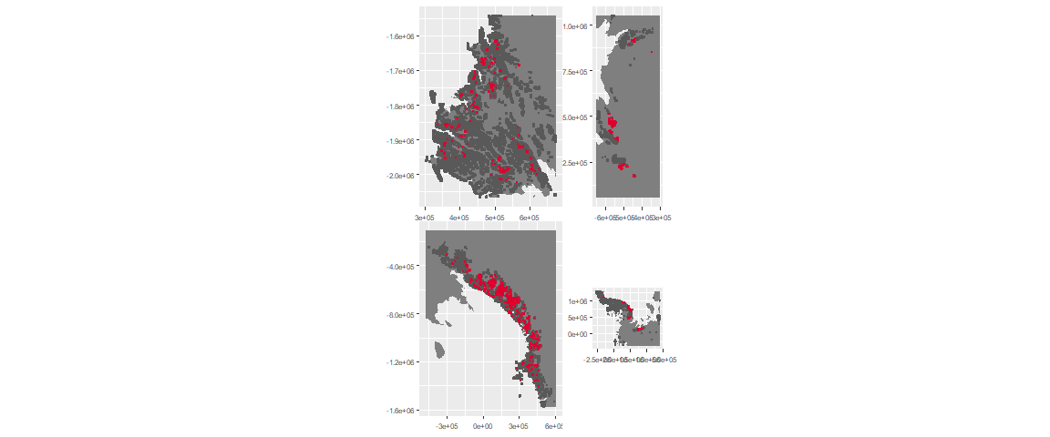

### Environment

The unit env5_sdm5 is part of the environmental supergroup env5.

This supergroup is, on average, substantially higher in elev than continental antarctica. It is substantially lower in modT_0315, rad, precip, temp, sumtemp and wind than the rest of the continent.

The elevation of unit env5_sdm5 ranges from 57 to 4260 metres above sea level, but 90% of its pixels fall above 711 and below 3010 metres. Its average elevation is 1754 metres.

The unit is higher in no variables and lower in sumtemp, temp and cloud than the rest of its environmental supergroup.

#### Distinctiveness of the unit from its group and the rest of Antarctica

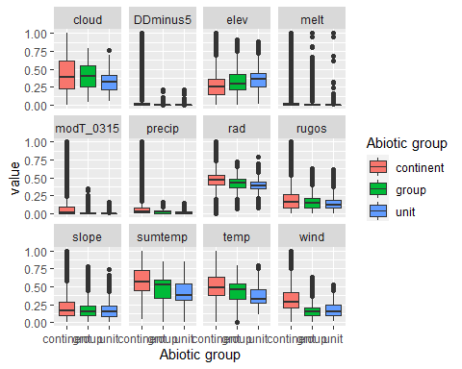

### Biota

Most widespread species in the unit (found in most pixels)

The top most widespread species in ecosystem env5_sdm5

| scientific | Functional_group | phylum | restricted | count | relative_pct |
| --- | --- | --- | --- | --- | --- |
| Desmococcus olivaceus | Chlorophyta_____ | Chlorophyta | FALSE | 4 | 4 |
| Pseudephebe minuscula | Ascomycota_Lecanoromycetes_Lecanorales_Parmeliaceae__ | Ascomycota | FALSE | 4 | 4 |
| Stichococcus bacillaris | Chlorophyta_____ | Chlorophyta | FALSE | 4 | 4 |
| Gloeocapsa punctata | Cyanobacteria_____ | Cyanobacteria | TRUE | 3 | 3 |
| Gloeocapsa ralfsiana | Cyanobacteria_____ | Cyanobacteria | TRUE | 3 | 3 |
| Omphalodiscus bakeri | Ascomycota_Unknown_Unknown_Unknown__ | Ascomycota | TRUE | 3 | 3 |
| Physcia caesia | Ascomycota_Lecanoromycetes_Teloschistales_Physciaceae__ | Ascomycota | FALSE | 3 | 3 |
| Umbilicaria decussata | Ascomycota_Lecanoromycetes_Umbilicariales_Umbilicariaceae__ | Ascomycota | FALSE | 3 | 3 |
| Usnea sphacelata | Ascomycota_Lecanoromycetes_Lecanorales_Parmeliaceae__ | Ascomycota | TRUE | 3 | 3 |
| Acarospora gwynnii | Ascomycota_Lecanoromycetes_Acarosporales_Acarosporaceae__ | Ascomycota | TRUE | 2 | 2 |
| Buellia frigida | Ascomycota_Lecanoromycetes_Teloschistales_Physciaceae__ | Ascomycota | TRUE | 2 | 2 |
| Buellia pernigra | Ascomycota_Lecanoromycetes_Teloschistales_Physciaceae__ | Ascomycota | TRUE | 2 | 2 |
| Calothrix parietina | Cyanobacteria_____ | Cyanobacteria | FALSE | 2 | 2 |
| Candelariella flava | Ascomycota_Lecanoromycetes_Candelariales_Candelariaceae__ | Ascomycota | TRUE | 2 | 2 |
| Gloeocapsa alpina | Cyanobacteria_____ | Cyanobacteria | FALSE | 2 | 2 |
| Gloeocapsa kuetzingiana | Cyanobacteria_____ | Cyanobacteria | TRUE | 2 | 2 |
| Gomphiocephalus hodgsoni | Arthropoda_Entognatha_Poduromorpha___ | Arthropoda | TRUE | 2 | 2 |
| Huea smaragdula | Ascomycota_Lecanoromycetes_Teloschistales_Teloschistaceae__ | Ascomycota | TRUE | 2 | 2 |
| Lecidea cancriformis | Ascomycota_Lecanoromycetes_Lecanorales_Lecideaceae__ | Ascomycota | TRUE | 2 | 2 |
| Pseudococcomyxa simplex | Chlorophyta_____ | Chlorophyta | TRUE | 2 | 2 |
| Rinodina olivaceobrunnea | Ascomycota_Lecanoromycetes_Teloschistales_Physciaceae__ | Ascomycota | FALSE | 2 | 2 |
| Schistidium antarctici | Bryophyta_Bryopsida_Grimmiales___ | Bryophyta | TRUE | 2 | 2 |
| Umbilicaria cristata | Ascomycota_Lecanoromycetes_Umbilicariales_Umbilicariaceae__ | Ascomycota | TRUE | 2 | 2 |
| Usnea antarctica | Ascomycota_Lecanoromycetes_Lecanorales_Parmeliaceae__ | Ascomycota | FALSE | 2 | 2 |

This supergroup is, on average, substantially higher in suitability for no variables functional groups than continental Antarctica. It is substantially lower in suitability for lichens_Acarosporacid, lichens_Parmelid, mites_Mesostigmata and lichens_Rhizocarpid than the rest of the continent.

Unit env5_sdm5 is higher in suitability for no variables and lower in suitability for Algae, mites_Mesostigmata, mites_Trombidiformes, mosses_Bryales, Nematodes, lichens,*Bacidiacid, mosses_Polytrichales, lichens_Cladonid, lichens_Candelarid, mosses_Hypnales*(feather), algae_Green, Springtails_slim, mosses_Dicranales, mosses_Pottiales, penguins_Chinstrap, penguins_Gentoo, lichens_Rhizocarpid, lichens_Teloschistid, lichens_Physcid_(shadow), mites_Sarcoptiformes, lichens_Lecanorid, lichens_Stereocaulid, lichens_Parmelid and lichens_Acarosporacid than the rest of its environmental supergroup.

Distinctiveness of the unit from the environmental group and the rest of Antarctica

