Ecosystem Description

Aniko B. Toth

## Ecosystem Env6_sdm1 Islands1

Env6_sdm1 Islands1. Occurs mainly on James Ross island, with a scattering of occurrences in other ACBRs. This unit’s most sampled biota are adelie penguins and Bryum pseudotriquetum (moss). Ochrophytes are also well-represented. Several Ochrophyte and Athropod species seem to prefer this unit over all others. Suitability is high for all functional groups in this environmental group, but this unit is especially suitable for Rotifers, Ochrophytes, and several Lichen groups (Acarosporaceae and Physcidaceae most pronounced).

### Photos (if available)

### Distribution

Maps - Full map

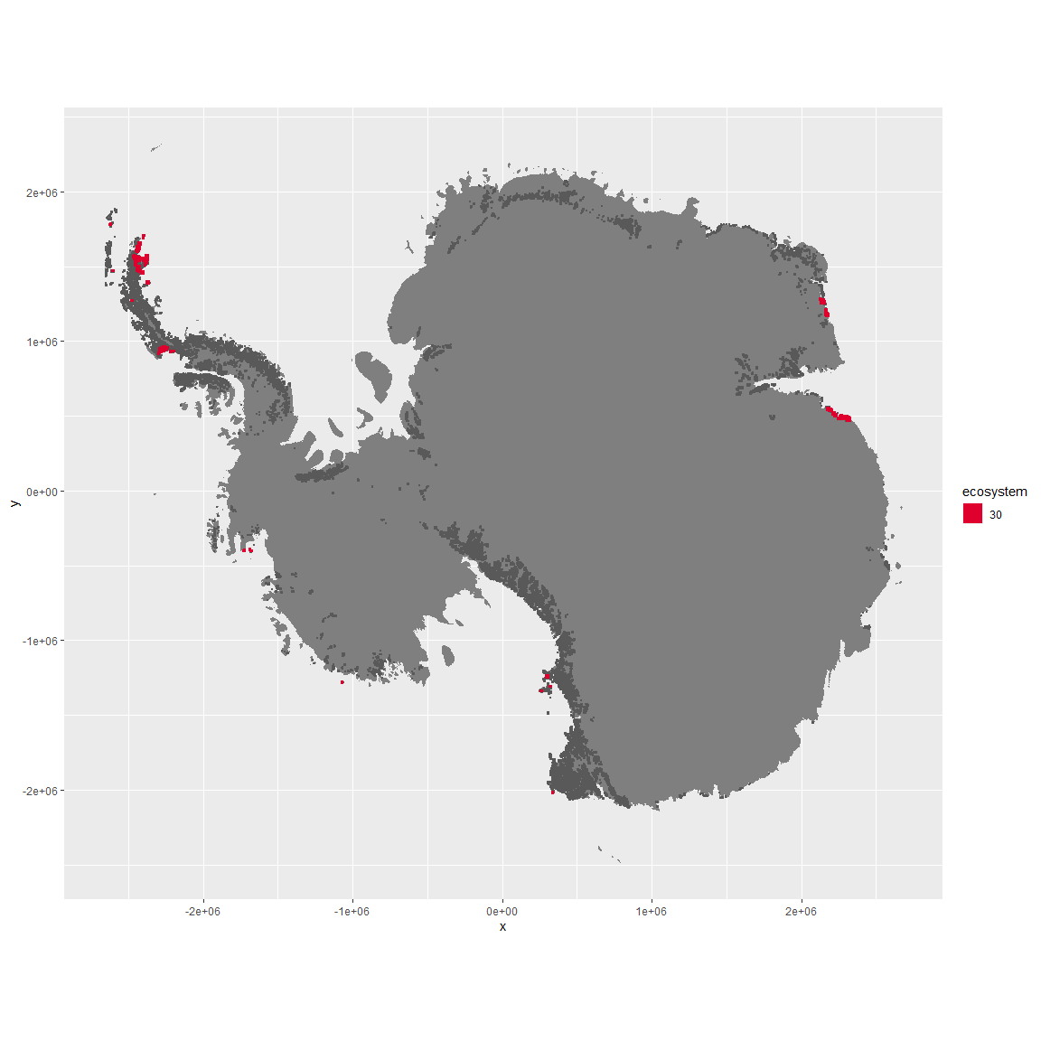

Regional maps

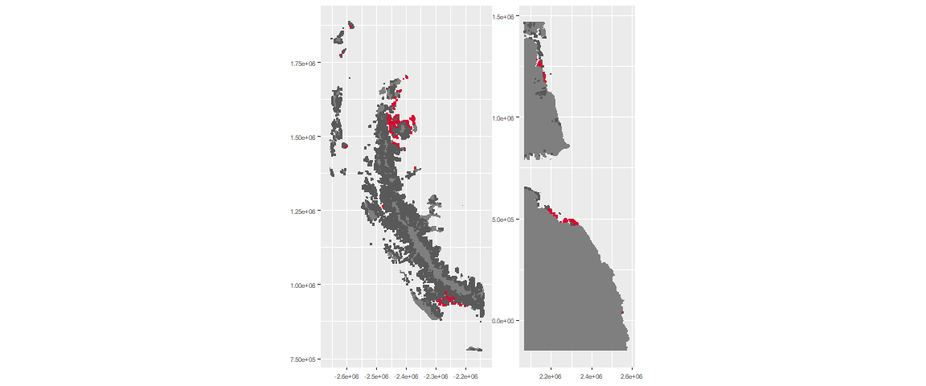

### Environment

The unit env6_sdm1 is part of the environmental supergroup env6.

This supergroup is, on average, substantially higher in NA, NA, NA, NA, NA, NA, NA, NA, NA, NA, NA and NA than continental antarctica. It is substantially lower in NA, NA, NA, NA, NA, NA, NA, NA, NA, NA, NA and NA than the rest of the continent.

The elevation of unit env6_sdm1 ranges from 0 to 792 metres above sea level, but 90% of its pixels fall above 0 and below 302 metres. Its average elevation is 40 metres.

The unit is higher in NA, NA, NA, NA, NA, NA, NA, NA, NA, NA, NA and NA and lower in NA, NA, NA, NA, NA, NA, NA, NA, NA, NA, NA and NA than the rest of its environmental supergroup.

#### Distinctiveness of the unit from its group and the rest of Antarctica

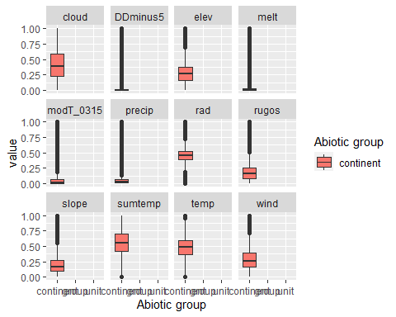

### Biota

Most widespread species in the unit (found in most pixels)

The top most widespread species in ecosystem env6_sdm1

| scientific | Functional_group | phylum | restricted | count | relative_pct |
| --- | --- | --- | --- | --- | --- |
| Pygoscelis adeliae | Chordata_Aves_Sphenisciformes_Spheniscidae_Pygoscelis_adeliae | Chordata | FALSE | 32 | 3.3438 |
| Bryum pseudotriquetrum | Bryophyta_Bryopsida_Bryales___ | Bryophyta | FALSE | 19 | 1.9854 |
| Umbilicaria decussata | Ascomycota_Lecanoromycetes_Umbilicariales_Umbilicariaceae__ | Ascomycota | FALSE | 16 | 1.6719 |
| Buellia frigida | Ascomycota_Lecanoromycetes_Teloschistales_Physciaceae__ | Ascomycota | TRUE | 12 | 1.2539 |
| Caloplaca citrina | Ascomycota_Lecanoromycetes_Teloschistales_Teloschistaceae__ | Ascomycota | TRUE | 12 | 1.2539 |
| Fragilaria sp. | Ochrophyta_____ | Ochrophyta | TRUE | 12 | 1.2539 |
| Navicula salinarum | Ochrophyta_____ | Ochrophyta | FALSE | 12 | 1.2539 |
| Pinnularia microstauron | Ochrophyta_____ | Ochrophyta | FALSE | 12 | 1.2539 |
| Xanthoria elegans | Ascomycota_Lecanoromycetes_Teloschistales_Teloschistaceae__ | Ascomycota | FALSE | 12 | 1.2539 |
| Chaetoceros sp. | Ochrophyta_____ | Ochrophyta | TRUE | 11 | 1.1494 |
| Navicula directa | Ochrophyta_____ | Ochrophyta | FALSE | 11 | 1.1494 |
| Physcia caesia | Ascomycota_Lecanoromycetes_Teloschistales_Physciaceae__ | Ascomycota | FALSE | 11 | 1.1494 |
| Rhizoplaca melanophthalma | Ascomycota_Lecanoromycetes_Lecanorales_Lecanoraceae__ | Ascomycota | FALSE | 11 | 1.1494 |

This supergroup is, on average, substantially higher in suitability for mites_Mesostigmata, lichens_Rhizocarpid, penguins_Gentoo, lichens_Parmelid, mites_Sarcoptiformes, penguins_Chinstrap, Springtails_slim, mosses_Pottiales, mosses_Polytrichales, mosses_Dicranales, mites_Trombidiformes, mosses_Hypnales_(feather), algae_Green, Nematodes, lichens_Physcid_(shadow), lichens_Acarosporacid, lichens_Teloschistid, lichens_Stereocaulid, lichens_Candelarid, lichens_Lecanorid, lichens_Cladonid, mosses_Bryales, lichens,_Bacidiacid, Algae and Rotifers functional groups than continental Antarctica. It is substantially lower in suitability for no variables than the rest of the continent.

Unit env6_sdm1 is higher in suitability for Rotifers, Algae, lichens_Acarosporacid, lichens_Lecanorid, lichens_Physcid_(shadow), lichens_Candelarid and lichens_Teloschistid and lower in suitability for no variables than the rest of its environmental supergroup.

Distinctiveness of the unit from the environmental group and the rest of Antarctica

