Ecosystem Description

Aniko B. Toth

## Ecosystem Env6_sdm4 Coastal/Island tundra

Env6_sdm4 Coastal/Island tundra. Occurs primarily on the western coast of the north peninsula, and sampling is dominated by penguins (Adelie, gentoo, and chinstrap). Imperial shag and southern giant petrel also present in good numbers. Hair grass and several Arthopod species are also abundant. This is the most popular ecosystem for the imperial shag and many arthropod species. Suitability is low for Ochrophytes and Rotifers but high for basically everything else, especially Mesostigmatid mites and Gentoo penguins.

### Photos (if available)

### Distribution

Maps - Full map

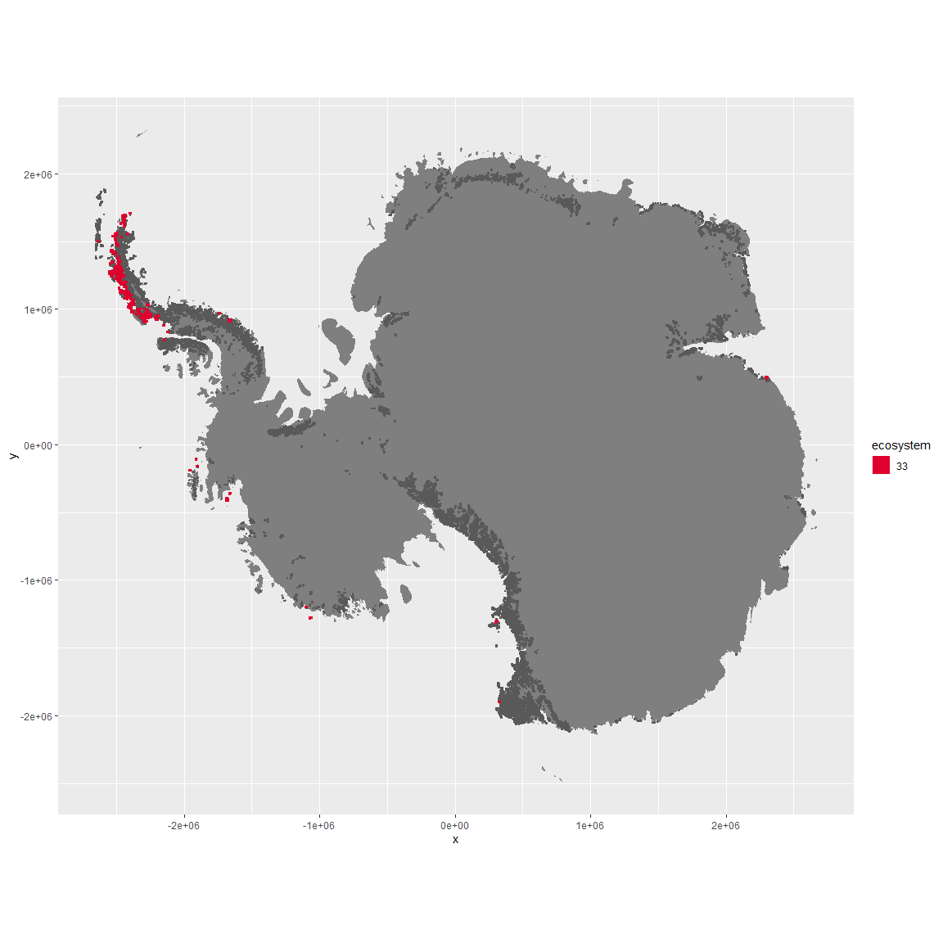

Regional maps

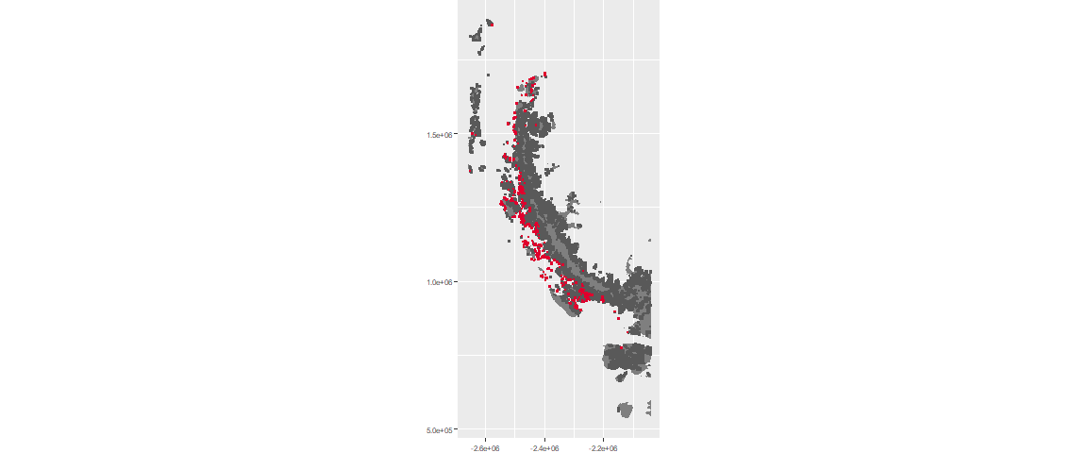

### Environment

The unit env6_sdm4 is part of the environmental supergroup env6.

This supergroup is, on average, substantially higher in NA, NA, NA, NA, NA, NA, NA, NA, NA, NA, NA and NA than continental antarctica. It is substantially lower in NA, NA, NA, NA, NA, NA, NA, NA, NA, NA, NA and NA than the rest of the continent.

The elevation of unit env6_sdm4 ranges from 0 to 742 metres above sea level, but 90% of its pixels fall above 0 and below 163 metres. Its average elevation is 21 metres.

The unit is higher in NA, NA, NA, NA, NA, NA, NA, NA, NA, NA, NA and NA and lower in NA, NA, NA, NA, NA, NA, NA, NA, NA, NA, NA and NA than the rest of its environmental supergroup.

#### Distinctiveness of the unit from its group and the rest of Antarctica

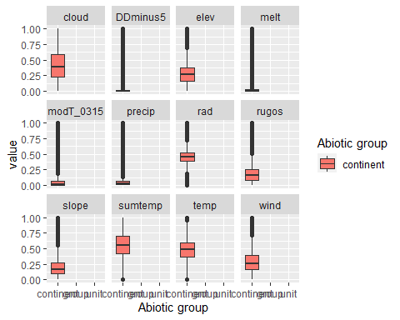

### Biota

Most widespread species in the unit (found in most pixels)

The top most widespread species in ecosystem env6_sdm4

| scientific | Functional_group | phylum | restricted | count | relative_pct |
| --- | --- | --- | --- | --- | --- |
| Pygoscelis adeliae | Chordata_Aves_Sphenisciformes_Spheniscidae_Pygoscelis_adeliae | Chordata | FALSE | 38 | 3.7291 |
| Pygoscelis antarctica | Chordata_Aves_Sphenisciformes_Spheniscidae_Pygoscelis_antarctica | Chordata | TRUE | 27 | 2.6497 |
| Pygoscelis papua | Chordata_Aves_Sphenisciformes_Spheniscidae_Pygoscelis_papua | Chordata | FALSE | 26 | 2.5515 |
| Friesea grisea | Arthropoda_Entognatha_Poduromorpha___ | Arthropoda | FALSE | 25 | 2.4534 |
| Cryptopygus antarcticus | Arthropoda_Entognatha_Entomobryomorpha___ | Arthropoda | TRUE | 24 | 2.3553 |
| Halozetes belgicae | Arthropoda_Arachnida_Sarcoptiformes___ | Arthropoda | TRUE | 21 | 2.0608 |
| Alaskozetes antarcticus | Arthropoda_Arachnida_Sarcoptiformes___ | Arthropoda | TRUE | 19 | 1.8646 |
| Leucocarbo atriceps | Chordata_Aves_Suliformes___ | Chordata | FALSE | 16 | 1.5702 |
| Rhagidia gerlachei | Arthropoda_Arachnida_Trombidiformes___ | Arthropoda | TRUE | 16 | 1.5702 |
| Usnea antarctica | Ascomycota_Lecanoromycetes_Lecanorales_Parmeliaceae__ | Ascomycota | FALSE | 16 | 1.5702 |

This supergroup is, on average, substantially higher in suitability for mites_Mesostigmata, lichens_Rhizocarpid, penguins_Gentoo, lichens_Parmelid, mites_Sarcoptiformes, penguins_Chinstrap, Springtails_slim, mosses_Pottiales, mosses_Polytrichales, mosses_Dicranales, mites_Trombidiformes, mosses_Hypnales_(feather), algae_Green, Nematodes, lichens_Physcid_(shadow), lichens_Acarosporacid, lichens_Teloschistid, lichens_Stereocaulid, lichens_Candelarid, lichens_Lecanorid, lichens_Cladonid, mosses_Bryales, lichens,_Bacidiacid, Algae and Rotifers functional groups than continental Antarctica. It is substantially lower in suitability for no variables than the rest of the continent.

Unit env6_sdm4 is higher in suitability for no variables and lower in suitability for mosses_Dicranales, mosses_Pottiales, lichens_Stereocaulid, Nematodes, lichens_Candelarid, lichens_Physcid_(shadow), algae_Green, lichens_Lecanorid, lichens_Teloschistid, lichens_Acarosporacid, Rotifers and Algae than the rest of its environmental supergroup.

Distinctiveness of the unit from the environmental group and the rest of Antarctica

