Ecosystem Description

Aniko B. Toth

## Ecosystem Env6_sdm5 Islands

Env6_sdm5 Islands. Occurs mainly on the coast of Enderby land, with a scattering of pixels on the north peninsula. Sampled biota mainly mosses and some common lichens, good representation of Adelies, southern giant petrels, snow petrels, wilsons storm petrels, and antarctic petrels, being the most preferred habitat for the latter three. Several Buellia (lichen) species also prefer this habitat, along with a chlorophyte and two tardigrade species. Suitability is relatively highest for Chlorophyta and Dicranales mosses, and also good for Rotifers.

### Photos (if available)

### Distribution

Maps - Full map

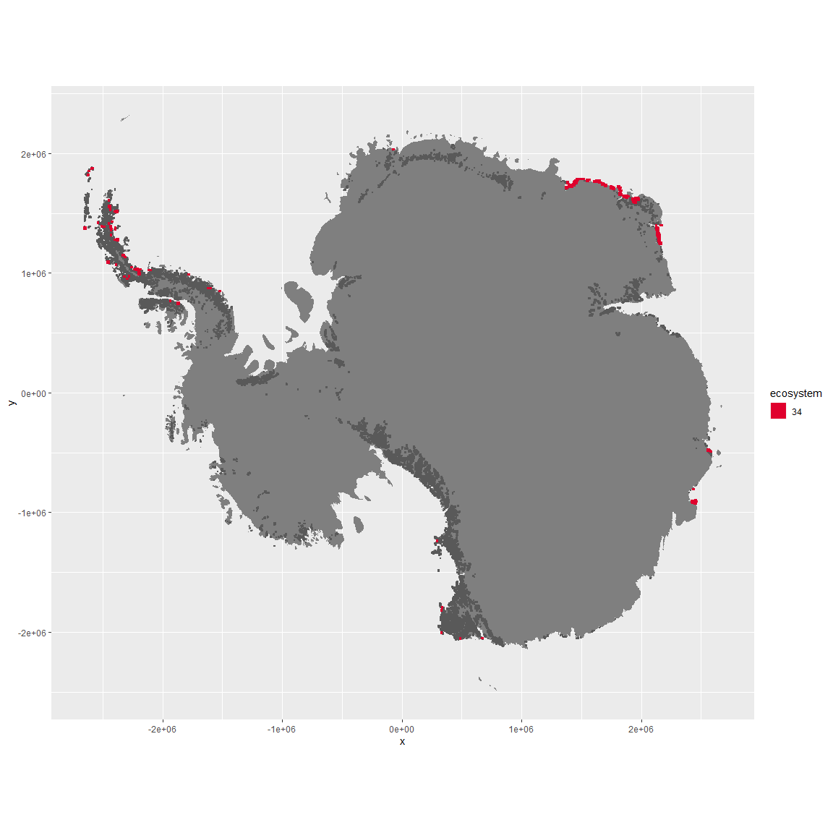

Regional maps

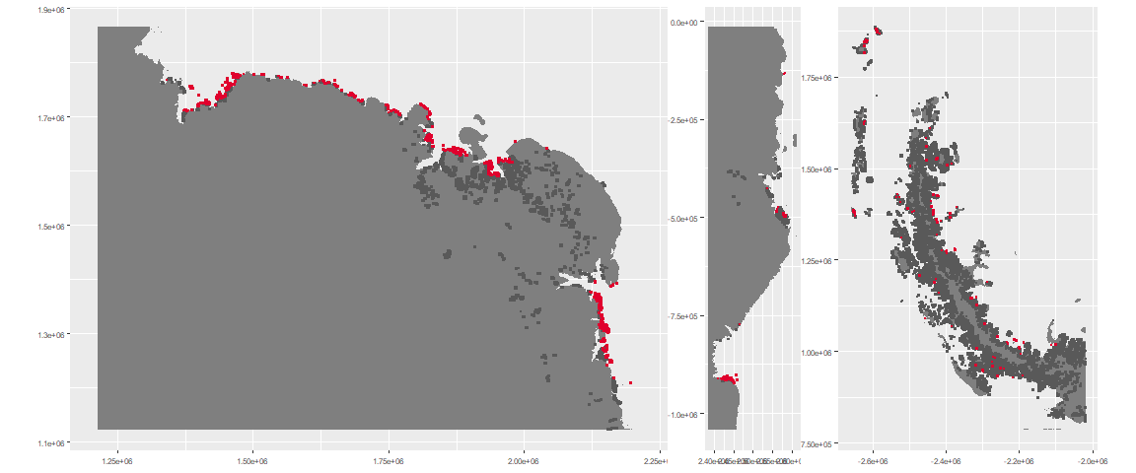

### Environment

The unit env6_sdm5 is part of the environmental supergroup env6.

This supergroup is, on average, substantially higher in NA, NA, NA, NA, NA, NA, NA, NA, NA, NA, NA and NA than continental antarctica. It is substantially lower in NA, NA, NA, NA, NA, NA, NA, NA, NA, NA, NA and NA than the rest of the continent.

The elevation of unit env6_sdm5 ranges from 0 to 2301 metres above sea level, but 90% of its pixels fall above 0 and below 327 metres. Its average elevation is 67 metres.

The unit is higher in NA, NA, NA, NA, NA, NA, NA, NA, NA, NA, NA and NA and lower in NA, NA, NA, NA, NA, NA, NA, NA, NA, NA, NA and NA than the rest of its environmental supergroup.

#### Distinctiveness of the unit from its group and the rest of Antarctica

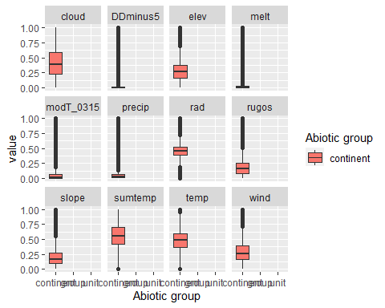

### Biota

Most widespread species in the unit (found in most pixels)

The top most widespread species in ecosystem env6_sdm5

| scientific | Functional_group | phylum | restricted | count | relative_pct |
| --- | --- | --- | --- | --- | --- |
| Ceratodon purpureus | Bryophyta_Bryopsida_Dicranales___ | Bryophyta | FALSE | 44 | 3.9604 |
| Bryum pseudotriquetrum | Bryophyta_Bryopsida_Bryales___ | Bryophyta | FALSE | 40 | 3.6004 |
| Pygoscelis adeliae | Chordata_Aves_Sphenisciformes_Spheniscidae_Pygoscelis_adeliae | Chordata | FALSE | 27 | 2.4302 |
| Umbilicaria decussata | Ascomycota_Lecanoromycetes_Umbilicariales_Umbilicariaceae__ | Ascomycota | FALSE | 19 | 1.7102 |
| Buellia frigida | Ascomycota_Lecanoromycetes_Teloschistales_Physciaceae__ | Ascomycota | TRUE | 17 | 1.5302 |
| Candelariella flava | Ascomycota_Lecanoromycetes_Candelariales_Candelariaceae__ | Ascomycota | TRUE | 17 | 1.5302 |
| Rhizoplaca melanophthalma | Ascomycota_Lecanoromycetes_Lecanorales_Lecanoraceae__ | Ascomycota | FALSE | 16 | 1.4401 |
| Rinodina olivaceobrunnea | Ascomycota_Lecanoromycetes_Teloschistales_Physciaceae__ | Ascomycota | FALSE | 15 | 1.3501 |
| Usnea antarctica | Ascomycota_Lecanoromycetes_Lecanorales_Parmeliaceae__ | Ascomycota | FALSE | 15 | 1.3501 |
| Caloplaca athallina | Ascomycota_Lecanoromycetes_Teloschistales_Teloschistaceae__ | Ascomycota | TRUE | 13 | 1.1701 |
| Pseudephebe minuscula | Ascomycota_Lecanoromycetes_Lecanorales_Parmeliaceae__ | Ascomycota | FALSE | 13 | 1.1701 |
| Xanthoria elegans | Ascomycota_Lecanoromycetes_Teloschistales_Teloschistaceae__ | Ascomycota | FALSE | 13 | 1.1701 |

This supergroup is, on average, substantially higher in suitability for mites_Mesostigmata, lichens_Rhizocarpid, penguins_Gentoo, lichens_Parmelid, mites_Sarcoptiformes, penguins_Chinstrap, Springtails_slim, mosses_Pottiales, mosses_Polytrichales, mosses_Dicranales, mites_Trombidiformes, mosses_Hypnales_(feather), algae_Green, Nematodes, lichens_Physcid_(shadow), lichens_Acarosporacid, lichens_Teloschistid, lichens_Stereocaulid, lichens_Candelarid, lichens_Lecanorid, lichens_Cladonid, mosses_Bryales, lichens,_Bacidiacid, Algae and Rotifers functional groups than continental Antarctica. It is substantially lower in suitability for no variables than the rest of the continent.

Unit env6_sdm5 is higher in suitability for Rotifers, Algae and mosses_Dicranales and lower in suitability for no variables than the rest of its environmental supergroup.

Distinctiveness of the unit from the environmental group and the rest of Antarctica

