Ecosystem Description

Aniko B. Toth

## Ecosystem Env6_sdm6 Islands

Env6_sdm6 Islands. Occurs mainly on the west coast of the north peninsula. Adelie, SP skua, Cape petrel, southern fulmar, chinstrap and gentoo pengins dominate along with a variety of moss species. Suitability low for ochrophytes and rotifers but high for everything else.

### Photos (if available)

### Distribution

Maps - Full map

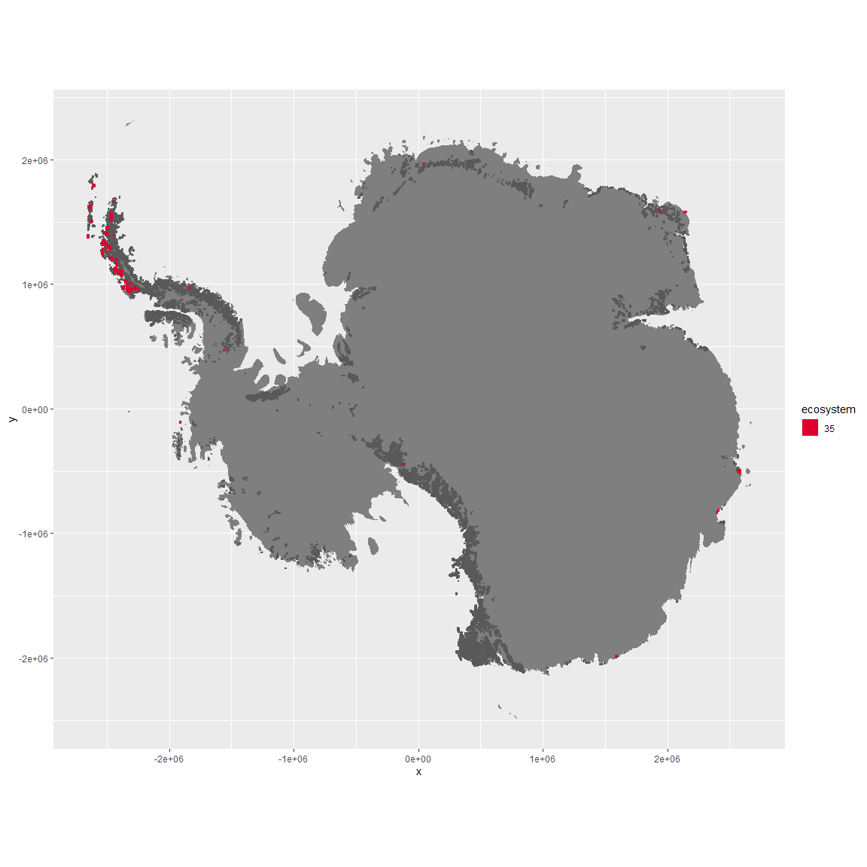

Regional maps

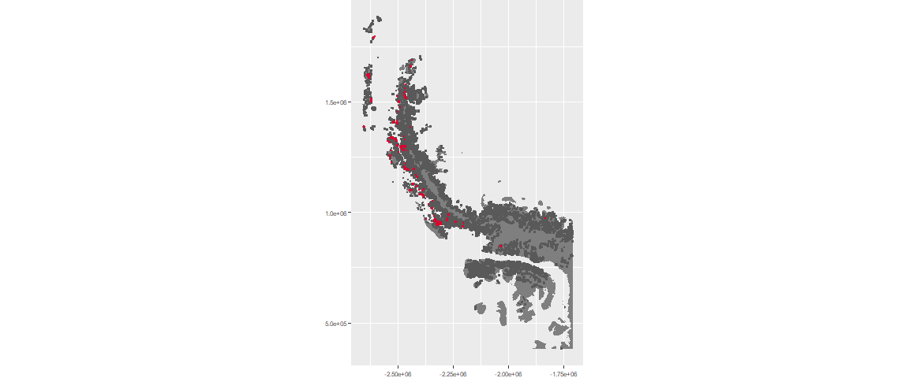

### Environment

The unit env6_sdm6 is part of the environmental supergroup env6.

This supergroup is, on average, substantially higher in NA, NA, NA, NA, NA, NA, NA, NA, NA, NA, NA and NA than continental antarctica. It is substantially lower in NA, NA, NA, NA, NA, NA, NA, NA, NA, NA, NA and NA than the rest of the continent.

The elevation of unit env6_sdm6 ranges from 0 to 2930 metres above sea level, but 90% of its pixels fall above 0 and below 669 metres. Its average elevation is 171 metres.

The unit is higher in NA, NA, NA, NA, NA, NA, NA, NA, NA, NA, NA and NA and lower in NA, NA, NA, NA, NA, NA, NA, NA, NA, NA, NA and NA than the rest of its environmental supergroup.

#### Distinctiveness of the unit from its group and the rest of Antarctica

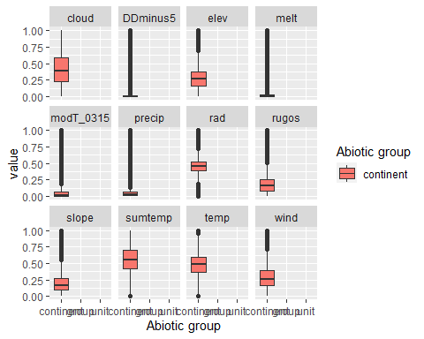

### Biota

Most widespread species in the unit (found in most pixels)

The top most widespread species in ecosystem env6_sdm6

| scientific | Functional_group | phylum | restricted | count | relative_pct |
| --- | --- | --- | --- | --- | --- |
| Pygoscelis adeliae | Chordata_Aves_Sphenisciformes_Spheniscidae_Pygoscelis_adeliae | Chordata | FALSE | 10 | 3.4247 |
| Pygoscelis antarctica | Chordata_Aves_Sphenisciformes_Spheniscidae_Pygoscelis_antarctica | Chordata | TRUE | 7 | 2.3973 |
| Sanionia uncinata | Bryophyta_Bryopsida_Hypnales___ | Bryophyta | FALSE | 7 | 2.3973 |
| Syntrichia princeps | Bryophyta_Bryopsida_Pottiales___ | Bryophyta | FALSE | 7 | 2.3973 |
| Cryptopygus antarcticus | Arthropoda_Entognatha_Entomobryomorpha___ | Arthropoda | TRUE | 6 | 2.0548 |
| Pohlia nutans | Bryophyta_Bryopsida_Bryales___ | Bryophyta | FALSE | 6 | 2.0548 |
| Polytrichastrum alpinum | Bryophyta_Bryopsida_Polytrichales___ | Bryophyta | FALSE | 6 | 2.0548 |
| Pygoscelis papua | Chordata_Aves_Sphenisciformes_Spheniscidae_Pygoscelis_papua | Chordata | FALSE | 5 | 1.7123 |
| Usnea antarctica | Ascomycota_Lecanoromycetes_Lecanorales_Parmeliaceae__ | Ascomycota | FALSE | 5 | 1.7123 |
| Friesea grisea | Arthropoda_Entognatha_Poduromorpha___ | Arthropoda | FALSE | 4 | 1.3699 |
| Leucocarbo atriceps | Chordata_Aves_Suliformes___ | Chordata | FALSE | 4 | 1.3699 |
| Oppia loxolineata | Arthropoda_Arachnida_Sarcoptiformes___ | Arthropoda | TRUE | 4 | 1.3699 |
| Rhagidia gerlachei | Arthropoda_Arachnida_Trombidiformes___ | Arthropoda | TRUE | 4 | 1.3699 |

This supergroup is, on average, substantially higher in suitability for mites_Mesostigmata, lichens_Rhizocarpid, penguins_Gentoo, lichens_Parmelid, mites_Sarcoptiformes, penguins_Chinstrap, Springtails_slim, mosses_Pottiales, mosses_Polytrichales, mosses_Dicranales, mites_Trombidiformes, mosses_Hypnales_(feather), algae_Green, Nematodes, lichens_Physcid_(shadow), lichens_Acarosporacid, lichens_Teloschistid, lichens_Stereocaulid, lichens_Candelarid, lichens_Lecanorid, lichens_Cladonid, mosses_Bryales, lichens,_Bacidiacid, Algae and Rotifers functional groups than continental Antarctica. It is substantially lower in suitability for no variables than the rest of the continent.

Unit env6_sdm6 is higher in suitability for no variables and lower in suitability for lichens_Acarosporacid, lichens_Teloschistid, lichens_Physcid_(shadow), lichens_Candelarid, lichens_Lecanorid, Rotifers and Algae than the rest of its environmental supergroup.

Distinctiveness of the unit from the environmental group and the rest of Antarctica

