Ecosystem Description

Aniko B. Toth

## Ecosystem Env6_sdm7 Outlying coastal islands

Env6_sdm7 Outlying coastal islands. Occurs mainly on the north peninsula and in Adelie land; may be slightly more isolated from mainland than other units in the group. Pengins are most commonly sampled but several other bird species make an appearance. It is not the favourite of any species. Several mosses and a common lichen group dominate the sampled flora. Low suitability for rotifers but high for everything else, particularly ochrophytes, chlorophytes, and Chinstrap penguins.

### Photos (if available)

### Distribution

Maps - Full map

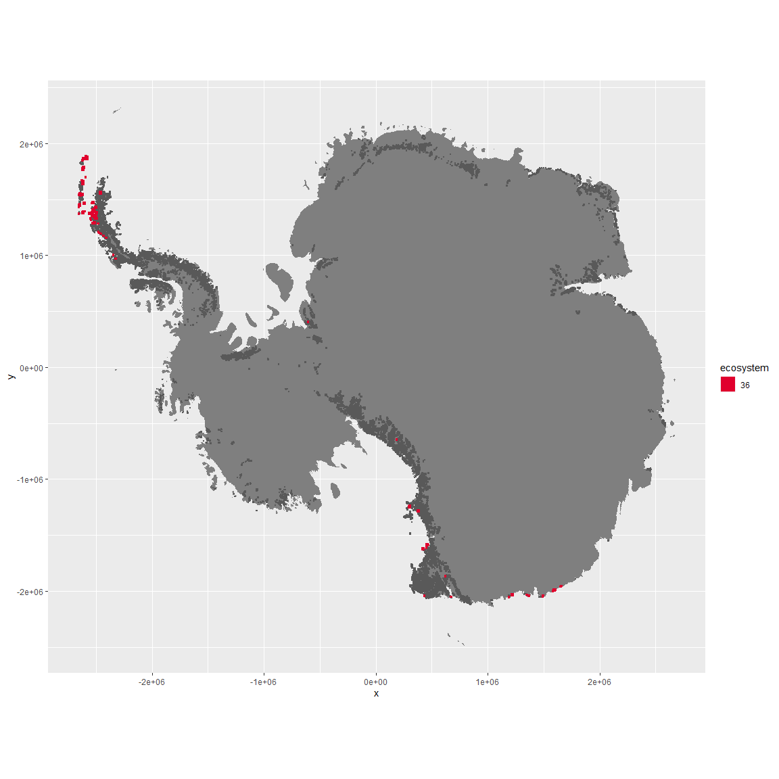

Regional maps

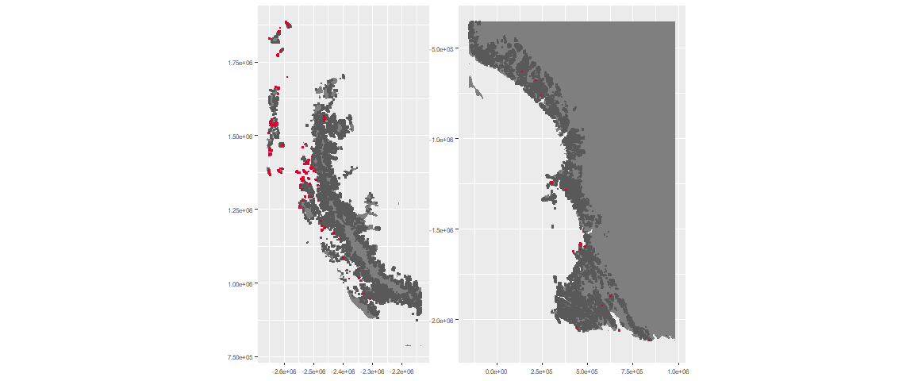

### Environment

The unit env6_sdm7 is part of the environmental supergroup env6.

This supergroup is, on average, substantially higher in NA, NA, NA, NA, NA, NA, NA, NA, NA, NA, NA and NA than continental antarctica. It is substantially lower in NA, NA, NA, NA, NA, NA, NA, NA, NA, NA, NA and NA than the rest of the continent.

The elevation of unit env6_sdm7 ranges from 0 to 2869 metres above sea level, but 90% of its pixels fall above 0 and below 781 metres. Its average elevation is 121 metres.

The unit is higher in NA, NA, NA, NA, NA, NA, NA, NA, NA, NA, NA and NA and lower in NA, NA, NA, NA, NA, NA, NA, NA, NA, NA, NA and NA than the rest of its environmental supergroup.

#### Distinctiveness of the unit from its group and the rest of Antarctica

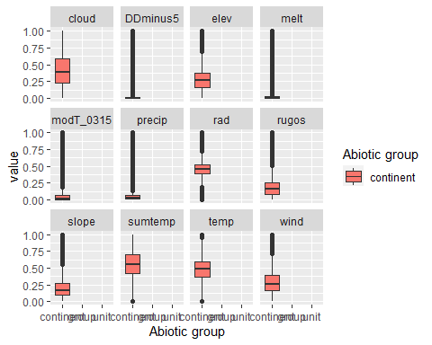

### Biota

Most widespread species in the unit (found in most pixels)

The top most widespread species in ecosystem env6_sdm7

| scientific | Functional_group | phylum | restricted | count | relative_pct |
| --- | --- | --- | --- | --- | --- |
| Pygoscelis antarctica | Chordata_Aves_Sphenisciformes_Spheniscidae_Pygoscelis_antarctica | Chordata | TRUE | 51 | 12.8141 |
| Pygoscelis adeliae | Chordata_Aves_Sphenisciformes_Spheniscidae_Pygoscelis_adeliae | Chordata | FALSE | 14 | 3.5176 |
| Usnea antarctica | Ascomycota_Lecanoromycetes_Lecanorales_Parmeliaceae__ | Ascomycota | FALSE | 9 | 2.2613 |
| Pygoscelis papua | Chordata_Aves_Sphenisciformes_Spheniscidae_Pygoscelis_papua | Chordata | FALSE | 8 | 2.0101 |
| Macronectes giganteus | Chordata_Aves_Procellariiformes___ | Chordata | FALSE | 6 | 1.5075 |
| Polytrichastrum alpinum | Bryophyta_Bryopsida_Polytrichales___ | Bryophyta | FALSE | 6 | 1.5075 |
| Ceratodon purpureus | Bryophyta_Bryopsida_Dicranales___ | Bryophyta | FALSE | 5 | 1.2563 |
| Brachythecium austro-salebrosum | Bryophyta_Bryopsida_Hypnales___ | Bryophyta | TRUE | 4 | 1.0050 |
| Leucocarbo atriceps | Chordata_Aves_Suliformes___ | Chordata | FALSE | 4 | 1.0050 |
| Ochrolechia frigida | Ascomycota_Lecanoromycetes_Pertusariales_Ochrolechiaceae__ | Ascomycota | FALSE | 4 | 1.0050 |
| Polytrichum strictum | Bryophyta_Bryopsida_Polytrichales___ | Bryophyta | FALSE | 4 | 1.0050 |
| Sanionia uncinata | Bryophyta_Bryopsida_Hypnales___ | Bryophyta | FALSE | 4 | 1.0050 |

This supergroup is, on average, substantially higher in suitability for mites_Mesostigmata, lichens_Rhizocarpid, penguins_Gentoo, lichens_Parmelid, mites_Sarcoptiformes, penguins_Chinstrap, Springtails_slim, mosses_Pottiales, mosses_Polytrichales, mosses_Dicranales, mites_Trombidiformes, mosses_Hypnales_(feather), algae_Green, Nematodes, lichens_Physcid_(shadow), lichens_Acarosporacid, lichens_Teloschistid, lichens_Stereocaulid, lichens_Candelarid, lichens_Lecanorid, lichens_Cladonid, mosses_Bryales, lichens,_Bacidiacid, Algae and Rotifers functional groups than continental Antarctica. It is substantially lower in suitability for no variables than the rest of the continent.

Unit env6_sdm7 is higher in suitability for no variables and lower in suitability for Rotifers than the rest of its environmental supergroup.

Distinctiveness of the unit from the environmental group and the rest of Antarctica

