SIMATS ENGINEERING
ASSESSMENT TOOL 1

COURSE CODE: CSA1407 COURSE NAME: COMPILER DESIGN

COURSE OUTCOME COVERED

CO3: Analyze syntax-directed translation method using synthesized and inherited attributes to generate a Parser Tree. (BL4)

Assessment Tool Weightage: 40%

QUESTIONS:5 Total Marks:100

Annexure A

EXPERIMENTS

Code of Conduct:

I ANIKSHA EVANJALIN M(192521308)(Name / Reg No) certify that this submission is my original work and that I have adhered to the guidelines specified for this assessment.
I understand that any violation of academic integrity rules will result in disciplinary action.

Signature of the student:

ANIKSHA EVANJALIN M

Annexure A

EXPERIMENTS

Q1.You are developing a compiler-based desk calculator that evaluates arithmetic expressions using syntax-directed definitions (SDD).
The system should:
(i) Accept an arithmetic expression with operators +, -, *, / and parentheses
(ii) Use syntax-directed evaluation to compute values based on operator precedence
(iii) Optimize evaluation by reducing unnecessary temporary computations
(iv) Display the final result of the expression
Demonstrate how SDD rules (synthesized attributes) are used for expression evaluation.
SDD
Grammar with semantic rules:
E → E + T { E.val = E1.val + T.val }
E → E - T { E.val = E1.val - T.val }
E → T { E.val = T.val }
T → T * F { T.val = T1.val * F.val }
T → T / F { T.val = T1.val / F.val }
T → F { T.val = F.val }
F → (E) { F.val = E.val }
F → digit { F.val = digit }

Q2. In a compiler, postfix expressions are evaluated during code generation using stack-based bottom-up evaluation.
Write a C program that:
(i) Evaluates a postfix expression
(ii) Demonstrates S-attributed definition evaluation
(iii) Shows how intermediate results are computed

Q3.You are designing a parser that uses L-attributed definitions, where inherited attributes are passed from parent to child.
Write a C program that:
(i).Evaluates a simple expression like a + b * c
(ii) Uses function parameters to simulate inherited attributes
(iii). Ensures correct precedence handling
(iv). Demonstrates top-down evaluation logic
Explain how inherited attributes influence computation.

Q4.In a compiler, it is important to check whether two type expressions are equivalent.
Write a C program that:
(i).Accepts two type expressions (e.g., int, float, int*)
(ii).Compares them for type equivalence
(iii).Displays whether they are:
(a).Equivalent
(b).Not equivalent
Extend the logic to handle pointer types (int*, float*).

Q5.You are building a semantic analyzer that detects type errors in arithmetic expressions.
Write a C program that:
(i). Accepts two operands and their types
(ii). Checks whether the operation (e.g., +, *) is valid
(iii). Reports:
(a).Valid expression
(b).Type error (e.g., int + char*)
Demonstrate how compilers detect semantic errors during type checking

Q1. Syntax-Directed Definition (SDD) using Synthesized Attributes

C Program:
#include <stdio.h>
#include <ctype.h>

char expr[100];
int pos = 0;

/* Function declarations */
int E();
int T();
int F();

/* Skip spaces */
void skipSpaces()
{
while (expr[pos] == ' ')
pos++;
}

/* E -> T { (+|-) T } */
int E()
{
int val = T();

while (1)
{
skipSpaces();

if (expr[pos] == '+')
{
pos++;
val = val + T();
}
else if (expr[pos] == '-')
{
pos++;
val = val - T();
}
else
{
break;
}
}

return val;
}

/* T -> F { (*|/) F } */
int T()
{
int val = F();

while (1)
{
skipSpaces();

if (expr[pos] == '*')
{
pos++;
val = val * F();
}
else if (expr[pos] == '/')
{
pos++;
val = val / F();
}
else
{
break;
}
}

return val;
}

/* F -> (E) | digit */
int F()
{
int val = 0;

skipSpaces();

if (expr[pos] == '(')
{
pos++;
val = E();

skipSpaces();

if (expr[pos] == ')')
pos++;
}
else if (isdigit(expr[pos]))
{
while (isdigit(expr[pos]))
{
val = val * 10 + (expr[pos] - '0');
pos++;
}
}

return val;
}

int main()
{
printf("Enter arithmetic expression: ");
scanf("%s", expr);

printf("Result = %d\n", E());

return 0;
}

Sample Output:
Enter arithmetic expression: 3+4*2
Result = 11

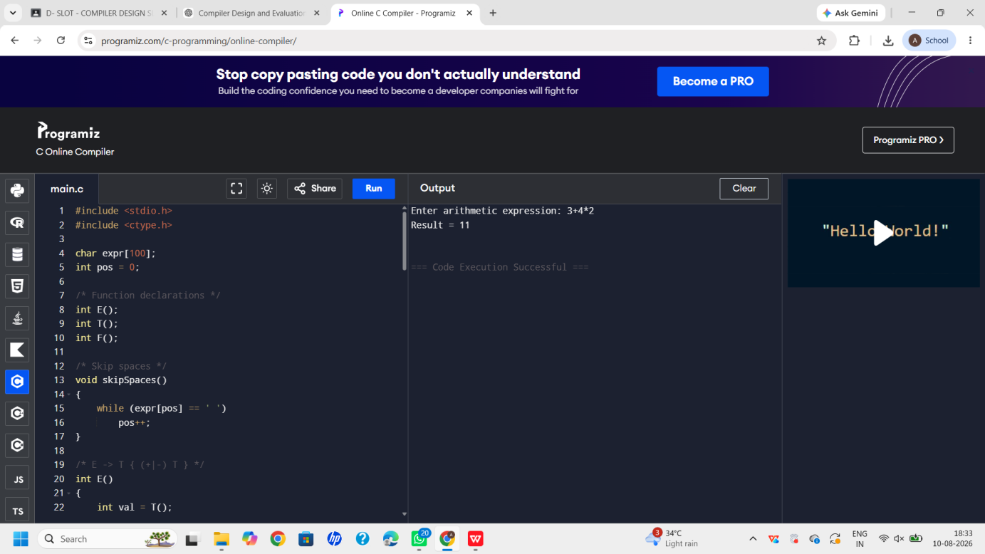

Q2. Postfix Expression Evaluation using S-Attributed Definition

C Program:
#include <stdio.h>#include <ctype.h>
#define MAX 100
int stack[MAX];int top = -1;
/* Push value */void push(int value)
{
stack[++top] = value;
}
/* Pop value */int pop()
{
return stack[top--];
}
/* Evaluate postfix expression */int evaluatePostfix(char exp[])
{
int i;
int a, b, result;

for (i = 0; exp[i] != '\0'; i++)
{
if (isdigit(exp[i]))
{
push(exp[i] - '0');

printf("Push %d\n", exp[i] - '0');
}
else
{
b = pop();
a = pop();

switch (exp[i])
{
case '+':
result = a + b;
break;

case '-':
result = a - b;
break;

case '*':
result = a * b;
break;

case '/':
result = a / b;
break;

default:
result = 0;
}

printf("%d %c %d = %d\n",
a, exp[i], b, result);

push(result);
}
}

return pop();
}
int main()
{
char exp[MAX];

printf("Enter postfix expression: ");
scanf("%s", exp);

printf("\nIntermediate computations:\n");

printf("\nFinal Result = %d\n",
evaluatePostfix(exp));

return 0;
}

Sample Output:
Enter postfix expression: 345+*

Intermediate computations:
Push 3
Push 4
Push 5
4 + 5 = 9
3 * 9 = 27

Final Result = 27
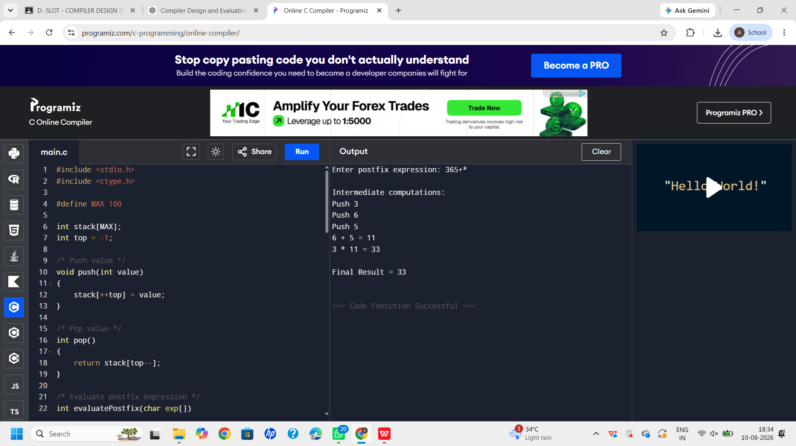

Q3. L-Attributed Definition using Function Parameters

C Program:
#include <stdio.h>
/*
L-attributed evaluation

Function parameters act as inherited attributes.
The current value is passed from parent to child.*/
/* Evaluate multiplication */int evaluateT(int inherited, int b, int c)
{
int result;

result = b * c;

printf("Inherited value = %d\n", inherited);
printf("b * c = %d * %d = %d\n", b, c, result);

return inherited + result;
}
/* Evaluate addition */int evaluateE(int a, int b, int c)
{
int inherited;

/* a is passed from parent to child */
inherited = a;

printf("Inherited attribute passed to T = %d\n",
inherited);

return evaluateT(inherited, b, c);
}
int main()
{
int a, b, c;
int result;

printf("Enter values of a, b and c: ");
scanf("%d %d %d", &a, &b, &c);

result = evaluateE(a, b, c);

printf("\nExpression: a + b * c\n");
printf("Result = %d\n", result);

return 0;
}

Sample Output:
Enter values of a, b and c: 2 3 4

Inherited attribute passed to T = 2
Inherited value = 2
b * c = 3 * 4 = 12

Expression: a + b * c
Result = 14

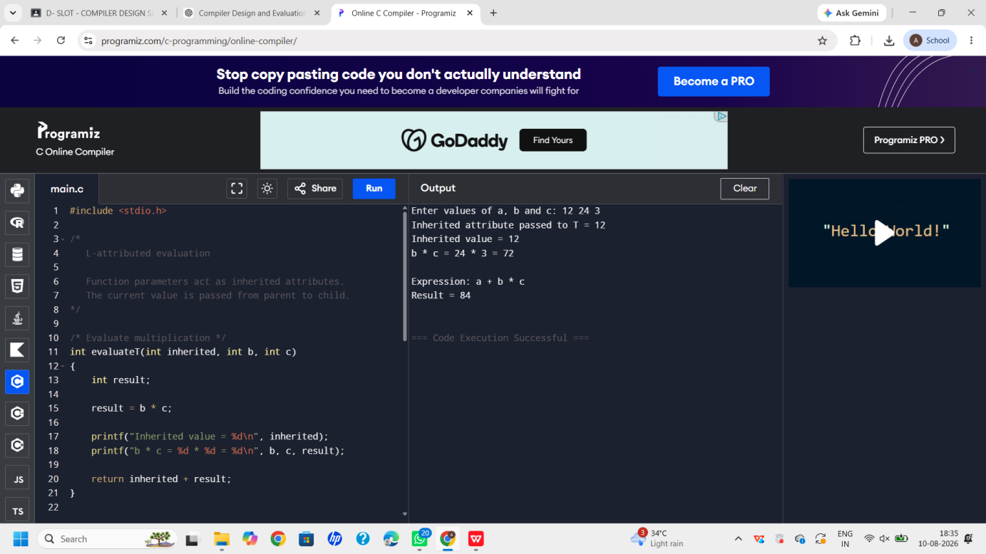

Q4. Type Equivalence Checker

C Program:
#include <stdio.h>#include <string.h>
int typeEquivalent(char type1[], char type2[])
{
char base1[20], base2[20];
int pointer1 = 0, pointer2 = 0;

strcpy(base1, type1);
strcpy(base2, type2);

/* Check pointer for type 1 */
if (base1[strlen(base1) - 1] == '*')
{
pointer1 = 1;
base1[strlen(base1) - 1] = '\0';
}

/* Check pointer for type 2 */
if (base2[strlen(base2) - 1] == '*')
{
pointer2 = 1;
base2[strlen(base2) - 1] = '\0';
}

/* Pointer level must be same */
if (pointer1 != pointer2)
return 0;

/* Base type must be same */
if (strcmp(base1, base2) == 0)
return 1;

return 0;
}
int main()
{
char type1[20], type2[20];

printf("Enter first type (int/float/char/int*/float*/char*): ");
scanf("%s", type1);

printf("Enter second type (int/float/char/int*/float*/char*): ");
scanf("%s", type2);

if (typeEquivalent(type1, type2))
printf("\nResult: Equivalent\n");
else
printf("\nResult: Not Equivalent\n");

return 0;
}

Sample Output
Enter first type (int/float/char/int*/float*/char*): int
Enter second type (int/float/char/int*/float*/char*): int

Result: Equivalent

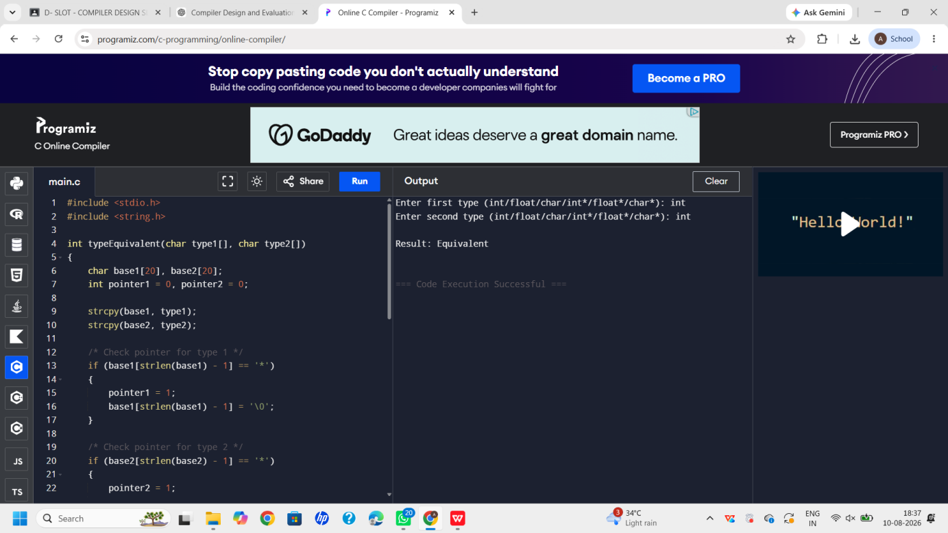

Q5. Semantic Analyzer – Type Checking

C Program
#include <stdio.h>#include <string.h>
int isNumeric(char type[])
{
if (strcmp(type, "int") == 0 ||
strcmp(type, "float") == 0)
{
return 1;
}

return 0;
}
void checkOperation(char type1[], char op, char type2[])
{
printf("\nChecking: %s %c %s\n",
type1, op, type2);

/*
Arithmetic operators are allowed
only for numeric types.
*/

if (isNumeric(type1) && isNumeric(type2))
{
if (op == '+' || op == '-' ||
op == '*' || op == '/')
{
printf("Result: Valid expression\n");
}
else
{
printf("Result: Invalid operator\n");
}
}
else
{
printf("Result: Type error\n");
}
}
int main()
{
char type1[20], type2[20];
char op;

printf("Enter first operand type (int/float/char/int*/float*/char*): ");
scanf("%s", type1);

printf("Enter operator (+, -, *, /): ");
scanf(" %c", &op);

printf("Enter second operand type (int/float/char/int*/float*/char*): ");
scanf("%s", type2);

checkOperation(type1, op, type2);

return 0;
}

Sample Output :
Enter first operand type (int/float/char/int*/float*/char*): int
Enter operator (+, -, *, /): +
Enter second operand type (int/float/char/int*/float*/char*): float

Checking: int + float
Result: Valid expression

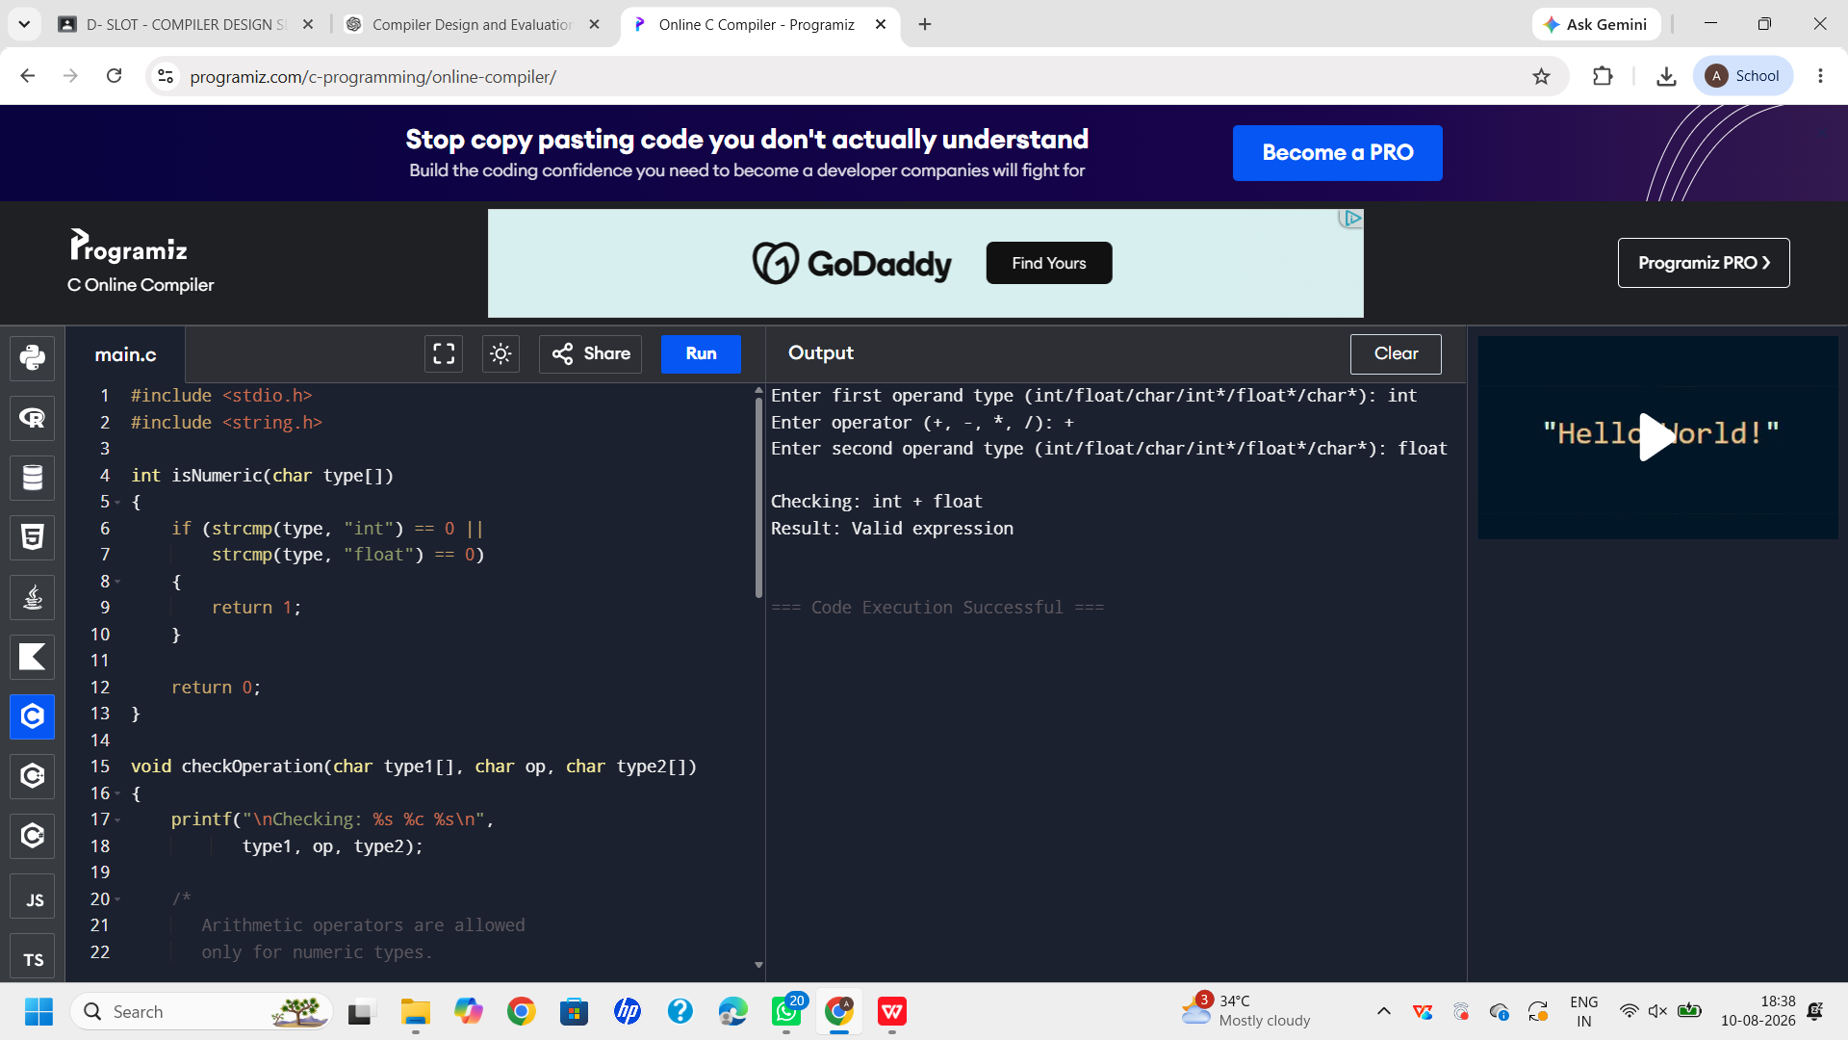

RUBRICS FOR CALCULATION

Criteria | Weightage | Level 4 – Exemplary | Level 3 – Proficient | Level 2 – Developing | Level 1 – Beginning
Understanding of Concepts | 25 | Demonstrates thorough understanding and effectively integrates multiple concepts/technologies | Good understanding with proper integration of most concepts | Basic understanding; limited or partial integration | Poor understanding; unable to integrate concepts
Experimental Design | 30 | Well-planned, systematic implementation with optimal solution | Correct implementation with minor issues | Basic implementation with errors or inefficiencies | Incorrect or incomplete implementation
Use of Tools | 20 | Effective and advanced use of tools/technologies with proper configuration | Appropriate use of tools with correct execution | Limited or inconsistent use of tools | Incorrect or minimal use of tools
Analysis of Results | 15 | Insightful analysis with accurate interpretation and validation of results | Good analysis with reasonable interpretation | Basic analysis with limited insights | Poor or incorrect analysis of results
Documentation | 10 | Clear, well-structured documentation with diagrams, code, and results | Organized documentation with necessary details | Basic documentation with missing details | Poor or incomplete documentation

