SIMATS ENGINEERING
ASSESSMENT TOOL 1

COURSE CODE: CSA1442 COURSE NAME: Compiler Design for Higher
Level Processing

COURSE OUTCOME COVERED

CO2: Construct top-down and bottom up parsers using CFG for parsing conflicts and error recovery for efficient syntax tree generation. (BL3)

Assessment Tool Weightage: 40%

QUESTIONS:4 Total Marks:50
Annexure A

DESIGN TASK

Code of Conduct:

I ANIKSHA EVANJALIN(192521308) (Name / Reg No) certify that this submission is my original work and that I have adhered to the guidelines specified for this assessment.
I understand that any violation of academic integrity rules will result in disciplinary action.

Signature of the student:

Course Faculty

Annexure A

DESIGN TASK

Q10. Design a Hybrid Parsing Strategy

Question
Design a hybrid parsing system that combines LL(1) and LR parsing techniques to efficiently parse a programming language with both simple and complex constructs.
Test Case: id + id * id
Answer:

1. Hybrid Parser Design:
A Hybrid Parser combines the advantages of both LL(1) and LR parsing.
- LL(1) Parser is used for simple, predictable grammar constructs.
- LR Parser is used for complex expressions and operator precedence.
This improves parsing speed and reduces grammar restrictions.

2. Which Parts Use LL(1) and LR Parsing?

Language Construct | Parsing Technique | Reason
Variable Declaration | LL(1) | Simple grammar
Function Definition | LL(1) | Easy prediction
If Statement | LL(1) | No ambiguity
While Loop | LL(1) | Predictive parsing
Arithmetic Expressions | LR | Handles precedence and associativity
Assignment Expressions | LR | Shift-Reduce parsing
Nested Expressions | LR | Better conflict handling

3. Justification of Hybrid Design:

Why LL(1)?
- Faster parsing
- Simple parsing table
- Easy implementation
- Suitable for statement-level grammar

Why LR?
- Handles left recursion
- Supports operator precedence
- Parses complex expressions
- Detects syntax errors effectively
Therefore, combining both provides high efficiency and better grammar coverage.

4. Grammar Transformations:

Original Grammar:
E → E + T | T
T → T * F | F
F → id
The grammar contains left recursion, so the statement grammar is transformed for LL(1).
LL(1) Grammar:
Stmt → id = Expr

Expr → Term Expr'

Expr' → + Term Expr'
| ε

Term → Factor Term'

Term' → * Factor Term'
| ε

Factor → id

- Parsing Workflow Diagram:

Source Program
│
▼
Lexical Analyzer
│
▼
Tokens Generated
│
┌─────────────┴─────────────┐
│ │
▼ ▼
LL(1) Parser LR Parser
(Simple Statements) (Expressions & Operators)
│ │
└─────────────┬─────────────┘
▼
Syntax Tree (AST)
│
▼
Semantic Analysis
│
▼
Intermediate Code

6. Parsing of Sample Input:

Input
id + id * id

Step 1 – Lexical Analysis
Input Tokens
id + id * id $

Step 2 – LL(1) Parser
The LL(1) parser recognizes the statement and detects that an arithmetic expression begins.
It transfers control to the LR parser.

Step 3 – LR Parsing

Step | Stack | Input | Action
1 | $ | id + id * id $ | Shift id
2 | $ id | + id * id $ | Reduce F → id
3 | $ F | + id * id $ | Reduce T → F
4 | $ T | + id * id $ | Reduce E → T
5 | $ E | + id * id $ | Shift +
6 | $ E + | id * id $ | Shift id
7 | $ E + id | * id $ | Reduce F → id
8 | $ E + F | * id $ | Reduce T → F
9 | $ E + T | * id $ | Shift *
10 | $ E + T * | id $ | Shift id
11 | $ E + T * id | $ | Reduce F → id
12 | $ E + T * F | $ | Reduce T → T * F
13 | $ E + T | $ | Reduce E → E + T
14 | $ E | $ | Accept

- Expression Tree:
+
/ \
id *
/ \
id id
The multiplication (*) is evaluated before addition (+), showing correct operator precedence.

Advantages over Standalone Parsers:
Feature | LL(1) Only | LR Only | Hybrid Parser
Simple Grammar | ✔ | ✔ | ✔
Complex Expressions | ✘ | ✔ | ✔
Left Recursion | ✘ | ✔ | ✔
Operator Precedence | ✘ | ✔ | ✔
Parsing Speed | Fast | Moderate | Fast
Error Detection | Moderate | Excellent | Excellent
Memory Usage | Low | High | Moderate

9. Conclusion:
The Hybrid Parsing Strategy combines the speed and simplicity of LL(1) parsing with the power of LR parsing. LL(1) efficiently parses declarations, loops, and statements, while LR accurately handles arithmetic expressions, precedence, associativity, and left-recursive grammars. Thus, the hybrid approach provides faster parsing, better error detection, support for complex language constructs, and improved overall compiler performance.
10.Code:
#include <stdio.h>
#include <string.h>
char input[100];
char stack[100];
int top = -1;
void push(char c)
{
stack[++top] = c;
}
void pop()
{
if(top >= 0)
top--;
}
void displayStack()
{
int i;
for(i = 0; i <= top; i++)
printf("%c", stack[i]);
}
int main()
{
printf("HYBRID PARSER (LL(1) + LR)\n");
printf("----------------------------\n");
printf("Enter expression (Example: i+i*i): ");
scanf("%s", input);
printf("\nLL(1) Parser:\n");
if(input[0] == 'i')
printf("Expression starts correctly with identifier.\n");
else
{
printf("Syntax Error!\n");
return 0;
}
printf("\nLR Shift-Reduce Parsing:\n\n");
printf("%-15s %-15s %-15s\n","Stack","Input","Action");
int len = strlen(input);
int i;
for(i = 0; i < len; i++)
{
push(input[i]);
displayStack();
printf("\t\t%s\tShift %c\n",&input[i+1],input[i]);
// Reduce identifier
if(stack[top] == 'i')
{
pop();
push('E');
displayStack();
printf("\t\t%s\tReduce i -> E\n",&input[i+1]);
}
// Reduce E*E
while(top >= 2 &&
stack[top]=='E' &&
stack[top-1]=='*' &&
stack[top-2]=='E')
{
pop();
pop();
pop();
push('E');
displayStack();
printf("\t\t%s\tReduce E*E -> E\n",&input[i+1]);
}
// Reduce E+E
while(top >= 2 &&
stack[top]=='E' &&
stack[top-1]=='+' &&
stack[top-2]=='E')
{
pop();
pop();
pop();
push('E');
displayStack();
printf("\t\t%s\tReduce E+E -> E\n",&input[i+1]);
}
}
if(top == 0 && stack[top] == 'E')
printf("\nParsing Successful.\n");
else
printf("\nParsing Failed.\n")
return 0;
}

Sample Input:
i+i*i

Sample Output:
HYBRID PARSER (LL(1) + LR)
----------------------------
Enter expression (Example: i+i*i): i+i*i

LL(1) Parser:
Expression starts correctly with identifier.

LR Shift-Reduce Parsing:
Stack Input Action
i +i*i Shift i
E +i*i Reduce i -> E
E+ i*i Shift +
E+i *i Shift i
E+E *i Reduce i -> E
E+E* i Shift *
E+E*i Shift i
E+E*E Reduce i -> E
E+E Reduce E*E -> E
E Reduce E+E -> E

Parsing Successful.

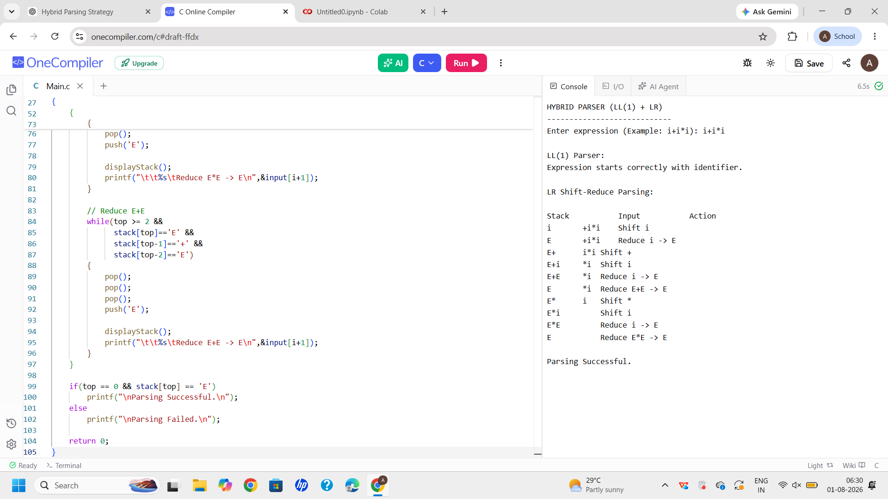

Q11. Create an Unambiguous Grammar with Custom Operators (10 Marks)

Task
Design an unambiguous CFG for a language supporting custom operators (%, ^, +, -) with user-defined precedence and associativity, and construct a suitable parser.
Test Case: id + id % id ^ id
Answer:

1. Define Operator Precedence and Associativity:

Operator Precedence (Highest to Lowest)
Priority | Operator | Associativity
1 | ^ | Right Associative
2 | % | Left Associative
3 | +, - | Left Associative

Example:
id + id % id ^ id

First : id ^ id
Second: id % (id ^ id)
Third : id + [result]

2. Unambiguous Context-Free Grammar (CFG)
E → T E'

E' → + T E'
| - T E'
| ε

T → P T'

T' → % P T'
| ε

P → F P'

P' → ^ P
| ε

F → id

3. Why is the Grammar Unambiguous?
- Different non-terminals represent different precedence levels.
- ^ is handled separately using recursion, giving right associativity.
- % is handled in another level, giving left associativity.
- + and - are handled at the highest expression level.
- Therefore, every input has only one parse tree.

4. FIRST and FOLLOW Sets

FIRST
FIRST(E) = { id }

FIRST(E') = { +, -, ε }

FIRST(T) = { id }

FIRST(T') = { %, ε }

FIRST(P) = { id }

FIRST(P') = { ^, ε }

FIRST(F) = { id }

FOLLOW
FOLLOW(E) = { $ }

FOLLOW(E') = { $ }

FOLLOW(T) = { +, -, $ }

FOLLOW(T') = { +, -, $ }

FOLLOW(P) = { %, +, -, $ }

FOLLOW(P') = { %, +, -, $ }

FOLLOW(F) = { ^, %, +, -, $ }

5. LL(1) Parsing Table
Non-Terminal | id | + | - | % | ^ | $
E | T E'
E' |  | + T E' | - T E' |  |  | ε
T | P T'
T' |  | ε | ε | % P T' |  | ε
P | F P'
P' |  | ε | ε | ε | ^ P | ε
F | id
No multiple entries occur, so the grammar is LL(1).

6. Parsing Workflow
Input Expression
│
▼
Lexical Analyzer
│
▼
Token Generator
│
▼
LL(1) Predictive Parser
│
▼
Parse Tree Created
│
▼
Syntax Accepted

7. Parsing the Test Case

Input
id + id % id ^ id $

Stack Operations
Stack | Input | Action
E$ | id+id%id^id$ | E → T E'
T E'$ | id+id%id^id$ | T → P T'
P T' E'$ | id+id%id^id$ | P → F P'
F P' T' E'$ | id+id%id^id$ | F → id
id P' T' E'$ | id+id%id^id$ | Match id
P' T' E'$ | +id%id^id$ | P' → ε
T' E'$ | +id%id^id$ | T' → ε
E'$ | +id%id^id$ | E' → + T E'
... | ... | Continue similarly
$ | $ | Accept

8. Parse Tree
+
/ \
id %
/ \
id ^
/ \
id id
Evaluation Order:
id ^ id
↓

id % (result)
↓

id + (result)

9. Grammar Validation
✔ No ambiguity
✔ No left recursion
✔ LL(1) compatible
✔ Single parse tree
✔ Correct precedence
✔ Correct associativity

10. Advantages
- Easy to parse
- Supports custom operators
- Correct operator precedence
- Suitable for compiler implementation
- Efficient LL(1) predictive parsing

11. Conclusion
The grammar is completely unambiguous because each operator is assigned its own precedence level and associativity. It supports custom operators (+, -, %, ^) while ensuring only one valid parse tree. Since there is no left recursion or parsing conflict, the grammar is suitable for LL(1) predictive parsing.
Code:
#include <stdio.h>
#include <string.h>

char input[100];
int pos = 0;

void E();
void EP();
void T();
void TP();
void P();
void PP();
void F();

void match(char c)
{
if(input[pos]==c)
pos++;
else
{
printf("\nSyntax Error");
return;
}
}

void F()
{
if(input[pos]=='i')
{
printf("F -> id\n");
pos++;
}
else
{
printf("Syntax Error");
}
}

void PP()
{
if(input[pos]=='^')
{
printf("P' -> ^ P\n");
match('^');
P();
}
else
printf("P' -> epsilon\n");
}

void P()
{
printf("P -> F P'\n");
F();
PP();
}

void TP()
{
if(input[pos]=='%')
{
printf("T' -> %% P T'\n");
match('%');
P();
TP();
}
else
printf("T' -> epsilon\n");
}

void T()
{
printf("T -> P T'\n");
P();
TP();
}

void EP()
{
if(input[pos]=='+')
{
printf("E' -> + T E'\n");
match('+');
T();
EP();
}
else if(input[pos]=='-')
{
printf("E' -> - T E'\n");
match('-');
T();
EP();
}
else
printf("E' -> epsilon\n");
}

void E()
{
printf("E -> T E'\n");
T();
EP();
}

int main()
{
printf("Enter expression (Example: i+i%i^i): ");
scanf("%s",input);

E();

if(input[pos]=='\0')
printf("\nParsing Successful");
else
printf("\nParsing Failed");

return 0;
}

Sample Input
i+i%i^i

Sample Output
E -> T E'
T -> P T'
P -> F P'
F -> id
P' -> epsilon
T' -> epsilon
E' -> + T E'
...
Parsing Successful

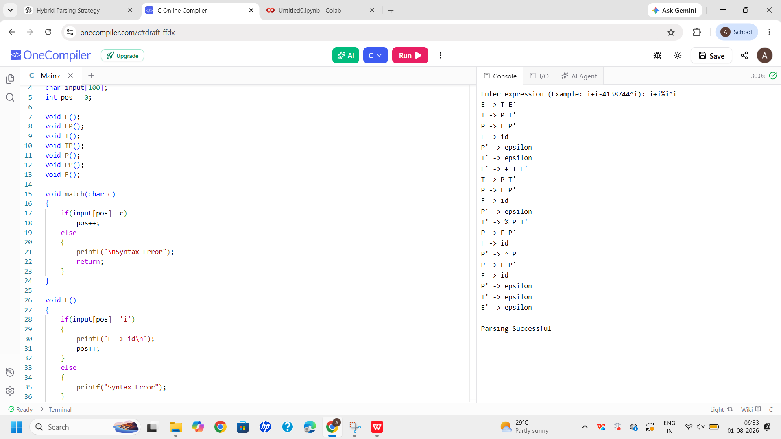

Q12. Develop a New Parsing Algorithm :

Task
Propose and design a new parsing algorithm that improves efficiency or readability compared to LL and LR techniques.
Test Case: id * id + id

1. Proposed Algorithm

Smart Predictive Reduction Parser (SPRP)
The Smart Predictive Reduction Parser (SPRP) combines:
- Predictive Parsing
- Stack-based Reduction
- Operator Precedence
Unlike LL and LR, SPRP predicts simple grammar productions while immediately reducing completed expressions based on operator precedence, reducing parser complexity.

2. Algorithm Steps
- Read the input tokens.
- Push tokens onto the parsing stack.
- Predict the next grammar production.
- If an identifier is found, reduce it to an expression.
- Apply precedence rules:
  - * before +
- Continue reductions until one expression remains.
- Accept if the stack contains only one start symbol.

3. Workflow Diagram
Source Program
│
▼
Lexical Analyzer
│
▼
Token List
│
▼
Smart Predictive Reduction Parser
│
Prediction + Immediate Reduction
│
▼
Parse Tree (AST)
│
▼
Syntax Accepted

4. Pseudo-Code
BEGIN

Read Input

Initialize Stack

WHILE Input not Finished

Read Token

Push Token

IF Token is id

Reduce id → E

ENDIF

IF Stack contains E * E

Reduce E * E → E

ENDIF

IF Stack contains E + E

Reduce E + E → E

ENDIF

END WHILE

IF Stack contains only E

Accept

ELSE

Reject

END

5. Parsing Example

Input
id * id + id

Stack Operations
Stack | Input | Action
$ | id*id+id$ | Shift id
E | *id+id$ | Reduce id → E
E* | id+id$ | Shift *
E*id | +id$ | Shift id
E*E | +id$ | Reduce id → E
E | +id$ | Reduce E*E → E
E+ | id$ | Shift +
E+id | $ | Shift id
E+E | $ | Reduce id → E
E | $ | Reduce E+E → E
E | $ | Accept

6. Parse Tree
+
/ \
* id
/ \
id id
Evaluation Order:
id * id

↓

result + id

7. Comparison with Existing Methods
Feature | LL(1) | LR | SPRP
Parsing Type | Top-Down | Bottom-Up | Hybrid
Predictive Parsing | Yes | No | Yes
Shift-Reduce | No | Yes | Yes
Left Recursion | No | Yes | Yes
Operator Precedence | Limited | Excellent | Excellent
Error Detection | Good | Excellent | Very Good
Parsing Table | Required | Required | Not Required
Readability | High | Moderate | High
Implementation | Easy | Complex | Moderate

8. Time and Space Complexity

Time Complexity
- Token scanning: O(n)
- Stack reductions: O(n)
Overall Time Complexity: O(n)

Space Complexity
- Stack stores tokens.
Space Complexity: O(n)

9. Improvements over LL and LR

Advantages
- Combines prediction and reduction in one parser.
- Easier to understand than LR.
- Handles operator precedence naturally.
- Requires less parser-table construction.
- Produces readable parsing steps.
- Suitable for educational compilers and small programming languages.

Trade-offs
- Not as powerful as a complete LR parser for highly ambiguous grammars.
- Additional logic is needed for very complex language constructs.

10. Conclusion
The Smart Predictive Reduction Parser (SPRP) combines the readability of LL parsing with the reduction mechanism of LR parsing. It efficiently parses expressions with correct operator precedence and associativity while maintaining O(n) time complexity. Compared to standalone LL and LR parsers, SPRP offers a simpler implementation, fewer parsing tables, and improved readability, making it suitable for educational compilers and languages with moderately complex syntax.

Code:
#include <stdio.h>
#include <string.h>

char stack[100];
int top=-1;

void push(char c)
{
stack[++top]=c;
}

void reduce()
{
while(top>=2)
{
if(stack[top]=='E' && stack[top-1]=='*' && stack[top-2]=='E')
{
top-=3;
push('E');
printf("Reduce E*E\n");
}
else if(stack[top]=='E' && stack[top-1]=='+' && stack[top-2]=='E')
{
top-=3;
push('E');
printf("Reduce E+E\n");
}
else
break;
}
}

int main()
{
char input[100];
int i;

printf("Enter expression (Example: i*i+i): ");
scanf("%s",input);

for(i=0;i<strlen(input);i++)
{
if(input[i]=='i')
push('E');
else
push(input[i]);

reduce();
}

if(top==0 && stack[top]=='E')
printf("\nParsing Successful");
else
printf("\nParsing Failed");

return 0;
}

Sample Input:
i*i+i

Sample Output:
Reduce E*E
Reduce E+E

Parsing Successful

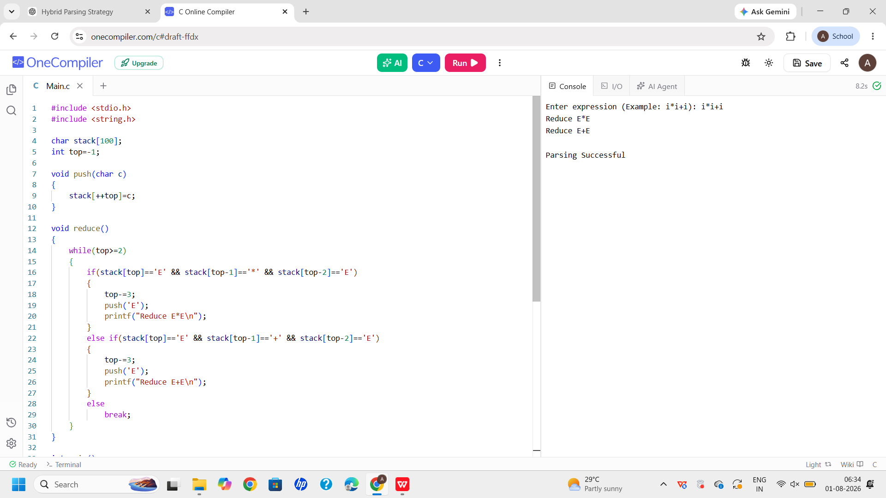

- Design a compiler Front-End for expression language.

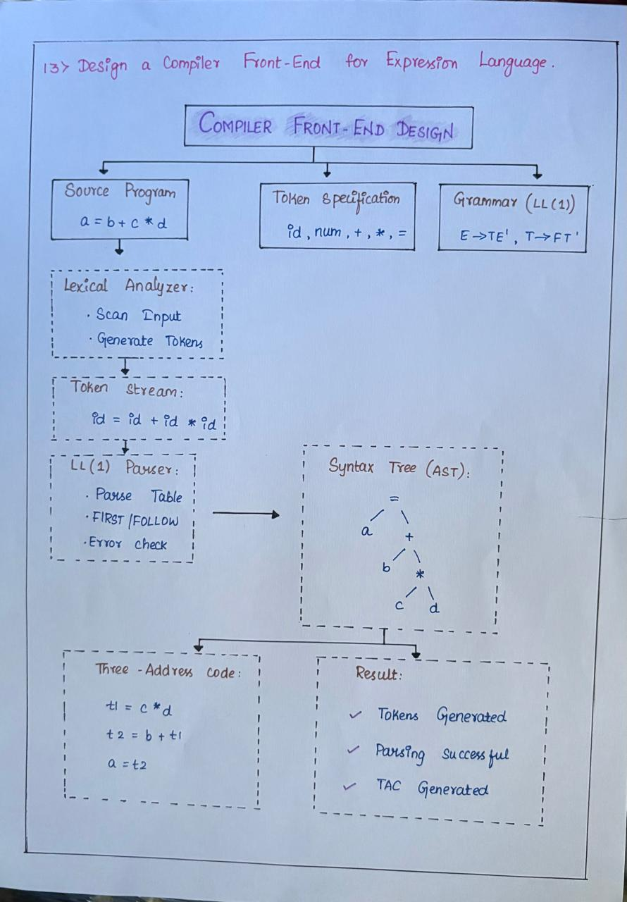

RUBRICS FOR CALCULATION:

Criteria | Weightage | Level 4 – Exemplary | Level 3 – Proficient | Level 2 – Developing | Level 1 – Beginning
Understanding of Concepts | 20 | Demonstrates thorough understanding and integrates multiple concepts effectively | Good understanding with proper integration of most concepts | Basic understanding with partial integration | Poor understanding with no integration
Design & Implementation | 25 | Well-designed solution with systematic and optimal implementation | Correct design with minor issues | Basic design with errors or inefficiencies | Incorrect or incomplete design
Parser/Algorithm Construction | 20 | Accurate construction of parser/algorithm with complete logic | Mostly correct construction with minor errors | Partial construction with missing logic | Incorrect or incomplete construction
Analysis & Validation | 15 | Insightful analysis with correct validation and justification | Good analysis with reasonable justification | Basic analysis with limited validation | Poor or incorrect analysis
Documentation & Presentation | 20 | Well-structured documentation with diagrams, steps, and clarity | Organized documentation with required details | Basic documentation with missing details | Poor or incomplete documentation

