DATABASE MANAGEMENT SYSTEMS
ASSIGNMENT 1 – CO1
CO1: Analyze DBMS architecture, different data models, schema types, and design ER/EER diagrams, relational schemas for case-based scenarios by identifying entities and relationships.
Nature of Assignment: Individual
Duration: 1 Week
Total Marks: 50
Submission Date: 04.11.2026

Assignment Title: Design, Analyse and Validate a Storage and Indexing Strategy for the Museum Condition-Report Database (Total Marks - 50)
Duration: 1 week

Scenario – Museum Collection Loans and Exhibition Planning
Meridian Museum borrows artifacts for temporary exhibitions. The same artifact has different catalog descriptions in the loan register and gallery plan. Loan expiry dates are not linked to display slots, and condition reports are filed by lender name rather than by physical object. The design must separate ownership, temporary custody, exhibition placement and condition evidence.
The fictional museum maintains 8 collection units, 35 curators, 1,200 lenders and 9,000 cataloged artifacts. Each artifact has one current lender. A loan belongs to one lender and contains multiple artifacts. Display slots are numbered within an exhibition. An artifact can have successive loans, and a curator may also lend a privately owned object.
Design Challenge:
Artifacts may have shared legal ownership, and ownership shares can change while an existing loan remains in force. The custody record must remain distinct from the ownership history.
Re-evaluate your original design and determine whether it should be retained, modified or redesigned.

TASK 1 – Analyse the Requirements and Propose Alternative Conceptual Designs | 5 Marks

Investigate Meridian Museum and construct three alternative conceptual approaches to loan coordination, paying particular attention to custody periods and condition evidence. Distinguish legal ownership, loan custody and exhibition placement.
Distinguish the alternatives by identity, relationship degree or historical representation. Show why merely renaming LOAN would leave the same model.
For each alternative, address the following case-specific requirements: Illustrate this through custody periods and condition evidence.
● Identify the operational users who create LOAN records and the information they must share.
● Contrast a dated relationship representation of loan coordination with an independently identified LOAN occurrence.
● Compare separate LENDER and employee records with shared PERSON identity when roles overlap. Illustrate this through custody periods and condition evidence.
● Explain how the proposed structure preserves custody periods and condition evidence.
● Sketch the core of each design, including the ownership of LOAN_OBJECT evidence.
● State a concrete failure case that each alternative is intended to resolve. Illustrate this through custody periods and condition evidence.

Choose the alternatives from the rules of Meridian Museum; support the comparison with a counterexample drawn from this case.
Evidence Expected
Three meaningfully different conceptual designs supported by requirement analysis, ER sketches and a justification of each modelling choice.
TASK 2 – Identify Entities, Attributes and Keys | 2 Marks

Build an entity and key catalog for the loan coordination models, distinguishing real-world identity from record labels. Decide whether an exhibition name can identify a display slot.
Discuss:
● Identify independently identifiable objects and existence-dependent DISPLAY_SLOT records.
● Classify contact information, CollectionType, source dates and calculated summaries by attribute type.
● Select stable primary keys, business candidate keys and owner-scoped keys for DISPLAY_SLOT.
● Explain how concurrent registration at Meridian Museum avoids issuing the same identifier twice.

Justify every key using the stated loan coordination rules, including a reason why a name is not a reliable identifier.
Evidence Expected
Correct identification and justification of entity types, attribute types and keys.
TASK 3 – Determine Relationships and Structural Constraints | 6 Marks

Derive the relationship constraints required to connect LENDER, operational events and their dependent evidence at Meridian Museum. Explain the composite placement-to-slot constraint.
Discuss:
● Distinguish binary associations from a possible ternary association involving LENDER, CURATOR and EXHIBITION.
● Explain which LOAN links are compulsory and which parent objects may exist without dependent records.
● Write minimum and maximum participation bounds for four relationships from the proposed schema. Illustrate this through custody periods and condition evidence.
● Decide whether dated or quantitative facts belong on LOAN, LOAN_OBJECT, or an association.
● Construct a small ternary instance and test whether its binary projections reconstruct it without extra tuples. Relate this to custody periods and condition evidence.

Use the case rules to defend every cardinality, including the effect of missing LOAN_OBJECT evidence.
Evidence Expected
Correct relationships with justified cardinality and participation constraints, including a demonstrated ternary versus binary analysis.
TASK 4 – Construct the ER Diagram | 4 Marks

Produce a Chen ER representation of the preferred loan coordination model and reconcile it with your entity catalog. Include separate paths for borrowed objects and condition reports.
The diagram must show:
● Include the LOAN core and every supporting entity, with an accompanying complete attribute catalog.
● Mark the identifying owner of DISPLAY_SLOT and show its owner-scoped key.
● Annotate cardinalities and compulsory participation from the business rules. Illustrate this through custody periods and condition evidence.
● Provide a legend and explain repeated entity references used to keep the drawing readable. Use the case issue of custody periods and condition evidence.

Evidence Expected
A complete, correctly notated and readable ER diagram consistent with Tasks 2 and 3.
TASK 5 – Extend the Model to an EER Model | 3 Marks

Use EER concepts to resolve overlapping roles and mixed contact identities in the Meridian Museum model. Handle a curator lending a personal collection.
Discuss:
● Generalize LENDER and employees into PERSON, then specialize employees into CURATOR and REGISTRAR.
● Decide whether role membership overlaps and whether the employee specialization covers all employees. Relate this to custody periods and condition evidence.
● Explain how the employee Role discriminator controls subtype membership. Illustrate this through custody periods and condition evidence.
● Represent a notification contact that can be either a person or an organization as a union category. Use the case issue of custody periods and condition evidence.
● Compare the subtype design with one wide record containing all LENDER, CURATOR and REGISTRAR fields.

Evidence Expected
A correct EER diagram with justified specialization constraints and use of aggregation/category.
TASK 6 – Model Weak Entities and Complex Attributes | 3 Marks

Resolve owner-dependent identities and complex attributes in the Meridian Museum design. Distinguish an artifact value from a loan-line valuation.
Discuss:
● Show the owner and local key of DISPLAY_SLOT; distinguish identifying links from ordinary foreign keys.
● Map multiple telephone numbers into separate rows rather than comma-separated values. Illustrate this through custody periods and condition evidence.
● Separate name components and explain which custody periods and condition evidence summaries should be computed. Use the case issue of custody periods and condition evidence.
● Decide which coded concepts need entity identity because they have their own data or relationships. Relate this to custody periods and condition evidence.

Evidence Expected
Correct and justified treatment of weak entities and composite, multivalued and derived attributes.

TASK 7 – Map the EER Model to a Relational Schema | 4 Marks

Derive relations from the preferred Meridian Museum EER model and explain the mapping decisions. Map several artifacts within one loan.
Discuss:
● Trace strong entities, DISPLAY_SLOT, 1:1 and 1:N associations, M:N associations and multivalued contacts into relations.
● Choose among the standard specialization mapping options for the overlapping PERSON roles. Use the case issue of custody periods and condition evidence.
● Specify primary and foreign keys and defend deletion behaviour for historical LOAN records. Relate this to custody periods and condition evidence.
● Draw a schema catalog whose references agree with the implementation. Illustrate this through custody periods and condition evidence.

Evidence Expected
A complete relational schema derived step by step from the EER model with justified mapping options.
TASK 8 – Implement the Schema and Populate Instances | 4 Marks

Implement the Meridian Museum relations in MySQL and construct reproducible valid states for four workload sizes. Check loan-period validity at the row level.
Scale the generated client population through: Relate this to custody periods and condition evidence.
100, 1,000, 10,000 and 100,000 lender records, with proportionate operational evidence. Illustrate this through custody periods and condition evidence.
Ensure that:
● Create the relations and constraints derived for loan coordination.
● Use seed 4211 and document how source keys are selected when generating linked rows. Illustrate this through custody periods and condition evidence.
● Show one stable schema with several changing LENDER and LOAN instances. Use the case issue of custody periods and condition evidence.
● Attempt invalid identity, workflow and category writes and retain the actual failure messages. Relate this to custody periods and condition evidence.
● Identify business rules that need more than a row-level CHECK constraint. Illustrate this through custody periods and condition evidence.

Evidence Expected
Working DDL and data-generation scripts with a clearly described, reproducible loading procedure.
TASK 9 – Validate the Design with Use-Case Queries | 3 Marks

Test whether the preferred model can answer operational questions about custody periods and condition evidence. Find artifacts that have no recorded condition evidence.
Record:
● Execute eight queries, including overdue loans still open and artifacts without condition evidence.
● Display SQL and actual output records, including empty results where no row meets a condition. Use the case issue of custody periods and condition evidence.
● Record result counts, explicit JOIN counts and median elapsed time for all four population sizes. Relate this to custody periods and condition evidence.
● Use a flat LOAN file to demonstrate insertion, update and deletion anomalies. Illustrate this through custody periods and condition evidence.

Evidence Expected
Systematically collected validation results presented in tables and/or graphs.
TASK 10 – Compare with File-Based, Network and Hierarchical Models | 4 Marks

Compare the selected loan coordination design with file processing, a hierarchical tree and a network model. Trace an exhibition inventory through placements.
Discuss:
● Represent the LENDER–LOAN–CURATOR access paths using tree nodes and network owner–member sets.
● Explain what happens when one person participates in several LOAN occurrences. Use the case issue of custody periods and condition evidence.
● Trace two of your case queries through each navigational model. Relate this to custody periods and condition evidence.
● Define an operational view, the shared conceptual model and an indexed internal representation for Meridian Museum.
● Explain which DBMS components coordinate a concurrent update to the same operational record. Use the case issue of custody periods and condition evidence.

Base your conclusions on the case access paths and identity rules, including custody periods and condition evidence.
Evidence Expected
A reasoned comparison of the data models supported by diagrams and the three-schema architecture.
TASK 11 – Recommend and Defend the Final Design | 4 Marks

Recommend one alternative for Meridian Museum using the schema, query outputs and constraint tests. Defend keeping custody evidence distinct from ownership history.
Discuss:
● Explain which alternative best preserves custody periods and condition evidence.
● Trace the requirements to specific entities, keys and association records. Illustrate this through custody periods and condition evidence.
● Use actual results from the implementation and distinguish them from untested business assertions. Use the case issue of custody periods and condition evidence.
● Identify cross-table rules and identity assumptions that remain limitations. Relate this to custody periods and condition evidence.
● Assess the implications of growing the generated lender population to 100,000. Illustrate this through custody periods and condition evidence.

Defend the design through the case evidence rather than the number of relations. Relate this to custody periods and condition evidence.
Evidence Expected
A technically justified final design supported by modelling arguments and validation evidence.
TASK 12 – Re-evaluate and Adapt the Design | 8 Marks

Changed Requirement
Artifacts may have shared legal ownership, and ownership shares can change while an existing loan remains in force. The custody record must remain distinct from the ownership history.
Reassess the original loan coordination model under this new requirement.
You may:
RETAIN, MODIFY, or REDESIGN
the original model, with a reasoned decision.
A. Impact Analysis – 2 Marks
Discuss:
● Identify the original assumption invalidated by the new requirement. Use the case issue of custody periods and condition evidence.
● Locate the affected entities, associations, business keys and temporal rules. Relate this to custody periods and condition evidence.
● Explain why the old identifier alone no longer describes the required fact. Illustrate this through custody periods and condition evidence.
● Trace the change through operational views, conceptual relations and internal access paths. Use the case issue of custody periods and condition evidence.

Evidence Expected
A clear analysis of how the changed requirements affect the original design.
B. Evaluation of the Original Design – 2 Marks
Assess whether your recommended design still represents the changed Meridian Museum rules.
Discuss:
● Test the original EXHIBITION representation against the new situation. Relate this to custody periods and condition evidence.
● Distinguish stable primary keys from constraints that must change. Illustrate this through custody periods and condition evidence.
● Reconsider the two rejected alternatives using the new rule. Use the case issue of custody periods and condition evidence.

Evidence Expected
A technically supported evaluation of the suitability of the original design under the new operating conditions.
C. Adaptation or Redesign – 2 Marks
Decide whether to:
Retain, extend or replace the model of Meridian Museum.
If you modify or redesign it:
● Show the revised EER construct that represents ARTIFACT_OWNER. Illustrate this through custody periods and condition evidence.
● Explain which old association is replaced, extended or versioned. Use the case issue of custody periods and condition evidence.
● Describe migration of existing records while preserving historical evidence. Relate this to custody periods and condition evidence.
● If retaining the model unchanged, demonstrate how it already represents the new facts. Illustrate this through custody periods and condition evidence.

Evidence Expected
An appropriate design response to the changed requirement, with clear database-design reasoning.
D. Evidence-Based Defence – 2 Marks
Defend the revised design for Meridian Museum with traceable evidence.
Use:
● Use the new identity and participation rules. Use the case issue of custody periods and condition evidence.
● Specify a query that would reveal an incorrect migration. Relate this to custody periods and condition evidence.
● Explain the effect on generated data and relationship counts. Illustrate this through custody periods and condition evidence.
● Show how existing operational views can preserve their interface. Use the case issue of custody periods and condition evidence.
● State the cost of the extra association and history checks. Relate this to custody periods and condition evidence.
● Relate the final decision directly to the changed requirement. Illustrate this through custody periods and condition evidence.

Evidence Expected
A well-supported final design decision integrating theoretical analysis, experimental evidence and the changed system constraints.

Task 1 - Requirements and three alternative designs :
Rules taken from the case: 1 lender per artifact; 1 lender per loan; a loan holds many artifacts; an artifact can have successive loans; slots are numbered inside an exhibition; a curator can also lend; condition evidence belongs to the physical object, not the lender name.
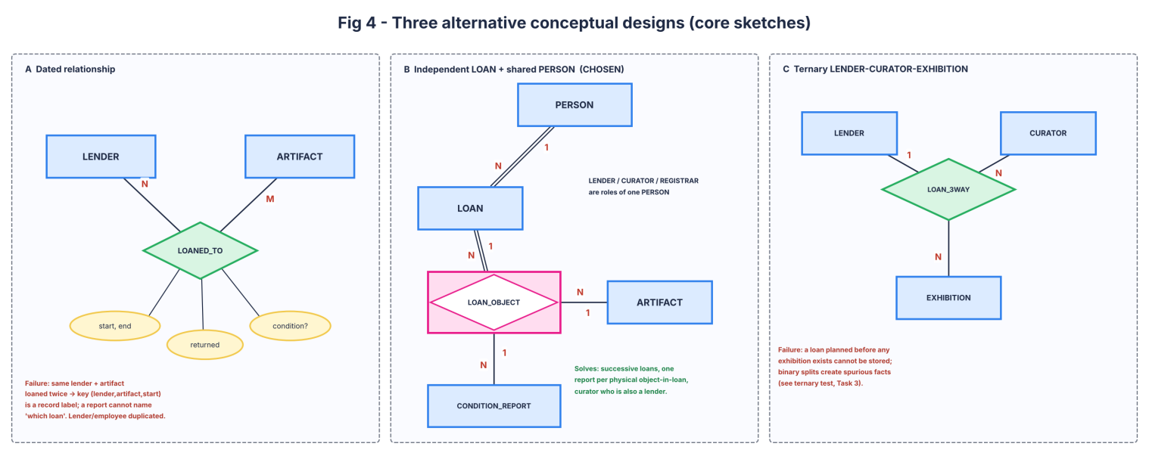
Fig 4 - core sketches of the three alternatives
 | A Dated relationship | B Independent LOAN + shared PERSON (chosen) | C Ternary LENDER-CURATOR-EXHIBITION
What differs | Identity: loan = (lender, artifact, start) record label; M:N with attributes | Identity: LOAN has its own id; degree: binary + association entity LOAN_OBJECT | Degree: one 3-way relationship; history by versioning rows
Users who create loans | Registrar (loan register) re-types lender data | Curator opens LOAN; registrar adds LOAN_OBJECT and reports | Curator needs exhibition at loan creation
Dated vs independent | Dates sit on the relationship; no way to refer to 'the loan' | Loan is an occurrence: id, period, status, contact | Dates on the ternary tuple
Separate vs shared person | Separate LENDER and EMPLOYEE (curator-lender duplicated) | Shared PERSON; roles are subtypes | Separate
Preserves custody / evidence | Weak: report can name lender+artifact, not which loan | Strong: report FK = (loan_id, artifact_id) | Medium: evidence needs the exhibition to exist
Failure case it resolves | Artifact loaned twice by same lender: two rows share the same pair | Loan planned before exhibition; curator who lends | One exhibition with several lenders' loans

Renaming LOAN does not change the model: calling the relationship LOANED_TO, LOAN_RECORD or LOAN does nothing while its identity is still (lender, artifact, start). What differs between A and B is the identity (a loan id) and the degree (LOAN_OBJECT as association entity), not the name.
Counterexample from the case: lender L1 lends artifact X in 2025 and again in 2026. Design A holds two rows with equal (L1, X) and the incoming report of 2026 cannot say which one it belongs to. In the generated data this happens: with 100 lenders, 61 artifacts have more than one loan (Q6).

Task 2 - Entities, attributes and keys
Entity | Primary key (surrogate) | Business candidate key | Notes
PERSON | person_id | email (unique) | name is NOT a key: repeated names exist even at 100 lenders
ORGANIZATION | org_id | - | contact identity only
CONTACT_PARTY | contact_id | - | category (union) of PERSON | ORGANIZATION
LENDER / EMPLOYEE / CURATOR / REGISTRAR | person_id (= FK to PERSON) | cert_no (registrar) | subtypes
ARTIFACT | artifact_id | catalog_no | one catalog description only
LOAN | loan_id | loan_ref | independent entity
LOAN_OBJECT | (loan_id, artifact_id) | - | association entity, existence-dependent on both parents
CONDITION_REPORT | report_id | (loan_id, artifact_id, report_type) | evidence of one object in one loan
EXHIBITION | exhibition_id | - | name not unique over years
DISPLAY_SLOT (weak) | (exhibition_id, slot_no) | (loan_id, artifact_id) unique | owner-scoped key; slot_no repeats in every exhibition
COLLECTION_UNIT, ARTIFACT_TYPE | unit_id, type_id | unit_name, type_name | coded concepts promoted to entities

Attribute classification
- phone = multivalued; name = composite (given_name, family_name); loan_days / custody_days / report count = derived; email, title, grade = simple single-valued; CollectionType (ARTIFACT_TYPE) = entity because it has its own data (name) and relationships.
- Source dates (loan_start, loan_end, received_date, returned_date) are stored; durations are computed.

Key justification
- Exhibition name cannot identify a slot: the same name recurs between years and slot numbers restart at 1 in each exhibition. The identifier is the pair (exhibition_id, slot_no). Test: inserting (1,1) twice fails with 'Duplicate entry 1-1 for key PRIMARY'.
- A name is not reliable: in the generated data, 11 / 258 / 300 / 300 given-name + family-name pairs occur more than once at 100 / 1,000 / 10,000 / 100,000 lenders.
- Concurrent registration: ids are AUTO_INCREMENT; InnoDB takes a short auto-increment lock so two sessions can never get the same value; business keys (catalog_no, loan_ref, email) carry UNIQUE constraints as a second guard. Test: inserting a second 'MM-00000001' fails with error 1062.

Task 3 - Relationships and structural constraints
Relationship | Cardinality | (min,max) participation | Reason
LENDER lends LOAN | 1 : N | LENDER (0,N) LOAN (1,1) | a lender may exist before lending; a loan has exactly one lender
LOAN includes ARTIFACT (via LOAN_OBJECT) | M : N | LOAN (1,N) ARTIFACT (0,N) | a loan must hold artifacts; an artifact may never be loaned
LOAN_OBJECT evidenced_by CONDITION_REPORT | 1 : N | LOAN_OBJECT (0,N) REPORT (1,1) | evidence may be missing: 70% have it in the data (Q2 shows the gaps)
EXHIBITION has DISPLAY_SLOT (identifying) | 1 : N | EXHIBITION (0,N) SLOT (1,1) | slot cannot exist without its exhibition
LOAN_OBJECT occupies DISPLAY_SLOT | 1 : 1 | LOAN_OBJECT (0,1) SLOT (0,1) | empty slots and unplaced objects both exist

- Binary vs ternary: LENDER-LOAN-CURATOR-EXHIBITION is not one ternary. A loan has one lender and one curator; the exhibition is a placement of a loan object. Three binaries (LENDS, SUPERVISES, OCCUPIES) are correct.
- Compulsory LOAN links: lender, curator, notification contact, period. Parents that can exist alone: LENDER, ARTIFACT, EXHIBITION, CURATOR.
- Dated and quantitative facts: loan_start/loan_end on LOAN (period of the agreement); received_date, returned_date, insured_value on LOAN_OBJECT (they differ per artifact within one loan; insured_value is a loan-line valuation, not catalog_value of the artifact). A missing LOAN_OBJECT row means the artifact is not in that loan, so no report or slot.

Ternary test (LENDER, CURATOR, EXHIBITION)
Instance R = {(L1,C1,E1), (L1,C2,E2), (L2,C1,E2)}. Projections: LC = {L1C1, L1C2, L2C1}; LE = {L1E1, L1E2, L2E2}; CE = {C1E1, C2E2, C1E2}.
Joining the three projections gives 4 tuples: the 3 originals plus the spurious (L1,C1,E2) (L1-C1 in LC, L1-E2 in LE, C1-E2 in CE all hold). The ternary fact is not reconstructed from binaries, but that only matters if the case really has a 3-way constraint; it does not, so binaries are chosen and the custody period stays on LOAN.

Task 4 - ER diagram
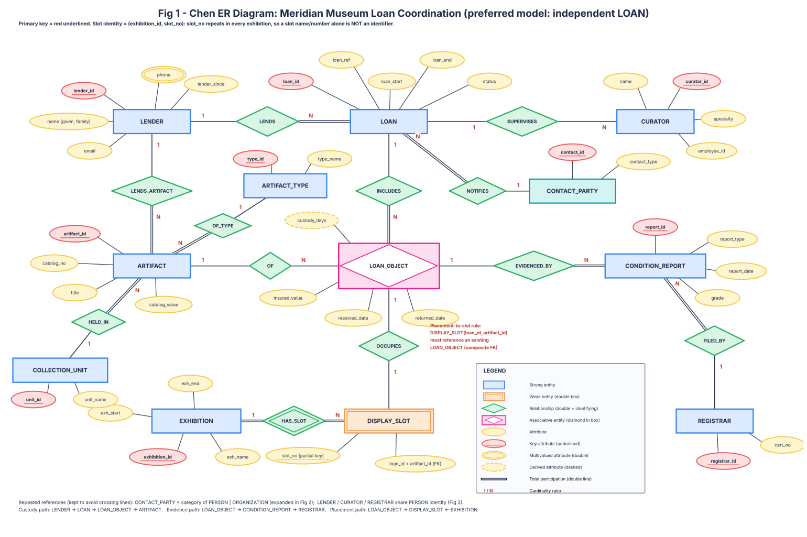
Fig 1 - Chen ER diagram of the preferred model
- Weak entity DISPLAY_SLOT: identifying owner EXHIBITION (double diamond HAS_SLOT); local key slot_no (dashed underline); full key (exhibition_id, slot_no).
- Custody path: LENDER -> LOAN -> LOAN_OBJECT -> ARTIFACT. Evidence path: LOAN_OBJECT -> CONDITION_REPORT -> REGISTRAR. Placement path: LOAN_OBJECT -> DISPLAY_SLOT <- EXHIBITION.
- Repeated references: CONTACT_PARTY and the PERSON roles are drawn as plain entities here and expanded in Fig 2, which avoids crossing lines.

Attribute catalog
Entity | Attributes
LENDER | lender_id (PK), given_name, family_name, email, phone (multi), lender_since
CURATOR | curator_id (PK), name, specialty, employee_id
REGISTRAR | registrar_id (PK), cert_no
ARTIFACT | artifact_id (PK), catalog_no, title, catalog_value, type_id, unit_id
LOAN | loan_id (PK), loan_ref, loan_start, loan_end, status; derived loan_days
LOAN_OBJECT | (loan_id, artifact_id) PK, insured_value, received_date, returned_date; derived custody_days
CONDITION_REPORT | report_id (PK), report_type, report_date, grade
EXHIBITION / DISPLAY_SLOT | exhibition_id (PK), exh_name, exh_start, exh_end / slot_no (partial key), loan_id + artifact_id (FK)
ARTIFACT_TYPE / COLLECTION_UNIT / CONTACT_PARTY | type_id, type_name / unit_id, unit_name / contact_id, contact_type

Task 5 - EER model
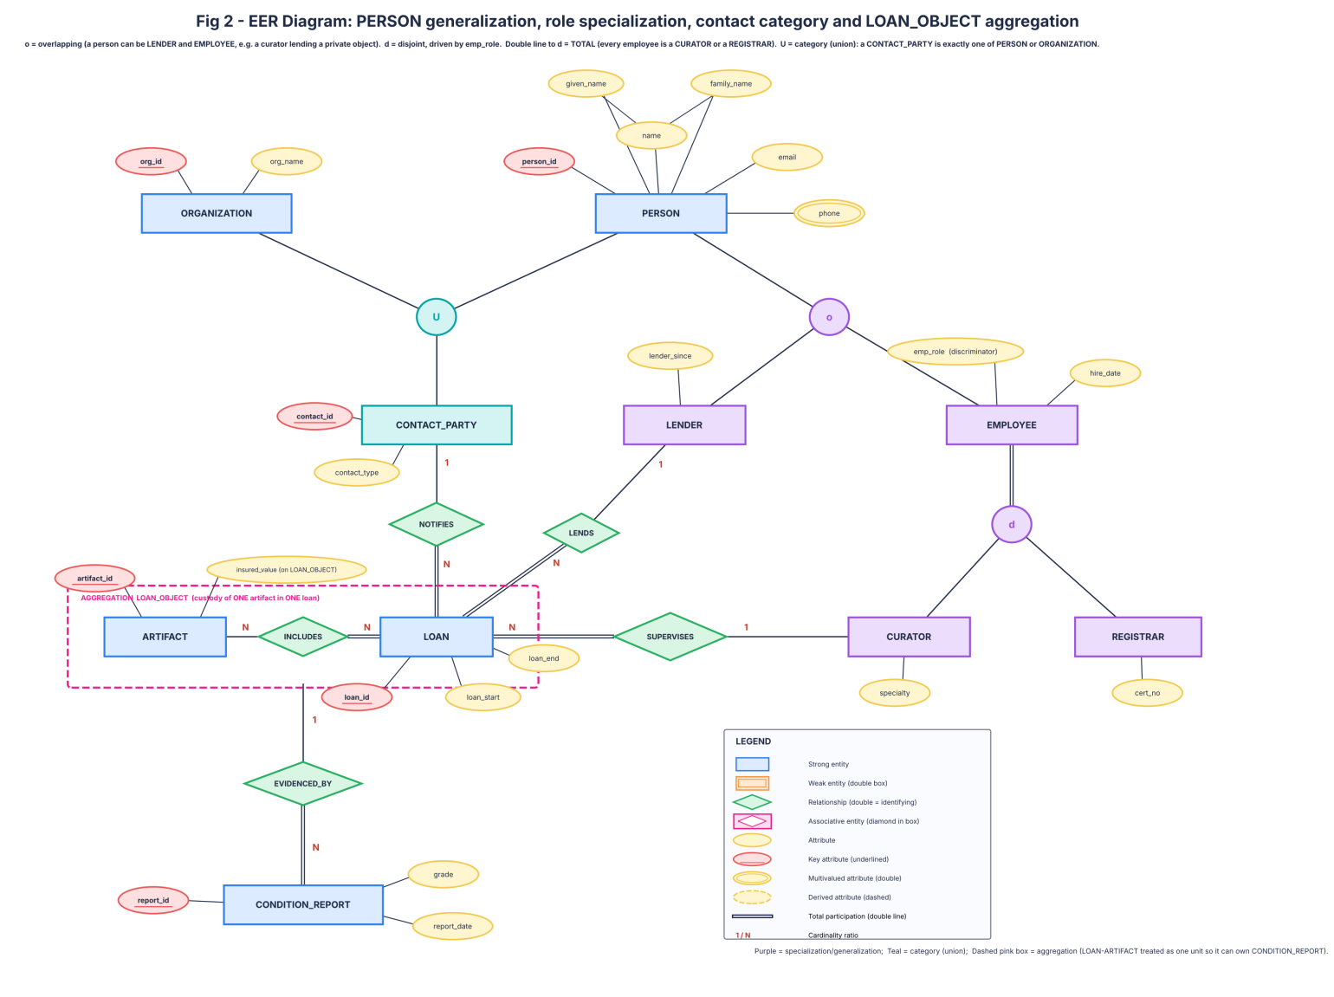
Fig 2 - EER diagram: specialization, category and aggregation
- Generalization: LENDER and EMPLOYEE become subtypes of PERSON; EMPLOYEE is specialized into CURATOR and REGISTRAR.
- Overlap: LENDER vs EMPLOYEE overlap (o): a curator can lend a private collection. In the data 1/4/41/416 curators are also lenders. CURATOR vs REGISTRAR are disjoint (d).
- Coverage: employee specialization is total (every employee is a curator or registrar); PERSON to LENDER/EMPLOYEE is partial (a person may be a contact only).
- Discriminator emp_role controls membership: CURATOR/REGISTRAR rows carry emp_role and a composite FK (person_id, emp_role) to EMPLOYEE; a curator row for a registrar fails (tested, Task 8).
- Category (union): CONTACT_PARTY is exactly one of PERSON or ORGANIZATION, enforced by a CHECK on contact_type and the two nullable FKs.
- Aggregation: LOAN-includes-ARTIFACT is treated as one unit (LOAN_OBJECT) so that CONDITION_REPORT attaches to the object-in-loan.
- Versus one wide record: a single table with all lender, curator and registrar columns would hold NULLs for unused roles, duplicate a curator-lender, and could not say which role a person plays. Subtypes keep only the facts of each role.

Task 6 - Weak entities and complex attributes
- DISPLAY_SLOT: owner EXHIBITION, local key slot_no. An identifying link is part of the primary key; an ordinary FK (such as LOAN.lender_id) is not. Deleting an exhibition cascades to its slots.
- Multiple phones: PERSON_PHONE(person_id, phone_no) one row per number, PK both columns. 184 / 1,769 / 17,965 / 180,347 rows at the four sizes. A comma list cannot be indexed or constrained.
- Name components given_name and family_name are stored; the full name is derived. Computed (not stored): loan_days = loan_end - loan_start; custody_days = returned_date - received_date; report count per object. Storing them would go stale when a date is corrected.
- Artifact value vs loan-line valuation: catalog_value on ARTIFACT; insured_value on LOAN_OBJECT, because the same artifact is insured differently in each loan.
- Coded concepts promoted to entities: ARTIFACT_TYPE and COLLECTION_UNIT (own names, own relationships to many artifacts). Plain domains kept as ENUM: report grade, report type, loan status.

Task 7 - Relational mapping
Rule applied | Result
Strong entities | PERSON, ORGANIZATION, ARTIFACT, LOAN, EXHIBITION, COLLECTION_UNIT, ARTIFACT_TYPE, CONDITION_REPORT
Specialization (option 8A: one relation per subtype, PK = FK to supertype) | LENDER, EMPLOYEE, CURATOR, REGISTRAR. Chosen because roles overlap, so single-table (8C) or table-per-leaf with copied columns (8B) would duplicate a curator who lends
Weak entity | DISPLAY_SLOT PK (exhibition_id, slot_no), FK exhibition_id ON DELETE CASCADE
1:N | FK on the N side: LOAN.lender_id, LOAN.curator_id, ARTIFACT.type_id, ARTIFACT.unit_id, CONDITION_REPORT(loan_id,artifact_id)
M:N with attributes | LOAN_OBJECT(loan_id, artifact_id, insured_value, received_date, returned_date)
1:1 optional | DISPLAY_SLOT(loan_id, artifact_id) composite FK to LOAN_OBJECT, UNIQUE so an object has one slot
Multivalued | PERSON_PHONE
Category | CONTACT_PARTY(contact_type, person_id, org_id) + CHECK exactly one

Deletion behaviour: lender, loan, loan object and artifact use RESTRICT (default), so historical custody and evidence cannot disappear (tested: deleting a lender with artifacts fails with error 1451). Only phones and slots cascade, because they have no history value without their owner.
Schema catalog: the full DDL is in schema.sql and the foreign keys listed above are exactly those created (checked by running it).

Task 8 - Implementation and instances
Files: schema.sql (DDL), gen.py (seed 4211 + N, TSV files), load.sh (LOAD DATA). Source-key rule in the generator: a child row takes foreign keys only from ids already written for its parent file, in fixed order, from one random.Random(4211+N). Every artifact is first assigned its single lender; a loan then picks only artifacts of its own lender that are free on its start date, so custody never overlaps. Loan period validity is a row-level CHECK (loan_end > loan_start).
Table | 100 | 1,000 | 10,000 | 100,000
PERSON | 107 | 1,033 | 10,334 | 103,334
LENDER | 100 | 1,000 | 10,000 | 100,000
EMPLOYEE | 8 | 37 | 375 | 3,750
ARTIFACT | 750 | 7,500 | 75,000 | 750,000
LOAN | 150 | 1,500 | 15,000 | 150,000
LOAN_OBJECT | 389 | 3,920 | 38,740 | 389,345
CONDITION_REPORT | 384 | 4,147 | 41,184 | 415,819
EXHIBITION | 6 | 63 | 620 | 6,230
DISPLAY_SLOT | 136 | 1,576 | 16,719 | 167,041
PERSON_PHONE | 184 | 1,769 | 17,965 | 180,347

One stable schema, many instances: the same DDL created meridian_100 ... meridian_100000; only rows differ.

Invalid writes and the real error text
Attempt | Result | Message
Identity: duplicate catalog_no | REJECTED | 1062: Duplicate entry 'MM-00000001' for key 'catalog_no'
Identity: duplicate (exhibition, slot_no) | REJECTED | 1062: Duplicate entry '1-1' for key 'PRIMARY'
Identity: artifact with unknown lender | REJECTED | 1452: Cannot add or update a child row: a foreign key constraint fails (`meridian_1000`.`ARTIFACT`, CONSTRAINT `ARTIFACT_ibfk_3` FOREIGN KEY (`current_lender_id`) REFERENCES `LENDER` (`person_id`))
Workflow: loan_end before loan_start | REJECTED | 4025: CONSTRAINT `ck_loan_period` failed for `meridian_1000`.`LOAN`
Workflow: returned before received | REJECTED | 4025: CONSTRAINT `ck_lo_dates` failed for `meridian_1000`.`LOAN_OBJECT`
Workflow: slot with artifact not on that loan | REJECTED | 1452: Cannot add or update a child row: a foreign key constraint fails (`meridian_1000`.`DISPLAY_SLOT`, CONSTRAINT `DISPLAY_SLOT_ibfk_2` FOREIGN KEY (`loan_id`, `artifact_id`) REFERENCES `LOAN_OBJECT` (`loan_id`, `artifact_id`))
Workflow: slot with only half of the pair | REJECTED | 4025: CONSTRAINT `ck_slot_pair` failed for `meridian_1000`.`DISPLAY_SLOT`
Workflow: condition report for object not in loan | REJECTED | 1452: Cannot add or update a child row: a foreign key constraint fails (`meridian_1000`.`CONDITION_REPORT`, CONSTRAINT `CONDITION_REPORT_ibfk_1` FOREIGN KEY (`loan_id`, `artifact_id`) REFERENCES `LOAN_OBJECT` (`loan_id`, `artifact
Category: contact is both person and organization | REJECTED | 4025: CONSTRAINT `ck_contact_exactly_one` failed for `meridian_1000`.`CONTACT_PARTY`
Category: curator row for a registrar's person_id | REJECTED | 1452: Cannot add or update a child row: a foreign key constraint fails (`meridian_1000`.`CURATOR`, CONSTRAINT `CURATOR_ibfk_1` FOREIGN KEY (`person_id`, `emp_role`) REFERENCES `EMPLOYEE` (`person_id`, `emp_role`))
Category: curator row with wrong role value | REJECTED | 4025: CONSTRAINT `ck_curator_role` failed for `meridian_1000`.`CURATOR`
Delete: remove a lender who has loans | REJECTED | 1451: Cannot delete or update a parent row: a foreign key constraint fails (`meridian_1000`.`ARTIFACT`, CONSTRAINT `ARTIFACT_ibfk_3` FOREIGN KEY (`current_lender_id`) REFERENCES `LENDER` (`person_id`))

Rules a row-level CHECK cannot enforce (both ACCEPTED by the database)
- LOAN_OBJECT received_date set to 2000-01-01 although loan 1 starts 2024-01-01: ACCEPTED (cross-table rule, needs trigger).
- Artifact 489 placed in a second loan with identical dates: ACCEPTED (overlapping custody; needs trigger).
- Also cross-table: a loan's artifacts must belong to the loan's lender; loan period must cover the display period (Q7 finds 35 conflicts at 100 lenders). These need triggers, a transactional procedure or audit queries.

Task 9 - Validation with use-case queries
Median of 5 runs, result rows and number of explicit JOINs. Reference date 2026-10-31.
Query | JOINs | 100 | 1,000 | 10,000 | 100,000
Q1 Overdue loans still open | 2 | 10 / 0.35 ms | 101 / 0.92 ms | 1,088 / 5.59 ms | 10,696 / 76.84 ms
Q2 Artifacts without condition evidence | 1 | 528 / 2.25 ms | 5,059 / 12.33 ms | 50,803 / 126.01 ms | 505,893 / 1341.74 ms
Q3 Loans holding 4+ artifacts | 1 | 49 / 0.83 ms | 448 / 12.77 ms | 4,266 / 57.11 ms | 43,684 / 1144.24 ms
Q4 Artifacts in museum custody today | 2 | 138 / 1.22 ms | 1,410 / 10.0 ms | 13,420 / 99.56 ms | 134,448 / 1319.88 ms
Q5 Inventory of exhibition 1 (slot order) | 4 | 45 / 0.5 ms | 16 / 0.39 ms | 19 / 0.7 ms | 17 / 0.93 ms
Q6 Artifacts with successive loans | 1 | 61 / 0.92 ms | 527 / 7.82 ms | 5,315 / 109.27 ms | 53,349 / 3755.54 ms
Q7 Loan expires before exhibition ends | 2 | 35 / 0.5 ms | 615 / 5.1 ms | 6,654 / 93.29 ms | 66,836 / 831.39 ms
Q8 Slot artifact not owned by loan lender (integrity) | 2 | 0 / 0.38 ms | 0 / 3.44 ms | 0 / 48.76 ms | 0 / 776.72 ms

SQL (as executed)
Q1 Overdue loans still open
SELECT l.loan_ref, p.family_name, l.loan_end FROM LOAN l JOIN LENDER ld ON ld.person_id=l.lender_id JOIN PERSON p ON p.person_id=ld.person_id WHERE l.loan_status='OPEN' AND l.loan_end < '2026-10-31' ORDER BY l.loan_end, l.loan_id
-- first rows at 100 lenders: LN-2024-0000011 | Pillar | 2024-09-24; LN-2024-0000009 | Das | 2025-04-06; LN-2024-0000047 | Joshi | 2025-04-26
Q2 Artifacts without condition evidence
SELECT a.artifact_id, a.catalog_no FROM ARTIFACT a LEFT JOIN CONDITION_REPORT cr ON cr.artifact_id=a.artifact_id WHERE cr.report_id IS NULL ORDER BY a.artifact_id
-- first rows at 100 lenders: 2 | MM-00000002; 4 | MM-00000004; 6 | MM-00000006
Q3 Loans holding 4+ artifacts
SELECT l.loan_ref, COUNT(*) AS n_artifacts FROM LOAN l JOIN LOAN_OBJECT lo ON lo.loan_id=l.loan_id GROUP BY l.loan_id, l.loan_ref HAVING COUNT(*)>=4 ORDER BY n_artifacts DESC, l.loan_id
-- first rows at 100 lenders: LN-2024-0000002 | 5; LN-2024-0000007 | 5; LN-2024-0000014 | 5
Q4 Artifacts in museum custody today
SELECT a.catalog_no, l.loan_ref, l.loan_end FROM LOAN_OBJECT lo JOIN LOAN l ON l.loan_id=lo.loan_id JOIN ARTIFACT a ON a.artifact_id=lo.artifact_id WHERE lo.received_date <= '2026-10-31' AND lo.returned_date IS NULL ORDER BY a.artifact_id
-- first rows at 100 lenders: MM-00000001 | LN-2025-0000102 | 2027-04-27; MM-00000005 | LN-2026-0000141 | 2027-02-06; MM-00000014 | LN-2026-0000145 | 2027-04-25
Q5 Inventory of exhibition 1 (slot order)
SELECT ds.slot_no, a.catalog_no, a.title, l.loan_ref FROM DISPLAY_SLOT ds JOIN EXHIBITION e ON e.exhibition_id=ds.exhibition_id JOIN LOAN_OBJECT lo ON lo.loan_id=ds.loan_id AND lo.artifact_id=ds.artifact_id JOIN LOAN l ON l.loan_id=lo.loan_id JOIN ARTIFACT a ON a.artifact_id=lo.artifact_id WHERE e.exhibition_id=1 ORDER BY ds.slot_no
-- first rows at 100 lenders: 1 | MM-00000374 | Ceramic no.374 | LN-2025-0000082; 2 | MM-00000160 | Ceramic no.160 | LN-2025-0000084; 3 | MM-00000664 | Textile no.664 | LN-2025-0000089
Q6 Artifacts with successive loans
SELECT a.catalog_no, COUNT(*) AS n_loans FROM LOAN_OBJECT lo JOIN ARTIFACT a ON a.artifact_id=lo.artifact_id GROUP BY a.artifact_id, a.catalog_no HAVING COUNT(*)>1 ORDER BY n_loans DESC, a.artifact_id
-- first rows at 100 lenders: MM-00000020 | 3; MM-00000041 | 3; MM-00000043 | 3
Q7 Loan expires before exhibition ends
SELECT e.exhibition_id, ds.slot_no, l.loan_ref, l.loan_end, e.exh_end FROM DISPLAY_SLOT ds JOIN EXHIBITION e ON e.exhibition_id=ds.exhibition_id JOIN LOAN l ON l.loan_id=ds.loan_id WHERE l.loan_end < e.exh_end ORDER BY e.exhibition_id, ds.slot_no
-- first rows at 100 lenders: 1 | 4 | LN-2025-0000096 | 2026-08-04 | 2026-09-21; 1 | 5 | LN-2025-0000099 | 2026-08-30 | 2026-09-21; 1 | 9 | LN-2025-0000108 | 2026-07-04 | 2026-09-21
Q8 Slot artifact not owned by loan lender (integrity)
SELECT ds.exhibition_id, ds.slot_no FROM DISPLAY_SLOT ds JOIN LOAN l ON l.loan_id=ds.loan_id JOIN ARTIFACT a ON a.artifact_id=ds.artifact_id WHERE a.current_lender_id <> l.lender_id
-- first rows at 100 lenders: (empty result set)

Flat LOAN file anomalies (100 lenders)
- Update: lender 88 appears in 14 rows (4 loans). Changing their email means 14 updates; changing one row leaves the file contradicting itself.
- Insertion: 21 of 100 lenders have no loan, so they cannot be stored at all in a flat file keyed by loan and artifact.
- Deletion: lender 1 appears in exactly one row; deleting that row also erases the lender's name and email.
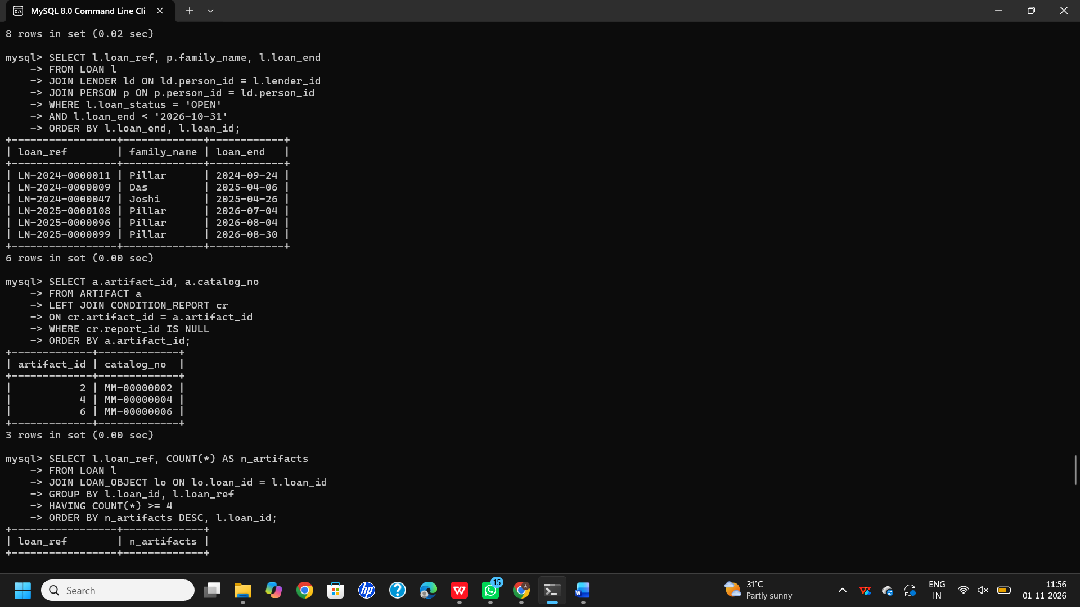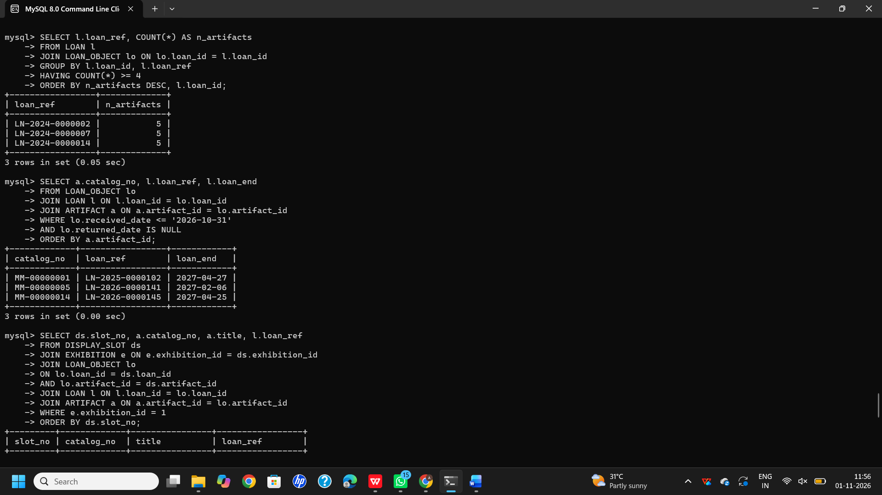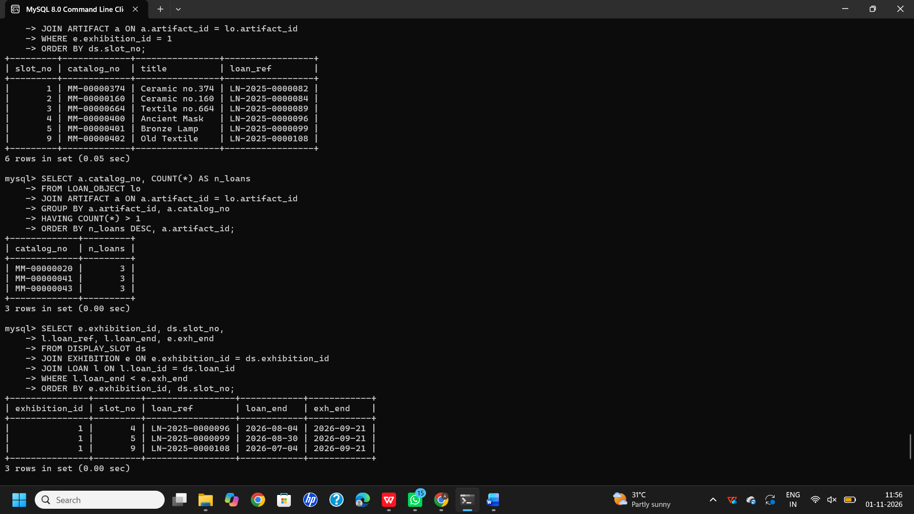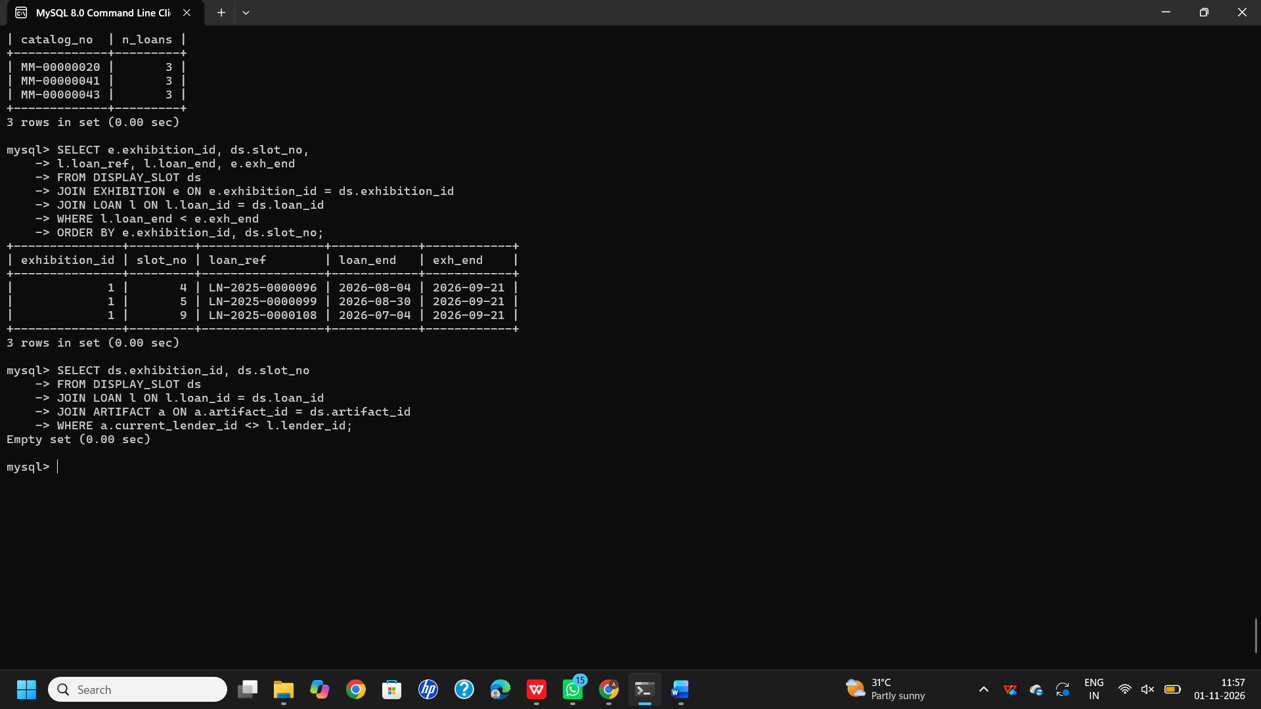

Task 10 - Comparison with file, hierarchical and network models
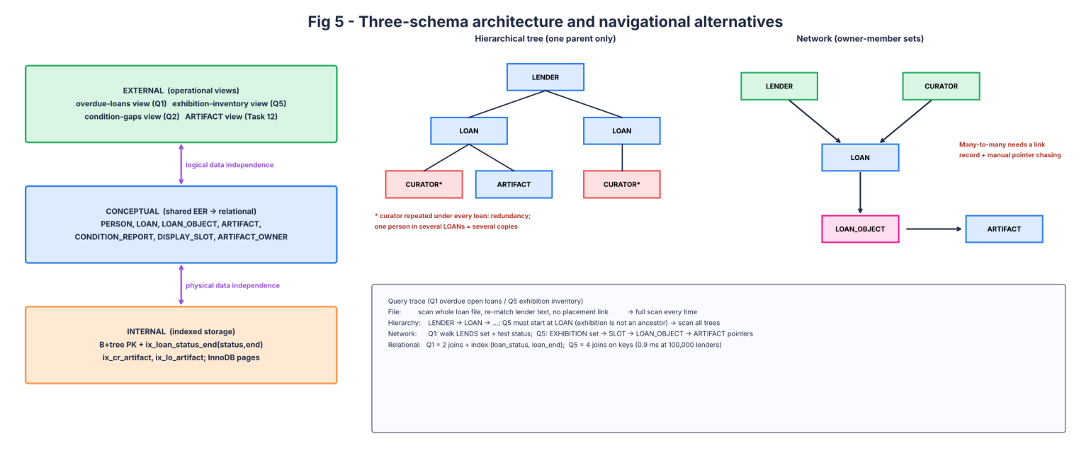
Fig 5 - three-schema architecture and navigational models
- Hierarchy: one parent per node, so a curator or artifact reached from several loans is stored again under each; exhibition inventory (Q5) is not on a LENDER-rooted path.
- Network: sets LENDS, SUPERVISES, INCLUDES are navigable, but the M:N between LOAN and ARTIFACT needs a link record and programmer-written pointer chasing.
- Person in several loans: file = repeated text; tree = repeated nodes; network = several set memberships; relational = one PERSON row referenced by FK.
- Views, conceptual model, internal: external = overdue-loan, inventory and condition-gap views; conceptual = the relational schema above; internal = B+tree primary keys and secondary indexes such as (loan_status, loan_end).
- Concurrency: for two sessions updating the same LOAN row, the lock manager (row lock in InnoDB), transaction manager and redo/undo log serialize the writes; the second waits, then sees the committed value.

Task 11 - Recommendation
Recommended: Alternative B. It is the only one where a condition report points to the object in a specific loan, successive loans are separate rows, and a curator who lends is one person.
Requirement | Entity / key / association | Evidence
Successive loans of one artifact | LOAN_OBJECT (loan_id, artifact_id) | Q6: 61 .. 53,349 artifacts with 2+ loans
Evidence by object, not lender | CONDITION_REPORT FK (loan_id, artifact_id) | FK rejects a report for an object not in the loan
Slot numbering inside exhibition | DISPLAY_SLOT (exhibition_id, slot_no) | duplicate (1,1) rejected
Curator lends | PERSON + LENDER + CURATOR | overlap rows 1 / 4 / 41 / 416
Loan expiry vs display | none (not enforced) | Q7 returns 35 .. 66,836 conflicts

- Tested: all keys, CHECKs and FKs in Task 8; all eight queries at four sizes.
- Assertions not tested: concurrent-insert behaviour under heavy load; real museum volumes.
- Limitations: overlap of custody periods, loan-period vs received_date, and loan-vs-exhibition dates are cross-table rules not in the schema (shown accepted in Task 8); names are not identity; one lender per loan.
- At 100,000 lenders (about 750,000 artifacts, 150,000 loans, 389,000 loan objects) point queries stay in milliseconds; full-scan reports take 0.8-3.8 s and would need summary tables or partitioning.

Task 12 - Changed requirement: shared, changing ownership (8)
Decision: MODIFY (extend). Keep the custody model; replace the single-owner assumption with a versioned ownership association.

A. Impact analysis
- Invalidated assumption: 'each artifact has one current lender' (ARTIFACT.current_lender_id). It cannot record shares, nor that shares change while a loan runs.
- Affected: ARTIFACT (the owner column), the rule 'loan lender = artifact lender' (now: the lender must be an owner on loan_start), Q8 integrity query, ownership temporal rule (shares of current owners sum to 100%).
- The old identifier (artifact_id, lender_id) no longer states the fact: the same pair needs a period and a share, so identity becomes (artifact_id, owner_id, valid_from).
- Trace: external views that read current_lender_id keep working through a view; conceptual layer gains ARTIFACT_OWNER; internal layer gains the index on (owner_id) and PK on (artifact_id, owner_id, valid_from).

B. Evaluation of the original design
- EXHIBITION and DISPLAY_SLOT still work: they refer to LOAN_OBJECT, not to an owner. Condition reports are unaffected.
- Stable keys: loan_id, (loan_id, artifact_id), report_id, (exhibition_id, slot_no). Constraint that must change: ARTIFACT.current_lender_id FK.
- Rejected alternatives: A (dated relationship) would mix ownership and custody dates in one record; C (ternary) has no place for owners at all. Neither improves.

C. Adaptation
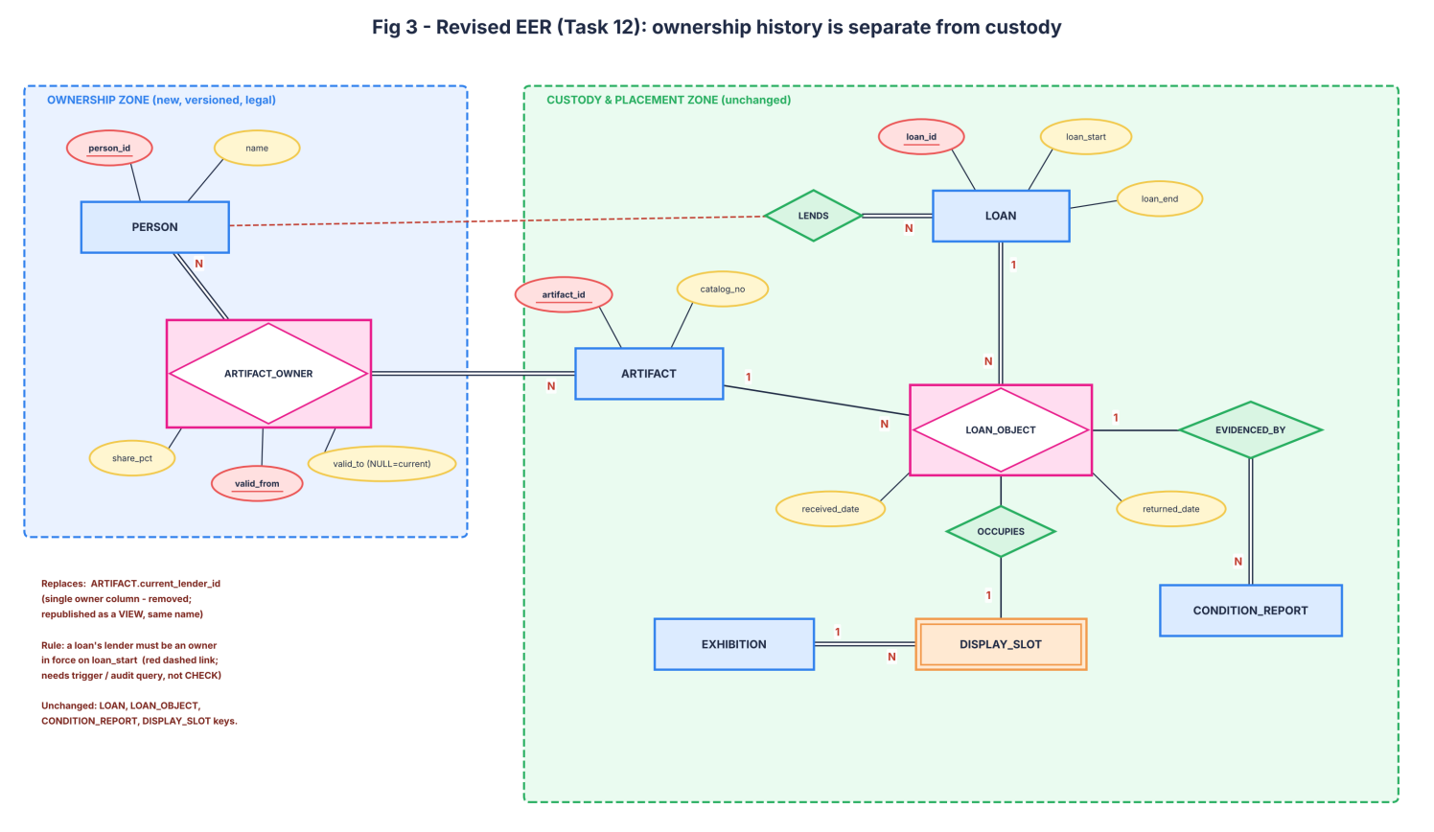
Fig 3 - revised EER: ARTIFACT_OWNER separates ownership from custody

- New construct: ARTIFACT_OWNER (artifact_id, owner_id, valid_from, valid_to, share_pct), an associative entity between PERSON and ARTIFACT. The old ARTIFACT-LENDER association is replaced; LOAN-LOAN_OBJECT is untouched.
- Migration (task12_migration.sql): each old current_lender_id becomes one 100% row; the column is dropped; ARTIFACT_CORE holds the base table and a view named ARTIFACT keeps the old interface.
- A first draft of the migration used valid_from = lender_since. The audit query 'lender not owner on loan_start' found 4 / 56 / 635 / 5921 violations (100 / 1,000 / 10,000 / 100,000) because some loans began before lender_since. The fix (valid_from = earlier of lender_since and first loan start) brought it to 0 at all sizes.

D. Evidence-based defence
- Live test (1,000 lenders): artifact 709 is in open loan 7. Ownership changes from 100% to 60% / 40% on 2026-10-31: the old row is closed, two rows are added. The loan, the loan-object dates and the condition reports (1 before, 1 after) are unchanged: custody snapshot identical = True. Open shares total 100.00.
- Query that exposes a wrong migration: SELECT artifact_id, SUM(share_pct) FROM ARTIFACT_OWNER WHERE valid_to IS NULL GROUP BY artifact_id HAVING SUM(share_pct)<>100. After a deliberate 60 + 70 error it returned artifact 709 with 130.00; on the migrated data it returns 0 rows at all four sizes.
Check / cost | 100 | 1,000 | 10,000 | 100,000
ARTIFACT_OWNER rows (= artifacts at migration) | 750 | 7,500 | 75,000 | 750,000
Migration time (s) | 0.04 | 0.14 | 0.74 | 9.31
Share-sum check (ms), rows | 0.41 ms, 0 | 5.0 ms, 0 | 22.89 ms, 0 | 361.19 ms, 0
Artifacts with no current owner (ms), rows | 0.9 ms, 0 | 18.68 ms, 0 | 112.38 ms, 0 | 1278.64 ms, 0
Old Q8 through the view (ms), rows (was 0.38 / 3.44 / 48.8 / 777 ms) | 1.0 ms, 0 | 19.04 ms, 0 | 172.58 ms, 0 | 2025.51 ms, 0

- Effect on generated data: one 100% owner row per artifact initially (relationship count = artifact count); each later share change adds rows. Extra cost: the view makes the old Q8 about 2.6x slower at 100,000 lenders (777 ms to 2,026 ms), and the share-sum rule needs a trigger or a periodic audit (not expressible as CHECK).
- Decision tied to the requirement: custody evidence (LOAN, LOAN_OBJECT, reports, slots) stays unchanged and only ownership history is added, so ownership share changes cannot rewrite custody periods or condition evidence.

MARK DISTRIBUTION
Task | Marks
Task 1 – Requirements and Alternative Designs | 5
Task 2 – Entities, Attributes and Keys | 2
Task 3 – Relationships and Constraints | 6
Task 4 – ER Diagram | 4
Task 5 – EER Modelling | 3
Task 6 – Weak Entities and Complex Attributes | 3
Task 7 – Relational Mapping | 4
Task 8 – Implementation and Instances | 4
Task 9 – Design Validation | 3
Task 10 – Comparison of Data Models | 4
Task 11 – Final Design Recommendation | 4
Subtotal | 42
Task 12 – Re-evaluation Design Challenge | 8
TOTAL | 50

