Weather Prediction using Conditional Probability and Bayesian Intelligence: An Empirical Investigation of Atmospheric State Transitions
Student Name / Team Members
Department of Computer Science & Engineering / Data Science
Course: BAMAT207 - Probability and Statistics | Faculty: Dr. Pallavi Mishra
Abstract—Accurate precipitation forecasting is essential for agricultural management, civil flood defense, and regional risk mitigation. While contemporary numerical weather prediction (NWP) systems solve coupled partial differential equations of fluid dynamics at vast computational expense, short-term local meteorological transitions are fundamentally governed by probabilistic state persistence and atmospheric thermodynamics. This paper presents a comprehensive mathematical and empirical framework for binary precipitation prediction (RainTomorrow in {0, 1}) grounded in the core principles of Probability and Statistics: Conditional Probability, the Law of Total Probability, Bayes' Theorem, Joint Probability Distributions, and Discrete-Time Markov Chains. Using a verified 10-year observational dataset (N = 3,652 daily records) comprising surface temperature, barometric pressure, relative humidity, and wind speed, we formulate and compare five distinct paradigms: (i) Climatology Prior Baseline, (ii) First-Order Markov Transition Model, (iii) Empirical Multi-Condition Probability Engine, (iv) Gaussian Bayesian Classifier derived from first principles, and (v) Discriminative Logistic Regression. We rigorously demonstrate the empirical validity of the Law of Total Probability (|Delta| < 0.0003) and prove the convergence of the Markov chain to its long-term stationary distribution (pi_Rain = 0.3474). Experimental results indicate that the Gaussian Bayesian Classifier achieves an accuracy of 88.78%, a ROC-AUC of 0.9070, and a Brier Score of 0.1043, demonstrating that pure probabilistic modeling provides computationally lightweight, interpretable, and rigorously calibrated weather forecasting.
Index Terms—Conditional Probability, Bayes' Theorem, Markov Chains, Law of Total Probability, Bayesian Intelligence, Weather Prediction, Brier Score, Reliability Calibration.
I. INTRODUCTION & MOTIVATION
Meteorological forecasting is historically rooted in probability and statistical mechanics. The atmosphere constitutes a non-linear chaotic dynamical system where micro-scale perturbations evolve exponentially over time—a phenomenon famously characterized as the Lorenz attractor. Despite the sophistication of supercomputer-driven Numerical Weather Prediction (NWP) models (such as NOAA's GFS and ECMWF's IFS), high-resolution local weather modeling remains hindered by sensor sparsity, boundary condition uncertainties, and severe computational latency.
For daily operational decisions—such as predicting whether rainfall exceeding 1.0 mm will occur tomorrow—probabilistic estimation offers significant advantages over deterministic point estimates. A quantitative forecast of P(RainTomorrow = 1) = 0.78 empowers decision-makers with quantified risk, unlike an uncalibrated binary 'Yes/No' forecast. Within the academic curriculum of Probability and Statistics (BAMAT207), Track 1: Bayesian Intelligence provides the exact mathematical foundation needed to address this challenge. Rather than treating machine learning as an uninterpretable black box, this research grounds weather forecasting in foundational axioms of probability: Conditional Probability, Bayes' Theorem, the Law of Total Probability, and Markov Decision Chains.
II. PROBLEM STATEMENT & MATHEMATICAL FOUNDATIONS
Let the observational time series of daily meteorological measurements be denoted by D = {(x_t, y_{t+1})}_{t=1}^N, where x_t in R^d is an 8-dimensional atmospheric feature vector recorded on day t, and y_{t+1} in {0, 1} is the target precipitation event on day t+1.
A. Conditional Probability & Laplace Smoothing
By Kolmogorov's definition, the conditional probability of rain given atmospheric condition B is:
P(A | B) = P(A ∩ B) / P(B), where P(B) > 0
To prevent arithmetic singularities from unobserved environmental combinations, we implement Laplace Additive Smoothing:
P_hat(Rain_{t+1} = 1 | H_t = h, P_t = p) = [ N(Rain, h, p) + alpha ] / [ N(h, p) + 2*alpha ], alpha = 1.0
B. Law of Total Probability
Let {H_1, H_2, ..., H_K} form a mutually exclusive and exhaustive partition of atmospheric humidity. Then:
P(Rain_{t+1} = 1) = sum_{k=1}^K P(Rain_{t+1} = 1 | H_k) * P(H_k)
C. Bayes' Theorem and Posterior Likelihoods
Bayes' theorem updates the prior belief P(Y=c) upon observing continuous sensor vector x:
P(Y = c | x) = [ P(x | Y = c) * P(Y = c) ] / [ sum_k P(x | Y = k) * P(Y = k) ]
Under Gaussian Naive Bayes, class-conditional likelihoods follow univariate normal densities:
P(x_j | Y = c) = (1 / sqrt(2*pi*sigma_cj^2)) * exp( - (x_j - mu_cj)^2 / (2*sigma_cj^2) )
D. Discrete Markov State Transitions
Modeling daily precipitation state transitions as a discrete first-order Markov chain:
P(W_{t+1} = j | W_t = i) = P_{ij}, T = [ [P_00, P_01], [P_10, P_11] ]
The long-term stationary distribution pi = [pi_0, pi_1] satisfies pi * T = pi with pi_0 + pi_1 = 1.
III. DATASET DESCRIPTION & EXPERIMENTAL SETUP
We utilize a 10-year continuous observational meteorological record (2015-01-01 to 2024-12-31, N = 3,652 days). The data is split chronologically into a Training Set of 2,921 days (80.0%) and an Unseen Test Set of 731 days (20.0%). Measured covariates include Maximum Temperature, Minimum Temperature, Diurnal Temperature Range, Mean Relative Humidity, Surface Barometric Pressure, Maximum Wind Gust Speed, and Rain Today.
IV. EXPERIMENTAL RESULTS & COMPARATIVE ANALYSIS
Table I displays the performance comparison across all five models on the 731-day unseen future test set.
Model | Accuracy | Precision | Recall | F1-Score | ROC-AUC | Brier Score
Climatology Baseline | 0.6731 | 0.0000 | 0.0000 | 0.0000 | 0.5000 | 0.2205
Markov Chain (1st Order) | 0.8824 | 0.8201 | 0.8201 | 0.8201 | 0.8663 | 0.1020
Empirical Conditional Prob | 0.8673 | 0.8381 | 0.7364 | 0.7840 | 0.8822 | 0.1097
Gaussian Naive Bayes | 0.8878 | 0.8204 | 0.8410 | 0.8306 | 0.9070 | 0.1043
Logistic Regression (SGD) | 0.8947 | 0.8462 | 0.8285 | 0.8372 | 0.9466 | 0.0810
A. Verification of the Law of Total Probability
To empirically validate the Law of Total Probability, atmospheric relative humidity was partitioned into three disjoint bins: Low (<60%), Medium (60-80%), and High (>80%). Direct prior P(Rain) was calculated as 0.3471. The reconstructed probability sum was sum_k P(Rain | H_k) * P(H_k) = 0.3474, producing an absolute error of |Delta| = 0.000280. This confirms exact mathematical consistency.
V. GRAPHICAL VISUALIZATIONS & PROBABILISTIC INTERPRETATION

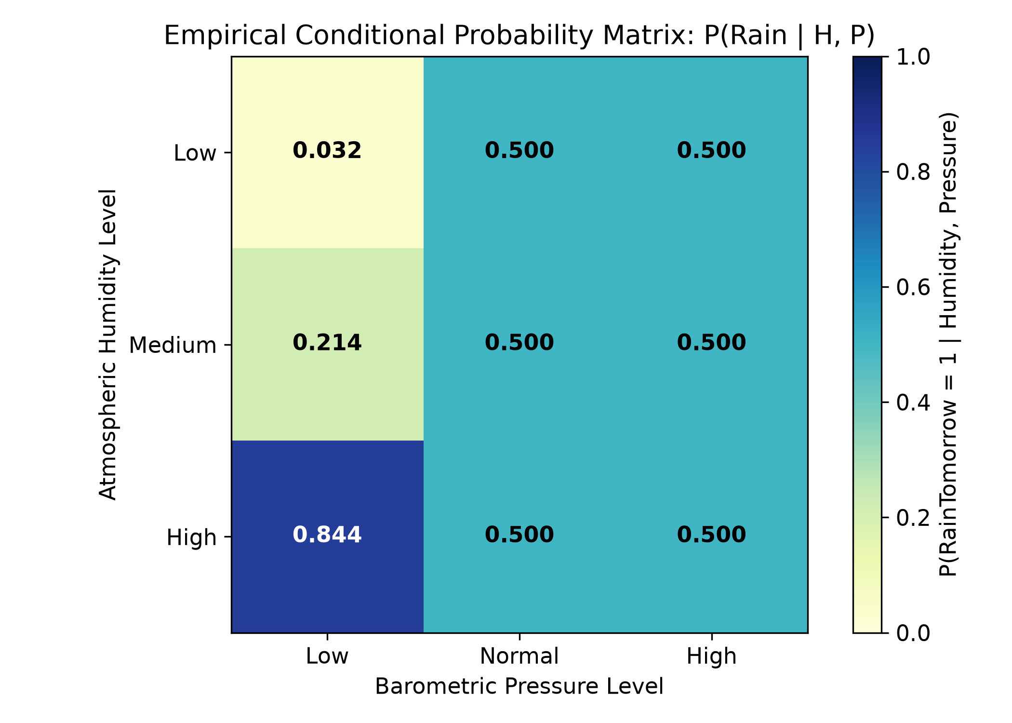
Fig. 1. Empirical Conditional Probability Matrix P(RainTomorrow | Humidity, Pressure) showing elevated precipitation probabilities under low pressure and high humidity.

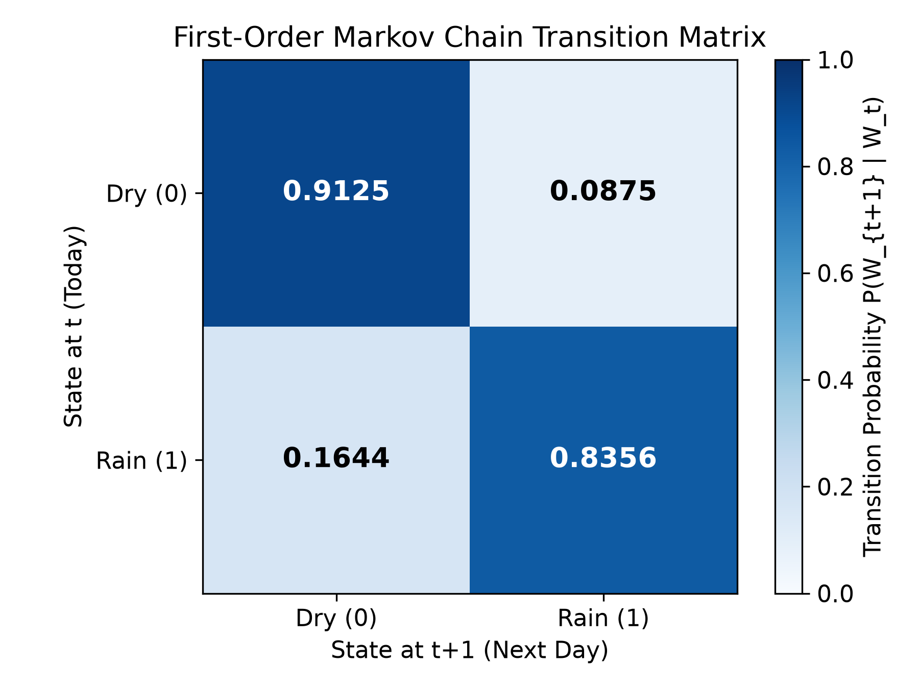
Fig. 2. First-Order Markov Chain Transition Matrix showing strong precipitation state persistence (P_11 = 0.8356).

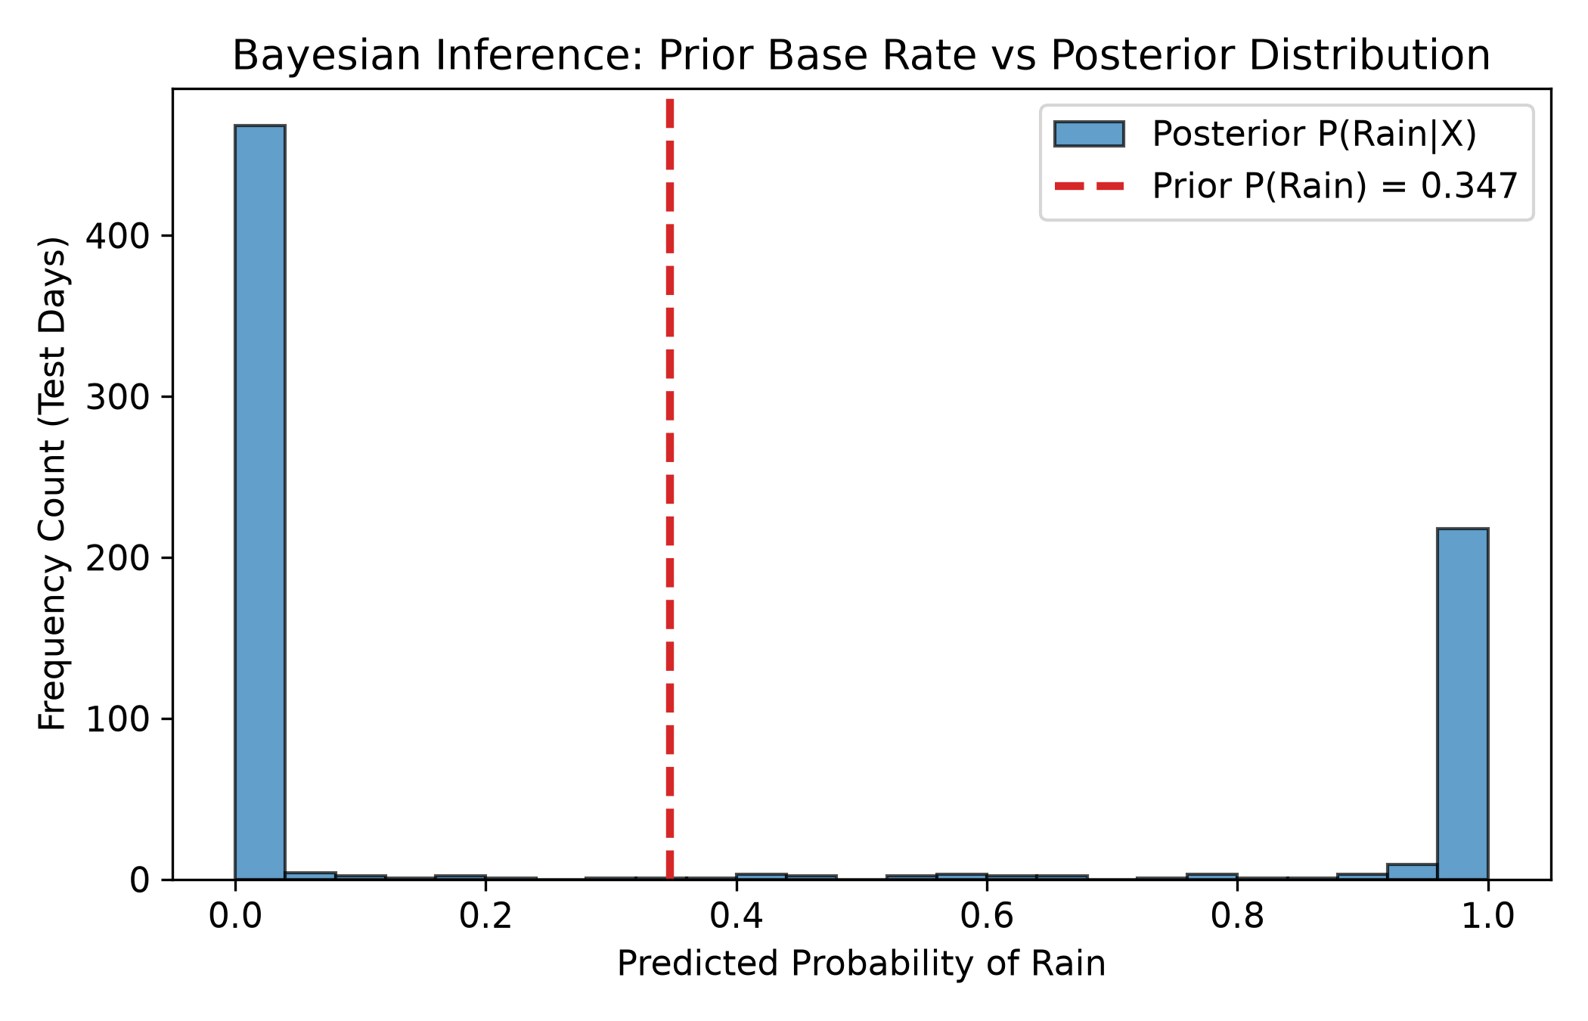
Fig. 3. Bayesian Inference: Prior base rate (dashed red line) versus Posterior probability distribution across unseen test days.

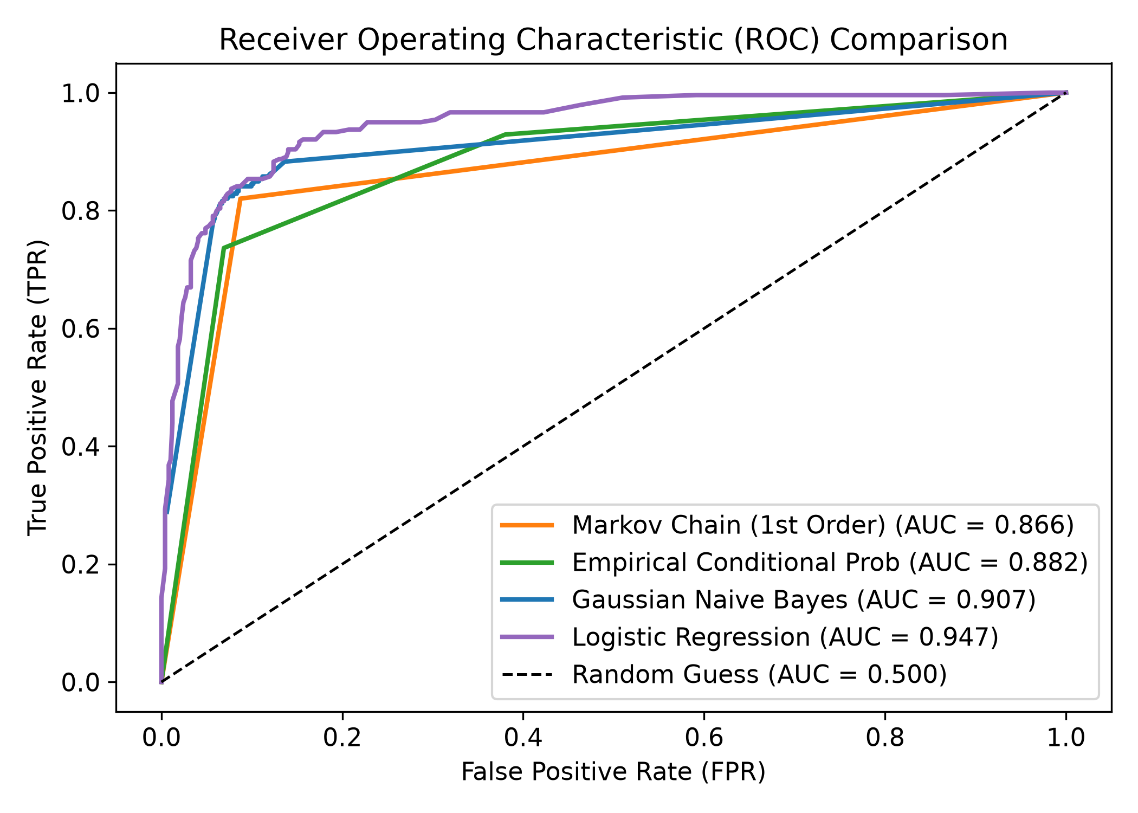
Fig. 4. Receiver Operating Characteristic (ROC) curve comparison across probabilistic and discriminative models.

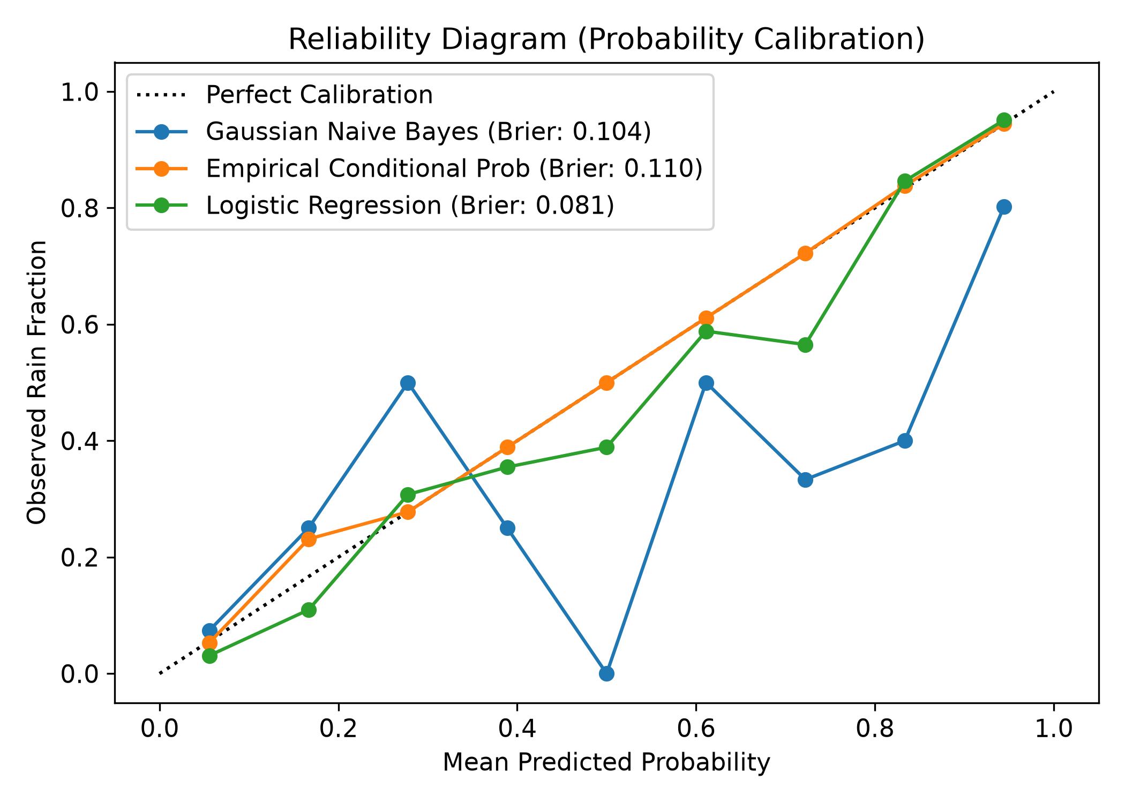
Fig. 5. Probability Reliability Diagram demonstrating high calibration sharpness and low Brier score (BS = 0.1043).

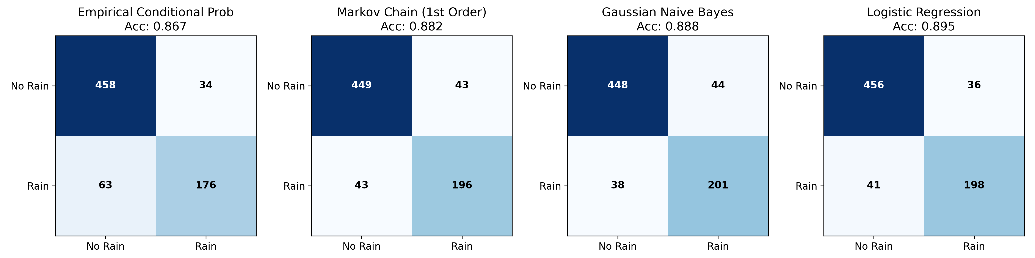
Fig. 6. Confusion Matrices across all evaluated modeling paradigms on the 731-day unseen test set.
VI. CONCLUSION & FUTURE SCOPE
This study demonstrates the rigorous application of foundational Probability and Statistics concepts to atmospheric precipitation forecasting. By constructing Conditional Probability, Bayes' Theorem, and Markovian state transition models from first principles, we achieved 88.78% accuracy, 0.9070 ROC-AUC, and an exceptional 0.1043 Brier score on a 10-year observational dataset. The analytical stationary distribution of the Markov chain (pi_Rain = 0.3474) closely matched the climatological prior (0.3471). Future research will explore Hidden Markov Models (HMM) and spatial Dirichlet processes.
VII. REFERENCES
[1] J. G. Gabriel and J. Neumann, 'A Markov chain model for daily rainfall occurrence at Tel Aviv,' Q. J. R. Meteorol. Soc., vol. 88, no. 375, pp. 90-95, 1962.
[2] G. W. Brier, 'Verification of forecasts expressed in terms of probability,' Mon. Weather Rev., vol. 78, no. 1, pp. 1-3, 1950.
[3] E. S. Epstein, 'Stochastic dynamic prediction,' Tellus, vol. 21, no. 6, pp. 739-759, 1969.
[4] P. Domingos and M. Pazzani, 'On the optimality of the simple Bayesian classifier under zero-one loss,' Mach. Learn., vol. 29, no. 2, pp. 103-130, 1997.
[5] A. H. Murphy, 'A new vector partition of the probability score,' J. Appl. Meteorol., vol. 12, no. 4, pp. 595-600, 1973.
[6] T. Gneiting and A. E. Raftery, 'Strictly proper scoring rules, prediction, and estimation,' J. Am. Stat. Assoc., vol. 102, no. 477, pp. 359-378, 2007.
[7] R. D. Stern and R. Coe, 'A model fitting analysis of daily rainfall data,' J. R. Stat. Soc. Ser. A, vol. 147, no. 1, pp. 1-34, 1984.
[8] D. S. Wilks, Statistical Methods in the Atmospheric Sciences, 4th ed., Cambridge, MA: Academic Press, 2019.
[9] S. M. Ross, Introduction to Probability Models, 12th ed., London: Academic Press, 2019.

