SCHOOL OF ENGINEERING & TECHNOLOGY
K.R. Mangalam University (KRMU)
ENSP465 — New Age Programming Languages Lab
Capstone Project — Phase I
Project Proposal & System Design
Smart Personal Finance and Expense Tracker Using Go
A web-based application built with Go and PostgreSQL
Course Code & Name | ENSP465 — New Age Programming Languages Lab
Project Title | Smart Personal Finance and Expense Tracker Using Go
Student Name(s) | [Anik Tripathi] | [Anuj Negi]
Roll Number(s) | [2301420046] | [2301420055]
Programme & Semester | B.Tech CSE — Semester VII
Academic Year | 2026–2027
Section | [Data Science]
Submission Date | 22 October 2026
Faculty Name | Dr. Hemraj Kumawat
Institution | School of Engineering & Technology, KRMU

1. Problem Statement & Motivation

1.1 Problem Description
Managing personal money has become harder even as payments have become easier. With UPI, cards and wallets, a single day can generate many small transactions that are recorded only in bank SMS alerts, separate app histories or not at all. As a result, most people cannot say with confidence how much they spent on food, travel or subscriptions last month, or whether they are on track to stay within their means this month.
This problem affects students living on a fixed allowance, salaried employees with recurring commitments, and freelancers with irregular income. Without categorised records and a defined budget, overspending is noticed only at the end of the month, when it is too late to correct, and savings goals are missed. Problems of this kind compound over time and weaken financial stability and long-term planning.
The proposed project addresses this by providing one secure web application where a user records income and expenses, assigns them to categories, sets monthly budgets, and receives visual summaries and timely alerts. The domain is a web service with a data-processing back end in the personal-finance (FinTech) space.

1.2 Motivation
- Real need: a clear view of spending is the first step towards saving, yet most users lack a simple tool that is both private and free.
- Prevention over reporting: budget alerts warn users before a limit is crossed, rather than showing the damage afterwards.
- Learning value: the project combines REST API design, relational databases, concurrency, security and basic machine learning in a single practical system.

1.3 Existing Solutions and Their Limitations
Existing approach | Limitation
Spreadsheets (Excel / Google Sheets) | Manual data entry, no real-time alerts, error-prone formulas, and no automatic charts or forecasting without extra effort.
Commercial budgeting apps | Many are subscription-based, store financial data on third-party servers, offer limited customisation, and are mostly reactive (history only) rather than predictive.
Bank / UPI app statements | Show only that bank's transactions, with weak or no custom categories, no monthly budget limits and no cross-account view.

2. Proposed Solution & Language Justification

2.1 Project Overview
The Smart Personal Finance and Expense Tracker is a web application that lets users register securely, record income and daily expenses, group them by category, set monthly budgets and monitor savings. It presents interactive dashboards with category-wise expense charts, generates monthly financial reports, raises budget alerts when spending nears or crosses a limit, and (as an advanced feature) predicts next month's expenses from past data. All records are stored in a PostgreSQL database.

2.2 Language Chosen: Go (Golang)
Go is selected as the primary implementation language, with optional Python used only for the machine-learning component. The reasons Go suits this specific problem are:
- Goroutines for background work. Budget-alert checks, monthly report generation and prediction calls must not block user requests. Goroutines and channels let these tasks run concurrently at very low memory cost, and a ticker can drive scheduled jobs [9].
- Static typing and compile-time safety for money. Financial code needs strict types, explicit error handling and no silent conversions. Go’s static types and mandatory error returns reduce bugs, and amounts can be kept as integers (paise) or decimals to avoid floating-point rounding errors.
- Fast, lightweight REST services. Go’s standard library (net/http, encoding/json, database/sql) and the Gin framework give high request throughput with low latency, which keeps dashboards responsive as transaction history grows [2], [3].
- Single static binary and easy deployment. The whole back end compiles to one executable that can be run or containerised easily, so a user can self-host the tracker and keep control of their financial data.
- Built-in testing and tooling. The standard `go test`, formatter and race detector support the testing required in Phase III, including checking concurrent alert code for data races.

2.3 Key Libraries and Frameworks
Library / Tool | Purpose
Gin (gin-gonic/gin) [3] | HTTP router, middleware chain, JSON binding and validation.
GORM / pgx [5] | ORM and PostgreSQL driver for repository layer; migrations.
golang-jwt, bcrypt (x/crypto) [6] | Token-based authentication and secure password hashing.
shopspring/decimal | Exact decimal arithmetic for monetary values.
Chart.js [7], HTML/CSS/JavaScript | Interactive dashboard and category-wise charts in the browser.
Python, scikit-learn, FastAPI (optional) [8] | Optional expense-prediction microservice.

3. Objectives & Scope

3.1 Objectives
- Build a secure REST API in Go with at least 15 endpoints covering authentication, transactions, categories, budgets, reports and predictions, protected by JWT.
- Support create, read, update and delete of income/expense records with filters (date, category, type), keeping 95% of API responses under 200 ms for up to 10,000 records per user.
- Implement a goroutine-based alert engine that raises a warning when a category or overall budget reaches 80% and an alert at 100% of the monthly limit.
- Deliver a dashboard with at least three charts (category-wise pie, monthly income-vs-expense bar, savings trend line) and a downloadable monthly report in CSV format.
- Predict next-month expenses per category from historical data and report the prediction error (MAPE) on test data; achieve at least 70% unit-test coverage on the service layer.

3.2 In-Scope and Out-of-Scope
In Scope (Phases II & III) | Out of Scope
- User registration, login, JWT sessions  - Income and expense CRUD with categories  - Monthly budgets and savings tracking  - Budget alerts (on-screen)  - Dashboard, charts and CSV reports  - Expense prediction (baseline model)  - PostgreSQL storage, input validation, tests | - Automatic bank/UPI account linking or SMS reading  - Real payment processing or fund transfers  - Native mobile application  - Investment, tax filing or loan advice  - Multi-currency conversion with live rates  - Email/SMS alert delivery (optional later)

4. System Architecture & Design

4.1 High-Level Architecture
The system follows a layered architecture. The browser communicates with the Go back end over REST (JSON). Inside the back end, requests flow through middleware, handlers, services and a repository layer to PostgreSQL. Background goroutines handle alerts, scheduled work and report generation, and an optional Python service supplies predictions.
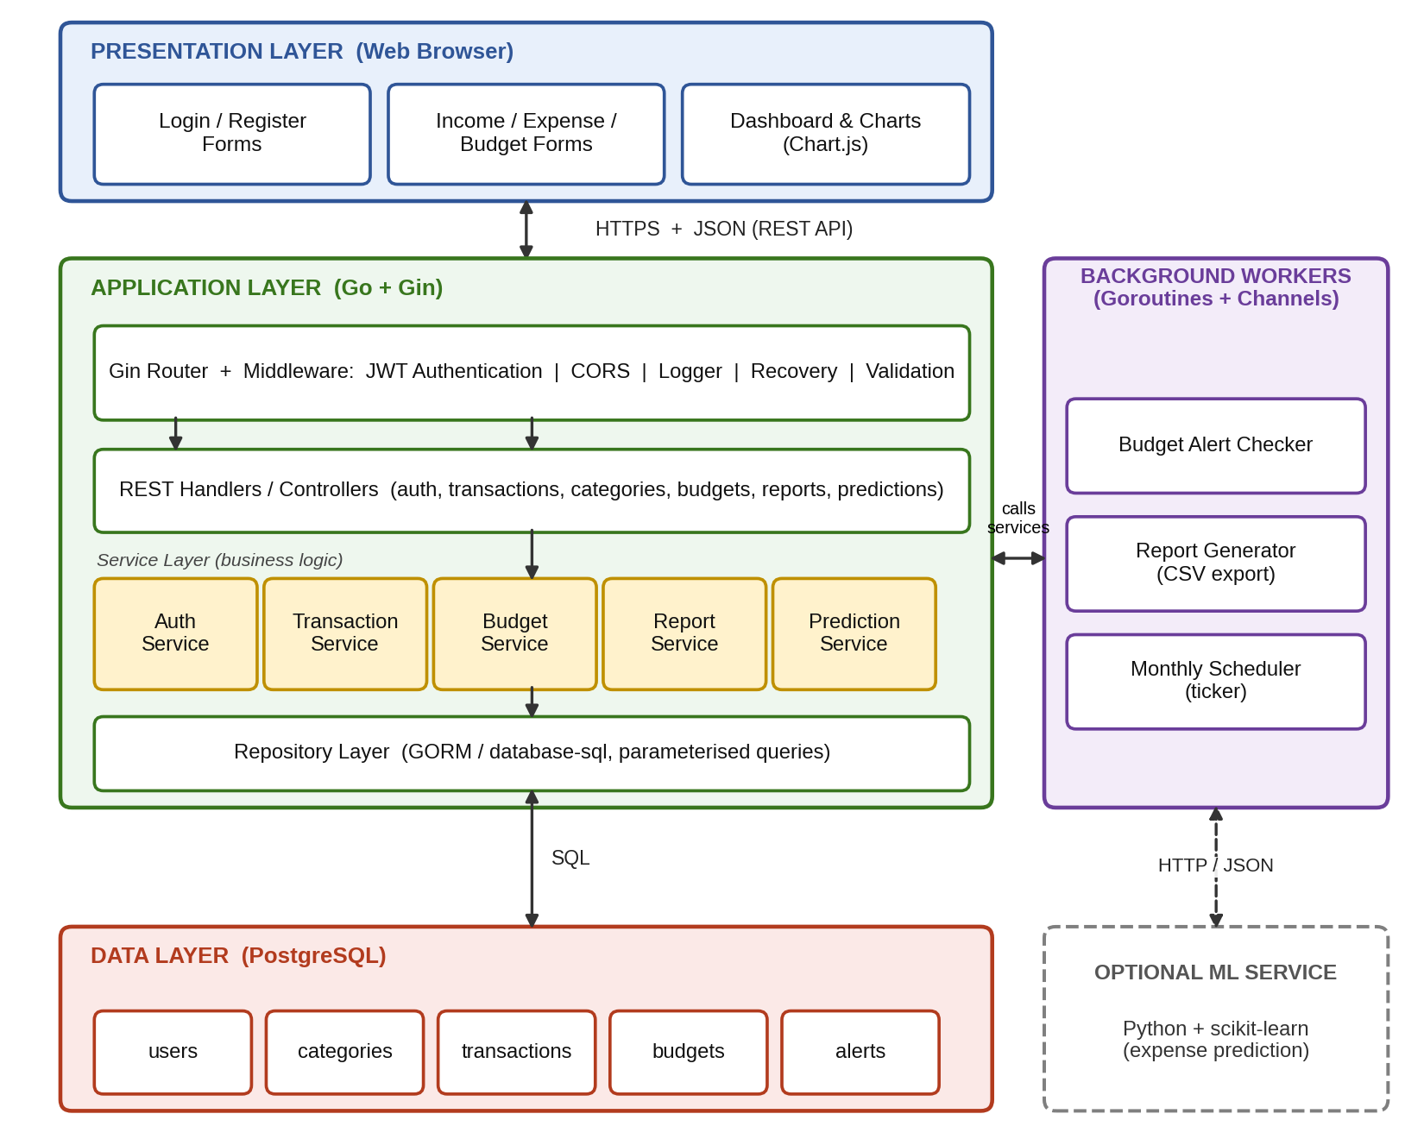
Figure 1: High-level architecture of the Smart Personal Finance and Expense Tracker

4.2 Component Description
Module | What it does | Input | Output
Web client | Forms, dashboard and charts rendered with HTML/CSS/JS and Chart.js. | User actions | HTTP/JSON requests; visual charts
Router & middleware | Routes requests; checks JWT, CORS, validation; logs and recovers from panics. | HTTP request, token | Authorised request or 401/400 error
Auth service | Registers users, hashes passwords (bcrypt), issues and verifies JWTs. | Credentials | JWT token, user record
Transaction service | CRUD and filtering of income/expense entries and categories. | Amount, type, category, date | Stored/updated records, lists
Budget service | Stores monthly budgets, computes spent vs limit and savings. | Budget limits, transactions | Budget status, savings value
Report service | Aggregates data by category and month; builds CSV report. | Month / date range | Chart data (JSON), CSV file
Prediction service | Forecasts next-month spending per category (moving average / regression; optional Python ML). | Monthly history | Predicted amounts, error metric
Alert worker (goroutine) | Re-checks budgets after each transaction and on a schedule; writes alerts. | Budget status events (channel) | Alert records for dashboard
Repository / PostgreSQL | Parameterised queries and transactions against the database. | Service calls | Persistent, consistent data

4.3 Data Flow Diagram (Level 1)
Figure 2 shows the main processes of the system, the single external entity (User) and the four data stores. For example, when the user adds an expense, process 2.0 validates it and writes it to D2; process 5.0 then reads D2 and D3, compares spending with the budget, and writes an alert to D4 if a threshold is crossed.
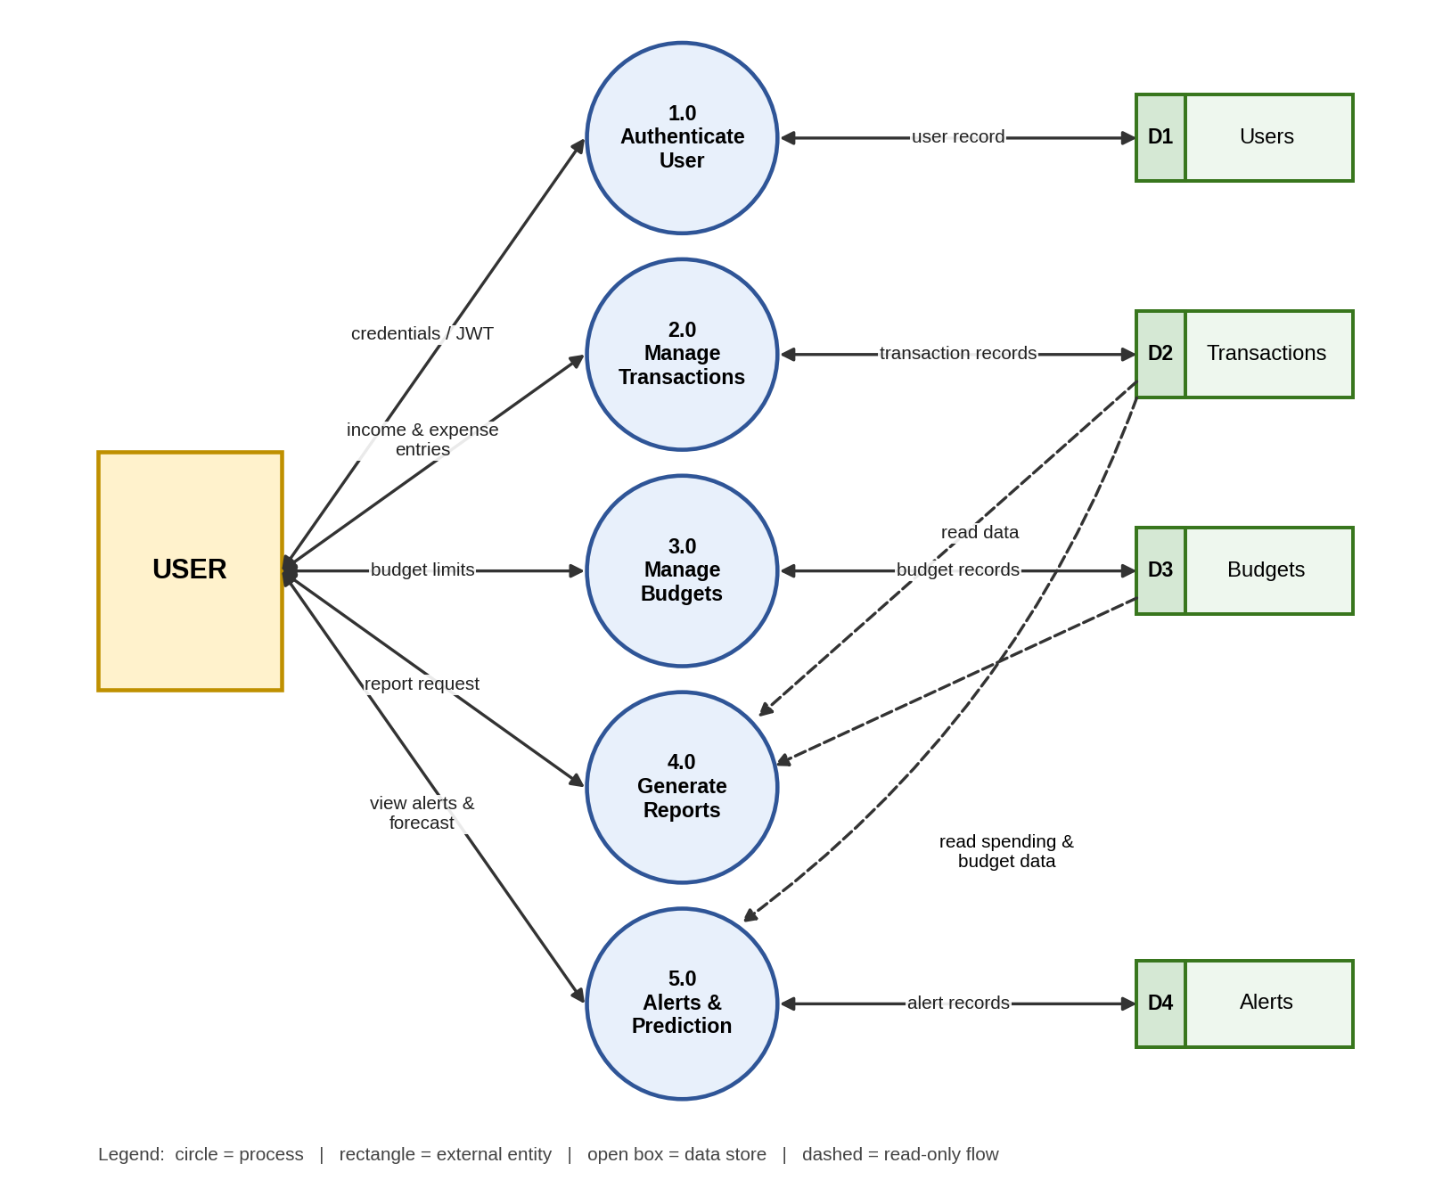
Figure 2: Level 1 Data Flow Diagram

4.4 Input–Process–Output (IPO)
Input | Process | Output
Registration and login details | Validate, hash password, verify credentials, issue JWT. | Authenticated session (token)
Income / expense entries (amount, category, date, note) | Validate, convert to exact decimal, store, trigger budget check through a channel. | Saved transaction; updated balance
Monthly budget limits per category | Store limits; compute spent %, remaining amount and savings. | Budget status and savings summary
Report / dashboard request | Aggregate by category and month using SQL group-by queries. | Charts and downloadable CSV report
Historical monthly expenses | Train/apply forecasting model on past months. | Predicted expenses and alerts (80% / 100%)

4.5 Core Data Model
Table | Main columns
users | id (PK), name, email (unique), password_hash, created_at
categories | id (PK), user_id (FK), name, type (income/expense)
transactions | id (PK), user_id (FK), category_id (FK), amount NUMERIC(12,2), type, txn_date, note
budgets | id (PK), user_id (FK), category_id (FK, nullable for overall), month, limit_amount
alerts | id (PK), user_id (FK), budget_id (FK), level (80% / 100%), message, created_at, is_read

4.6 Key Go Features and Data Structures
Go feature | Planned use in this project
Goroutines + channels | Transaction handler sends an event on a buffered channel; a worker goroutine consumes it and runs the budget check without delaying the HTTP response.
`time.Ticker` and `sync.WaitGroup` | Scheduled monthly summary and clean shutdown of workers.
`sync.Mutex` / `sync.RWMutex` | Protect shared in-memory caches of dashboard totals.
Structs and struct tags | Models and request/response DTOs with `json` and `binding` validation tags.
Interfaces | Repository and service interfaces so business logic can be unit-tested with mock repositories.

5. Work Plan & Timeline
The plan below maps the work from the Phase I submission to the Phase III final submission. Dates are tentative and will be aligned with the official Phase II and Phase III schedule announced by the faculty.
No. | Tentative dates | Tasks and deliverables | Phase
M1 | 24 Oct 2026 | Phase I: proposal and system design document submitted on Zosima. | Phase I
M2 | 25 Oct – 8 Nov 2026 | Environment setup, Git repository, PostgreSQL schema and migrations, Gin project skeleton, authentication (register/login/JWT). | Phase II
M3 | 9 Nov – 22 Nov 2026 | Category and transaction CRUD, budget API, basic HTML/CSS/JS front end for forms. | Phase II
M4 | 23 Nov – 6 Dec 2026 | Dashboard charts (Chart.js), goroutine-based budget alert engine, intermediate demonstration. | Phase II
M5 | 7 Dec – 17 Dec 2026 | CSV reports, expense prediction module (Go baseline; optional Python service), incorporate Phase I/II feedback. | Phase III
M6 | 18 Dec – 28 Dec 2026 | Testing: unit, API and load tests, race detector, security checks (SQL injection, password hashing, token expiry). | Phase III
M7 | 29 Dec 2026 – Jan 2027 | Final report, user manual, deployment (Docker), final demo and viva preparation. | Phase III

Task distribution: This is planned as an individual project; all modules (back end, database, front end, alerts, prediction and testing) will be developed by the student named on the cover page. In a team, work would be split as: authentication/database, transactions/budgets, alerts/prediction, and front end/testing.

6. References
[1] A. A. A. Donovan and B. W. Kernighan, The Go Programming Language. Boston, MA, USA: Addison-Wesley, 2015.
[2] The Go Authors, “Documentation – The Go Programming Language,” go.dev. [Online]. Available: https://go.dev/doc/ (Accessed: Oct. 2026).
[3] Gin Contributors, “Gin Web Framework Documentation,” gin-gonic.com. [Online]. Available: https://gin-gonic.com/docs/ (Accessed: Oct. 2026).
[4] The PostgreSQL Global Development Group, “PostgreSQL Documentation,” postgresql.org. [Online]. Available: https://www.postgresql.org/docs/ (Accessed: Oct. 2026).

