Report
Of

A STUDY OF USER ACCESS MANAGEMENT (UAM) OPERATIONS IN THE CYBER SECURITY

Submitted
To

School of Computer Science and Engineering
IILM University, Greater Noida, U.P.

In partial fulfilment of the requirement of degree of
Master of Computer Applications (MCA)

By

Roll Number of Student: 25SCS2040002714
Name of Student: ANIKET KUMAR
Batch: 2025-29

2026-27
CANDIDATE'S DECLARATION

I, ANIKET KUMAR do hereby declare that the internship report titled “A STUDY OF USER ACCESS MANAGEMENT (UAM) OPERATIONS IN THE CYBER SECURITY” has been completed by me to fulfil the requirement for the award of the degree of Bachelor of Technology in CSE. All the references have been quoted and I have not taken as such any material from any other source. I affirm to you that this report is my own and has not been submitted to any other institute for any degree/diploma requirement and further I shall be solely responsible for any kind of copyright violation in this regard.

Signature: ______________________
Student Name: ANIKET KUMAR
Roll No.: 25SCS2040002714

ACKNOWLEDGEMENT

I am using this opportunity to express my gratitude to everyone who supported me throughout the Internship Program. I am thankful for their aspiring guidance, invaluable constructive criticism and friendly advice during this work. I am sincerely grateful to them for sharing their truthful and illuminating views on a number of issues related to this work.
I express my gratitude to my parents for their blessings.

Signature: ______________________
Student Name: ANIKET KUMAR
Roll No.: 25SCS2040002714
INTERNSHIP COMPLETION CERTIFICATE
(Letter of Appointment)

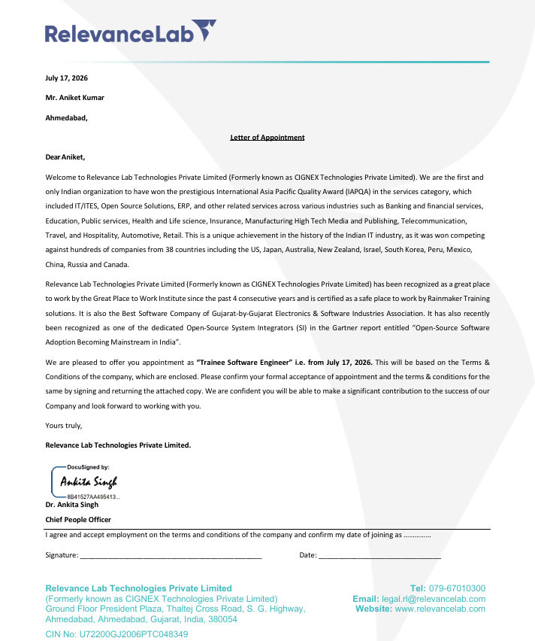
TABLE OF CONTENTS

Chapter No. | Chapter Name | Page Nos.
 | Cover Page | —
1. | Candidate's Declaration | i
2. | Acknowledgement | ii
3. | Internship Completion Certificate | —
4. | Project Description
 | 4.1 Introduction | 1
 | 4.2 Organization Profile | 1
 | 4.3 Problem Statement | 2
 | 4.4 Project Objectives | 3
 | 4.5 Scope of the Project | 3
 | 4.6 Technologies and Tools Used | 4
 | 4.7 System Architecture | 4
 | 4.8 Methodology | 5
 | 4.9 Expected Outcomes | 6
 | 4.10 Certificates & Communication Proof | 7
5. | Bibliography / References | 8

LIST OF TABLES

Table Title | Page No.
Table 4.1: Tools and Technologies Used in UAM Operations | 4
LIST OF FIGURES
Figure Title | Page No.
Figure 4.1: System / Workflow Architecture — Access Request Lifecycle | 4

4. PROJECT DESCRIPTION
4.1 Introduction
As part of the curriculum of the Master of Computer Applications (MCA) programme at IILM University, students are required to undergo a period of industry engagement to gain first-hand, practical exposure to real-world IT operations and to apply classroom concepts in a professional environment. This report documents my engagement as a Trainee Software Engineer with Relevance Lab Technologies Private Limited (formerly CIGNEX Technologies Private Limited), where I have been deployed on the client account of Aon since July 17, 2026, as confirmed by the Letter of Appointment enclosed in Chapter 3 of this report.
My role is situated within the User Access Management (UAM) function, which forms a core part of Aon's Cyber Security operations. UAM is the discipline of granting, modifying, reviewing, and revoking the access that employees, contractors, and business applications have to enterprise systems, in accordance with the organization's information security policies. It is one of the most critical operational control layers in any large enterprise, since improperly managed access is among the leading causes of data breaches, compliance failures, and insider-risk incidents.
This chapter presents an overview of the host organizations, the operational problem that the UAM function addresses, the objectives and scope of my role, the tools and technologies used on a daily basis, the workflow architecture that governs how an access request is fulfilled, the methodology I follow while executing my responsibilities, and the outcomes and learnings I have derived from this experience so far.
4.2 Organization Profile
4.2.1 Relevance Lab Technologies Private Limited
Relevance Lab Technologies Private Limited, formerly known as CIGNEX Technologies Private Limited, is an IT services organization with a strong focus on Cloud, DevOps, Automation, Digital Transformation, and Managed IT/Cyber Security services for global enterprise clients. The organization holds the distinction of being the first and only Indian company to have won the International Asia Pacific Quality Award (IAPQA) in the services category, an achievement earned while competing against enterprises from 38 countries across sectors such as banking and financial services, education, healthcare, manufacturing, telecommunications, travel, and retail.
Relevance Lab has been recognized as a Great Place to Work for four consecutive years and has been certified as a Safe Place to Work by Rainmaker Training Solutions. It has also been recognized as the Best Software Company of Gujarat by the Gujarat Electronics and Software Industries Association (GESIA), and has been identified as a dedicated Open-Source System Integrator in a Gartner report on the adoption of open-source software in the mainstream enterprise IT landscape.
4.2.2 Aon (Client Organization)
Aon plc is a leading global professional services firm that provides organizations with advice and solutions across two broad areas of capability: Risk Capital and Human Capital. Its services span insurance and reinsurance brokerage, risk consulting, retirement solutions, and health and benefits advisory. Aon operates across more than 120 countries with a global workforce of tens of thousands of colleagues, helping clients navigate an increasingly volatile economic, social, and geopolitical environment by protecting them against risk while also helping them grow and realize the full potential of their workforce.
As a client of Relevance Lab Technologies, Aon's internal IT and Cyber Security operations — including User Access Management — are supported by a dedicated deployed team, of which I am a part. This engagement gives me direct exposure to how a Fortune-listed global professional services firm structures and governs access to its enterprise systems at scale.
4.3 Problem Statement
A global organization of Aon's scale operates thousands of internal applications, systems, and shared resources that must be made available to a large and constantly changing population of employees, contractors, and vendors spread across more than 120 countries. Left unmanaged, this creates a significant operational and security challenge: access requests raised manually or without a defined process are slow to fulfil, inconsistently reviewed, and difficult to audit; former employees or contractors may retain access after they should have been de-provisioned; and users may accumulate excessive or unused permissions over time (a phenomenon commonly known as privilege creep), increasing the organization's exposure to unauthorized access, data leakage, and compliance findings.
The UAM function exists to solve exactly this problem — by ensuring that every access request is logged, verified against a legitimate business need and proper managerial approval, fulfilled by a trained analyst within a defined Service Level Agreement (SLA), and executed strictly in line with the principle of least privilege. My role as a Trainee Software Engineer within this function is to help operationalize this control on a day-to-day basis: reviewing incoming tickets, validating approvals, executing the required changes in Active Directory, and ensuring that every action is completed within its SLA window and is fully auditable.
4.4 Project Objectives
The key objectives of my engagement in the User Access Management function are as follows:
- To gain hands-on, practical exposure to enterprise-level Identity and Access Management (IAM) / User Access Management operations within a global professional services organization.
- To understand and correctly apply core access-governance principles such as least privilege, role-based access control (RBAC), and segregation of duties (SoD).
- To process user access requests and incidents raised through the Aon Service Portal accurately and within the defined SLA timelines.
- To develop working proficiency in enterprise-grade tools, namely Active Directory, Active Directory Users and Computers (ADUC), Windows PowerShell, and Citrix Workspace.
- To contribute effectively to a collaborative team environment that jointly resolves access-related incidents and time-critical requests.
- To document day-to-day operational learnings for both academic and professional development, in fulfilment of the MCA industry-engagement requirement.
4.5 Scope of the Project
The scope of my role as a Trainee Software Engineer in the UAM team is operational in nature and covers the routine, day-to-day servicing of access-related requests and incidents raised against the Aon account. The following activities fall within scope:
- Creating, modifying, disabling, and deleting user accounts in Active Directory based on approved requests.
- Adding or removing users from security and distribution groups to grant or revoke application/resource access.
- Processing password resets, account unlocks, and other routine identity-support requests.
- Validating that every request carries the appropriate managerial or data-owner approval before action is taken.
- Monitoring ticket queues and prioritising work to avoid SLA breaches, and escalating ambiguous or high-risk requests to senior analysts.
Activities such as the design of new IAM architecture, changes to organization-wide access-governance policy, and enterprise tool procurement are handled by senior architecture and governance teams and fall outside the scope of my current trainee role.
4.6 Technologies and Tools Used
Table 4.1 summarises the principal tools and technologies used on a daily basis while carrying out UAM responsibilities on the Aon account.
Tool / Technology | Purpose in the UAM Workflow
Aon Service Portal (ITSM Tool) | Intake, tracking, and SLA monitoring of all user access requests and incidents raised by employees, contractors, and business stakeholders.
Citrix Workspace | Provides secure, virtualised remote access to internal Aon applications and desktops required to perform day-to-day UAM tasks.
Active Directory (AD) | Central enterprise directory service that stores user accounts, security groups, organizational units, and access permissions.
Active Directory Users and Computers (ADUC) | Graphical management console used to create, modify, disable, and delete user/computer objects and to manage group memberships.
Windows PowerShell | Used to script and automate repetitive or bulk account-management tasks (e.g., bulk group additions, leaver de-provisioning), improving speed and consistency.
SLA / Ticket Dashboard | Used to track ticket ageing, prioritise requests nearing SLA breach, and maintain an auditable record of actions taken.
Table 4.1: Tools and Technologies Used in UAM Operations
4.7 System Architecture
Figure 4.1 illustrates the end-to-end workflow followed for every access request handled by the UAM team, from the moment a business need is raised to the point at which the change is verified, closed, and logged for audit.
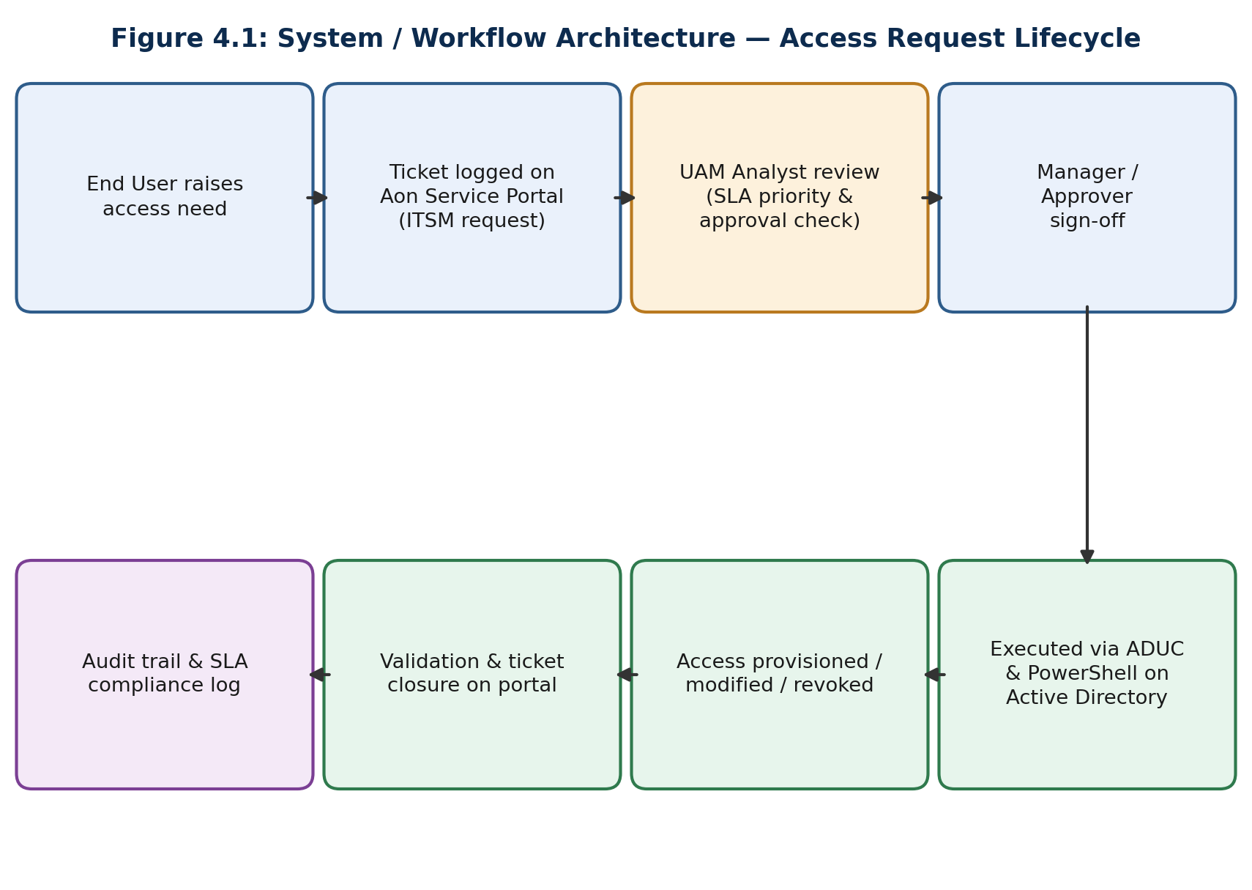
The workflow begins when an end user or business requester raises an access need, which is logged as a formal ticket on the Aon Service Portal (the organization's ITSM platform). The ticket is then picked up by a UAM analyst, who prioritises it based on its SLA window and verifies that the requested access carries valid managerial or data-owner sign-off. Once verification is complete, the change is executed on Active Directory using ADUC for individual/ad-hoc changes or Windows PowerShell for scripted and bulk operations. The provisioned, modified, or revoked access is then validated, the ticket is closed on the Service Portal with resolution notes, and the action is recorded in the SLA compliance and audit log, ensuring the entire lifecycle of the request remains fully traceable.
4.8 Methodology
On a typical working day, I begin by reviewing the shared ticket queue on the Aon Service Portal, which lists all pending access requests and incidents colour-coded by their proximity to SLA breach (commonly represented as red, amber, and green). I prioritise red and amber tickets first to avoid SLA breaches, while ensuring green tickets are still addressed well within their allotted window.
For each ticket, I follow a consistent verification-before-execution approach: I first confirm that the requester's manager or the relevant data/application owner has approved the request, and I check the request against the principle of least privilege — granting only the specific role, group, or application access that has actually been approved, rather than broader access that may be convenient but excessive. Once verified, I execute the change directly in Active Directory: routine, one-off changes are made through ADUC, while repetitive or bulk actions (such as adding a large group of new joiners to a standard set of security groups, or disabling a batch of leaver accounts) are handled through Windows PowerShell scripts, which improves both turnaround time and consistency.
After execution, I validate that the change has taken effect as intended, update the ticket with clear resolution notes, and close it within the Service Portal so that the action is properly logged for audit and SLA-reporting purposes. Where remote or virtualised access to internal Aon systems is required to perform these tasks, I connect through Citrix Workspace. For requests that fall outside my current authority — such as ambiguous approvals, conflicting role assignments, or requests that could violate segregation-of-duties rules — I escalate to a senior analyst or team lead rather than proceeding unilaterally. During periods of high ticket volume or major incidents (for example, an organization-wide access review or a bulk leaver event), the team works collaboratively, dividing tickets among members and reconvening to resolve the incident jointly.
4.9 Expected Outcomes
Through this engagement, I expect to consolidate the following technical and professional outcomes:
- Consistent adherence to SLA timelines while processing user access requests and incidents, reflecting strong operational discipline.
- A measurable reduction in access-related security risk through the correct, verified application of least-privilege and role-based access principles.
- Practical, hands-on proficiency in enterprise IAM tools — Active Directory, ADUC, and Windows PowerShell scripting — that extends well beyond classroom-level exposure.
- A deeper working understanding of enterprise access-governance frameworks, including segregation of duties and audit-readiness, within a real Cyber Security operations setting.
- Improved professional soft skills, including stakeholder communication, time management under SLA pressure, and collaborative incident resolution within a team.
- A stronger bridge between the theoretical concepts covered in my MCA curriculum and their practical application in a live, enterprise-scale Cyber Security environment.
4.10 Certificates of Completion and Other Communication/Mail Proof
Since this engagement is an ongoing, permanent placement rather than a fixed-term internship, no separate certificate of completion has been issued at the time of submission of this report. The official Letter of Appointment issued by Relevance Lab Technologies Private Limited, confirming my placement as Trainee Software Engineer on the Aon client account with effect from July 17, 2026, has accordingly been enclosed as documentary proof of engagement in Chapter 3 (Internship Completion Certificate) of this report.

5. BIBLIOGRAPHY / REFERENCES
Aon plc. (2026). About Aon. Retrieved September 2026, from https://www.aon.com
Relevance Lab Technologies Private Limited. (2026). Letter of Appointment — Trainee Software Engineer (internal organizational document).
Microsoft. (2026). Introduction to Active Directory Domain Services (AD DS). Microsoft Learn. Retrieved from https://learn.microsoft.com/en-us/training/modules/introduction-to-ad-ds/
Microsoft. (2026). Active Directory Domain Services learning path. Microsoft Learn. Retrieved from https://learn.microsoft.com/en-us/training/paths/active-directory-domain-services/
Microsoft. (2026). PowerShell Documentation. Microsoft Learn. Retrieved from https://learn.microsoft.com/en-us/powershell/
Cloud Software Group, Inc. (2024). Citrix Workspace app documentation. Retrieved from https://docs.citrix.com/en-us/citrix-workspace-app/citrix-workspace-app.pdf
Axelos. (2019). ITIL Foundation: ITIL 4 Edition. London: TSO (The Stationery Office).
Gujarat Electronics and Software Industries Association (GESIA). Best Software Company of Gujarat recognition, as cited in the Relevance Lab Technologies Private Limited Letter of Appointment (2026).

