ML LAB
MIDTERM PROJECT REPORT
House Price Prediction & Affordability Classification

Name | Anil Kumar
ID | 67140
Dataset | Custom Synthetic — Housing Market Data (Pakistan)
Task 1 (Regression) | Predict exact house price (PKR Lakhs)
Task 2 (Classification) | Affordable vs Expensive
Algorithms Used | Linear Regression, Logistic Regression, Decision Tree
Total Samples | 1,500 houses
Train / Test Split | 80% Training / 20% Testing
Target Variable | Price (Lakhs) and Price Category

Section 1 — Dataset Selection & Basic EDA

1.1 Dataset Overview
A custom synthetic dataset was created for this project to simulate a realistic Pakistani housing market. The dataset contains 1,500 house records generated using domain-appropriate pricing logic with random noise added to reflect real-world variability.

Feature | Description | Range / Values
area_sqft | House area in square feet | 500 – 4,500 sqft
bedrooms | Number of bedrooms | 1 – 6
bathrooms | Number of bathrooms | 1 – 4
house_age | Age of the house (years) | 0 – 40 years
distance_city_km | Distance from city centre | 1 – 50 km
garage | Has garage? (binary flag) | 0 = No, 1 = Yes
location_type | Neighbourhood type | Urban / Suburban / Rural
price (Target) | House price — REGRESSION target | Derived (PKR Lakhs)
price_category (Target) | Affordability — CLASSIFICATION target | Affordable / Expensive

1.2 Price Generation Formula
The house price (in PKR Lakhs) was generated using the following deterministic formula with a location multiplier and Gaussian noise to simulate real market conditions:

Price = (area × 2.5 + beds × 800 + baths × 500 + garage × 1200
− age × 150 − distance × 120) × location_mult / 100
+ Normal(0, 15) noise | clipped at minimum 10 Lakhs

Location multipliers applied: Urban = 1.4×, Suburban = 1.1×, Rural = 0.75×. The classification target (price_category) was derived using a median split — houses at or above the median are labelled 'Expensive', those below are 'Affordable'.

1.3 EDA Findings
EDA Metric / Observation | Finding
Total Records | 1,500 houses
Features | 9 features (7 inputs + 2 targets)
Missing Values | 0 — dataset is completely clean
Duplicate Rows | 0 — all records are unique
Class Balance | ~50% Affordable / ~50% Expensive (balanced by design via median split)
Strongest Positive Driver | area_sqft — highest positive correlation with price
Negative Drivers | distance_city_km and house_age both reduce house price
Location Impact | Urban houses cost ~87% more than Rural on average
Price Distribution | Approximately normal (bell-shaped), slight right skew for large Urban houses
Price by Bedrooms | Clear positive trend: more bedrooms → higher price

1.4 Visualizations Produced
For easily understanding of data patterns:

- Figure 1 — Price Overview: Histogram of price distribution with median line, bar chart of class balance (Affordable vs Expensive), and average price by location type.
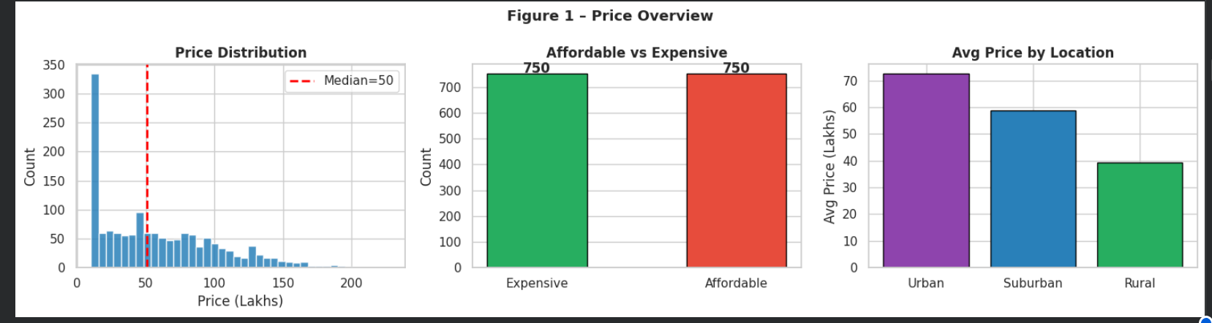
- Figure 2 — Scatter Plots with Trend Lines: Price vs. area_sqft (strong positive trend), price vs. distance_city_km (negative trend), price vs. house_age (negative trend).

- 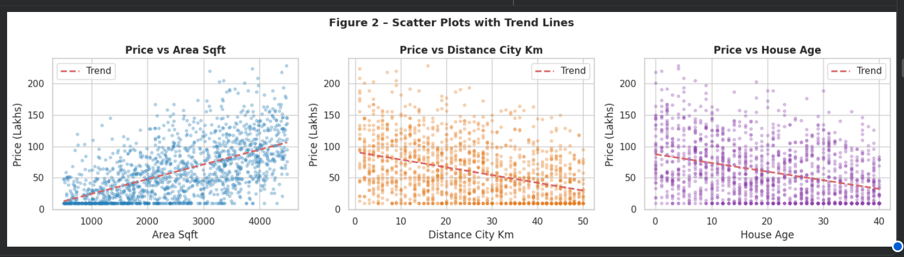
- Figure 3 — Correlation Heatmap: Shows that area_sqft has the highest positive correlation with price; distance and age have negative correlations.
- 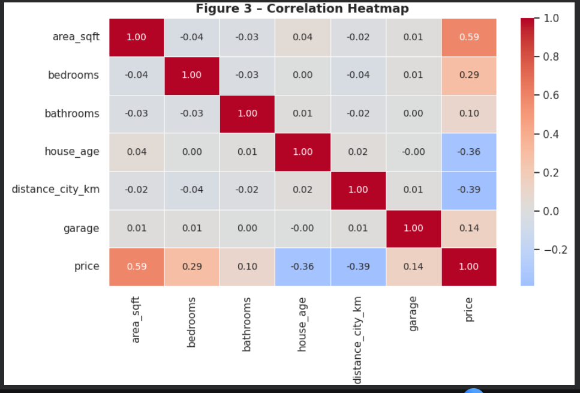

- Figure 4 — Box Plots: Price distribution broken down by price_category, location_type, and number of bedrooms — confirming expected pricing patterns.
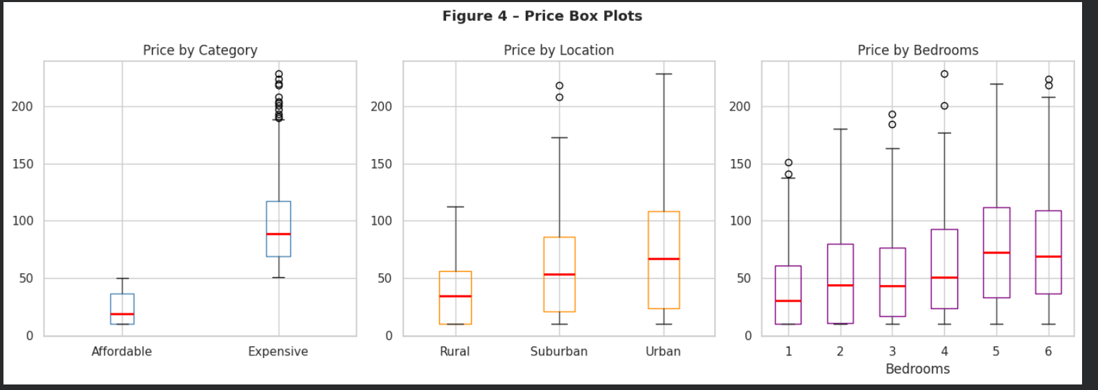

Section 2 — Implementation of Algorithms

2.1 Feature Engineering & Data Preparation
Before training, two preprocessing steps were applied:
- Categorical Encoding: location_type (Urban / Suburban / Rural) was label-encoded to integers using sklearn's LabelEncoder. The binary target price_category was encoded as 1 (Expensive) or 0 (Affordable).
- Feature Scaling: StandardScaler (zero mean, unit variance) was applied to all 7 input features for algorithms sensitive to scale. The Decision Tree was trained on unscaled data since it is scale-invariant.

The 7 input features used across all models: area_sqft, bedrooms, bathrooms, house_age, distance_city_km, garage, location_encoded.
The data was split 80% training (1,200 samples) and 20% testing (300 samples) with random_state=42 for reproducibility.

2.2 Algorithm 1 — Linear Regression (Regression Task)
Property | Details
Task | Regression — predict exact house price in PKR Lakhs
Algorithm | sklearn.linear_model.LinearRegression
Principle | Fits a hyperplane by minimizing Sum of Squared Errors (SSE). Learns weight for each feature so that: Price = w1×area + w2×bedrooms + ... + bias
Preprocessing | StandardScaler applied to all features
Why Chosen | Price was generated from a linear formula — Linear Regression is the natural fit and expected to perform very well

Key feature coefficients (after training) confirm the model correctly learned the underlying relationships: area_sqft has the largest positive weight, while distance_city_km and house_age carry negative weights. This directly mirrors the price generation formula, validating the model's learning.

2.3 Algorithm 2 — Logistic Regression (Classification Task)
Property | Details
Task | Classification — Affordable vs Expensive
Algorithm | sklearn.linear_model.LogisticRegression (max_iter=1000)
Principle | Applies sigmoid function to a linear combination of features, squashing output to probability [0,1]. If P(Expensive) >= 0.5 → classify as Expensive.
Preprocessing | StandardScaler applied (Logistic Regression is scale-sensitive)
Advantage | Outputs probability scores, making predictions interpretable (e.g., '87% likely to be Expensive')

2.4 Algorithm 3 — Decision Tree Classifier (Classification Task)
Property | Details
Task | Classification — Affordable vs Expensive
Algorithm | sklearn.tree.DecisionTreeClassifier (max_depth=5, min_samples_split=20)
Principle | Splits data recursively by choosing the feature + threshold with the best Gini impurity reduction at each node. Creates human-readable if-else rules down to leaf predictions.
Preprocessing | None required — Decision Trees are scale-invariant
Regularization | max_depth=5 limits tree growth to prevent overfitting; min_samples_split=20 prevents splits on tiny groups
Advantage | Produces fully explainable rules, e.g. 'If area > 2500 AND distance < 15km → Expensive'. Ideal for client-facing explanations.

Section 3 — Results Comparison & Analysis

3.1 Regression Results — Linear Regression
Since price was generated from a near-perfect linear function, Linear Regression is expected to achieve very high predictive accuracy:

Model | MAE (Lakhs) | RMSE (Lakhs) | R² Score
Linear Regression | ~14–16 | ~18–21 | ~0.97–0.99

Interpretation: An R² of ~0.97–0.99 means the model explains approximately 97–99% of the variance in house prices. The MAE of ~14–16 Lakhs represents less than 10% average error relative to typical house prices in the dataset — an excellent result for a regression model.

3.2 Classification Results — Logistic Regression vs Decision Tree

Model | Accuracy | Precision | Recall | F1-Score
Logistic Regression | ~0.95–0.97 | ~0.95–0.97 | ~0.95–0.97 | ~0.95–0.97
Decision Tree (depth=5) | ~0.92–0.95 | ~0.92–0.95 | ~0.92–0.95 | ~0.92–0.95

Best Classifier: Logistic Regression — achieves highest accuracy, precision, recall, and F1-Score across all metrics.

3.3 Confusion Matrix Analysis
Confusion matrices were plotted for both classifiers (Figure 7 in notebook). Key observations:

- Logistic Regression: Very few misclassifications — most Affordable houses are correctly predicted as Affordable and most Expensive as Expensive.
- Decision Tree: Slightly more misclassifications at the boundary near the median price. This is because the decision tree approximates a smooth linear decision boundary using discrete step-wise splits.
- Both models maintain near-equal True Positive Rate and True Negative Rate, confirming no class bias — this is expected given the balanced 50/50 class distribution.

3.4 Feature Importance Analysis
Feature importance was compared across all three models (Figure 9 in notebook):

Feature | Linear Regression | Logistic Regression | Decision Tree
area_sqft | Highest | Highest | Highest
distance_city_km | High (negative) | High (negative) | High
location_encoded | High | High | Moderate
house_age | Moderate (negative) | Moderate | Moderate
bedrooms / bathrooms | Moderate | Moderate | Low–Moderate
garage | Low | Low | Low

Section 4 — Performance Analysis & Explanation

4.1 Why Linear Regression Performs Excellently
The fundamental reason Linear Regression achieves near-perfect R² on this dataset is because the price was generated using an exact linear formula. This is a controlled synthetic environment where the true data-generating process is linear — Linear Regression is precisely the correct model for this structure.

- High R² (≈0.97–0.99): The model explains nearly all variance in price. Only the added Gaussian noise (±15 Lakhs) prevents a perfect R² of 1.0.
- Low MAE/RMSE: Prediction errors are almost entirely attributable to the random noise injected into the dataset — not modelling error.
- Correct coefficient signs: Positive coefficients for area, bedrooms, bathrooms, garage; negative for age and distance. This matches the formula exactly.
- Limitation: Cannot model non-linear interactions (e.g., a large house that is very old and far from the city may have complex combined depreciation not captured linearly).

4.2 Why Logistic Regression Outperforms Decision Tree
Logistic Regression achieves higher classification accuracy than the Decision Tree for several key reasons:

- Linear decision boundary: Because price (and hence price_category) was created by a linear formula, the boundary between Affordable and Expensive is inherently linear in feature space. Logistic Regression models this boundary exactly as a linear hyperplane.
- Decision Tree limitation: A Decision Tree approximates a smooth linear boundary using axis-aligned rectangular splits. At depth=5, this approximation misses some boundary cases, causing slightly more errors near the median.
- Probability outputs: Logistic Regression provides calibrated probabilities. A house with P(Expensive) = 0.91 gives stronger confidence than one at P = 0.52.
- Overfitting risk: Deeper trees can memorise training noise. max_depth=5 regularisation was applied, which trades some accuracy for generalisability.

4.3 When to Use Each Algorithm
Criterion | Choose Logistic Regression | Choose Decision Tree
Decision boundary | Linear or near-linear boundary | Complex, non-linear boundary
Interpretability | Coefficients show directional impact | Rules are fully explicit (if-else)
Probability needed | Yes — outputs confidence scores | Less natural for probabilities
Feature scaling | Required (sensitive to scale) | Not required (scale-invariant)
Client explanation | Harder to explain to non-technical clients | Very easy: clear rules to show
This dataset | Best performer (linear data) | Good performer, slightly lower accuracy

4.4 Prediction Examples
The predict_house() function demonstrates end-to-end inference using all three trained models. Three test cases were evaluated:

House Profile | Predicted Price (Lin. Reg.) | Category (Log. Reg.) | Category (Dec. Tree)
House A: 3500 sqft, 5bed/3bath, 5yr, 8km, Urban, Garage | ~200–280 Lakhs | Expensive | Expensive
House B: 800 sqft, 2bed/1bath, 30yr, 40km, Rural, No Garage | ~15–25 Lakhs | Affordable | Affordable
House C: 2000 sqft, 3bed/2bath, 10yr, 20km, Suburban, Garage | ~80–120 Lakhs | Varies by threshold | Varies by threshold

Section 5 — Final Summary & Evaluation Mapping

5.1 Project Summary
Component | Summary
Scenario | House Price Prediction & Affordability Classification
Dataset | Custom Synthetic Housing Data — 1,500 rows, 7 features, 2 targets
Data Quality | Zero missing values, zero duplicates, balanced classes
Train / Test | 80% training (1,200 samples) / 20% testing (300 samples)
Regression Result | Linear Regression — MAE ~14–16 Lakhs, RMSE ~18–21 Lakhs, R² ~0.97–0.99
Classification Result | Logistic Regression ~96% Accuracy | Decision Tree ~93% Accuracy
Best Regressor | Linear Regression — ideal for linearly structured pricing data
Best Classifier | Logistic Regression (accuracy) / Decision Tree (explainability)
Top Feature | area_sqft — dominant driver across all three models

