**What is Augmented Reality (AR) and how it can be used**

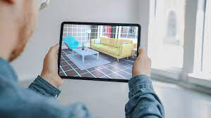

[Augmented Reality](https://www.arnxt.com/) is an enhanced and interactive experience in which a real-world environment is enriched with computer-generated visual elements, sounds and other stimuli. It can be helpful in providing users with a more immersive experience.

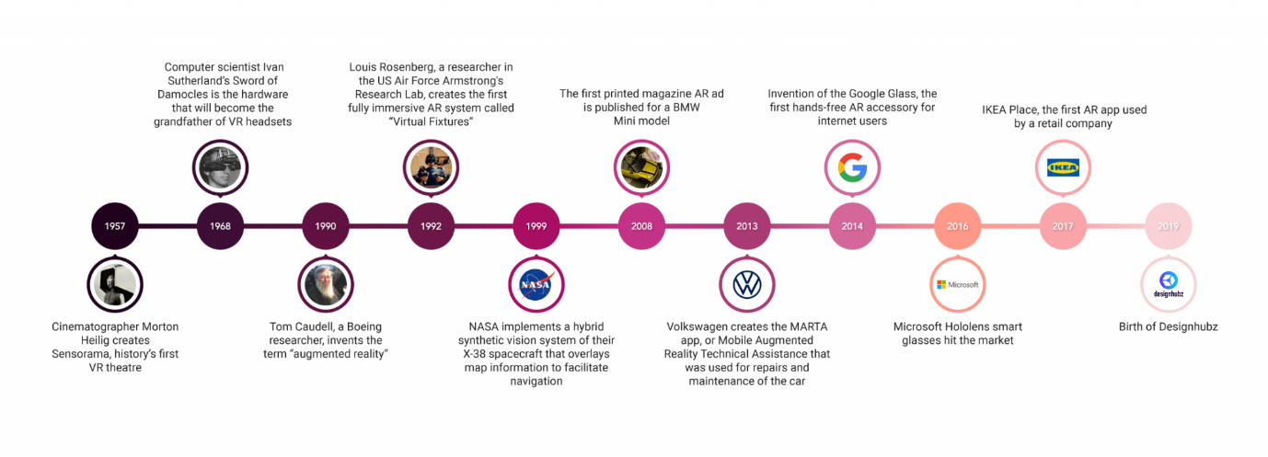

[Augmented Reality (AR](https://www.arnxt.com/)) is the integration of digital information with the user's environment in real time. Augmented reality delivers visual elements, sound, and other sensory information to the user through a device such as a smartphone or glasses. This information is overlaid on the device to create an interwoven experience where the digital information changes the user's perception of the real world. The overlaid information can be added to an environment or obscure part of the natural environment.

[Augmented reality apps](https://www.arnxt.com/) are written in special 3D programs that allow developers to link animations or contextual digital information in the computer program to an augmented reality marker in the real world.

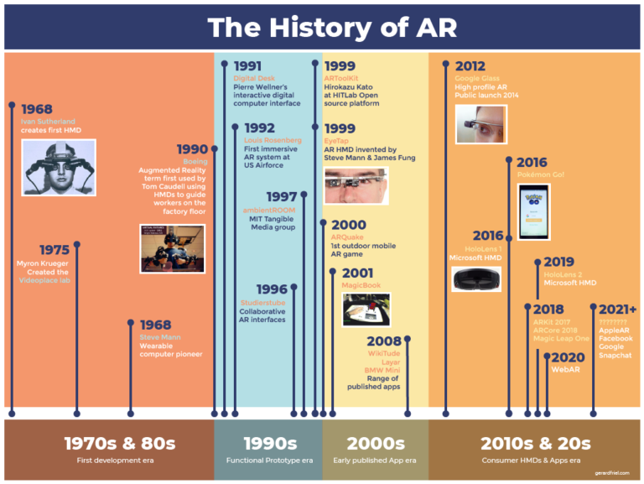

[**Augmented Reality**](https://www.arnxt.com/) **(AR) can be used in the following ways:**

**Retail -** Consumers can use a store's online app to see how products, such as furniture, will look in their own home before making a purchase.

By using AR, consumers can virtually try on products and see how they look on themselves or in their surroundings in real-time. This feature has been particularly beneficial for products like makeup and clothing, as it allows shoppers to visualize how they will look or fit before making a purchase.

Augmented Realty App by [ARnxt](https://www.arnxt.com/) enables users to visualize how products will look and how well they will fit in your home or office environment.

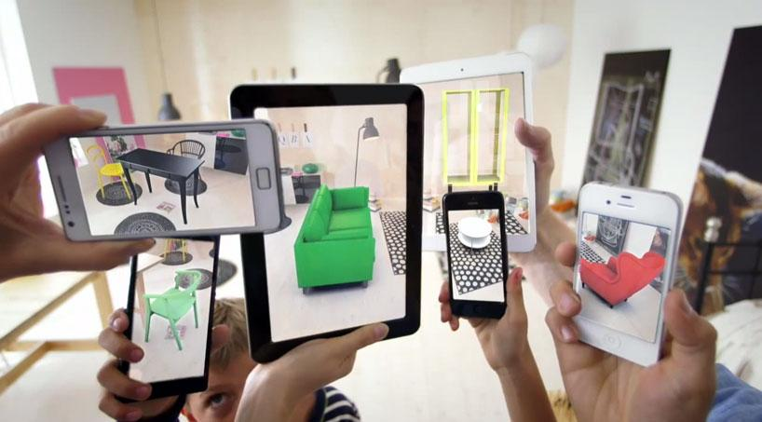

**Entertainment and gaming -** AR can be used to overlay a virtual game in the real world or allow users to animate their faces in different and creative ways on social media.

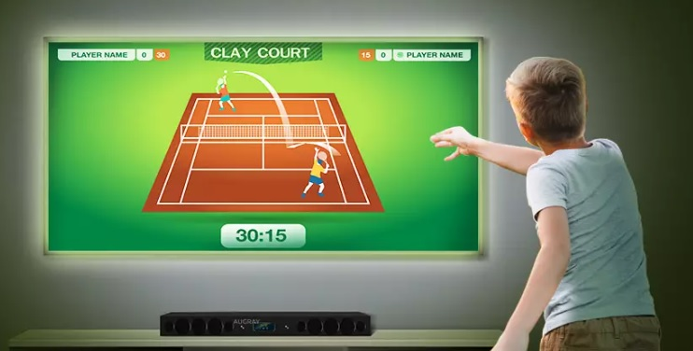

**Navigation -** AR can be used to overlay a route to the user's destination over a live view of a street. AR can also display information about local businesses in the user's immediate area for navigation.

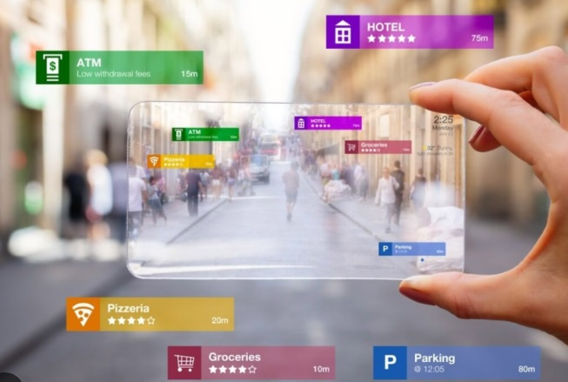

**Tools and measurement -** Mobile devices can use Augmented Reality (AR) to measure different 3D points in the user's environment.

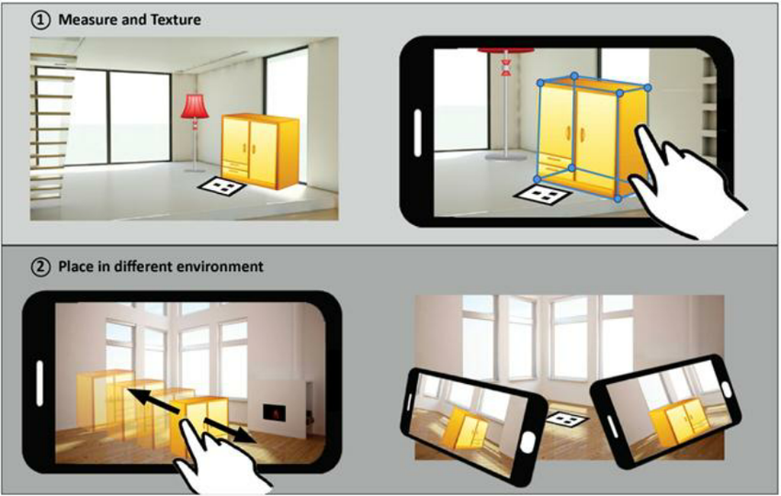

**Architecture -** Augmented Reality can help architects to visualize a building project. The main use of augmented reality in architecture is for project presentations, where you can showcase a realistic 3D model of your building concept in an interactive way.

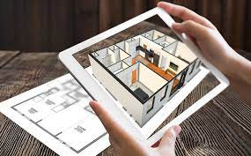

**Military -** There are two ways AR is used in military.

1. Information about directions, distances, weather, and road conditions can be shown on a vehicle's windshield.
2. Augmented Reality has been adopted by the military where it is mostly used for training purposes. It is useful for training soldiers for combat situations or other dangerous settings. An Augmented Reality simulation enables the soldiers to do so but without the risk of death or an injury. It is safer and less costly than traditional training methods.

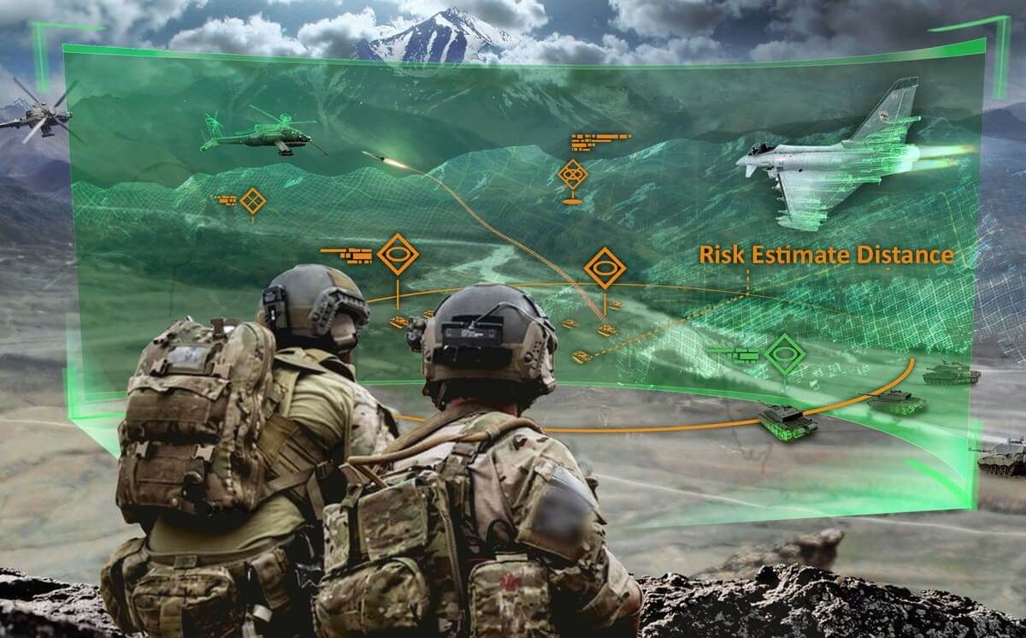

**Archaeology -** AR has helped archaeologists reconstruct sites, which has aided archaeological research. 3D models help museum visitors and future archaeologists experience an excavation site as if they were there.

