We started with a requirement to call a concurrent program.

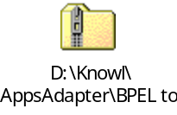
To understand this process, the document lists the three ways to invoke that concurrent program. By comparing the values in the first two, one can easily figure out the correct values to be passed to the bpel program
- Using Oracle Apps UI
- Using PL/SQL code
- Using BPEL code

- Concurrent Process Name: MR Price List Line Import Program.
- Short Name: XXQP_PRICELISTINTF
- Executable: XXQP_PRICELISTINTF
- Parameters:
- 10; Master Organization Id; Value Set: 10/Number; Default: Constant, 84
- 20; Set Process Id; Value Set: 10/Number; Default: Constant, 1
- 30; Delete Processed Records? ; Value Set: OM:Yes No; Default: Constant, Yes

1. Invoking through Apps
If we try to invoke it through Apps, this is how the screen looks like
This user has been given the following responsibilities

MR QP Pricing Manager – xx

So when we login to apps, we see all the responsibilities that user has access to.

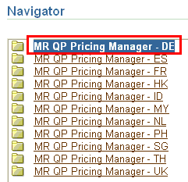

Click on the first one. The various functions assigned to this responsibility show up. Here we can see we have a function to View ConCurrent Requests.
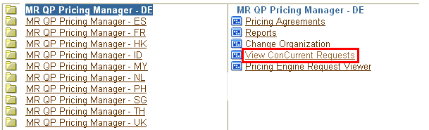

We come to this screen, where we can search for all submitted requests

Click on Submit a New Request
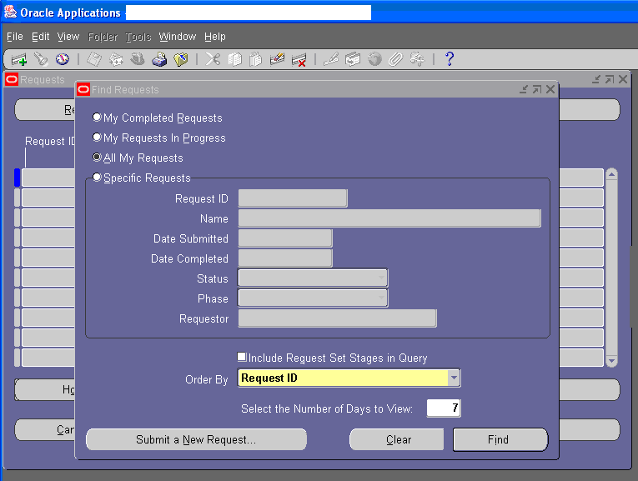

Browse and search for the concurrent program you are interested in
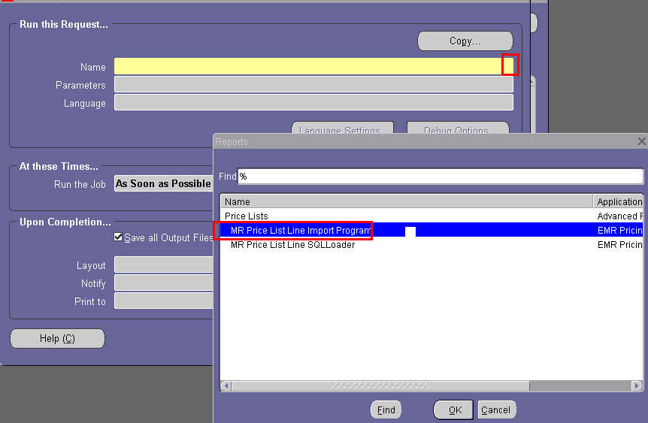

So now we are sure that this concurrent program does exist.

As soon as you say OK, the concurrent program is selected and it shows a parameter window

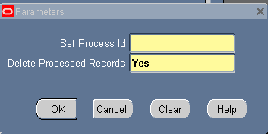

Enter some parameters and press OK. At this point you can submit the request
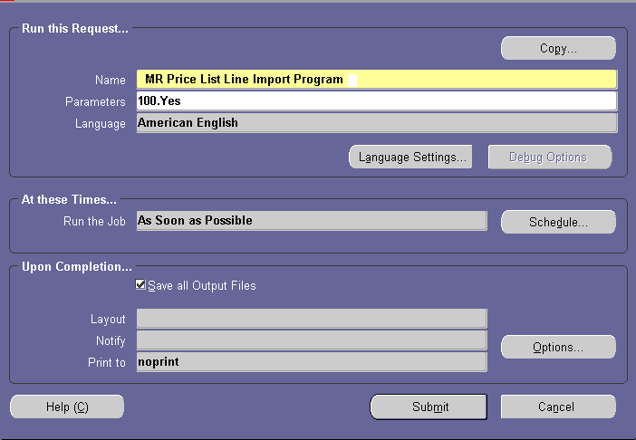

2. Invoking through PLSQL

declare
v_user_name varchar2(15):='FUSION_TEAM';--password is apps_dianad2
v_responsibility_name varchar2(85):='EMR QP Pricing Manager - DE';
v_user_id number;
v_resp_id number;
v_appl_id number;
p_errbuf varchar2(20);
v_req_id number;
V_RETURN_STATUS boolean;
V_PHASE varchar2(115);
V_STATUS_REQ varchar2(115);
V_DEV_PHASE varchar2(115);
V_DEV_STATUS varchar2(115);
V_MESSAGE_STR varchar2(115);
begin

-------------------------------------------------------------------
--Submitting the Price request Import Program
-------------------------------------------------------------------
-- Derive the user_id, responsibility_id and application_id

select user_id
into v_user_id
from fnd_user
where user_name like v_user_name
and nvl(end_date, sysdate) >= sysdate; -- 16064

select responsibility_id
into v_resp_id
from fnd_responsibility_vl
where responsibility_name like v_responsibility_name;

select application_id
into v_appl_id
from fnd_application_vl
where application_short_name like 'QP';

--Setting of environment for the Concurrent Requests
fnd_global.apps_initialize(v_user_id, v_resp_id, v_appl_id);

--Submitting Conc.req serially
v_req_id := fnd_request.submit_request(
application =>'XXQP'
, -- short name of the Req.Import
program =>'XXQP_PRICELISTINTF'
, -- name of the concurrent pgm
description => NULL
, -- Description
start_time =>NULL
, -- Start time
sub_request =>FALSE
, -- Sub_request
argument1 =>'84'
, --Interface Source Code
argument2 =>'1'
, --Batch ID
argument3 =>'Y'
);

COMMIT;

IF (v_req_id= 0) THEN
-- Handle submission error
dbms_output.put_line( 'Request Failed... '|| v_req_id);
p_errbuf := 'FAILED';
ELSE
p_errbuf := 'COMPLETED';
dbms_output.put_line( 'Waiting for the Requisition Import to complete...'|| v_req_id);
LOOP
--Calling API to Refresh the submitted Request
v_return_status := fnd_concurrent.wait_for_request(
request_id => v_req_id
, INTERVAL => 10
, max_wait => 6000
, phase => v_phase
, status => v_status_req
, dev_phase => v_dev_phase
, dev_status => v_dev_status
, MESSAGE => v_message_str
);

IF UPPER(v_phase) = 'COMPLETED' THEN
EXIT;
END IF;
END LOOP;

IF UPPER(v_status_req) = 'NORMAL' THEN
dbms_output.put_line('Concurrent Request completed successfully');
ELSIF UPPER(v_status_req) = 'WARNING' THEN
p_errbuf := 'WARNING';
dbms_output.put_line('Concurrent Request generated Warnings. Some records'||
' may be in Error. Check the Output');
ELSE
p_errbuf := 'FAILED';
dbms_output.put_line('Error: Concurrent Request to Import Requisitions failed ' ||SUBSTR(SQLERRM,1,100));
END IF;
END IF;
end;

3. Invoking through BPEL

These are the steps

- Get hold of the following information
  - Concurrent program name - XXQP_PRICELISTINTF
  - What parameters to pass
  - Application name – XXQP
  - Responsibility name - MR QP Pricing Manager – DE
  - User name – FUSION_TEAM
  - Apps database uid,pwd – apps/apps
  - Apps database hostname – somedb.company.com:1521/dianad2
- Create a bpel process. Add a Apps adapter to it
- Select the concurrent program
- Create a variable based on the header
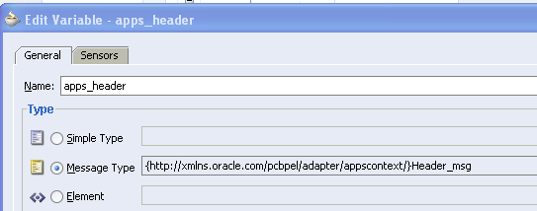
- Add an invoke activity, connect it to the apps adapter
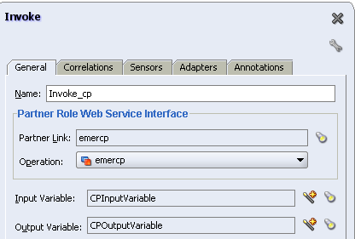

- Assign the apps_header variable in Invoke
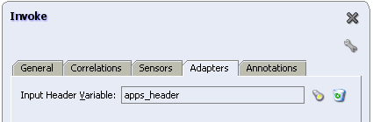
This is one way of passing the username and responsibility. If however, we feel that these are known before, they can be hardcoded in the WSDL file. By default, the adapter wsdl file uses Username="sysadmin" and Responsibility="System Administrator".

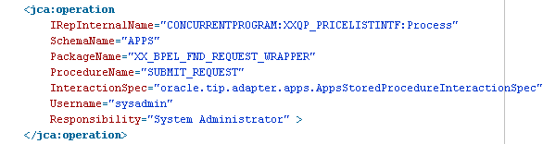

If we want we can put Username=”FUSION_TEAM” and Responsibility=” MR QP Pricing Manager – DE”

- Add an assign activity. Assign FUSION_TEAM to username, MR QP Pricing Manager – xx to Responsibility
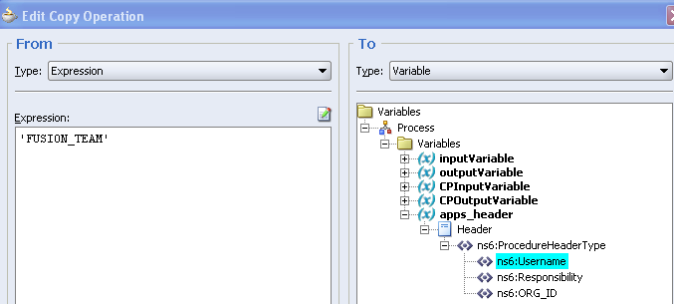

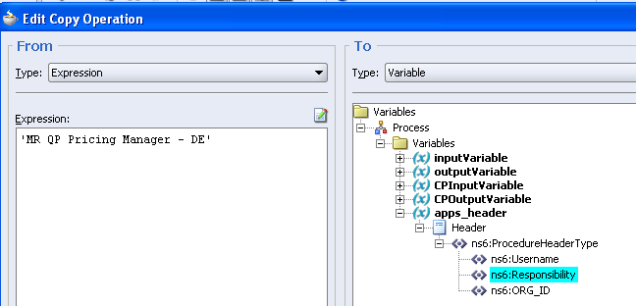

- Add a transform activity

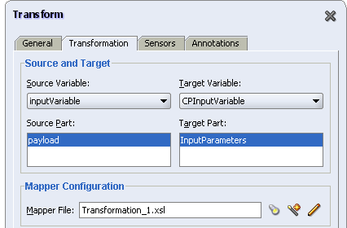

Most values are assigned statically.
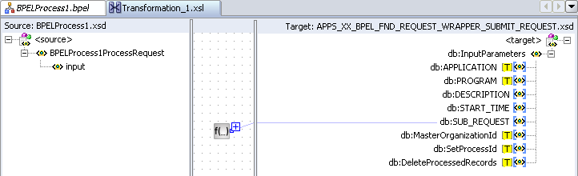

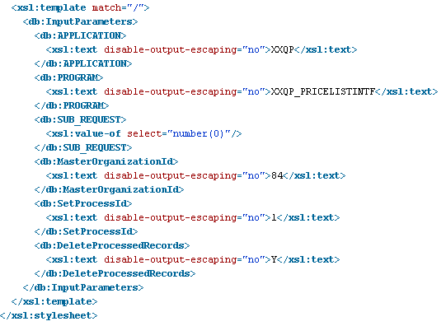

Here I have hardcoded all inputs. I just wanted to see if concurrent program works.

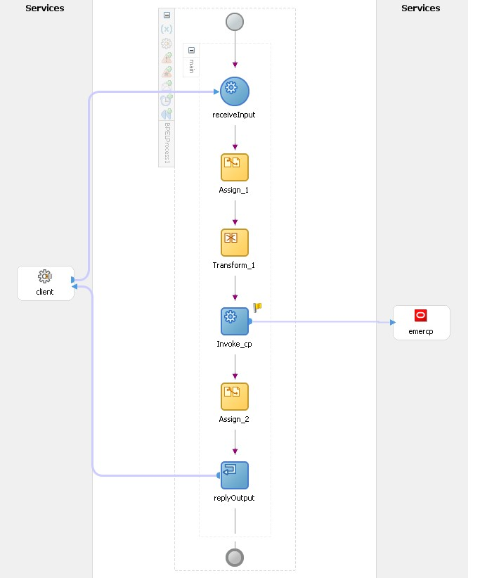

We now need to make connection pool, datasource and apps adapter connection factory. Datasource and connection pool is same as a normal db adapter. Once you have created the datasource, just mention its jndi name in the Apps adapter

Connection pool

Data source

Apps adapter connection factory
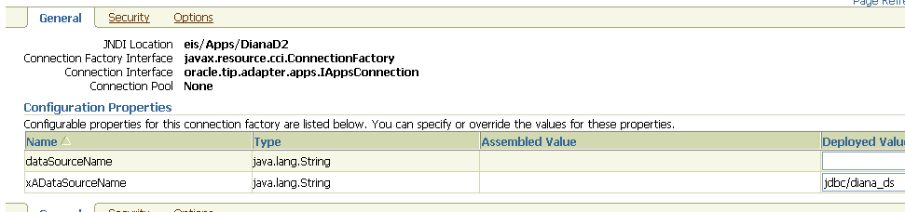

- Run the bpel process
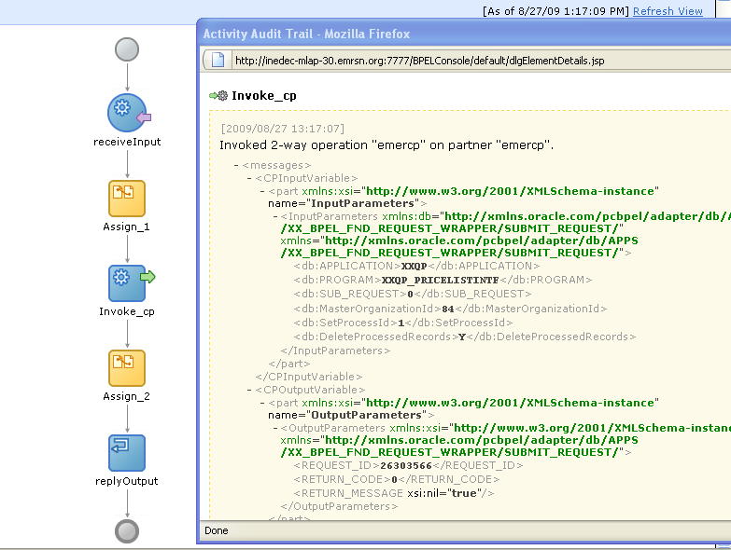

We can verify in apps screen that an instance has been created.

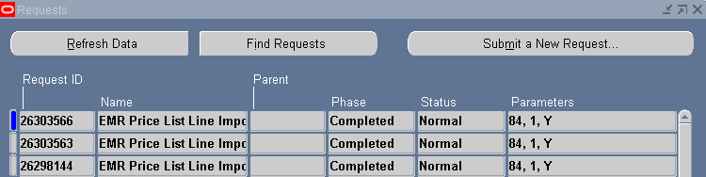

The same can be verified using sql statements:
select * from FND_CONCURRENT_REQUESTS where request_id= 26303566;

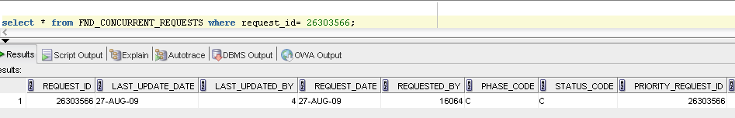

Just playing around

We can find the user id and resp id from this row

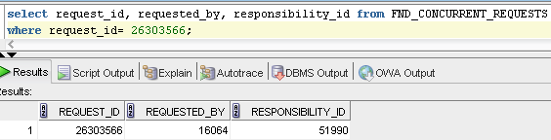

Use this query: This gives all responsibilities containing EMR, that the user FUSION TEAM has access to.

Select fu.User_ID,
frt.Application_ID,
frt.Responsibility_ID,
Responsibility_Name
From FND_User fu,
FND_Responsibility_TL frt,
FND_User_Resp_Groups furg
Where fu.User_Name = 'FUSION_TEAM'
And frt.Responsibility_Name like '%MR%'
And frt.Language = 'US'
And furg.User_ID = fu.User_ID
And furg.Responsibility_ID = frt.Responsibility_ID
And sysdate between furg.start_date and nvl(furg.End_Date, sysdate);

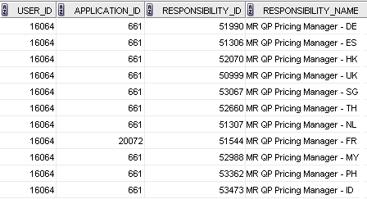

The following query gives details of all the responsibilities plus all the org id in those responsibility that user FUSION_TEAM, whose user idis 16064 has access to

select distinct FURGA.USER_ID , FRTL.responsibility_id,
FRTL.application_id, a.profile_option_value org_id, FRTL.responsibility_name
from FND_USER_RESP_GROUPS_ALL FURGA,
FND_RESPONSIBILITY_TL FRTL,
fnd_profile_option_values a , fnd_profile_options e
where FURGA.RESPONSIBILITY_ID = FRTL.RESPONSIBILITY_ID (+)

and a.level_id=10003
and a.profile_option_id = e.profile_option_id
and e.profile_option_name = 'ORG_ID'
and FURGA.user_id=16064;

