Aim

We want to give default input to our BPEL process to ease testing. That is, when you open the initiate tab in the BPEL console, it comes pre-populated with some values.

BPEL provides configuration properties like defaultInput that can be used to achieve this. This property gets stored in the bpel.xml file.

Let’s see how we can give default input to HelloWorld.

First deploy the plain HelloWorld to BPEL console. Then open the initiate tab and go to XML source. Copy the format

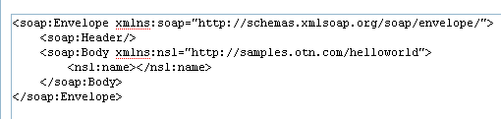

Use this as a guide to create your input. Copy whatever there is under the soap:Body element. Then add the namespace declaration

<ns1:name xmlns:ns1="http://samples.otn.com/helloworld"></ns1:name>

Adding the configuration property is a piece of cake. It can be done by directly manipulating bpel.xml, but there is an easier way, through JDeveloper

Select the Deployment Descriptor property as shown

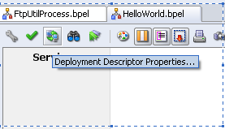

Select the Configurations tab. Then click Create icon and select the defaultInput from the dropdown. Then give the value, which we prepared above. Also check Store as CDATA section option
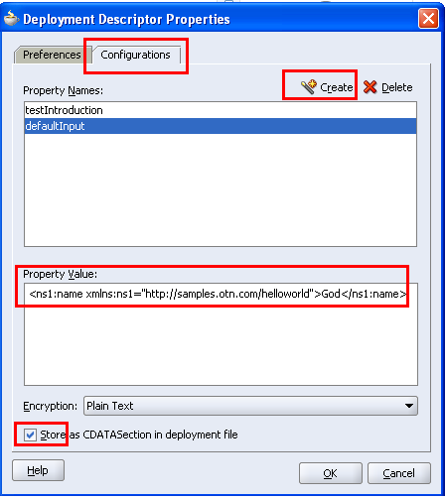

Redeploy the BPEL process now. Now when you open the initiate tab in the BPEL Console, it shows exactly what you have entered

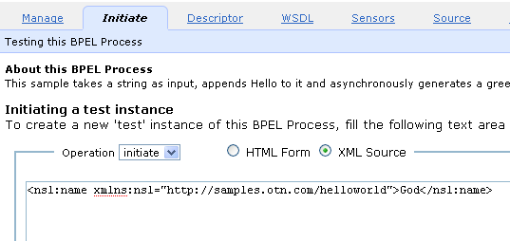

Invoke the application and verify that we have the desired output.

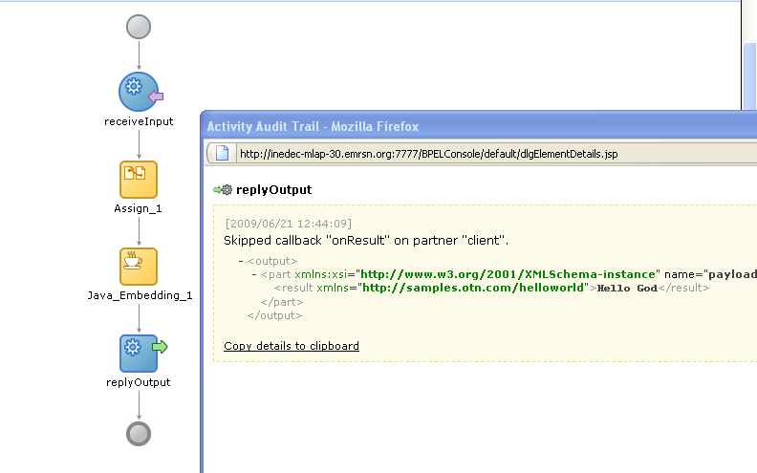

A look at the bpel.xml also tells that this property got stored in the bpel.xml file.

