Aim

Modify HelloWorld example to not use ‘Hello’ by default. User can set the value to be prepended at deployment time.

We make use of BPEL properties here. We will specify the value that we want to be prepended as a property (called preference in BPEL) in the descriptor file (in bpel.xml)

You can manually edit the bpel.xml file. However, JDeveloper provides a way to add preference. Click on the Deployment Descriptor Properties icon as shown:

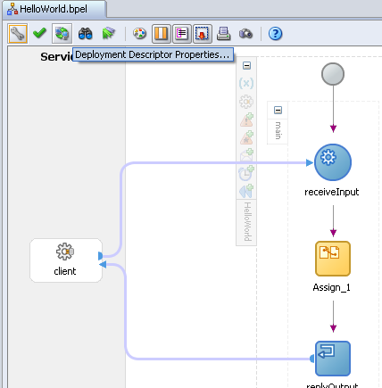

The Deployment Descriptor Properties dialog opens up. Click on the Create icon.
Give name to the property you want to create. Here we give HelloStrProperty
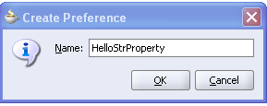

In the Property Value section, give a value. Here we give Hello
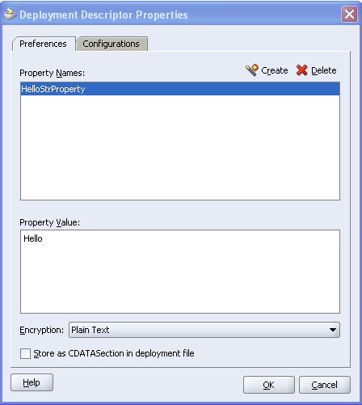

This completes the changes to the descriptor file. Press OK.
You can verify these changes in bpel.xml too
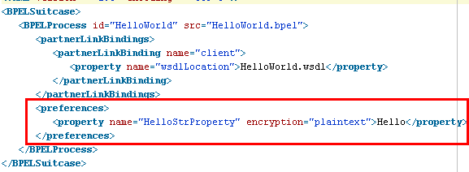

Now we need to read this property and then use it in the copy rule which earlier used to prepend ‘Hello’ to the input

First, create a new string variable named HelloStr in the bpel process
Click on (x)
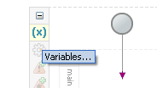

Select Create
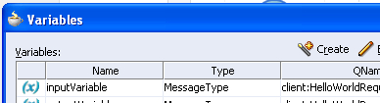

Give name as HelloStr. Create a simple type. Select string
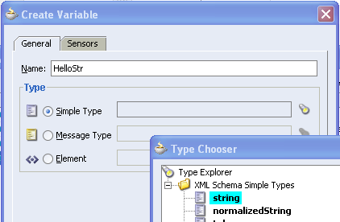

Variable is created
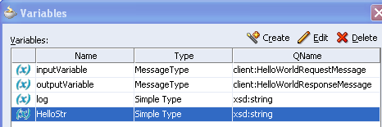

Open Assign activity and add a copy rule as follows
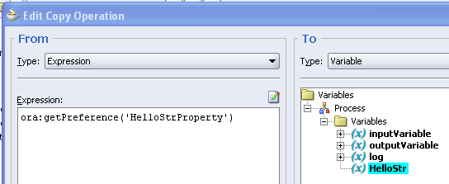

Here we are using ora:getPreference() function to retrieve a value from the descriptor.

Move this copy rule above the previous rule. First select the rule then press the Up button in Assign dialog
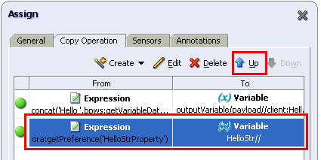

Now modify the concat copy rule as follows

Instead of an hardcoded ‘Hello’ we now use the value in HelloStr
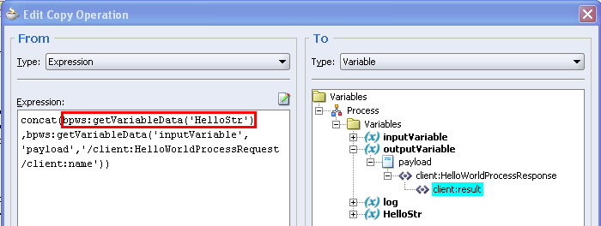

concat(bpws:getVariableData('HelloStr'),bpws:getVariableData('inputVariable','payload','/client:HelloWorldProcessRequest/client:name'))

This completes the changes. Deploy and test.

Give input as God

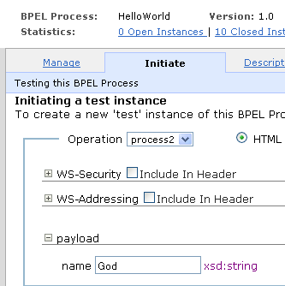

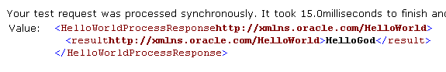

Now we shall see the power of the descriptor. Click on the descriptor link
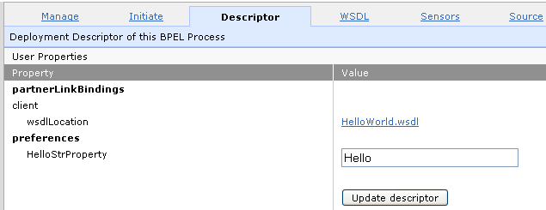

As you can see, the property is editable!. You can change the value, press Update descriptor, and the new value shall be used – no need to undeploy your bpel process in case you want to change any property at runtime!!

Change the property to give some other value, say Namaste
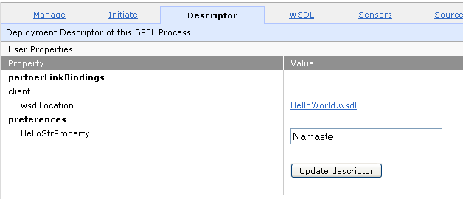
Press Update descriptor. Now retest
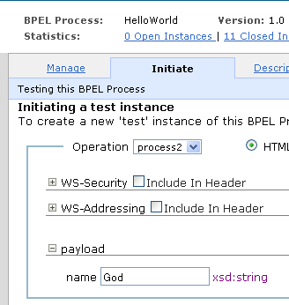
The output uses the new value.
