Delete all the vm instances and delete all the custom vpc networks.First delete all vms then delete all vpcs.

E commerece product flow images

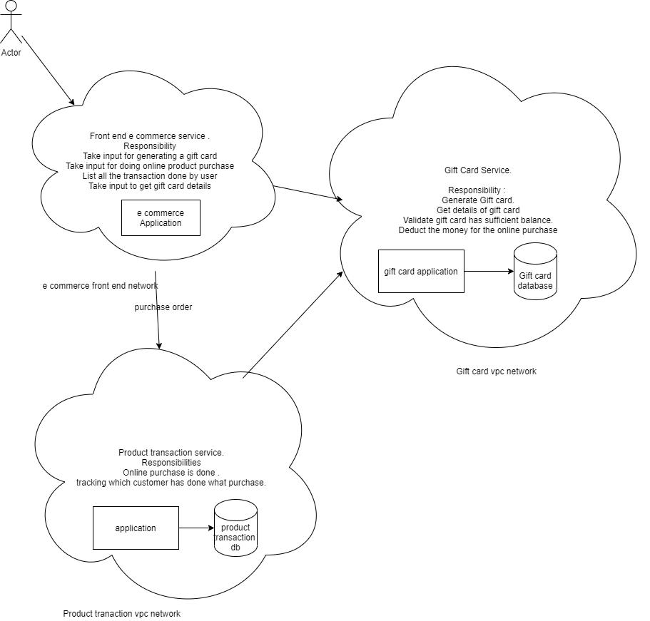

1)Create a custom network for internet facing (e-commerce-front-end-network) having subnet present in us-central-1 .put cidr range as 10.0.0.0/29.Keep rest of things as it is and click create

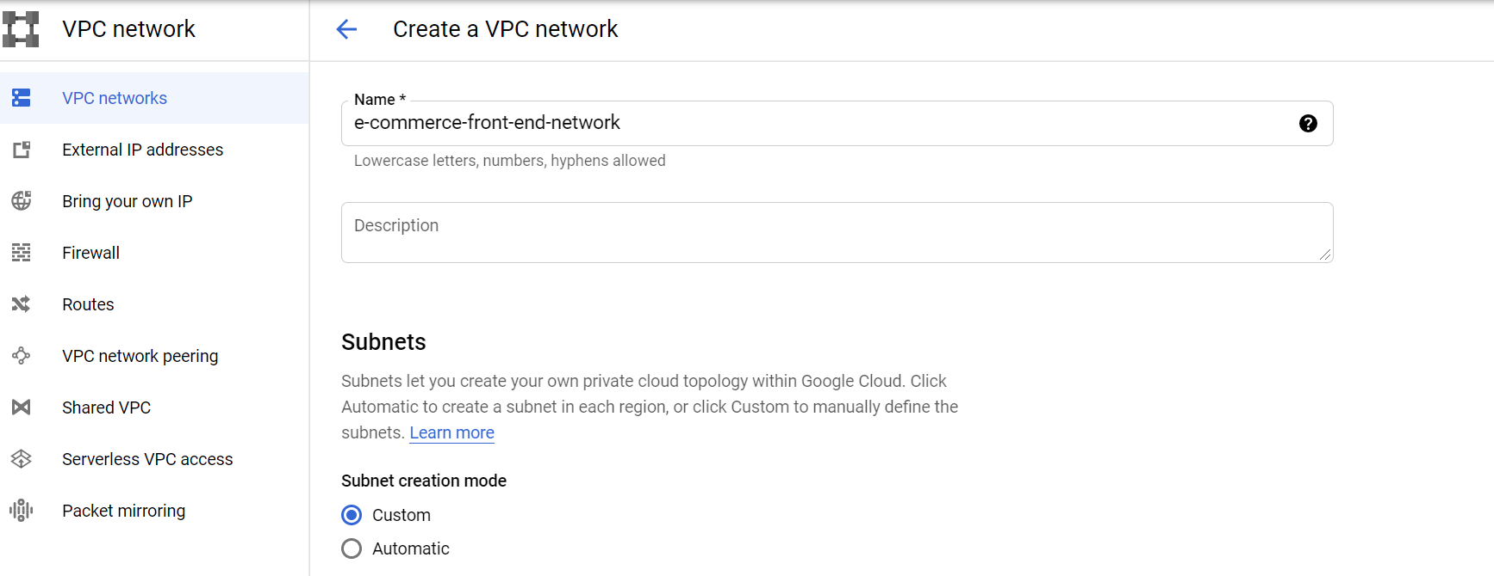

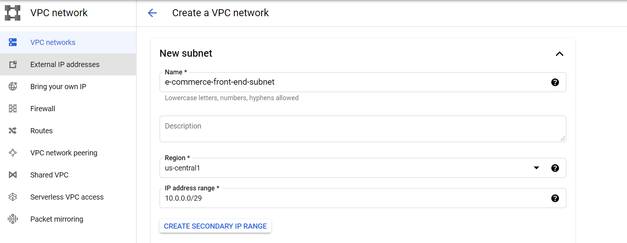

4) Create another network known as gift-card-backend-internal-network with subnet in us-central-1 and cidr range as 10.0.1.0/29.Keep rest of things as it is and click create.

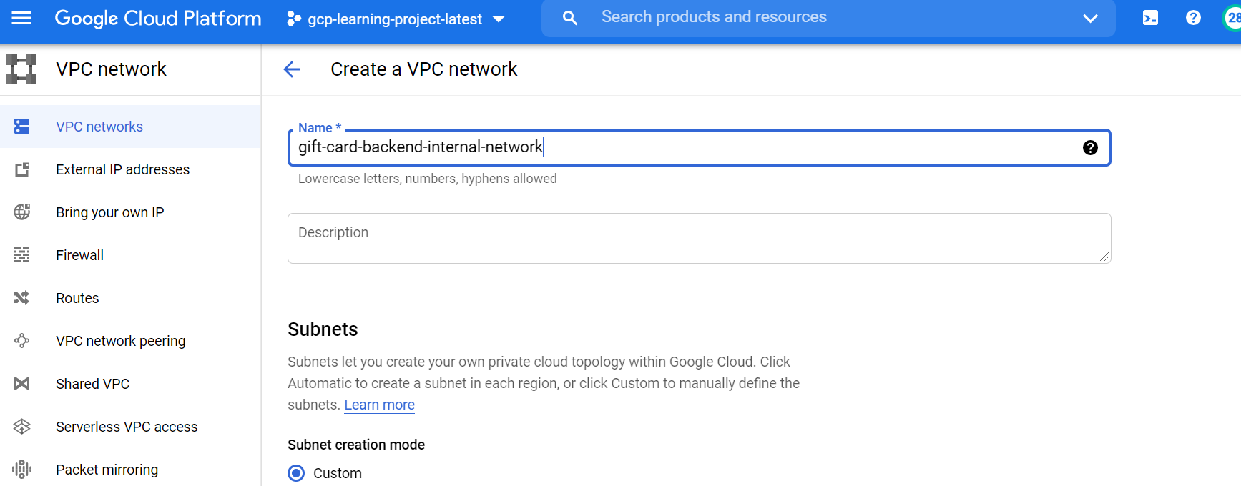

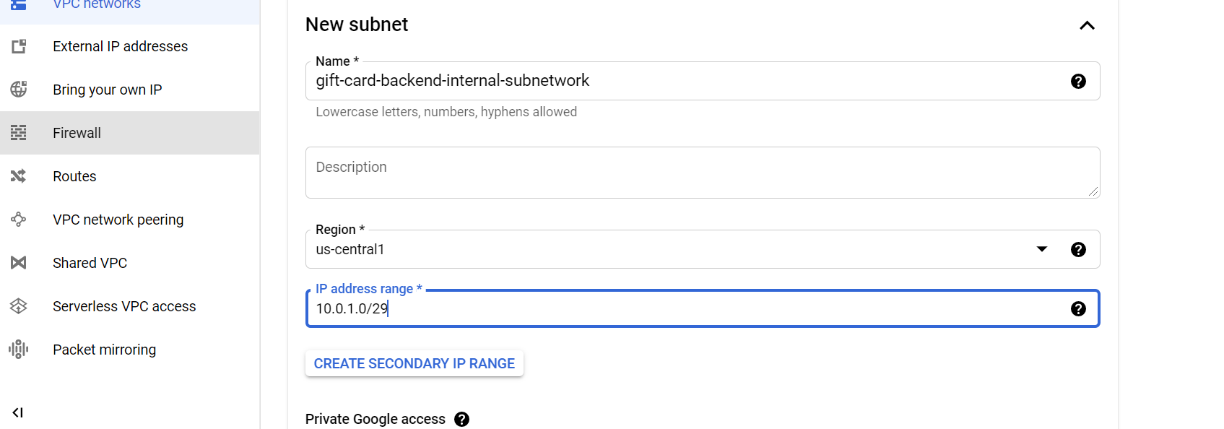

5) Create another network known as product-transactions-backend-internal-network with subnet in us-central-1 and cidr range as 10.0.2.0/29.Keep rest of things as it is and click create.

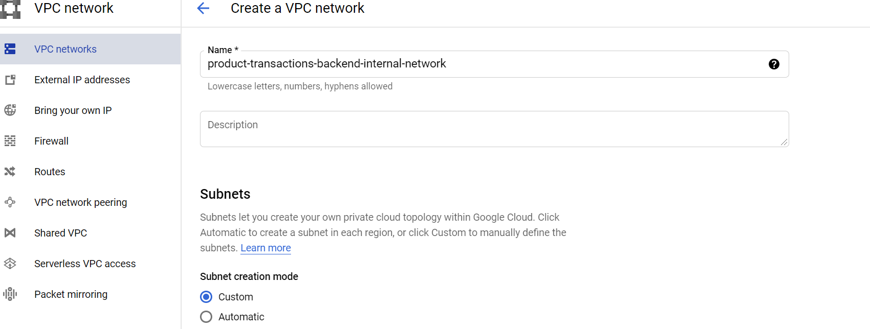

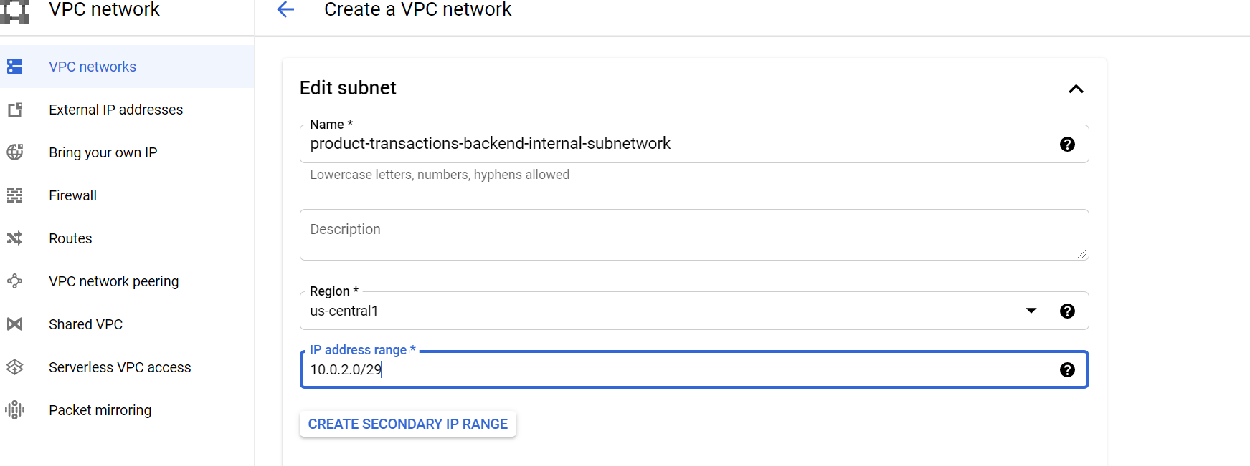

6) Create a virtual machine (e-commerce-vm) in network e_commerece_front_end_network having N1,g1 small and Ubuntu 18.04.Put network tag as “e-commerce-front-end”.

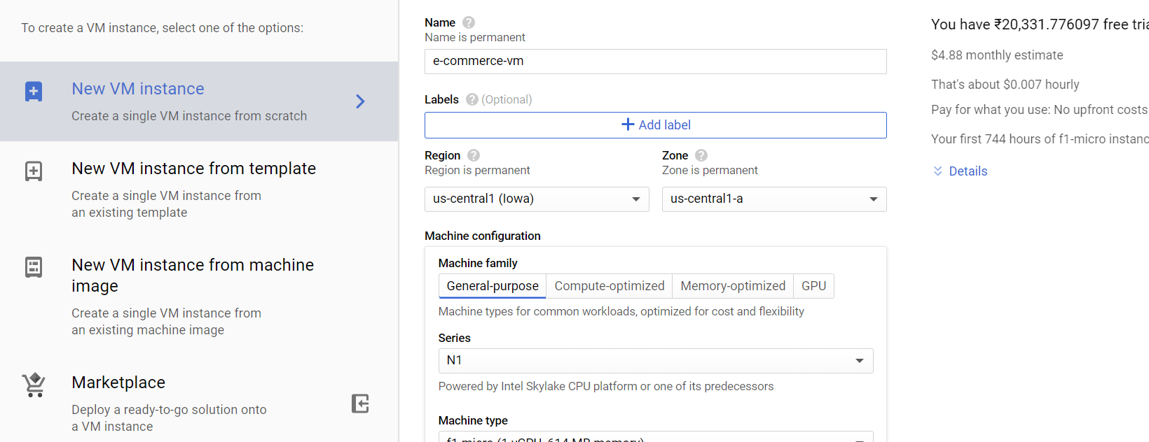

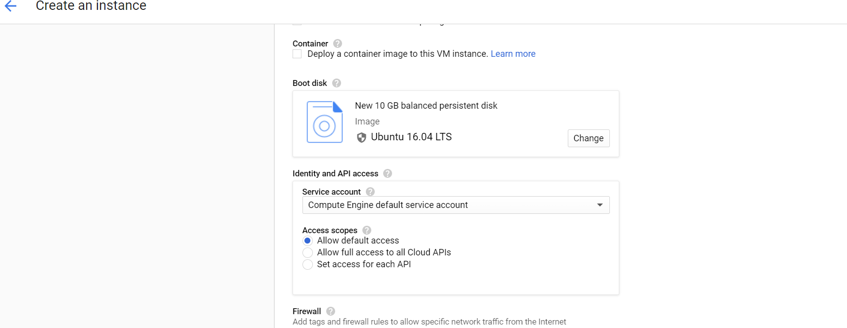

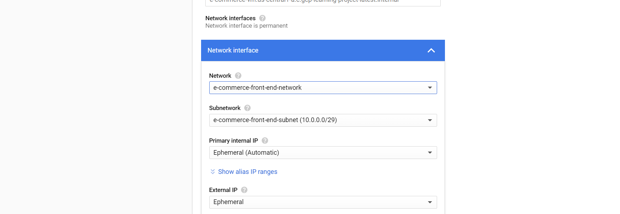



7) Create a virtual machine (gift-card-vm) in network gift_card_backend_internal_network having N1,g1 small and Ubuntu 18.04.put network tag as “gift-card-back-end”

8) Create a virtual machine (product-transactions-vm) in network product_transaction_backend_internal_network having N1,f1 micro and Ubuntu 18.04.put network tag as “product-transaction-back-end”

9) create a firewall rule on tcp port 22 for all the custom VPC networks with source ip as 0.0.0.0/0.

Select target as “all_instances_in_network”

10) Login to e_commerce_vm and upload the e_commerce_front_end.py.

Put the respective internal ip of gift card vm and product transaction vm in e_commerce_front_end.py.

Below ip need to be changed in e_commerce_front_end.py

gift_card_ip="127.0.0.1"  
product_store_ip="127.0.0.1"

Do the application level set up on this machine

sudo su

apt update

apt install python3-pip

pip3 install flask

pip3 install requests

Start the application e_commerce_front_end.py

python3 e_commerce_front_end.py

11) Login to vm gift_card_vm and upload file gift_card_engine.py

sudo su

apt update

apt install python3-pip

pip3 install flask

pip3 install requests

apt-get install libpq-dev

pip3 install psycopg2-binary

apt-get install postgresql

sudo -u postgres psql

create table gift_card_info (customer_id text,amount int,gift_card_no text);

alter user postgres password '123456';

\q (to come out of database)

Start application

python3 gift_card_engine.py

12)Login to product transaction vm and upload file product_transaction_engine.py

Change the ip of gift_card to internal ip of gift card vm in the file.

Below gift_card_ip need to be changed in file product_transaction_engine.py

gift_card_ip="127.0.0.1"

sudo su

apt update

apt install python3-pip

pip3 install flask

pip3 install requests

apt-get install libpq-dev

pip3 install psycopg2-binary

apt-get install postgresql

sudo -u postgres psql

create table product_transaction(products text,customer_id text,total_amount int ,transaction_id text);

alter user postgres password '123456';

\q

Start the application of product transaction

python3 product_transaction_engine.py

13) Create a firewall on port 3000 to allow external traffic in network e-commerece-front-end-network.

Put target tag as “e-commerce-front-end” source ip range is “0.0.0.0/0” .Tcp 3000

//Skip step no 14 & 15

14)From Postman access the url

<http://EXTERNAL_IP:3000/healthcheck>

where EXTERNAL_IP is external ip of e-commerce front end

This is to ensure that we are able to access our application from outside

15)Hit the url from postman

External_ip:3000/generate_gift_card?customer_id=999&amount=10000.

Observe all the application windows, we shall not be able to get response from cloud.

16)Create a VPC peering from e-commerce-network to gift-card-network and vice versa.

Enter the below detail and keep rest as default.

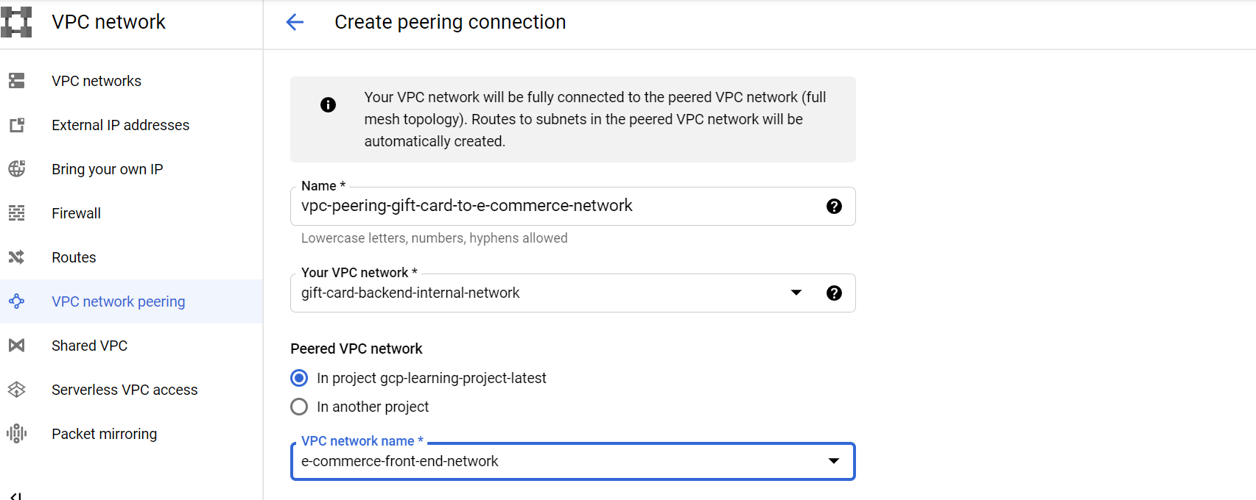

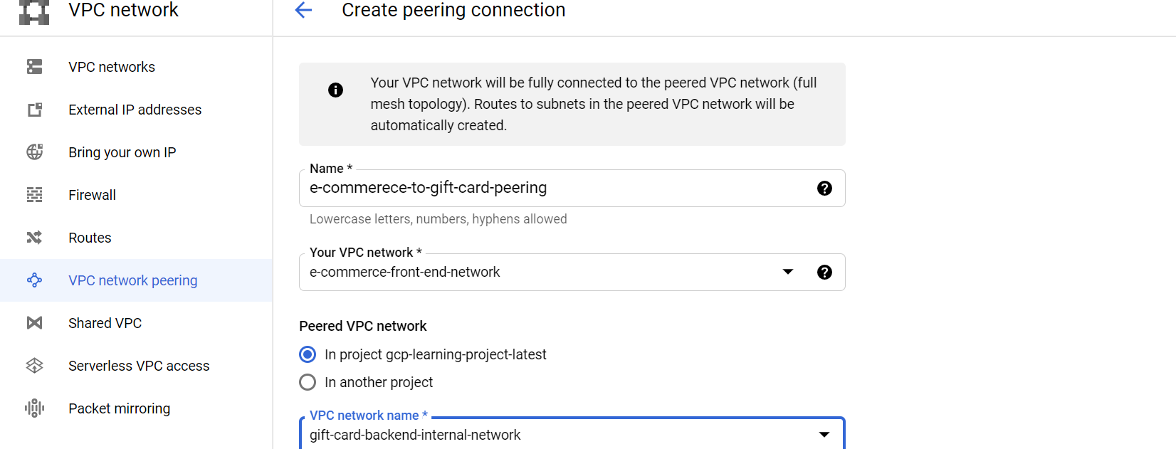

17)Verify VPC peering is done on both sides (green tick shall come).

18)Take a new login session of e_commerece_vm and do telnet on internal_ip of gift_card_vm on port 3001.

telnet internal_ip_gift_card 3001

19)verify Telnet shall not go through as there is no firewall to allow the connect.

20)Create a firewall in network (gift_card_backend_internal) .Specify target tag as “gift-card-back-end” and source ip range as 10.0.0.0/29. Tcp port is 3001

21)Verfiy now telnet from e_commerece_vm to gift_card_vm shall work fine now.

22)Hit the url

External_ip:3000/generate_gift_card?customer_id=999&amount=10000

And

External_ip:3000/get_gift_card?gift_card_no=1620757142

Here External_ip is external ip address of e_commerece_vm .

We shall be able to get the response.

//skip step no 23

23)Hit the URL

External_ip:3000/buy_products?products=soap,mask,hand-sanitizers&customer_id=999&total_amount=500&gift_card_no=1620757142.

This shall also fail as there is no VPC peering yet between e_commerece_to_product_transaction

24)Establish vpc peering between e_commerece to product_transaction and vice versa.

25)Do a telnet from e_commerece_vm to product_transaction on internal ip on port 3002.

It shall not go through.

26)Create a firewall rule in network (product-transactions-backend-internal) with target tag as “product-transaction-back-end” and source ip cidr is “10.0.0.0/29) on port 3002

//skip step no 27 and 28

27) verify now telnet is going through from e_commerece to production transaction on port 3002.

28) Hit the URL

External_ip:3000/buy_products?products=soap,mask,hand-sanitizers&customer_id=999&total_amount=500&gift_card_no=1620757142.

This shall again fail as there is dependency product_transaction and gift_card.

29)Create a network vpc peering between product_transaction and gift_card and vice versa.

30)create a firewall rule in network “gift-card-internal-backend” with target tag as “gift-card-back-end” and source ip range is “10.0.2.0/29” port 3001

31)Hit all the urls

External_ip:3000/buy_products?products=soap,mask,hand-sanitizers&customer_id=999&total_amount=500&gift_card_no=1620757142.

External_ip:3000/list_all_transactions?customer_id=999

Now all the end point shall work properly