CS 6375 – Project 4 Report

Introduction

This project explores two unsupervised learning algorithms: K-Means Clustering and Expectation-Maximization (EM) using Gaussian Mixture Models (GMMs). Using synthetic datasets (blobs and moons), I compared clustering performance, visualize results, and evaluate models quantitatively using silhouette score, log-likelihood, and BIC.

Part 1: K-Means Clustering

K-Means is an unsupervised clustering algorithm that partitions data into k clusters by minimizing the within-cluster sum of squares.
Initialization has a big impact on how well K-Means works. With random initialization, the starting centers can be placed poorly, which sometimes leads to slow convergence and clusters that don’t match the real structure of the data. In contrast, k-means++ usually spreads the initial centers out more effectively, so the algorithm starts in a better position. This makes it converge faster and produces more stable, higher-quality clusters across different runs.
The elbow method was optional, and I did not include it in this project. I focused on silhouette scores as the main quantitative metric for evaluating K-Means performance.

2.1 Visualizations
K-Means Clustering Results on Blobs Dataset (k = 2–5)
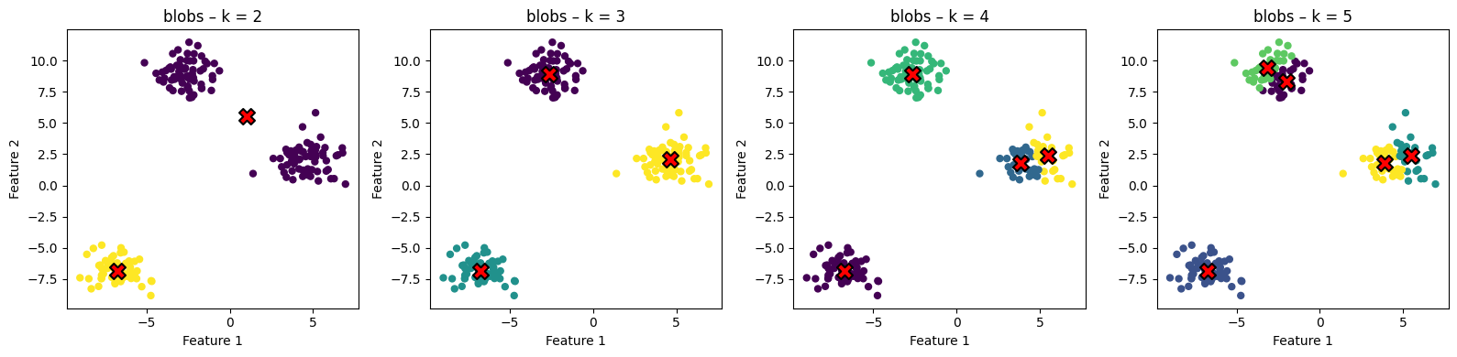
K-Means Clustering Results on Moons Dataset (k = 2–5)
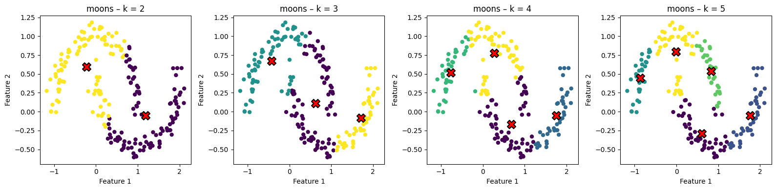
Elbow Plots
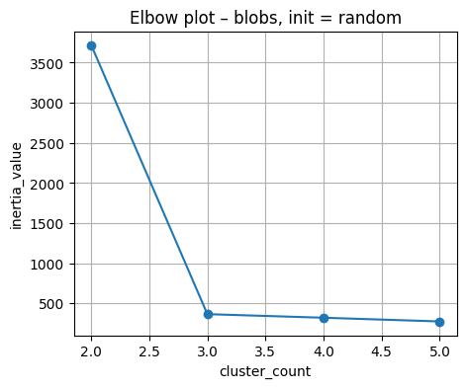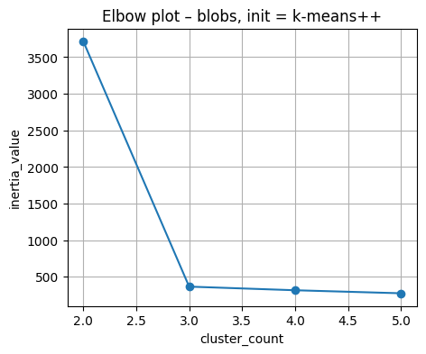

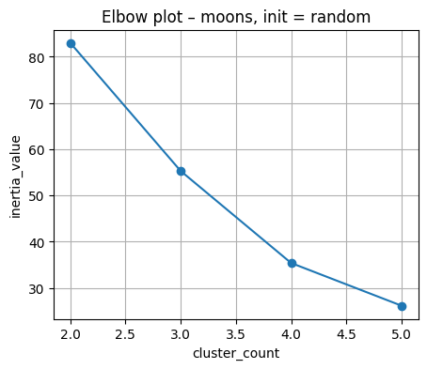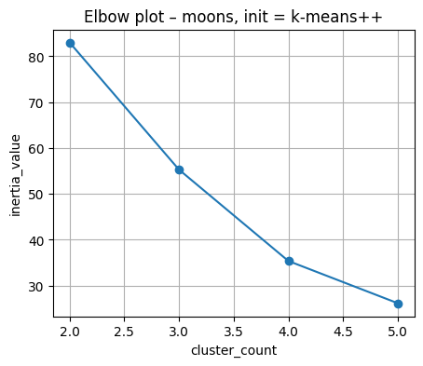

2.2 Quantitative Evaluation

k | Blobs (random) | Blobs (k-means++) | Moons (random) | Moons (k-means++)
2 | 0.7066 | 0.7066 | 0.4799 | 0.4799
3 | 0.8467 | 0.8467 | 0.4204 | 0.4230
4 | 0.6780 | 0.6798 | 0.4556 | 0.4551
5 | 0.5095 | 0.5095 | 0.4785 | 0.4803
From the plots, the blobs dataset showed clear, well-separated clusters, which matched the higher silhouette scores.
The moons dataset had lower scores because the curved clusters were harder for K-Means to separate. Overall, the silhouette score works well for simple shapes but is less reliable for non-convex clusters.
2.3 Discussion
Compare the effect of different initializations.
Both random and k-means++ gave similar results in our plots, but k-means++ was more consistent and avoided poor starting positions.
k-means++ generally converged more reliably, while random sometimes produced slightly less stable clusters
Which dataset is better suited for K-Means, and why?
The blobs dataset is better suited for K-Means because its clusters are round and well separated.
The moons dataset is non-convex and curved, so K-Means struggles to form clean boundaries and gives lower silhouette scores.
How does the choice of k affect clustering quality?
For blobs, the quality improved until around k = 3, which matches the natural structure of the data.
For moons, changing k did not help much because the shape of the clusters doesn’t match K-Means assumptions.
In general, increasing k can temporarily improve separation, but after a point it splits clusters unnecessarily.

2.4 Observations
K-Means worked very well on the blobs dataset, which matched its assumption of round, well-separated clusters. The silhouette scores were highest at k = 3, which also matches the natural structure of the data. On the moons dataset, K-Means struggled because the clusters are curved and non-convex, leading to lower silhouette scores and visibly poorer separation in the plots. Overall, K-Means performed best when the clusters were simple and spherical but was limited when the shapes became more complex.

3. Part 2 – Expectation-Maximization with Gaussian Mixture Models

Gaussian Mixture Models use a probabilistic approach where the dataset is modeled as a mixture of Gaussian distributions. EM iteratively updates the assignment probabilities and parameters of each Gaussian component.

3.1 Visualizations
GMM experiments for dataset: blobs
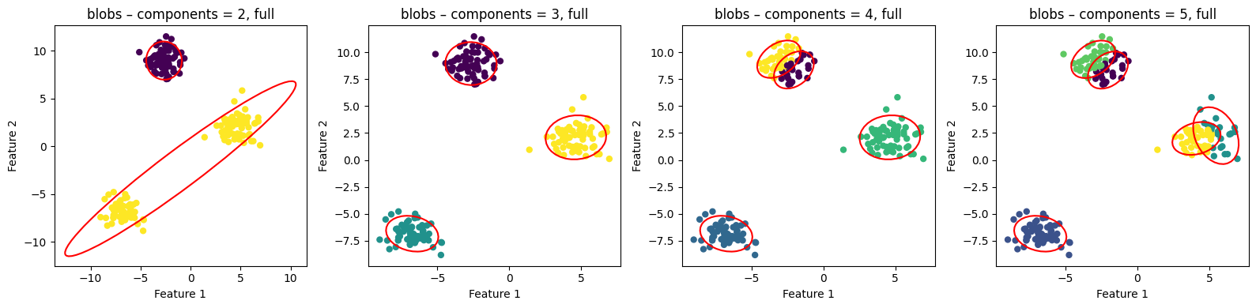
GMM experiments for dataset: moons
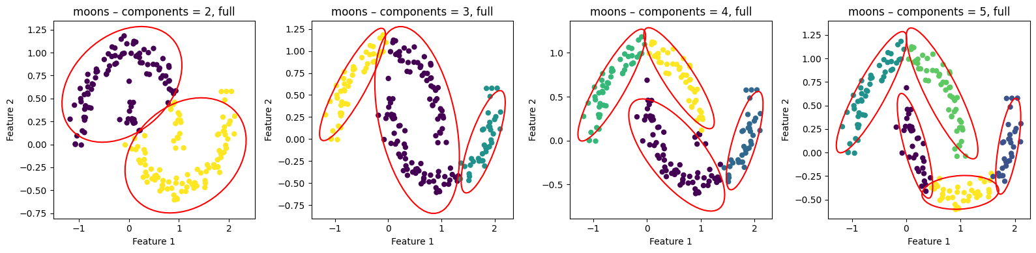

3.2 Quantitative Results
dataset_name | component_count | covariance_type | silhouette_score | average_log_likelihood | bic_value
blobs | 2 | full | 0.519518 | -4.739742 | 1954.178092
blobs | 2 | diag | 0.519518 | -5.607928 | 2290.856184
blobs | 3 | full | 0.846700 | -3.823259 | 1619.375098
blobs | 3 | diag | 0.846700 | -3.829603 | 1606.017620
blobs | 4 | full | 0.666481 | -3.817704 | 1648.942825
blobs | 4 | diag | 0.662793 | -3.828153 | 1631.929310
blobs | 5 | full | 0.503397 | -3.795893 | 1672.008508
blobs | 5 | diag | 0.493045 | -3.813983 | 1652.752980
moons | 2 | full | 0.459472 | -1.730802 | 750.602293
moons | 2 | diag | 0.457767 | -1.768522 | 755.093527
moons | 3 | full | 0.400461 | -1.453709 | 671.555061
moons | 3 | diag | 0.410668 | -1.752421 | 775.144982
moons | 4 | full | 0.453257 | -1.270043 | 629.878339
moons | 4 | diag | 0.372125 | -1.437724 | 675.757637
moons | 5 | full | 0.456296 | -1.092853 | 590.792314
moons | 5 | diag | 0.393023 | -1.367242 | 674.056453

Silhouette scores were highest for blobs at k = 3 and generally lower for moons, with full covariance performing slightly better than diagonal on most values of k.

Average log-likelihood improved (became less negative) as k increased, and full covariance consistently gave better likelihood values than diagonal, especially on the moons dataset.
BIC was lowest at k = 3 for blobs and at k = 5 for moons, showing that these component counts provided the best balance between fit and model complexity.

3.3 Discussion

Analyze how GMMs handle elliptical clusters better than K-Means, especially on non-convex datasets.
In our results, GMMs fit the blobs dataset very well and produced higher silhouette scores whenever the cluster shapes were slightly elongated. On the moon’s dataset, GMMs handled the curved structure better than K-Means, especially with full covariance, because they can form flexible elliptical boundaries instead of the circular ones K-Means forces. This allowed GMMs to capture shapes that K-Means could not separate cleanly.
In what scenarios does EM outperform K-Means?
EM outperformed K-Means whenever the clusters were not perfectly spherical, which we saw clearly on the moons dataset where K-Means struggled. EM also performed better as k increased because it adjusts cluster shapes through covariance rather than just moving fixed-radius centroids. This made EM more accurate on datasets with uneven or overlapping shapes.
How does the covariance type influence cluster shape and separation?
Full covariance consistently gave better scores than diagonal because it let the GMM components rotate and stretch to match the true structure of the data. On both blobs and moons, diagonal covariance was more restrictive and sometimes produced worse BIC values. Overall, full covariance produced cleaner separation and fit the data more naturally.

3.4 Observations
GMM handled both datasets more flexibly because it can model elliptical clusters through covariance. The full covariance type consistently produced better fits, reflected in higher silhouette scores, better log-likelihood values, and lower BIC. On the moon’s dataset, GMM performed noticeably better than K-Means, capturing more of the curved structure even though the clusters were still challenging. Overall, EM provided a more adaptable clustering approach, especially when cluster shapes were not spherical.

4. Conclusion
This project demonstrated practical clustering with K-Means and GMMs. K-Means is efficient for simple cluster structures, while EM/GMM provides flexible probabilistic modeling for more complex data shapes. Evaluation metrics and visualizations confirm that model choice should depend heavily on dataset geometry.

