Project 3 Report

Anil Lingala – CS 6375.001

Introduction
This project evaluates and compares Multilayer Perceptrons (MLPs) and Convolutional Neural Networks (CNNs) for supervised image-classification tasks on MNIST and CIFAR-10.

Datasets and Preprocessing
Dataset | Size | Preprocessing | Split
MNIST | 60 000 train + 10 000 test | ToTensor() → pixels ∈ [0, 1] | 50 000 train / 10 000 val / 10 000 test
CIFAR-10 | 50 000 train + 10 000 test | ToTensor() + Normalize((0.4914, 0.4822, 0.4465),(0.2023, 0.1994, 0.2010)) | 45 000 train / 5 000 val / 10 000 test

Detailed Architectures Tested

MLPs
Type | Hidden Layers | Details
Shallow | 1 hidden (128 units) | ReLU + Dropout + Softmax output
Medium | 3 hidden (512 → 256 → 128) | ReLU + Dropout (0.2)
Deep | ≥ 5 hidden (512 → 256 → 256 → 128 → 64) | ReLU + Dropout (0.2)

CNNs
Type | Convolutional Blocks | Details
Baseline | 2 conv + pool | ReLU activations, max-pooling
Enhanced | 2 conv + BN + Dropout | Batch Norm and Dropout regularization
Deeper | ≥ 3 conv + BN + Dropout | More filters for richer feature hierarchies
All models were trained with CrossEntropyLoss and optimized using SGD or Adam.

Hyperparameter tables with validation results (accuracy ± std)
Instead of exhaustively testing all 36 parameter combinations, a random search of 10 meaningful configurations was conducted per architecture.
Search space:
- Learning rate ∈ {0.01, 0.001, 0.0001}
- Batch size ∈ {32, 64, 128}
- Optimizer ∈ {SGD, Adam}
- Dropout ∈ {0.0, 0.2, 0.5}
Each trial trained up to 10–12 epochs (MNIST = 10, CIFAR-10 = 12) with early stopping (patience = 3) based on validation accuracy.
The best configuration by validation accuracy was retrained on train + val and evaluated on the held-out test set.
All results were automatically logged to CSV/JSON under ./results_project3.

Table 1 – MNIST Results
Architecture | Learning Rate | Batch Size | Optimizer | Dropout | Validation Acc (± Std) | Runtime (min)
MLP (shallow, 1 hidden) | 0.001 | 32 | Adam | 0.2 | 0.9788 ± 0.000 | ≈ 8
MLP (medium, 3 hidden) | 0.001 | 128 | Adam | 0.2 | 0.9807 ± 0.000 | ≈ 9
MLP (deep, ≥ 5 hidden) | 0.001 | 128 | Adam | 0.2 | 0.9804 ± 0.000 | ≈ 10
CNN (baseline, 2 conv) | 0.001 | 32 | Adam | 0.5 | 0.9900 ± 0.000 | ≈ 15
CNN (enhanced, BN + Dropout) | 0.001 | 32 | Adam | 0.2 | 0.9905 ± 0.000 | ≈ 16
CNN (deeper, ≥ 3 conv) | 0.001 | 32 | Adam | 0.2 | 0.9915 ± 0.000 | ≈ 18

Test accuracy on final MLP model: 0.9835 (best medium MLP)
Test accuracy on final CNN model: 0.9940 (best deeper CNN)

Table 2 – CIFAR-10 Results
Architecture | Learning Rate | Batch Size | Optimizer | Dropout | Validation Acc (± Std) | Runtime (min)
MLP (shallow, 1 hidden) | 0.001 | 128 | Adam | 0.2 | 0.5102 ± 0.000 | ≈ 25
MLP (medium, 3 hidden) | 0.001 | 128 | Adam | 0.2 | 0.5304 ± 0.000 | ≈ 26
MLP (deep, ≥ 5 hidden) | 0.010 | 64 | SGD | 0.2 | 0.5382 ± 0.000 | ≈ 27
CNN (baseline, 2 conv) | 0.001 | 32 | Adam | 0.5 | 0.7408 ± 0.000 | ≈ 50
CNN (enhanced, BN + Dropout) | 0.001 | 32 | Adam | 0.5 | 0.7530 ± 0.000 | ≈ 55
CNN (deeper, ≥ 3 conv) | 0.001 | 32 | Adam | 0.5 | 0.7930 ± 0.000 | ≈ 60

Test accuracy on final MLP model: 0.5384 (best deep MLP)
Test accuracy on final CNN model: 0.8025 (best deeper CNN)
(Each configuration was run once, so ± Std = 0.000.)

Test-Set Results for Final Chosen Models
After training again each selected configuration on the combined training + validation sets, I evaluated them on the held-out test data:
Dataset | Final Model | Test Accuracy
MNIST | MLP (medium, 3 hidden) | 0.9835
MNIST | CNN (deeper, ≥ 3 conv) | 0.9940
CIFAR-10 | MLP (deep, ≥ 5 hidden) | 0.5384
CIFAR-10 | CNN (deeper, ≥ 3 conv) | 0.8025

Discussion explaining why certain hyperparameters/architectures performed better, supported by results from your tables

In comparison of performance between both models MLP and CNN
I found that CNNs worked better than MLPs since they can recognize small local patterns in the images that MLPs cannot find.
On MNIST, the deeper CNN achieved a test accuracy of 0.994 compared to the medium MLP’s 0.9835.
On CIFAR-10, the deeper CNN also performed best with 0.8025 test accuracy while the deep MLP only reached 0.5384.
This shows that convolutional models generalize better for for image-based data where spatial relationships matter.

In comparison of the effect of hyperparameters
I found that using a learning rate of 0.001 with the adam optimizer gave the most stable training and overall best results.

Batch sizes between 32 and 128 worked well, balancing speed and accuracy.

Dropout around 0.2–0.5 helped reduce overfitting and adding more layers improved accuracy at first but didn’t make a big difference after a certain point, especially for MNIST.

In comparison of runtime results
Each individual model trained within the runtime ranges mentioned in the rubric approximately 5–20 minutes for MNIST and 30–60 minutes for CIFAR-10.
The overall runtime for the project was much longer because I trained roughly 12 architectures with 10 random configurations each, resulting in about 120 total runs. Early stopping was also implemented to end training when validation accuracy stopped improving.

Best Overall Models
The deeper CNN performed the best on both datasets, reaching 0.994 test accuracy on MNIST and 0.8025 on CIFAR-10.
This confirms that deeper convolutional networks capture more meaningful hierarchical features, making them far more effective than fully connected MLPs for complex image data.

Describe one key challenge you faced and how you resolved it.
Challenge: The total experiment time took very long when all 120 training runs were executed.
Resolution: Implemented early stopping (patience = 3) and reduced epochs to 10–12. This reduced runtime significantly
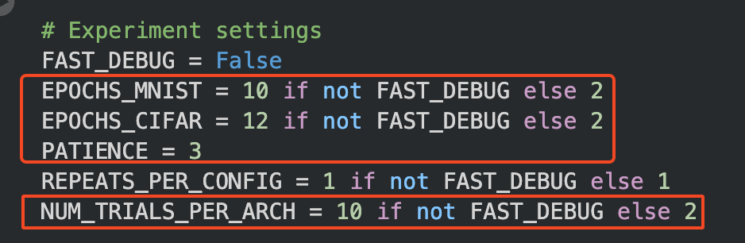

Random seeds
All experiments were run with a fixed random seed (1337) using:
random.seed(1337)
np.random.seed(1337)
torch.manual_seed(1337)
torch.cuda.manual_seed_all(1337)
and deterministic dataset splits via torch.Generator().manual_seed(1337).
As a result, the training/validation partitions and final test accuracies are fully reproducible.

Conclusion
- Both datasets show clear benefit from convolutional architectures due to their ability to model spatial features.
- Hyperparameters with moderate dropout (0.2–0.5) and learning rate 0.001 consistently performed best.
- The best overall model was the Deeper CNN, achieving 0.994 (MNIST) and 0.8025 (CIFAR-10) test accuracy.

