Assignment for Hyperce
Steps for 1 and 2:
- I took the Sample application and package.json and the steps below are listed to dockerize this application:
- Open a VScode
- In VScode open the terminal and create a folder using mkdir
- Install nodejs and docker in your local
Screenshot of Dockerfile:
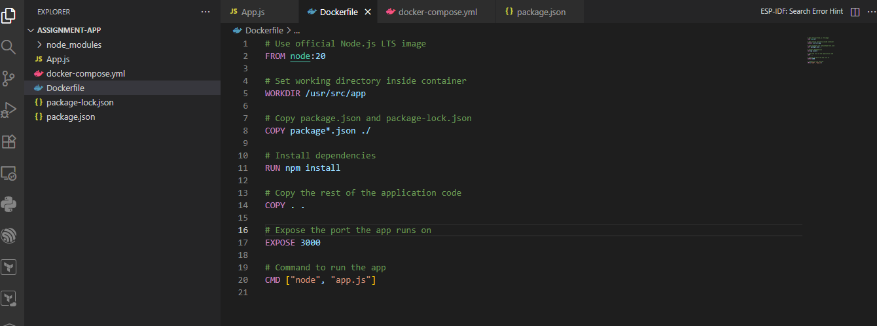

Output shown by the Terminal that our app is running on port as I have mentioned i.e 3000
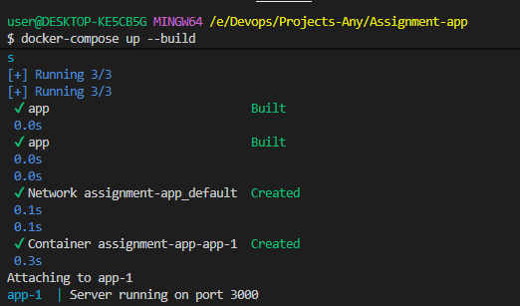
Output:
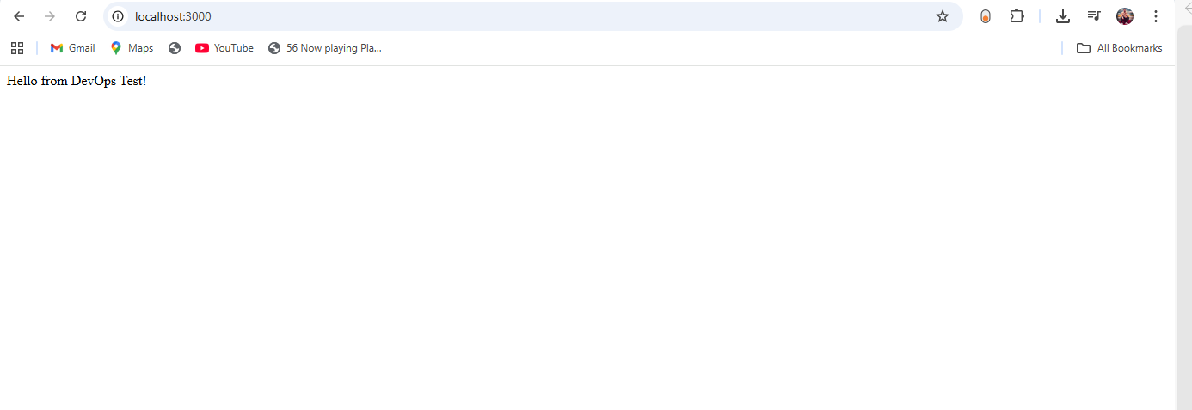

Docker image in Docker Desktop:
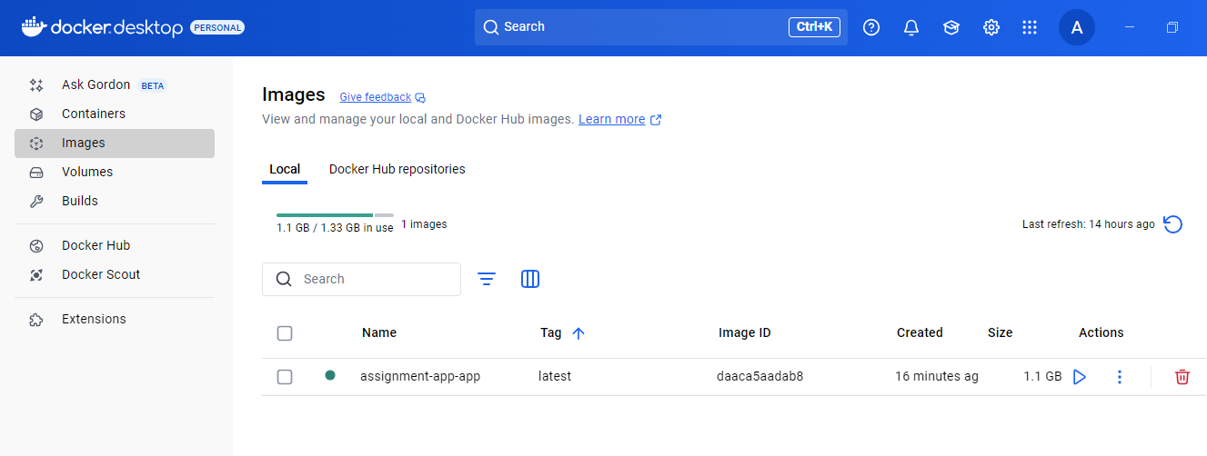
3. CI/CD with GitHub Actions
Output:
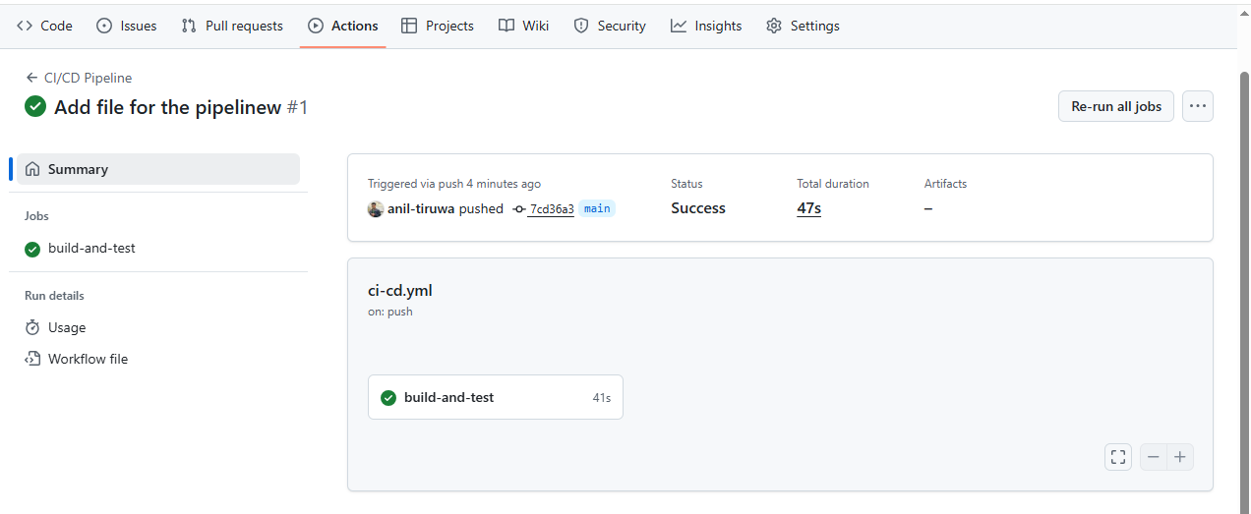
4. Logging and monitoring
- I applied expose metrics in my app.
- I also used prom-client and add/metrics endpoint in app.js
- I setup the target of my Prometheus file
- I created different containers for my app, Prometheus and Grafana
Updated Docker-compose.yml:
version: '3.9'
services:
app:
build: .
ports:
- "3000:3000"
volumes:
- .:/usr/src/app # Mount local code for live reload
- /usr/src/app/node_modules
environment:
NODE_ENV: development
command: node app.js

prometheus:
image: prom/prometheus:latest
container_name: prometheus
volumes:
- ./prometheus:/etc/prometheus
ports:
- "9090:9090"
command:
- "--config.file=/etc/prometheus/prometheus.yml"
depends_on:
- app

grafana:
image: grafana/grafana:latest
container_name: grafana
ports:
- "3001:3000"
environment:
- GF_SECURITY_ADMIN_PASSWORD=admin
depends_on:
- prometheus
volumes:
- grafana-storage:/var/lib/grafana

volumes:
grafana-storage:
Prometheus
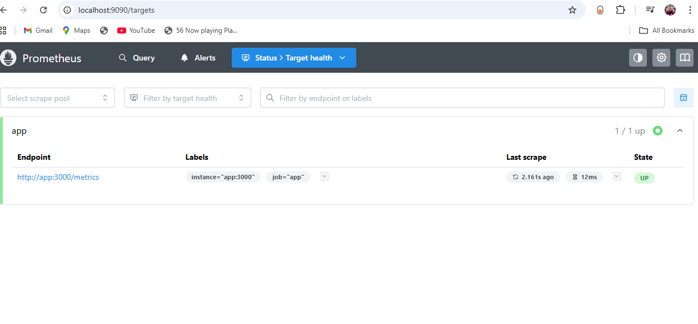
- Prometheus data source (http://prometheus:9090)
- Created dashboards using Http requests total, CPU, memory, and event loop metrics.
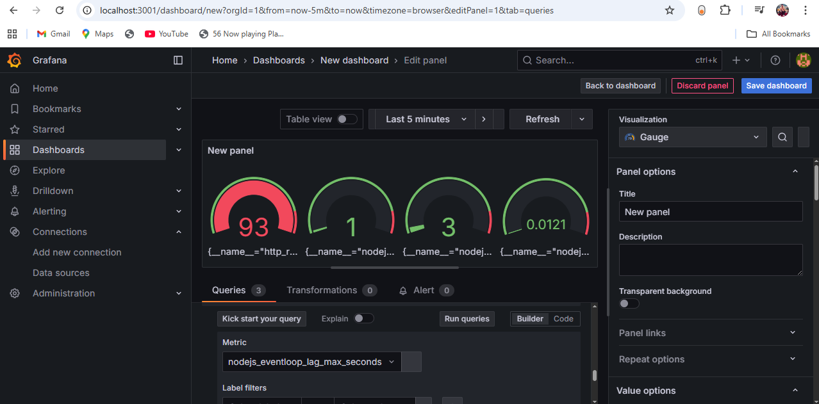

5) Bash Automation script:
I create a new file deploy.sh
#!/bin/bash

# deploy.sh - Automates Docker setup and deployment for multiple containers

echo "Starting deployment..."

# 1. Check if Docker and docker-compose are installed
if ! command -v docker &> /dev/null; then
echo "Error: Docker is not installed."
exit 1
fi

if ! command -v docker-compose &> /dev/null; then
echo "Error: docker-compose is not installed."
exit 1
fi

echo "Docker and docker-compose are installed."

# 2. Build Docker images
echo "Building Docker images..."
docker-compose build
if [ $? -ne 0 ]; then
echo "Error: Docker image build failed."
exit 1
fi

# 3. Start all containers
echo "Starting containers..."
docker-compose up -d
if [ $? -ne 0 ]; then
echo "Error: Failed to start containers."
exit 1
fi

# 4. Wait a few seconds for containers to initialize
sleep 5

# 5. Get list of all service names from docker-compose.yml
SERVICES=$(docker-compose config --services)

# 6. Check if each container is running
echo "Checking container status..."
ALL_RUNNING=true

for SERVICE in $SERVICES; do
CONTAINER_ID=$(docker ps --filter "name=${SERVICE}" --filter "status=running" -q)
if [ -n "$CONTAINER_ID" ]; then
echo "✅ $SERVICE is running."
else
echo "❌ $SERVICE is NOT running."
ALL_RUNNING=false
fi
done

# 7. Final status
if [ "$ALL_RUNNING" = true ]; then
echo "All containers are running successfully!"
else
echo "Some containers failed to start."
docker-compose ps
exit 1
fi

Output:
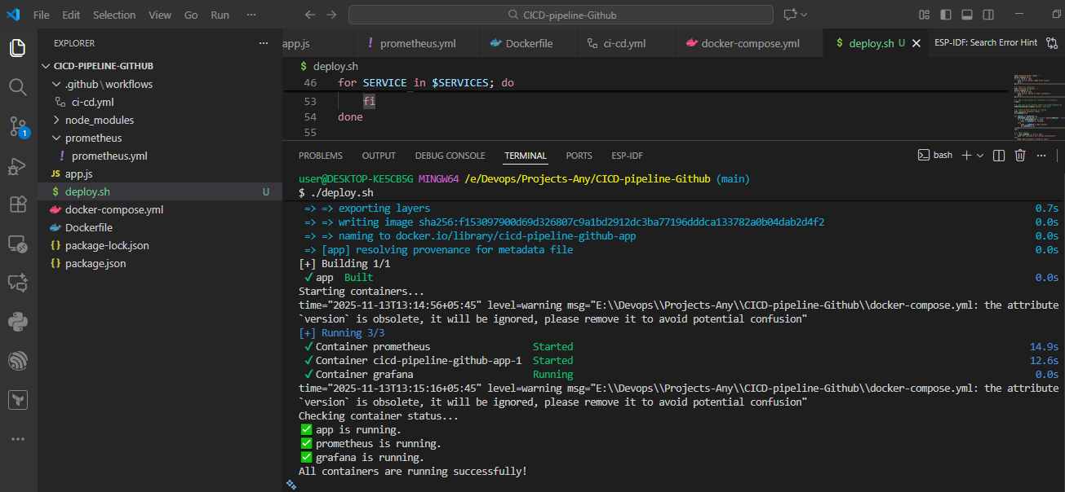
CI/CD in GitHub Actions:
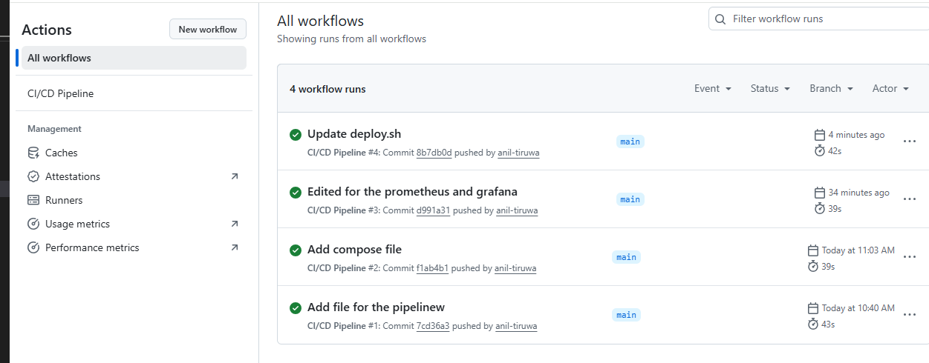

Images in Docker Desktop:
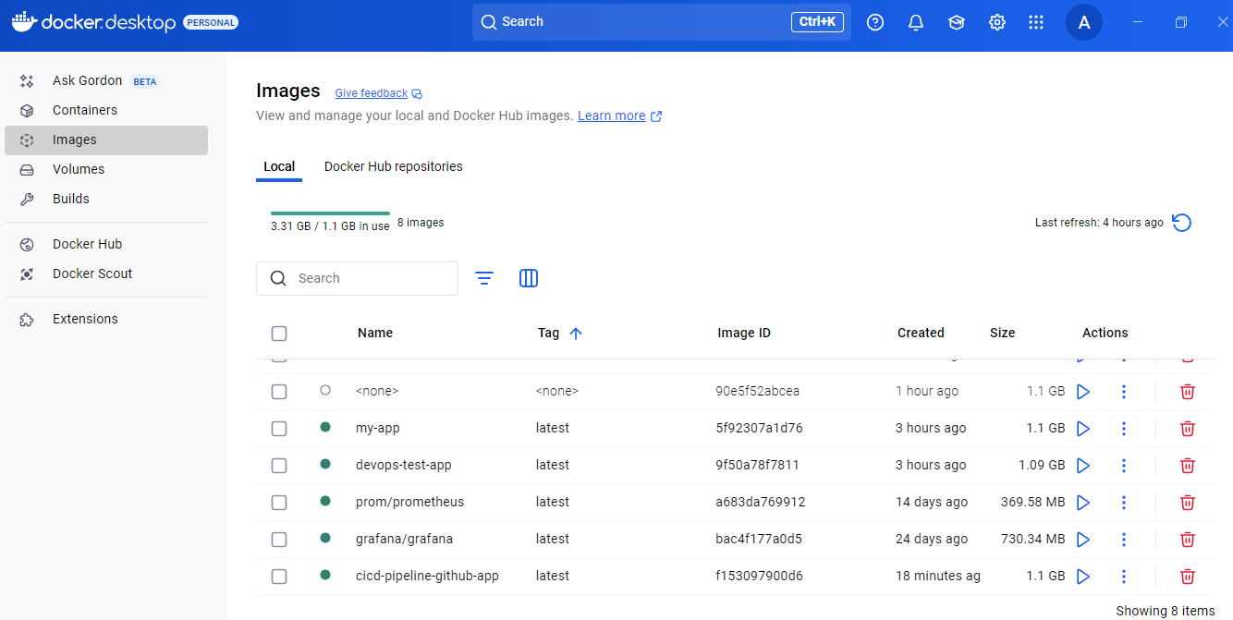

Issue:
I faced indentation problems while writing the docker-compose.yaml file. Services like Loki, Grafana, and Promtail were not correctly nested under services, causing errors. Additionally, I encountered port mapping issues while trying to expose the containers.
Solution:
I carefully corrected the indentation to ensure all services were properly nested under services and verified the YAML structure. I also reviewed and fixed the port mappings to avoid conflicts, which allowed the containers to run successfully.

