**CARPOOL INFORMATION SYSTEM**

PCS.ANIL KUMAR CHUKKALA 11CS10032 SHAIK.SALMAN AHMAD 11CS10041 YARRAMSETTY MANOJ KUMAR 11CS10055 KURAPATI.GOWTAHM SRI CHARAN 11CS10025 NADITOKA.CHANDRA SEKHAR 11CS10033

REPORT:

**Schema** :

We used 5 Tables for meeting the requirements.

USERS (**user_id**, name, email, mobile, password, address)

VEHICLES (**veh_id**, user_id, Vehicletype,VehicleModel, ManufactureYear, DriverType,Drivername,Seating cap,LicenseNo,Licensedate)

SHARING (user_id, **share_id**, start, dest, date, veh_preference, veh_id, cost)

REQUEST (user_id, **request_id**, start, dest, date, veh_preference, veh_type, gender, age, cost)

MESSAGE (**msg_id**, share_id, request_id, sender_id, receiver_id, receiver_name, status)

**Workflow :**

USER REGISTRATION:

Users make their registration into the system by providing the details like name, email -id, mobile, address, and unique password .After each registration a unique user-id is generated by the system. This whole information is stored in the users database. Then the user is prompted to make login.

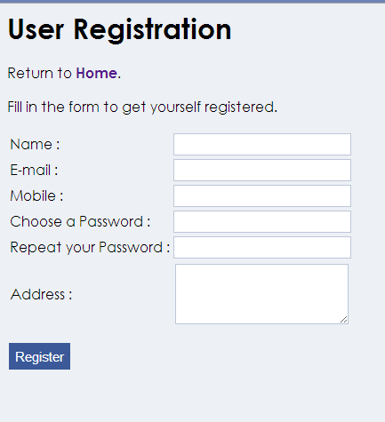

REGISTRATION OF VEHICLES:

Registered users can register their vehicle either own vehicle or hired vehicle by providing the details like vehicle type whether it is a minicab or some SUV ,model, manufactured year, driver type, seating capacity, driver name, license number, license date. After every successful vehicle registration a unique vehicle id is generated which is primary key for the vehicle database. All these data is stored in the vehicle data base.

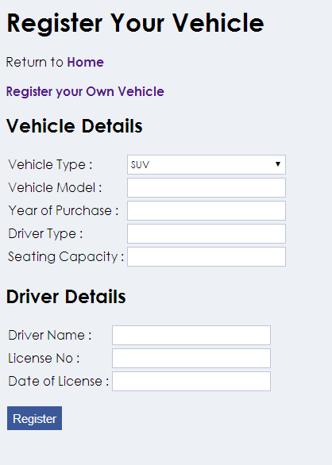

SHARING VEHICLE:

Registered user after registering can share a vehicle they registered for other user. To do so the user must provide details like start point, destination point, whether the service is for daily basis or particular day, sharing cost, number of allowable passengers, vehicle preference etc. Every time a unique share id is generated for every request and this data is stored into shared requests database.

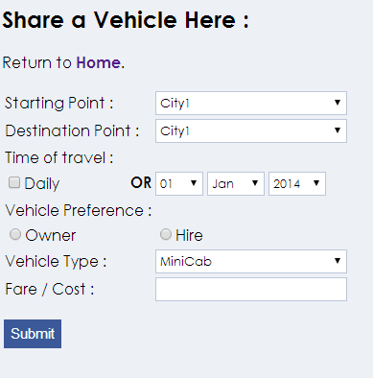

REQUEST FOR SHARED VEHICLE (OPEN MESSAGE):

Any user can request for a shared vehicle by providing details regarding his interests like starting point , destination point, date of travel whether it is daily basis or on a particular day, vehicle preference, maximum bearable cost on journey and information like users gender, age group. Then a message is generated to all the users registered in the system.

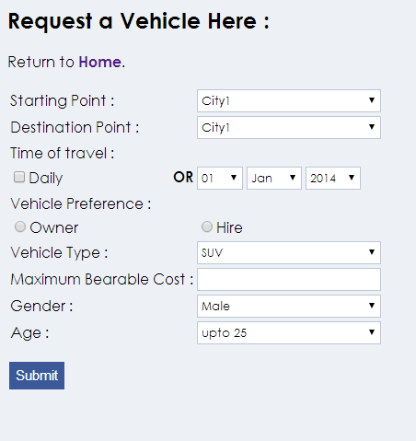

FINDING A SHARED VEHICLE (Carpool search):

Any user who wants to find a shared vehicle can do so by providing details like start and destination point, date of journey(daily or particular date) .

User can also sort the search results in order of cost, vehicle type (minicab, SUV, Volvo bus, Jeep), vehicle preference (owner or hire), year of purchase. After search user can send a request to the particular user he is interested in.

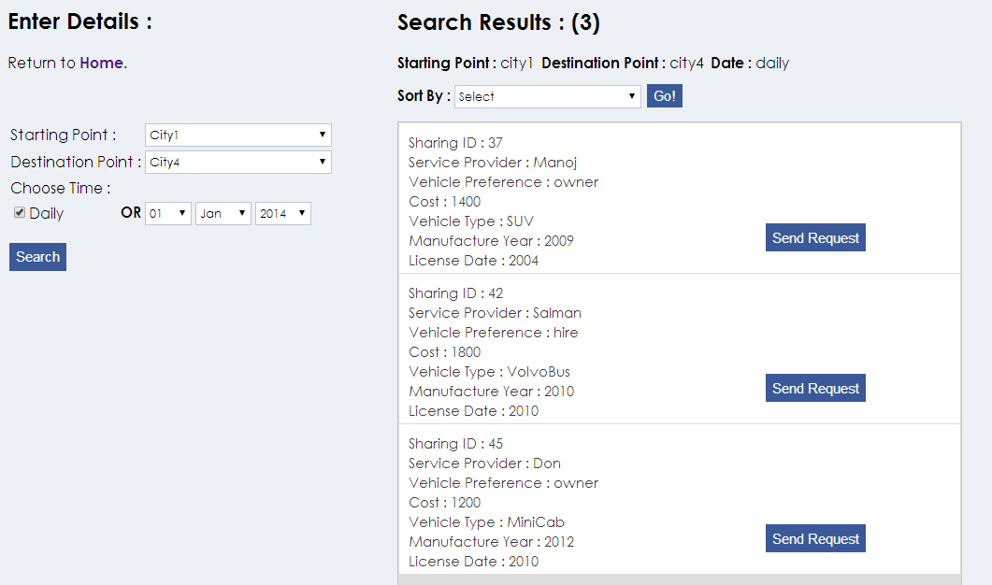

SEARCH REQUESTER:

A user can check if there are any requesters with interests matching to his journey date just by providing starting point and destination point. Here user can sort the search results in order of cost, gender, age group. Then he can accept the requests of other users.

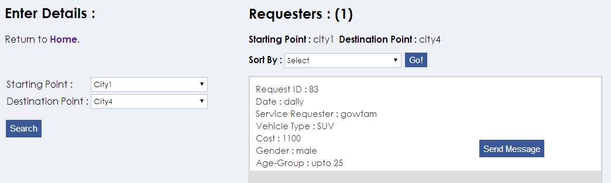

Accepting Requests:

A user accepts requests either by responding to the messages from other user or by searching requesters and accepting their requests.

Messages: A user gets a message whenever some other user requests this particular user his vehicle.

User page:

Every registered user consists of a page which displays details messages he got, vehicles he possess. User can perform actions like changing his profile information, password and also above stated actions like carpool search, search requester, vehicle registration, sharing a vehicle, sharing a request etc. Every registered user is prompted to make login every time he makes visit.

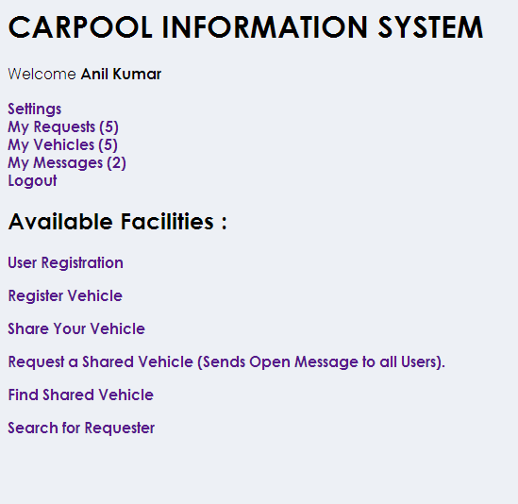

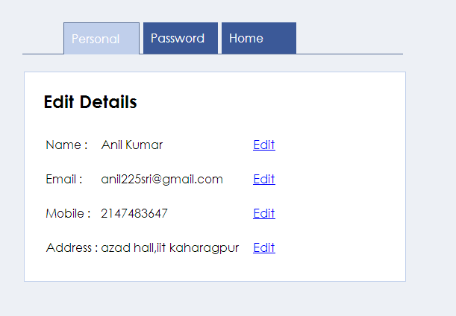

**Languages Used** :

We used HTML,CSS for design and styling purpose and PHP and MySQL for Database Queries.We used Xampp for database connection.

-----------------------------------------------------END-------------------------------------------------------------------