**Docker Basic Command:**

1. Docker install --- apt-get install docker.io
2. Docker images --- Lists all images
3. Docker pull image-name --- To download the images from the Docker hub
4. Docker run image-name --- to create container(pull + run)

{docker run + docker start from docker file}

“Docker run nginx” will create a container and exit

“Docker run –d nginx” will create and up

Docker stop id & Docker start id to stop and start the container

1. Docker ps –a ---- to see all the created containers

Docker ps will show only running containers

1. Docker rmi image_name , docker rm container id, docker stop, docker start --- to Remove images, containers, stop , start
2. To delete all Docker containers rm $(docker ps -a -q), Docker rmi $(docker images -q)
3. Docker run –d –p 90:80 –t nginx

Here the image nginx is downloaded and run in demon mode (-d) with port (-p). 80 is container port and 90 is host port where we can access from browser. <http://127.0.0.1:90>

1. To enter inside a running container with interactive mode

docker exec -it containerName bin/bash for interactive mode to a container

**Installing Kubernetes**

1. First add the kubernetes signing key

🡺curl -s https://packages.cloud.google.com/apt/doc/apt-key.gpg | sudo apt-key add

1. Adding kubernetes repository

🡺 sudo apt-add-repository "deb http://apt.kubernetes.io/ kubernetes-xenial main"

1. Installing kubeadm

🡺 sudo apt install kubeadm

1. kubectl run <name of pod> --image=<name of the image from registry>

**Git Pull & Git Push:**

### create a new repository on the command line

echo "# Docker Tutorial" >> README.md

git init

git add README.md

git commit -m "first commit"

git remote add origin https://github.com/Amerepal/Docker_Tutorial.git

git push -u origin master

### …or push an existing repository from the command line

git remote add origin https://github.com/Amerepal/Docker_Tutorial.git

git push -u origin master

| Command | Description |
| --- | --- |
| [docker attach](https://docs.docker.com/engine/reference/commandline/attach/) | Attach local standard input, output, and error streams to a running container |
| [docker build](https://docs.docker.com/engine/reference/commandline/build/) | Build an image from a Dockerfile |
| [docker checkpoint](https://docs.docker.com/engine/reference/commandline/checkpoint/) | Manage checkpoints |
| [docker commit](https://docs.docker.com/engine/reference/commandline/commit/) | Create a new image from a container’s changes |
| [docker config](https://docs.docker.com/engine/reference/commandline/config/) | Manage Docker configs |
| [docker container](https://docs.docker.com/engine/reference/commandline/container/) | Manage containers |
| [docker cp](https://docs.docker.com/engine/reference/commandline/cp/) | Copy files/folders between a container and the local filesystem |
| [docker create](https://docs.docker.com/engine/reference/commandline/create/) | Create a new container |
| [docker deploy](https://docs.docker.com/engine/reference/commandline/deploy/) | Deploy a new stack or update an existing stack |
| [docker diff](https://docs.docker.com/engine/reference/commandline/diff/) | Inspect changes to files or directories on a container’s filesystem |
| [docker events](https://docs.docker.com/engine/reference/commandline/events/) | Get real time events from the server |
| [docker exec](https://docs.docker.com/engine/reference/commandline/exec/) | Run a command in a running container |
| [docker export](https://docs.docker.com/engine/reference/commandline/export/) | Export a container’s filesystem as a tar archive |
| [docker history](https://docs.docker.com/engine/reference/commandline/history/) | Show the history of an image |
| [docker image](https://docs.docker.com/engine/reference/commandline/image/) | Manage images |
| [docker images](https://docs.docker.com/engine/reference/commandline/images/) | List images |
| [docker import](https://docs.docker.com/engine/reference/commandline/import/) | Import the contents from a tarball to create a filesystem image |
| [docker info](https://docs.docker.com/engine/reference/commandline/info/) | Display system-wide information |
| [docker inspect](https://docs.docker.com/engine/reference/commandline/inspect/) | Return low-level information on Docker objects |
| [docker kill](https://docs.docker.com/engine/reference/commandline/kill/) | Kill one or more running containers |
| [docker load](https://docs.docker.com/engine/reference/commandline/load/) | Load an image from a tar archive or STDIN |
| [docker login](https://docs.docker.com/engine/reference/commandline/login/) | Log in to a Docker registry |
| [docker logout](https://docs.docker.com/engine/reference/commandline/logout/) | Log out from a Docker registry |
| [docker logs](https://docs.docker.com/engine/reference/commandline/logs/) | Fetch the logs of a container |
| [docker manifest](https://docs.docker.com/engine/reference/commandline/manifest/) | Manage Docker image manifests and manifest lists |
| [docker network](https://docs.docker.com/engine/reference/commandline/network/) | Manage networks |
| [docker node](https://docs.docker.com/engine/reference/commandline/node/) | Manage Swarm nodes |
| [docker pause](https://docs.docker.com/engine/reference/commandline/pause/) | Pause all processes within one or more containers |
| [docker plugin](https://docs.docker.com/engine/reference/commandline/plugin/) | Manage plugins |
| [docker port](https://docs.docker.com/engine/reference/commandline/port/) | List port mappings or a specific mapping for the container |
| [docker ps](https://docs.docker.com/engine/reference/commandline/ps/) | List containers |
| [docker pull](https://docs.docker.com/engine/reference/commandline/pull/) | Pull an image or a repository from a registry |
| [docker push](https://docs.docker.com/engine/reference/commandline/push/) | Push an image or a repository to a registry |
| [docker rename](https://docs.docker.com/engine/reference/commandline/rename/) | Rename a container |
| [docker restart](https://docs.docker.com/engine/reference/commandline/restart/) | Restart one or more containers |
| [docker rm](https://docs.docker.com/engine/reference/commandline/rm/) | Remove one or more containers |
| [docker rmi](https://docs.docker.com/engine/reference/commandline/rmi/) | Remove one or more images |
| [docker run](https://docs.docker.com/engine/reference/commandline/run/) | Run a command in a new container |
| [docker save](https://docs.docker.com/engine/reference/commandline/save/) | Save one or more images to a tar archive (streamed to STDOUT by default) |
| [docker search](https://docs.docker.com/engine/reference/commandline/search/) | Search the Docker Hub for images |
| [docker secret](https://docs.docker.com/engine/reference/commandline/secret/) | Manage Docker secrets |
| [docker service](https://docs.docker.com/engine/reference/commandline/service/) | Manage services |
| [docker stack](https://docs.docker.com/engine/reference/commandline/stack/) | Manage Docker stacks |
| [docker start](https://docs.docker.com/engine/reference/commandline/start/) | Start one or more stopped containers |
| [docker stats](https://docs.docker.com/engine/reference/commandline/stats/) | Display a live stream of container(s) resource usage statistics |
| [docker stop](https://docs.docker.com/engine/reference/commandline/stop/) | Stop one or more running containers |
| [docker swarm](https://docs.docker.com/engine/reference/commandline/swarm/) | Manage Swarm |
| [docker system](https://docs.docker.com/engine/reference/commandline/system/) | Manage Docker |
| [docker tag](https://docs.docker.com/engine/reference/commandline/tag/) | Create a tag TARGET_IMAGE that refers to SOURCE_IMAGE |
| [docker top](https://docs.docker.com/engine/reference/commandline/top/) | Display the running processes of a container |
| [docker trust](https://docs.docker.com/engine/reference/commandline/trust/) | Manage trust on Docker images |
| [docker unpause](https://docs.docker.com/engine/reference/commandline/unpause/) | Unpause all processes within one or more containers |
| [docker update](https://docs.docker.com/engine/reference/commandline/update/) | Update configuration of one or more containers |
| [docker version](https://docs.docker.com/engine/reference/commandline/version/) | Show the Docker version information |
| [docker volume](https://docs.docker.com/engine/reference/commandline/volume/) | Manage volumes |
| [docker wait](https://docs.docker.com/engine/reference/commandline/wait/) | Block until one or more containers stop, then print their exit codes |

**To Remove a container:**

1. We need to stop the container

🡺 docker ps –a (to see running containers)

🡺 docker stop 826fd5fb5525 (container id)

1. We need to remove the stopped container

🡺 docker rm 826fd5fb5525

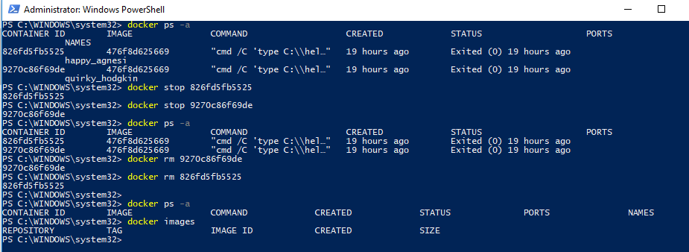

**To Remove an image:**

To see all the available local images

🡺 docker images

To remove the image

🡺 docker rmi <imagename>

NOTE:

An image which is running in a container cannot be deleted. In order to delete the image we need to delete the container first.