**git rebase –I HEAD~4**

**the below pop-up comes, replace pick with s**

**save and exit**

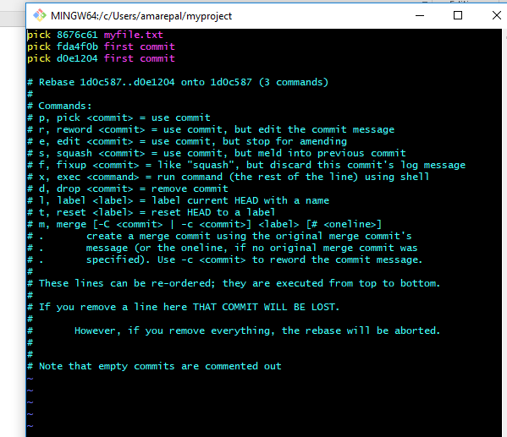

Now remove the last 2 commits ie,: message1,message 2

Save and exit

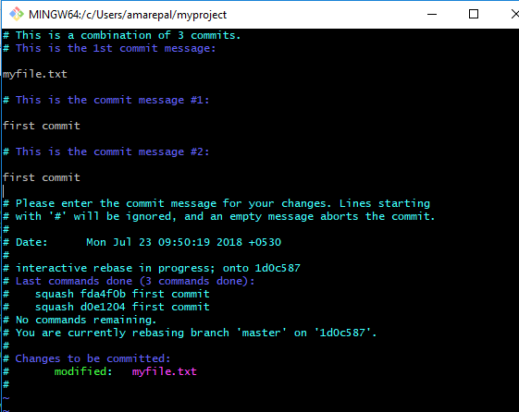

Now check with git log the commits will get removed