**Client Creation:**

Remove mandatory field for phone number.

Possibility to change order of the price units in a price list:

Client contact person not visible, even when added during creation:

Also, name of business unit should show as SpellUp, and not SPEU_

Phone number should not be mandatory for Contact Person:

It should be possible to add/edit the Scoop name, so we can add additional information if it’s multiple batches of a project.

It would also be great to create a batch check box that can be clicked, in case we need to do batch deliveries of a project.

The batch option should then show a field for Batch Name and possibility to choose words/hours and include quantity.

We also should be able to set separate deadlines and include a short description (i.e. name of files).

These batches should also be possible to assign to linguists within their job.

Batches should be without payable, it’s a sub section of the Scoop. So the amount to be paid and get paid should be connected to the Scoop/Job.

Scoop Issue

When I added the details of 1 of the 5 scoops and clicked saved. The information disappeared when I clicked on it thought the dashboard.

Also, the price in the pricelist is not fetched. When I select Translation (Hour), it doesn’t fetch the price from the price list.

Save button:

We need a better saving option for Scoops.

Can we place one Save button that follows the scrolling of the page, so it’s always available?

In addition, can we include autosave for the entire TMS?

Scoop Price:

On item 3, Scoop price isn’t shown and the same happens for the rest of the items:

Part of the Scoop name shows up as Null:

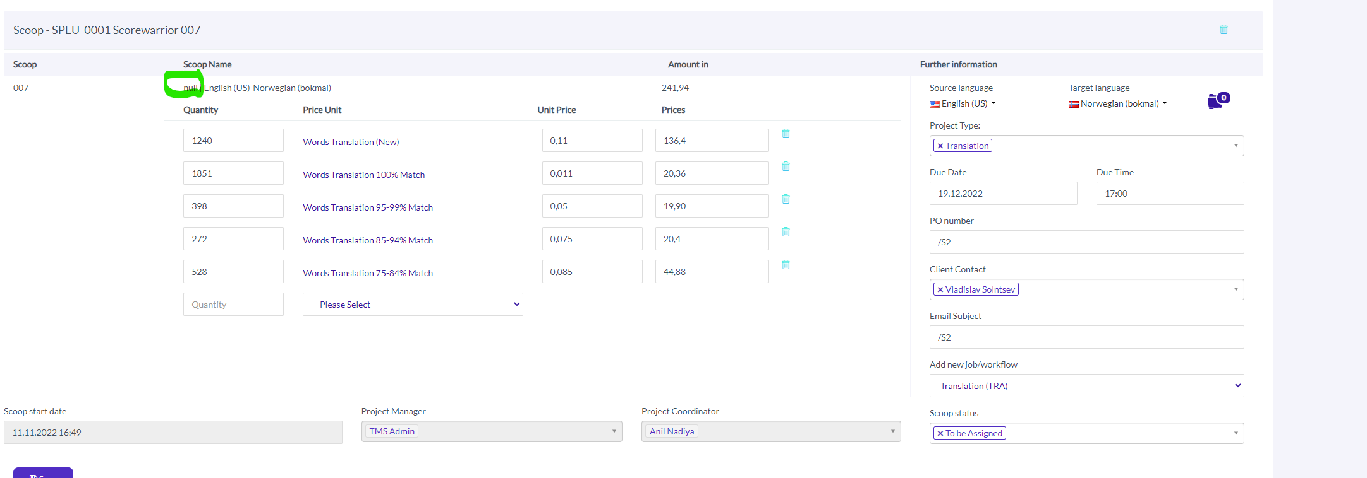

Wrong total price for Scoop (same for multiple scoops after):

When adding new scoops, and trying to save them, all prices for those scoops disappeared. I got error message for API key, but no error message when working on it originally. I was logged out, then logged back in, clicked on the project via Dashboard, and all those new 5 scoops added didn’t have any information saved.

It also suddenly logs me out, when I finish up the Scoop part.