**Dashboard – Layout**

**First some feedback on the work done:**

1.

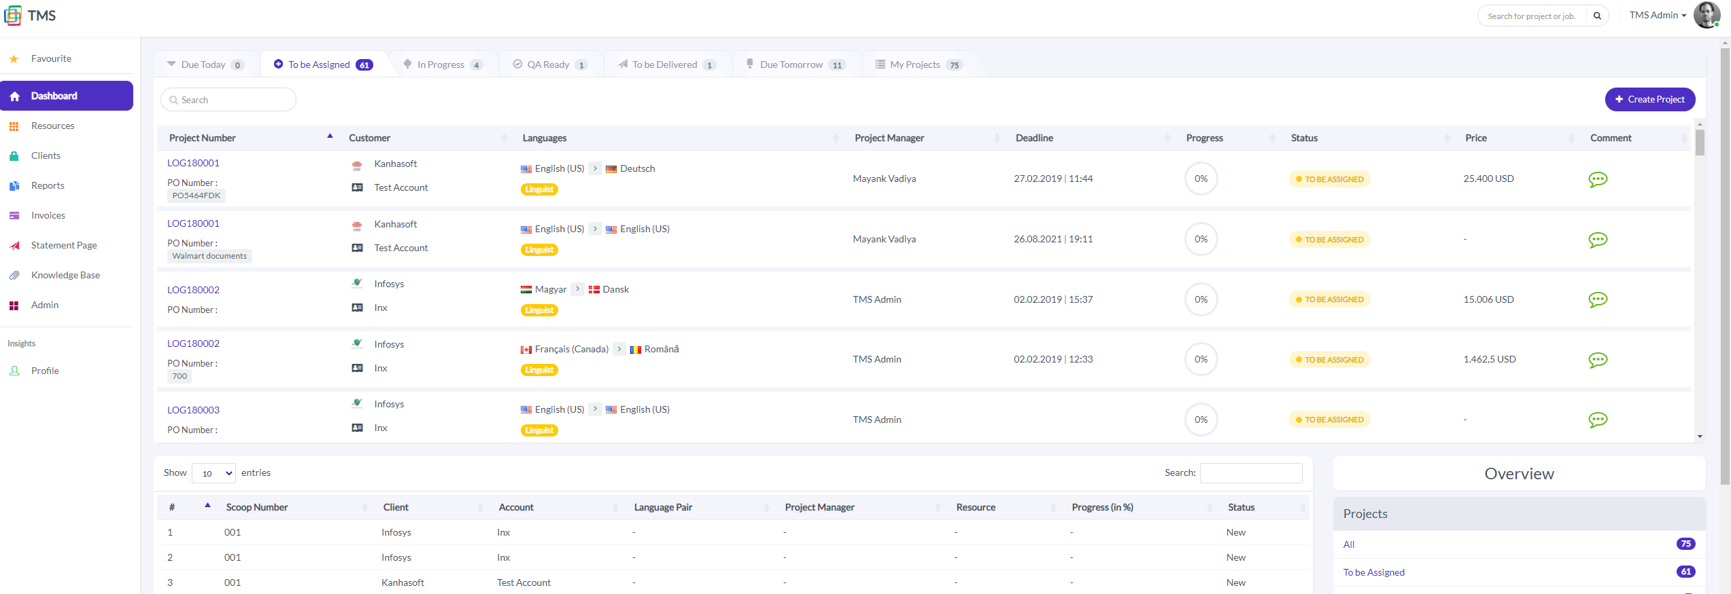

The list of scoops shouldn’t be space limited, so please make it fill the page itself, so all scoops are visible in the list.

2.

This Linguist part, what is that referring to?

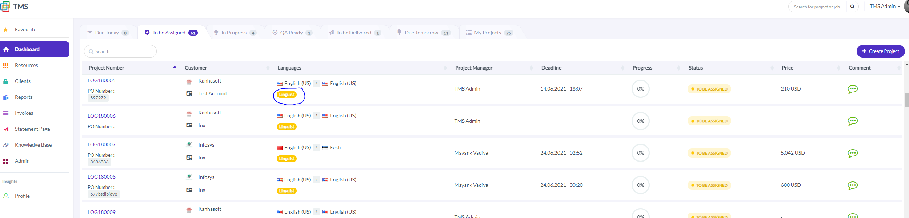

3.

The default sorting method for the list of scoops should be according to deadline.

When I sort by deadline now, it doesn’t show the correct way, as the time (hours and minutes) doesn’t sort correctly:

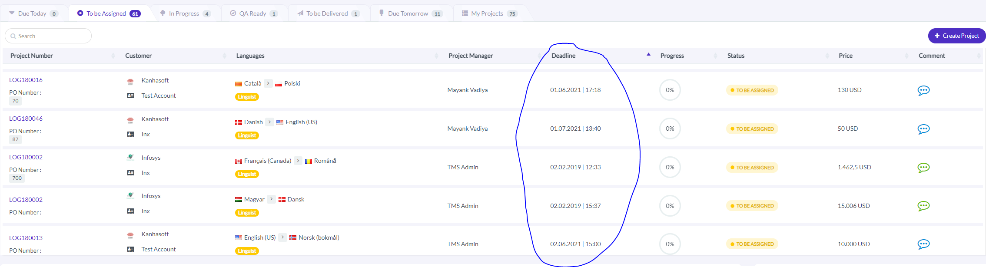

4.

As for the statuses, could we try them without the dot?

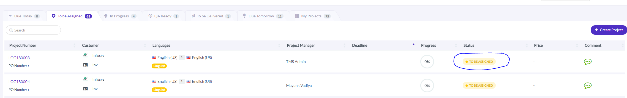

5.

The languages, can we please have them shown in English language, and not how they are written in the actual languages (i.e. Norsk for Norwegian)

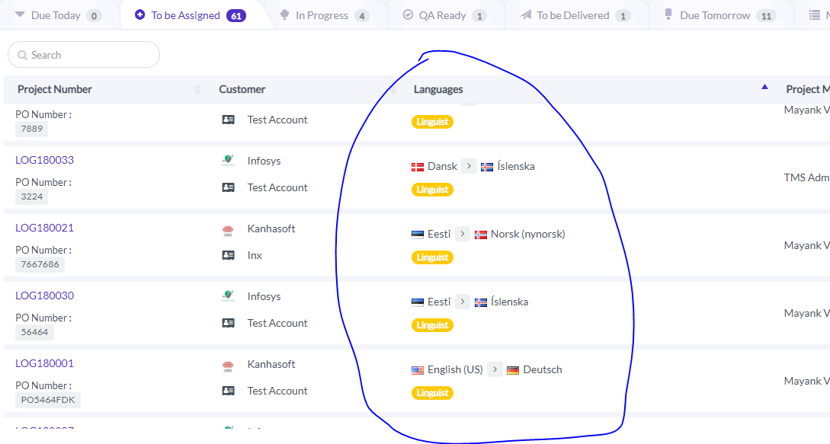

6.

Could we add a small space between the tabs, like the example link?

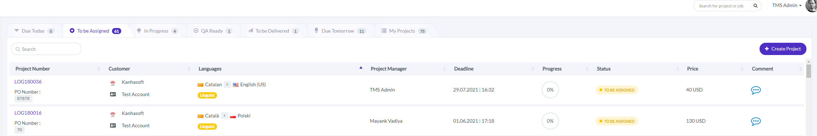

<https://dribbble.com/shots/6773387-Sales-orders-list>

7.

All these overviews of steps and jobs at the bottom, can they be hidden, unless they are selected and clicked on in the Overview list of the right side?

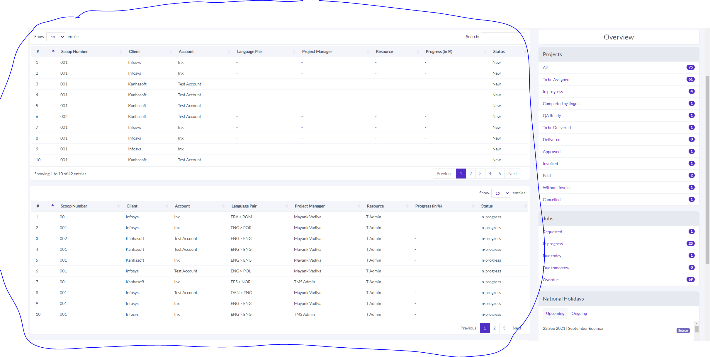

8.

Under the Insight menu item, could we also include Inbox, Notifications and Comments, according to this? 😊

<https://dribbble.com/shots/14216896-Unity-Dashboard-Kit>

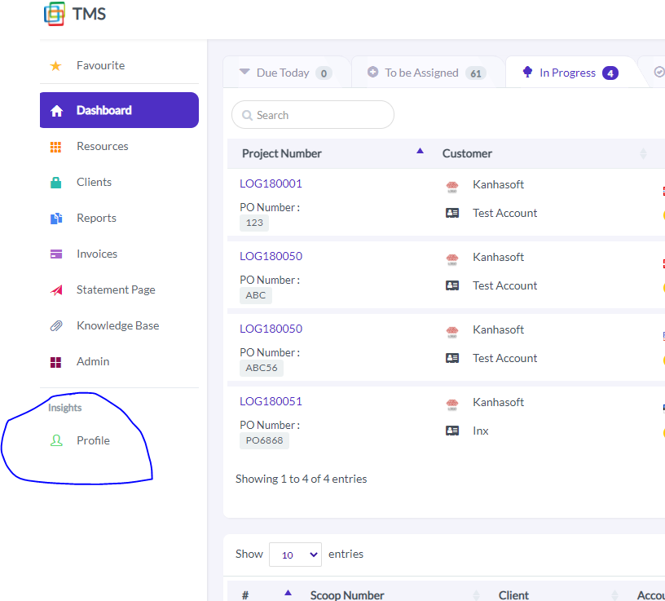

9.

As for the chat/comment section, could this be a pop-up window?

Also, are we able to place messages on the right and left side, like the example below, instead of them all being on the right side?

Could we also do grey background and white text box for writing new messages, like the below example?

It would also be great to add the green check mark, when a message is read.

Could we also include the hours in the estimated delivery under Status?

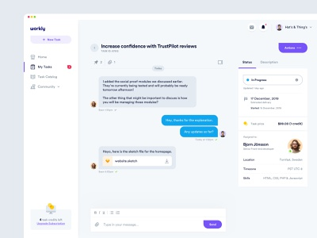

<https://dribbble.com/shots/10965270-Workly-Task-Management>

Could we also include the team working on the task here:

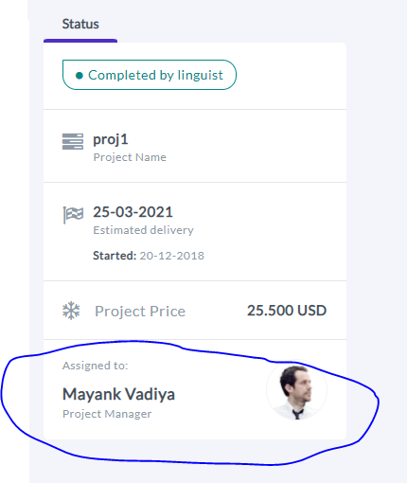

So that is says, Project Team:

And then we list the following team members:

Project Coordinator

Project Manager

Linguist

QA Specialist

**Create Project Design**

This part also needs to design lift, to match the new design feel we have made and are making for the dashboard and chat/comment function.

I’m struggling a bit to find some good examples, but could you maybe try to be a bit creative to incorporate the same style and design here?

Would also prefer round buttons, and maybe place the Cancel button just as an X mark in the right top corner.

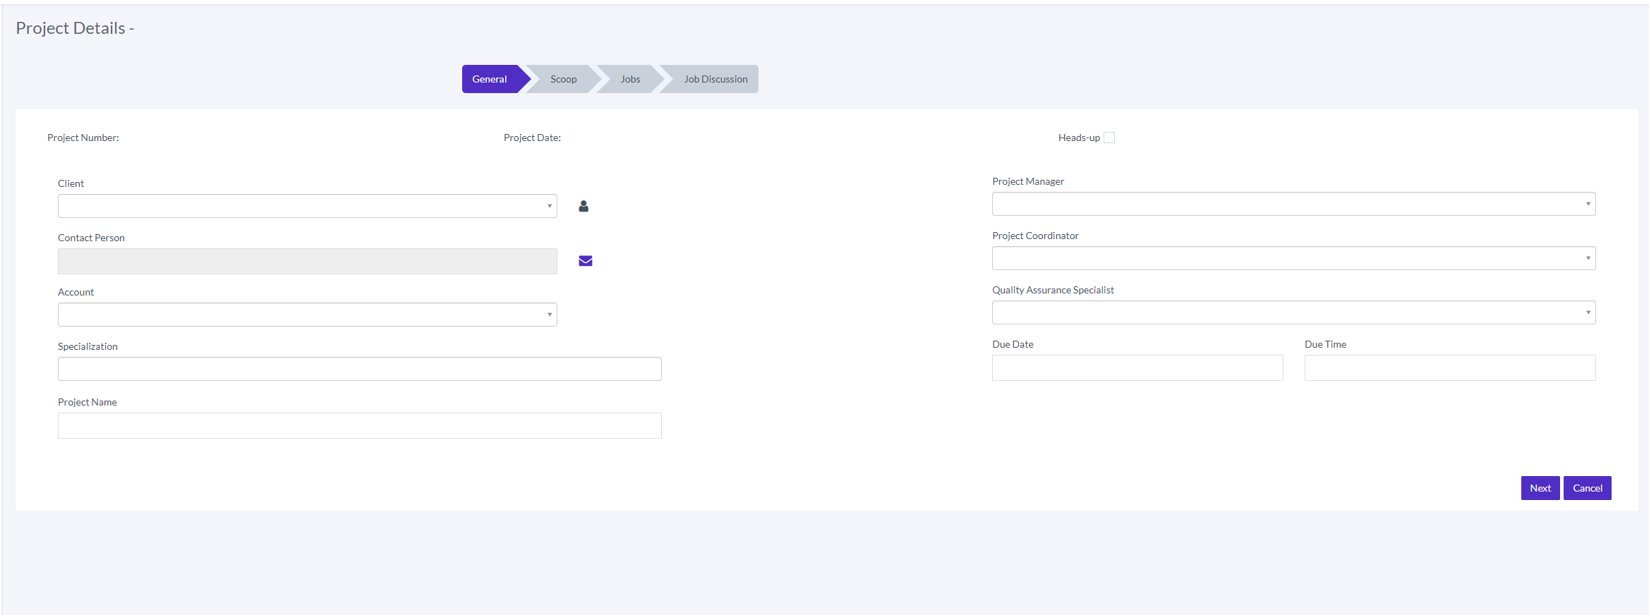

Scope:

I’m struggling here as well with the design.

Here there should be round buttons as well, and the Back button can be removed.

Maybe we could also remove the Create scope button, and just have a drop down menu in the center of the screen where number of scopes can be selected? I think it’s enough to have the number 1-5.

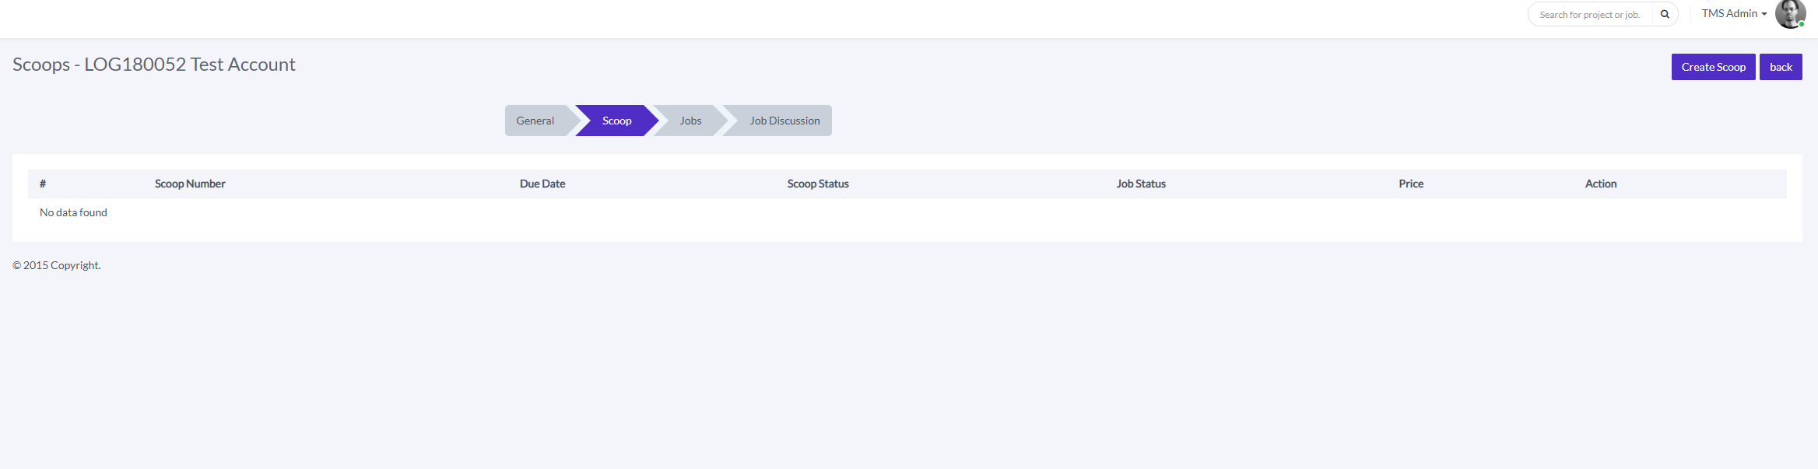

Maybe we can also make the scoop window a bit smaller, more grey background and a bit less space for the scoop window itself.

In addition, we could probably place the non-editable fields at the bottom of each scope, to shrink the number of fields needed on the right side.

I drop down field option I like for the entire site is this:

https://dribbble.com/shots/4371972-Graphics-Editor-Selection-Drop-Down